0

Mihey Matev

**Words With Friends  
(with AI)**

Contents

Task 1: Introduction and Analysis 3

Introduction 3

Why this problem is a good choice for solving programmatically 4

Stakeholders 5

Research 6

Limitations 7

Features 8

Requirements 11

Software/Hardware 11

Features 12

Success Criteria 13

Task 2: Design 14

Design Specification 14

Top-down design diagram 16

Screen designs 18

Input/output Design 21

Data Dictionary 23

Flowchart 26

Test Plans 29

Development Testing 29

Post Development Testing 34

Pseudocode 39

White-box Testing (dry runs) 49

Usability Features 53

Validation 54

Task 3: Implementation 55

Implementation Iteration 1 (v 0.1) – Basic Setup 55

Between Iteration 75

Implementation Iteration 2 (v 0.2) – Scene changes 76

Prototype Iteration 1 108

Implementation Iteration 3 (v 0.3) - Finishing graphics 109

Prototype Iteration 2 149

Implementation Iteration 4 (v 1.0) – finishing player vs. player 153

Prototype Iteration 3 169

Implementation Iteration 5 (v 1.1) – finishing player vs. player 171

Implementation Iteration 6 - GADDAG Iteration 173

Implementation Iteration 7 (v 1.2) - AI development 176

Implementation Iteration 8 (v 1.2.1) 199

Extra note 203

Task 4: Post Development Testing 204

Post Development Testing Tables 204

End User Testing 204

Robustness Testing 221

Whole System Testing 229

Success Criteria 241

Usability Testing 242

Questionnaire 243

Questionnaire Results 246

Usability Features 254

Task 5: Evaluation of Solution 257

Success Criteria 258

Further Development for Success Criteria 261

Usability Features 262

Further Developments for Usability Features 269

Maintenance 270

Limitations 270

Bibliography 272

# Task 1: Introduction and Analysis

## Introduction

My project is a Scrabble like game. I plan on making it smaller and two player only, so it’s going to be more like ‘Words With Friends’ (made by Zynga). I plan on also making an AI to play against, and then allowing the user the choice of starting first or second against the AI, but also having the option to play against another player. If there is enough time, I would like to also make it multiplayer.

Scrabble was first invented by Alfred Mosher Butts in 1938 as a board game. However, ‘Words With Friends’ was released in 2009.

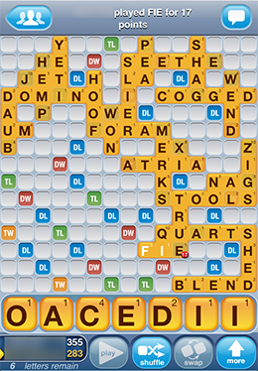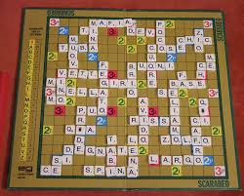The game has already been made, so by making the AI it would allow me to win most of my games against my friends. The original Scrabble game is a physical board game and has no AI However, with my game, if there is no real person you can play against, you can just play against the AI and not be bored.

## Why this problem is a good choice for solving programmatically

The program will need to calculate the score of each player after each turn, after making sure that the word laid down was actually a valid word, and not just something made up.

By adding an AI, large amounts of calculation are also going to be needed, as when I will want the AI to place down the highest scoring word, I will need to find a way of combining the letters to form a word, and then also finding a valid place to put the word down. This requires running a lot of checks, which are just repeated calculations, which computers are very good at carrying out.

This program involves handling, and potentially sorting large amounts of data, in the form of a list of words. The list of words is required to make sure that each word that is placed down is a valid word, and each word will have to be checked against this list, to make sure it’s in it. A human is less efficient at searching a very long list than a computer, especially if the search algorithm is optimised.

Sorting could be required to shrink the number of possibilities for words to check against, especially for when the AI needs to choose a correct word to make. I would do this by eliminating all words that contain letters which are not available to the AI, and also sorting them in ways such as three letters after the letter ‘a’, contains the string ‘th’, or similar. By doing research, I found out that a DAGGAD/GADDAG ( (A Faster Scrabble Move Generation, n.d.), (Developing an Artificial Intelligence to Play, n.d.), (A Scrabble Artificial Intelligence Game, n.d.), (Gaddag Data Structure – A Way To Quickly Find Scrabble Words, n.d.) ) data structure would be a good way to store this information in, and this would require a lot of memory, which these days, a computer has, but if it was all on paper, it would take up a lot of paper and space, and be difficult to use by a human.

Along with that large amount of data, there is going to be the need of handling positions of tiles, state of tile (such as knowing whether it’s some sort of a multiplier, whether it has a letter on it etc.). A programmatical approach for representing these tiles isn’t necessary, as a physical board can very easily do this, however the board can be modelled as a 2D array, containing a lot of information, which as mentioned before, the program can use for all of the other important calculations.

An alternative to making software to do this would be to have a humans adding up their score, and also a human who knows every single word and always makes the choice of the best word based on the letters they are holding. This is almost impossible, especially if you just want to play by yourself, in which case it is impossible. However, a game with an AI can be played by just one person.

This game could be scaled up to have a bigger board quite easily, possibly have multiple players. It can be scaled up with and AI which checks a bigger board of works with more letters, however this would require more processing and therefore more time, and might be implausible to always find the best word. By using an algorithm which limits time (or finds a local maximum), such as simulated annealing, it might become more plausible, but it would still have the disadvantage of not playing the best word.

The AI part of the program will involve brute force to find the highest scoring word given the current board and currently held letters. Computers being fast, are good at brute forcing, and because the amount of information that there is in this game, it shouldn’t take a long time to brute force the highest scoring word.

Setting up the board and keeping score for each player should be quite easy. The most difficult part is going to be programming the AI, as there are a lot of options that will require to be checked.

The program will help people to save time, as if they were to play the physical board game, then they would need to take their time to count up the score and make sure that a word that’s been placed down is a valid word. It’s more convenient as one person can play on their own.

Doing this on a computer is also useful as if I decide to make it multiplayer, I can also allow people from different parts of the world to connect and play together without being physically in the same place.

Another advantage of making the game for a computer, is that it will save physical space (you won’t have to store the physical game somewhere in a cupboard). This also means that it requires no physical resources to produce the game, as it is just software which can be downloaded onto a computer, and could potentially be cheaper than buying the physical scrabble game.

## Stakeholders

My main target audience is anyone who wants to play a game in their spare time, and so they probably don’t have a very specific need that they are looking for my program to fulfil. However, as this might be too broad of an audience to satisfy, I might target my game at a range of people who would know how to use a computer sufficiently without having to be led by a tutorial of how to interact with such games, and actually want to play such games. This age range would probably be people less than 50, but over 30, as there are probably games that adults would be more interested in playing when younger, but in this range they might want to use it to teach their children, or to just kill time. This does also mean that the game would need to have nice attractive colours so that if they do give it to their children, their children like it, but it would be assumed that the parent would be teaching their child how to play the game. Above this range, the adults would probably not want to deal with technology as they might not know how to use it, and would just use a physical board. This would mean that the game would have to be functional, with an easy UI, so that the user can make the most of their time instead of having to troubleshoot problems and figure out what things do.

My program is just a game to spend your extra time on. This could include players of any age, even players of and age younger than three, as scrabble says, because there are no small parts that small children could swallow when playing on a computer. This could help their parents have more time on their hands without having to worry about their child being in danger.

It could potentially be used by schools to teach people English words, and improve their knowledge by expanding their lexicon. It is a fun way for pupils to learn new words through a game, and would also require the teacher to prepare less for a lesson.

The game could be put on a platform, and just like any other free online game, there can be adverts displayed on it, which could earn both me and the platform money. Currently, ‘Words with Friends’ is on Facebook, and there are ads on it which earns Facebook and Zynga money, and the advertisers more customers, and therefore also more money (if invested correctly). This would require the game to have some kind of feature which would cause a player to come back to it, such as a high score ranking against your friends, so that people keep coming back to it to beat their friends, or some kind of daily reward, such as a daily ‘tell me the best word I can play in this situation’ with each log-in, which there is no other way to get, but you can collect them.

If I want to make this game multiplayer over a network, then I might have problems with the school network restrictions that are in place to restrict such games from being played on the school network. The solution which I would come up with could be useful to others in my situation. These people could be other students of my age who are facing the same problem, or somebody else out there in the game industry who wants to make an online multiplayer program. Their needs would be a simple way to set up such a network, which I might be able to offer them.

A scrabble program such as this requires natural language processing. Natural language processing is used in a lot of places, such as in cryptography, AI learning to talk (machine learning), and statistics connected to these. These are of interest to cryptographers, the government and researchers. It could potentially help lonely people have a computer to talk to. This could meet their requirements of word recognition, such as in a place where parts of words are missing or are encrypted, and my program can give all of the possibilities that this partly encrypted word could be, and with an addition of machine learning, give a probability that it is that word.

The data structure DAGGAD is based on the DAWG (also called DAG, meaning ‘directed acyclic word graph’, as used in (The World's Fastest Scrabble Program, n.d.)) data structure (where DAGGAD is like a two-way DAWG). These data structures can be used for searching up words in large lexicons, and spell checks, such as those in Microsoft Word. It could also similarly be used for predictive text, meaning that it could speed up someone’s typing, if they know how to use it, just like an IDE such as visual studio predicts which method from a class you might want to use based on the first few letters you type in.

Every game has a menu screen, and these are very similar to each other even for different games. So, people who want to make games might also benefit from my program, in the sense that they could reuse parts of my code to speed up their development. I could develop some kind of menu screen template or class which any developer could copy and paste, and just change a few things so that it changes to their correct scenes.

## Research

### Limitations

Scrabble has been invented as a board game, where 2-4 players can play. However, the limitations to this is that your opponent doesn’t always make the best play, and your opponent has to be human in the classical game.

The game that I want to make has obviously already been made. Zynga has also developed an AI that you can play against, however if you want to play a game against the AI, you have to wait two minutes after each of your move to play the game, which is a restriction put in place probably to make people play others more than playing against the AI. There are also many annoying advertisements.

As Zynga’s game is not open source, I do not know how their game is made, and therefore I don’t know whether my way is going to be an improvement to their way. However, as Zynga is a big company, they might be making use of neural networks and genetic algorithms for their AI, and because they have had a lot of time to develop their game, with a big team of game designers, they have probably figured out a very efficient way of making their game. This means that’s it’s highly unlikely that I will be able to develop something that improves on an already existing way in which the game has been made.

The limitations to my solution of making the base game would be that the players would be able to see each others’ racks. To overcome this, I could put a 5 second timer in between each players’ turn so that they can swap and not look at the other players’ rack. This wouldn’t be a limitation for the online version, however, to make it online, it might be difficult due to network restrictions at school which might be difficult to overcome.

Making the game as just a multiplayer game isn’t the difficult part. The most demanding part might be to make sure that each word that is placed down is a valid word, however even this shouldn’t take a modern computer very long. The difficulty, as mentioned above, comes from designing the AI which I want to allow a player to be able to play against.

Brian Sheppard has also made a scrabble AI, called ‘Maven’. This AI has been used in Hasbro’s Scrabble games. The AI not only chooses the currently best word to play, but also looks at possible outcomes and future plays, determining which current play can lead to the best future play, by actually simulating possible play. While there are tiles in the bag, it does not do this deep (only goes 2-ply deep, and does not play out the entire game). However, once there are no more tiles in the bag, and it is possible to deduce the other player’s tiles, it uses B* to determine the best play.

Other programs such as the one by ANDREW W. APPEL AND GUY J. JACOBSON ( (The World's Fastest Scrabble Program, n.d.)) are simpler, and does what I want my program to do, which is to find all of the possible plays on a scrabble board. It does this by similar means to the way that MAVEN does it, however it does not ‘think’ ahead or strategise: “The algorithm described here is merely that: a fast move generator.” This is a suitable approach, as it is difficult enough for a person to play against, and is also not as demanding to code as the above AI (Maven). Most people will struggle to play against an AI which always plays the highest scoring word. An additional B* search would require the computer to do more calculations, and so the program would be slower when it’s the AI’s turn. However, if it was a human opponent, it would probably still be even slower, and because of the speed of modern day computers, this should still be not a very noticeable delay.

The oldest scrabble AI that I could find was the 1986 version of Maven ( (Maven (scrabble), n.d.)), and the oldest scrabble game made for a computer, might have been made in 1985 ( (scrabble online, n.d.)). However, because scrabble is a popular board game, like chess, and chess has been made for a computer in the 1950s or 1960s, it is possible that an earlier version of scrabble for a computer exists, but due to copyrights, it might be called something else, or just difficult to find for other reasons.

The core functionality of my game is to allow two human players to play a scrabble like game (Words with Friends), on the same computer, and making sure that each word that is placed down is a valid word before they can end their move. After this, I would like to make an AI which always plays the highest scoring word on a given turn, and after this, I would like to make the game multiplayer if there is enough time.

### Features

Some of the features of my game would include:

Being able to place tiles down, either with drag and drops (as shown in screenshot) or by clicking on the letter you want to place down from your rack, into the position you want to place is down in.

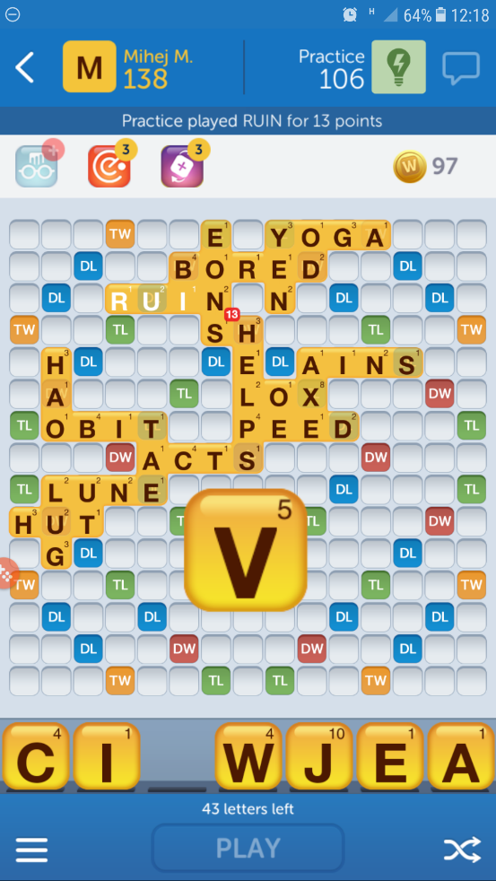

As shown in the top left and top right of the app, the game keep track of each players’ scores.

The button with two wiggly arrows in the bottom right of the game shuffle the letters on my rack:

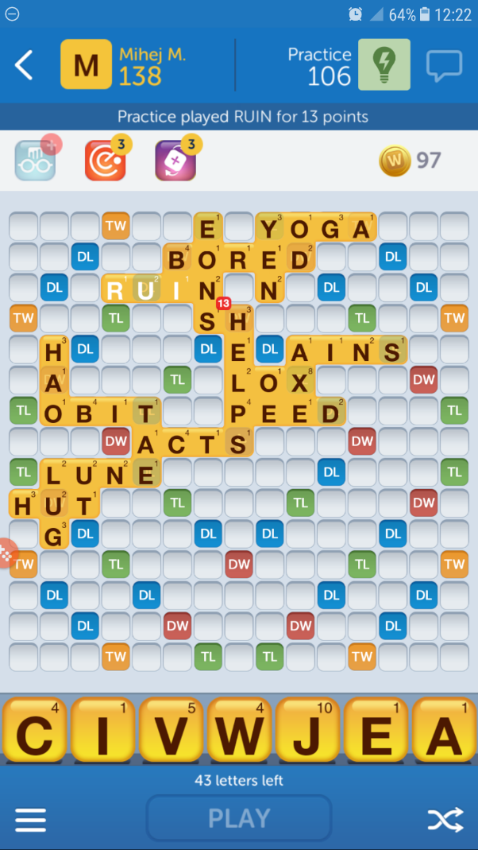 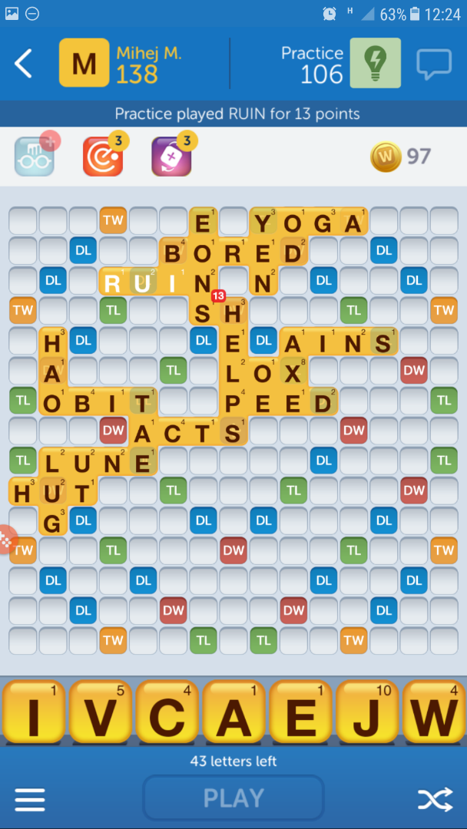

In the bottom left corner, there is a more options button, which includes the tile bag button, which shows you all of the tiles left in the bag and the tiles from your opponent; allows you to pass a move; allows you to resign; allows you to take your turn to swap tiles from your rack for tiles from the bag

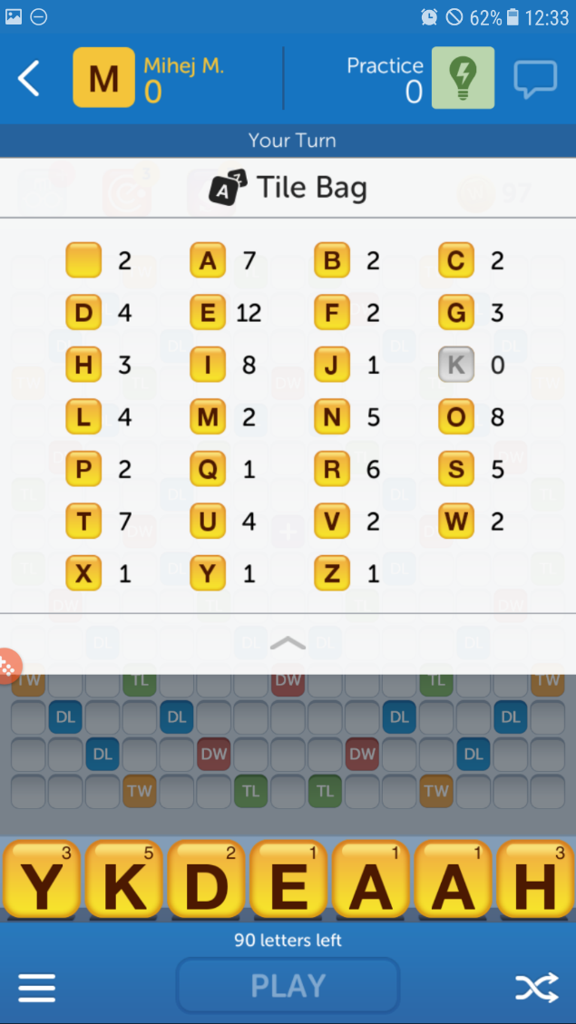 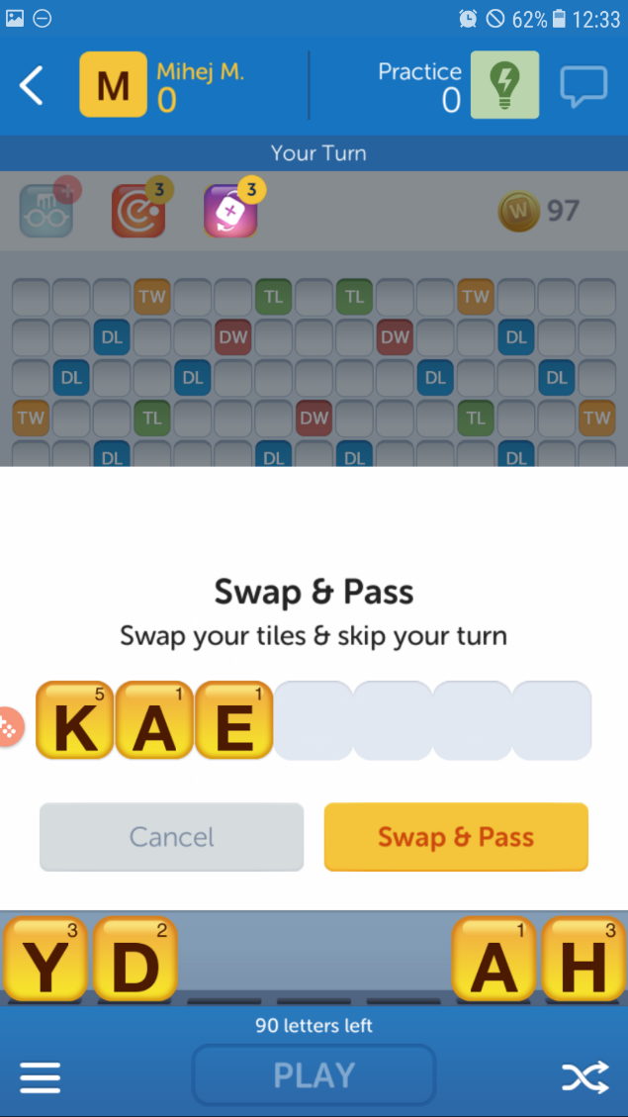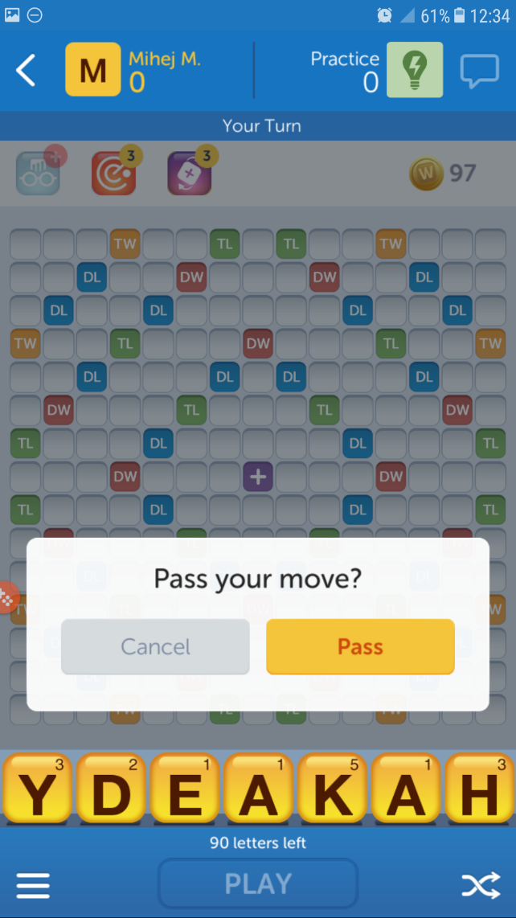 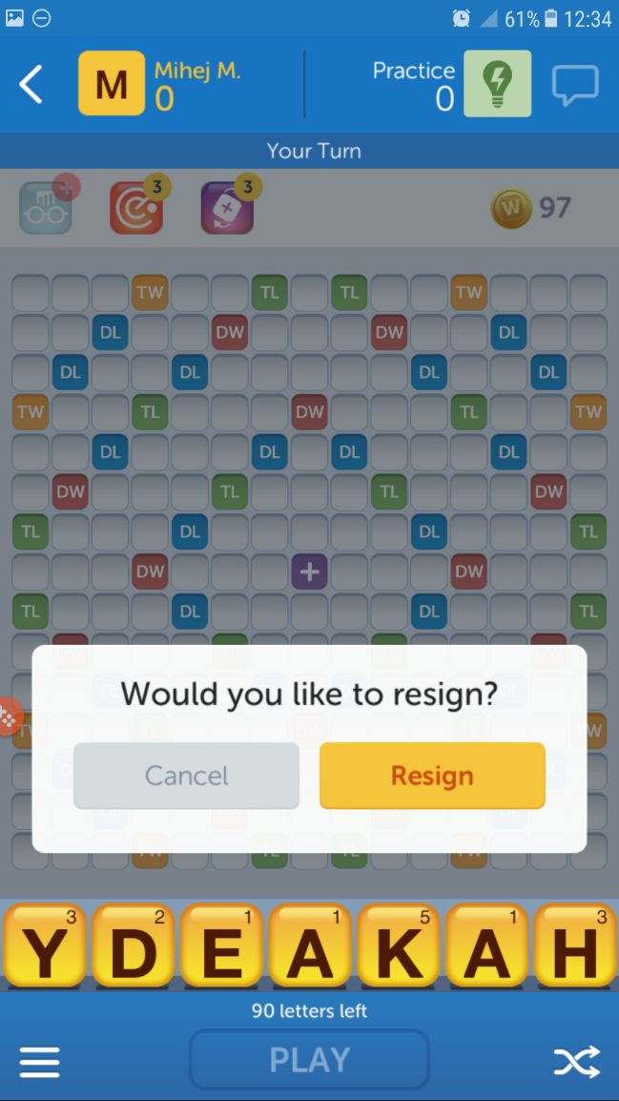

## Requirements

### Software/Hardware

Hardware requirements would include having enough memory to run the program, and hold the dictionary in a suitable data structure. From my research, the scrabble AI Maven requires 0.5 MB for the DAWG data structure storage of the dictionary. The DAGGAD data structure to store the dictionary would require about 5 times more, so approximately 2.5 MB. For modern day computers, which have an average of 8 GB of memory, this is no problem. However, this does not take into consideration the amount of memory required to run the game, or programming language structures’ size in memory. A text-based game of this would not require much memory either, so is definitely going to be possible to run even on low-end modern-day computers. If it is a graphical game, it is going to require more memory, but even a not very well optimised game should not require more than 2GB of memory, as there are minimal graphical contents that will need to be loaded and held in memory. Most of them are just static images used as backgrounds. Words With Friends requires 15 MB of memory on average, and has features that I do not plan on adding.

On the side of storage, a 1TB HDD is under £70, and Words With Friends only requires 114 MB. If my game is so unoptimised that it is 10 times larger, that’s still only about 1 GB, which for a modern-day computer is still nothing.

Words With Friends can run on a phone with an octa-core 1.6 GHz processor and a phone GPU. Most computer CPUs are much faster than this, but even if it is a cheaper weaker CPU, the calculations that my program would need to do are minimal. As shown by Maven, which was made over 30 years ago, when processor power was much weaker, it was still fast enough to play against, meaning that for a modern-day computer, the calculations required to run this game should not be very demanding.

Depending on which language I decide to use, from my limited research, I might need to install extra modules or libraries such as pygame (which also requires pip), QT widgets, OpenGL and a compiler/interpreter for the language itself. To run the game, the user will also need to have an operating system, and as I am making the game in Windows 10, and will be testing it in Windows 10, they should preferably have Windows 10.

### Features

1. My program will need to have a way for the user to put tiles on the board. This would mean either having drag and drop features for each tile, or clicking on the tile that you want to place, and clicking in the place that you want to put it in.
2. Being a game for two players (or a player and an AI), the game needs to be able to keep track of scores, and realise when the game ends and report who the winner is when the game ends. Keeping track of scores would also involve making sure that the bonus tiles are scored correctly.
3. The player should be able to choose whether they want to play with another player in the room, or if I manage it, also have the options of playing online against someone else who has the game (or over the network that I would have set up at school), or play against the AI.
4. If they want to play against the AI, they should be able to choose a difficulty of the AI.
5. You should be able to resize the window of the game ‘successfully’.
6. The AI should always play the currently highest scoring word it can from its rack (unless lower difficulty is chosen).
7. As I want the game to be easily playable for most people, I want to have a GUI, and not just a text/console based game. This would involve a menu and the board itself once a game has started. In the menu, there might be options to toggle sounds, change colour schemes, etc.
8. The game should allow the user to pass their turn if they want to.
9. The user should be able to shuffle their rack by clicking a button.
10. Once the user makes a move, and wants to submit it, they should only be able to submit their word if it is a valid word. The AI should also only be able to make valid moves.
11. A player should be able to resign/quit a game they are currently playing. This is also going to allow them to restart a game more quickly, if they know they are going to lose.
12. The player should be able to look at a list of all of the tiles that are remaining in the bag, so that they can form a strategy based on what they have a chance of drawing, or what letters their opponent has if it’s the end game, and there are no more tiles in the bag.

## Success Criteria

According to my requirements, the game should:

1. Register when a tile has been placed, and allow the tile to stay in the place where it was placed, unless the user moves it again. This should be shown graphically. Depending on the library I use to make my game graphical, this could be of varying degrees of difficulty, as I will somehow need to make sure that what the user is dragging and dropping visually actually lines up with the code.
2. When a player makes a valid move and confirms it, their score should increase, based on how much the tiles they placed down are worth and the bonus squares they are placed on. This also assumes that the word placed down was a valid word.
3. Once the user clicks on a button to choose whether they want to play against another player or the AI, the game should start. If they chose another player, once their turn ends, it should be the other player’s turn. If they chose to play against the AI, then once their turn ends, they AI should make a move, and then it should be their turn again.
4. Similarly to above, once they choose to play against the AI, I might allow them to click another button to choose AI difficulty. To alter AI difficulty, hardest would be for the AI to play the highest scoring word on their current turn, and for every easier level they choose, instead of playing the highest scoring word, the AI plays the second, or third highest scoring word.
5. When the user resizes the window of the game, the game should shrink (down to a minimum size, set by me) in such a way that every element is still accessible. This could mean that the game will have to either lose its aspect ratio or have black pillars on the sides/top and bottom, which might be frustrating for some users.
6. To test if the AI is playing the highest scoring word, I would either have to find a program which definitely plays the highest scoring word, or to just test it by giving it certain letters, where I know what the highest scoring word is. This approach of testing could be difficult as I would firstly need to find a program which already does what I want mine to do, or coming up with a situation where I know all possibilities and seeing if the AI plays the best one.
7. The success of this would be obvious: the user could interact with everything without actually typing much in, and doing most things in the game by using the graphical interface. How difficult this is depends on the library I decide to use. The limitations of a graphical interface compared to a textual interface is that it requires more coding.
8. This would mean that if the user selects the ‘pass turn’ button, then they forfeit their turn, and the turn goes to their opponent, just as if they had placed a word down, without any errors. This would also mean that they would have to score no points.
9. During a player’s turn, there should be a button that they can click, on the GUI which just shuffles all of their letters around on their rack. By shuffling their rack, all that should change should be the order in which the letters on their rack is. This is easily done for a textual based interface by shuffling a list randomly, however for a graphical interface, I might need to refresh the screen after the shuffle so that in the GUI the letters are actually mixed up, although they are the same letters.
10. When the user places a word down on the board, and tries to submit it, it should be checked whether their word was a valid word by the game. I will know that this is successful by trying to put a word on the board, and then submitting it, and checking the game’s feedback against the dictionary file’s contents. A similar thing should happen for the AI, or the AI should just follow the dictionary file, meaning all of the words it makes are already valid, and not needed to be checked. The limitations to this might be that because the dictionary file is so large, it could take a long time to search through it each time to see if a word is valid. This is why the DAGGAD data structure could come in useful again, as it’s much faster to search through than a pure dictionary file.
11. There would be a button that the user can click to resign the game. This would give the other player the win, and potentially ask whether the players would want a rematch, or at least put the user on the main menu. This would force a game to end, and because the winning conditions are different than to a normal game (where the players play until one runs out of letters), it would require a different step in checking winning conditions.
12. The user should be able to click a button which displays all of the letters which are left in the bag (and the opponent’s rack). This list of letters should be quite easy to keep track of, as I will have a bag ‘list’ out of which letters will be drawn, and once a letter is drawn, it is just removed from that list and put into the player’s rack list.

# Task 2: Design

## Design Specification

|  |  |  |
| --- | --- | --- |
| **No.** | **Requirement** | **How** |
| **1.** | My program will need to have a way for the user to put tiles on the board. | This would mean either having drag and drop features for each tile, or clicking on the tile that you want to place, and clicking in the place that you want to put it in. This would involve registration of clicks on different elements. |
| **2.** | The game needs to keep track of scores. | This will be done by detecting which square a letter tile has been placed on, and making sure that if there is a multiplier, it is applied correctly before giving the player a score for the word, and adding it onto their current score. I will need to display two text boxes to the two players so that they know what their scores are. |
| **3.** | The player should be able to choose their opponent | The player should be able to choose whether they want to play with another player in the room, or if I manage it, also have the options of playing online against someone else who has the game (or over the network that I would have set up at school), or play against the AI. There would need to be a menu where the player will be allowed to choose who their opponent is. This would most likely be a button on the menu which the user should be able to click. |
| **4.** | The player should be able to choose the difficulty of the AI | Similarly to above, in the menu there would be a sub-menu after selecting AI as their opponent for how difficult they would want the AI to be. |
| **5.** | You should be able to resize the window of the game ‘successfully’ | This would mean that if the user tries to resize the window, the correct scaling will be held as to not distort elements too much or have them display in places that are wrong. To do this, I would have to use relative sizes instead of fixed pixel sizes for my assets or pygame drawn things. |
| **6.** | The AI should always play the currently highest scoring word it can from its rack (unless lower difficulty is chosen). | This would probably involve making a list of all possible words that the AI can place down, calculating how much they would score, and then sorting the list based on the score, and choosing the highest scoring word, then playing it in the correct position. |
| **7.** | As I want the game to be easily playable for most people, I want to have a GUI, and not just a text/console based game. | This would involve a menu and the board itself once a game has started. In the menu, there might be buttons for options to toggle sounds, change colour schemes, etc. This would be interactable through mouse controls. The buttons would be a coloured text box with text describing what would be displayed to the user if they clicked the button, and on click of one such button, the user’s scene should change. |
| **8.** | The game should allow the user to pass their turn if they want to. | This would involve allowing the user to click on a button when it’s their turn, without having to place down any letter tiles, and handing over the turn to the other player (which could be the AI). |
| **9.** | The user should be able to shuffle their rack by clicking a button. | This would only change the order of letters on the player’s rack (i.e. on their screen), and they would be able to do it at any time, even if it isn’t their turn. This could help the player to notice a word. |
| **10.** | Once the user makes a move, and wants to submit it, they should only be able to submit their word if it is a valid word. | The AI should also only be able to make valid moves. This would involve having a button to submit play, which would call a function which would check whether the word played is valid. If it’s invalid, it should tell the user, by the means of a text box that their word was invalid, and prompt them to play a valid word. |
| **11.** | A player should be able to resign/quit a game they are currently playing. | This would again be done by the means of a button, which would ask them to make sure that they want to resign, and send a notification to both users of who’s won (most likely by the means of a text box) |
| **12.** | The player should be able to look at a list of all of the tiles that are remaining in the bag (and opponent’s rack). | This is so that they can form a strategy based on what they have a chance of drawing, or what letters their opponent has if it’s the end game, and there are no more tiles in the bag. This would require another button which would display the contents of the bag plus contents of the opponent’s rack. This would be displayed as a textbox displaying the dictionary structure of the bag in a humanly readable manner. |

## Top-down design diagram

The following diagram shows the different objects or functions my game will need to consist of, and how they can be programmed by breaking them down into easier sub-processes.

The most complex task will probably be finding the highest scoring word for the AI, and after that the most difficult would be checking whether the player’s input (i.e. where the player puts their letter tiles) is valid.

Finding the highest scoring word for the AI is the most difficult task as it requires a lot of searches to be done to find all valid moves, and then rank them. The searching for the highest scoring word is the most difficult task from here, as it requires almost every letter that has been laid down on the board to be tested for possibilities.

To check if a user’s word input is valid, I would also have to make sure that both the vertical and horizontal lines are satisfied along with all further horizontal or vertical lines that get changed, treating the letter which has already been laid down as an anchor for GADDAG, and then treating each new word as an anchor on its own.

## Screen designs

|  |  |  |
| --- | --- | --- |
| **Object** | **Property** | **Settings** |
| VSAIBtn | Button | Visible as soon as form is; opens the menu where the user would be allowed to choose the AI difficulty, which looks similar to this one. |
| VSPlayerBtn | Button | Visible as soon as form is; starts a game where two players have to play offline. |
| OnlineBtn | Button | Visible as soon as form is; this would load a new screen which looks very similar to this, containing a text field where they need to enter their nickname. Once submitted, leads to another menu which has options to go back and displays ‘looking for opponents’ while showing visual buffering effect. Once two players are matched, the game starts. |
| ExitGameBtn | Button | Visible as soon as form is; this just ends the program if clicked. |
| GameNameTxt | Text field | Visible as soon as form is; this is just for aesthetics and displays the name of the game. |
| PlayerNameTxt | Text field | Visible as soon as form is; the player name text fields just show the player who they are up against along with what they chose as their nickname. |
| PlayerScoreTxt | Text field | Visible as soon as form is; this shows what their own score is, or what their opponent’s score is. |
| LetterTile | (Custom) Button | Visible as soon as form is; these will be moveable by clicking once to pick them up, and clicking on an empty tile on the board to place it down. If right clicked while a tile is held, it should go back to the rack. |
| EmptyTile | (Custom) Button | Visible as soon as form is; if the player has picked up a letter tile and clicks on an empty tile, the letter tile should be placed down in it, and logically contain the letter tile. |
| SubmitWordBtn | Button | Visible as soon as form is; this would check the validity of the word against a dictionary are mentioned in above documentation. |
| TileBagBtn | Button | Visible as soon as form is; this button would show a pop-up with all tiles and how many remain of each, which would have an ‘x’ button in the top right to close it. |
| PassTurnBtn | Button | Visible as soon as form is; this would initiate a player turn swap just as if they played a word, but skipping the word validity checking stage after having removed all tiles placed by the player on their turn. |
| SwapTilesBtn | Button | Visible as soon as form is; this would allow the user to choose tiles which they would like to swap with random tiles from the tile bag, and then run the pass turn procedure. |
| ShuffleTilesBtn | Button | Visible as soon as form is; all this button would do is visually re-order the letter tiles on the player’s rack. |
| ResignBtn | Button | Visible as soon as form is; this button would firstly ask for confirmation that the user really does want to resign. If they don’t, the pop-up disappears and the game continues. If they do, the opponent is announced as the winner, and after a delay, the player/s are brought back to the starting screen. |
| ErrorMsgTxt | Text field | Only visible is user attempts to submit and invalid word; it appears for a few seconds, then fades away. |
| Board | (Coloured) Rectangle | Visible as soon as form is; contains all empty tile objects |
| Rack | (Coloured) Rectangle | Visible as soon as form is; contains all letter tile objects that belong to a player |
| OptionBar | (Coloured) Rectangle | Visible as soon as form is; contains the five buttons shown in the image. |
| This is just a text field/box holding the name of the game  These are all buttons which the user can interact with, and have been covered in the success criteria. They all eventually lead to the next screen (except for the exit button), after the player goes through other similar looking menus to select AI difficulty, etc.  This is the first screen the user would see once they enter the game    These fields, which would just be text boxes, would display the player’s name and their score. The player name box text size can resize dynamically  This whole 15x15 grid will be made of buttons, and will contain the letter tiles which will no longer act as buttons after a successful submission of a word.  If the user tried to submit an invalid word, this message would pop up.  A similar type text box would pop up once all tiles have been used up and a user as won, announcing who the winner was. This disappears after a few seconds.  This section displays the letter tiles that the user has. It would probably be easiest to treat these as buttons which once the user clicks on move around with their mouse.  All the coloured tiles are word/letter multipliers, and other than that are no different to the rest of the tiles in the grid.  These are buttons which I have mentioned in my success criteria.  The centre tile is the starting tile | | |

After a player has their turn, there will be a short timer (about 5 seconds) to allow the players to swap so they don’t see each other’s letter tiles. In this time, I will also swap their rack and names. In online multiplayer, although the players would be on opposite sides for a player looking at the screen, both see the same screen, only with switched names and scores. For offline play, the scores and names switch after each player’s turn.

## Input/output Design

|  |  |  |
| --- | --- | --- |
| **Inputs** | **Processes** | **Outputs** |
| The user clicks with the mouse on one of their letter tiles | Each letter tile has its own ‘click box’ that if a left click is detected within, that letter tile is visually moved and the image of the piece is “attached” to the mouse-pointer if the mouse isn’t holding another letter tile. | The image of the piece follows the mouse-pointer around until the user clicks again by its coordinates changing to be equal to those of the mouse constantly. |
| The user clicks on an empty tile on the board while they are ‘holding’ a letter tile | Each empty tile has its own ‘click box’ that if a left click is detected within, that empty tile can respond to. Firstly, the empty tile would make sure that there has been no tile placed on it before, then that there is a letter tile attached to the mouse, and if both are successful, the letter tile would have a pseudo-link (as the word hasn’t been submitted yet) to the letter tile, and its coordinates and size would be changed to equal those of the empty tile. | In a valid situation, the letter tile no longer follows the mouse and is instead stationary on the empty tile on the board. |
| The user clicks on the shuffle button | Logically the coordinates held for the letter tiles is adjusted | All tiles which have been placed down on the board on this user’s turn are returned back to their rack, and then the visual order that the tiles are in is changed randomly |
| Right clicking while holding a letter tile | If user right clicks, it is checked whether they are holding a letter tile. If they are, the letter tile will no longer follow their cursor, and its coordinated will be changed to those prior to being picked up. | The letter tile held by the user goes back to their rack |
| User clicks on tile bag button | A dictionary file contains the tile letter as a key and number of them that there are as a value. Once the button is clicked, these will just be reported. | A pop-up like overlay appears showing the number of each letter tile that remain, which can be closed. |
| User clicks on pass turn button | The user is given no points and their turn would be terminated. | The tiles which the current player placed down on the board are removed, and then the players’ turns are switched |
| User clicks on swap tiles button | This would cause the same number of tiles to be randomly chosen from the tile bag, their tiles put into the bag, and then the random tiles put into their rack. If they try to swap more tiles than there are in the bag, then an error message similar to that of an invalid word should pop up. After the swap takes turn, the same procedure as pass turn would be initiated. | The user’s letter tiles are replaced with new ones and the players’ turns are changed. |
| User clicks on resign button | This would outright end the game, and the player who presses the button would automatically lose (hence the other player wins). This would call the end game procedure with the opposing player as an argument for the winner | The game would display an overlay for the winner for a few seconds after which the main menu would be displayed. |
| User clicks on submit word button | The rows and columns which have been edited will be checked to make sure that all words are contained in the dictionary. If they are, the current player’s score is increased accordingly, and it becomes the other player’s turn | The score of the current player increases and it’s no longer their turn to play a word |
| User clicks on VS. Player button | The current scene is changed. The final board game will be set up so that two players physically using the same computer can play the game. | The current screen disappears, and a screen asking the first player for their name appears, which after being submitted, asks for the other player’s name, which after being submitted brings the players to the main game where they can see the board |
| User clicks on Online button | The current scene is changed. The final board game will be set up so that two players connected by a network can play the game. | Same as above, only for one player. |
| User clicks on VS. AI button | The current scene is changed. The final board game will be set up so that a player plays offline against an AI | Same as above |
| User clicks on Exit Game button | All processes are finished, and all memory is freed up (as much as possible with pygame in python) | Game closes |
| After the user selects VS. Player or online play, just before their game starts, they should be prompted to enter their name in a text field | The names of both players are recorded and put in the name fields as shown in the above section | The players are able to see each other’s’ name once the game starts. |
| User clicks on small ‘x’ button of the tile bag pop-up | Makes the overlay invisible and uninteractable | The user no longer sees the tile bag overlay |
| User clicks on the window’s ‘x’ button | Same process as if the user clicks the exit game button | The game closes |

## Data Dictionary

My planned classes include:

|  |  |  |  |
| --- | --- | --- | --- |
| **Name** | **Description** | **Contains type/s** | **Size, S** |
| Node | Each node has arcs labelled with letters leading to other nodes, which if followed eventually form a word. | A **dictionary** with letters as keys (**string**) and other nodes as values | 18B <= S <= 190kB |
| GADDAG | This will contain the root node, and therefore all nodes will be accessible using it, which would involve having methods to do this. | Contains the whole network of nodes by containing the root **node** | ~2GB (this is the approximate total size of all nodes; the size of it is in reality zero, as it doesn’t contain any data types which aren’t user defined) |
| Scene | Just a collection of visual elements connected to their classes. It would contain a method that clears the current visual elements, and displays the one it has. | A **dictionary** with tuple of two tuples as keys, and **images** as values. The tuple is a tuple of two coordinates: the bottom left and top right coordinates (as **float**s) of an object. Limitation of this is that two objects are not allowed to overlap, but this shouldn’t be a problem. | Can vary a lot |
| LetterTile | The tiles which the user interacts with. Inherits from **Button** class | The class will include a letter value as a **string**, an **image** of the letter, and whether the letter tile is locked on the board or not as a **boolean** | ~4kB |
| BoardTile | These are the tiles on the board which the players put their letters on. Inherits from **Button** class | (has a ‘pointer’ to) the LetterTile which has been put on it and potentially its colour as a **tuple** | ~50B |
| Board | The board class would draw out the board and would contain all BoardTiles in a 2D list. During initialisation, the board size can be altered. | A 2D **list** of all BoardTiles. | ~200kB (this is just the size that the list would be, as the size of tiles also affect it, and this changes depending on how many letter tiles are placed down on the board) |
| Player | This class contains information about the user so that their experience of the game is better. It would also display the players’ names and score. | The player’s name as a **string**, their score as an **integer**, their LetterTiles as a **list**, their rack as a **Rack** objects | 35kB <= S <= 340kB (depending on name length) |
| AI | The AI would inherit everything from the player class, but it would just have extra methods for finding the optimal move. | (same as Player) | ~35kB |
| Button | This class would just allow me to easily make buttons. All buttons would in some way contain a procedure. It will have to be an abstract class, as different buttons would have to run different procedures. | **Image** for the button shape, **tuple** for its coordinates and **string** for the button text. It would also contain a **Boolean** value of whether it can be interacted with and a tuple with 2 **integers** containing the user’s mouse click coordinates. | If button is an image, about 4kB. However, as some will only be a coloured shape with a string, it might be much less. |
| Rack | The rack just contains the user’s letters so they can see them and interact with them | Seven **LetterTile** objects in a list | As this contains other objects, on its own it is nothing, but considering the letter tiles, it would be about 28kB. |
| TileBag | Contains methods to deal with giving players tile from it, displaying which ones remain, etc. | Contains a **dictionary** with all letters that will be dealt out, where the letters (**string**) are the key, and how many remain are the value (**integer**) | ~ 1kB |
| Game | The game class is initialised each time the player wants to play a new game | Two **player** objects, 6 **button** objects (see next entry). There would also need to be a **GADDAG** object (which would be a static variable) to help with validation of words. | As this contains other objects, on its own it is nothing, but in total with everything considered is about 2GB. |
| Vs ai, Exit, vs player, online, tile bag, pass turn, swap tiles, shuffle tiles, resign, submit word Buttons | All of these are buttons, however they have to run different procedures when clicked, which is why they need to all be separate classes. | Same as button | Same as button |

My planned variables are:

|  |  |  |  |  |
| --- | --- | --- | --- | --- |
| **Name** | **Type** | **Size** | **Scope** | **Description** |
| n | integer | 24B | Local, to various functions/methods | I’m probably going to need an iterable somewhere and will probably name it n if it’s for something general |
| currentGame | Game | (see above table) | Local to main | (see above table) |
| scenes | Dictionary (strings as keys, scene objects as values | ~30B | Global | Easy access to scene changing |
| exitGameBtn | Button | (see above table) | Local to StartMenu | Exit game when clicked; calls ‘exitGame’ method |
| vsAIBtn | Button | (see above table) | Local to StartMenu | Refer to input/output design |
| vsPlayerBtn | Button | (see above table) | Local to StartMenu | Refer to input/output design |
| onlineBtn | Button | (see above table) | Local to StartMenu | Refer to input/output design |
| easyBtn | Button | (see above table) | Local to VsAIMenu | Passes an argument of ‘easy’ into the instantiation process of AI |
| mediumBtn | Button | (see above table) | Local to VsAIMenu | Passes an argument of ‘medium’ into the instantiation process of AI |
| hardBtn | Button | (see above table) | Local to VsAIMenu | Passes an argument of ‘hard’ into the instantiation process of AI |
| player1Name | String | 20B | Local to VsOnlineMenu and VsPlayerMenu | Temporary variable that will be passed into the player object |
| player2Name | String | 20B | Local to VsOnlineMenu and VsPlayerMenu | Temporary variable that will be passed into the player object |

## Flowchart

Disclaimer: Some sub-processes have not been mentioned here because they: aren’t a part of the main functionality of the program (e.g. shuffle button); they already exist as methods of pygame (e.g. exit game, displaying visual elements); they are self-explanatory/explained before in this document (e.g. checking whether a word is valid could easily be done by checking whether it’s in the list of valid words, or using my GADDAG method described above)

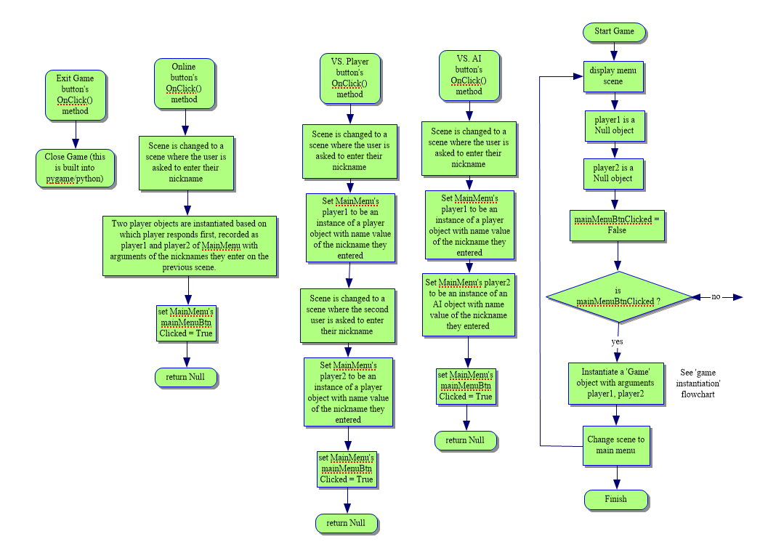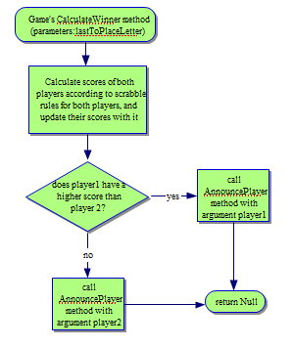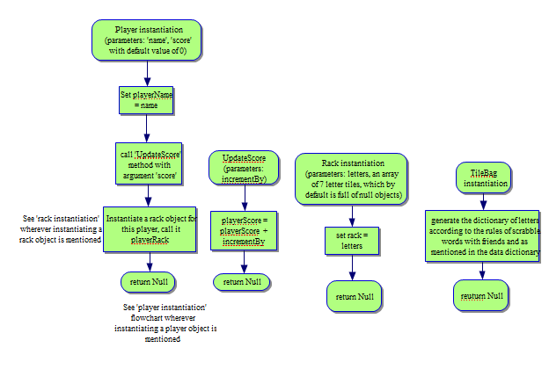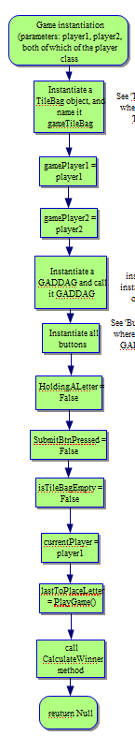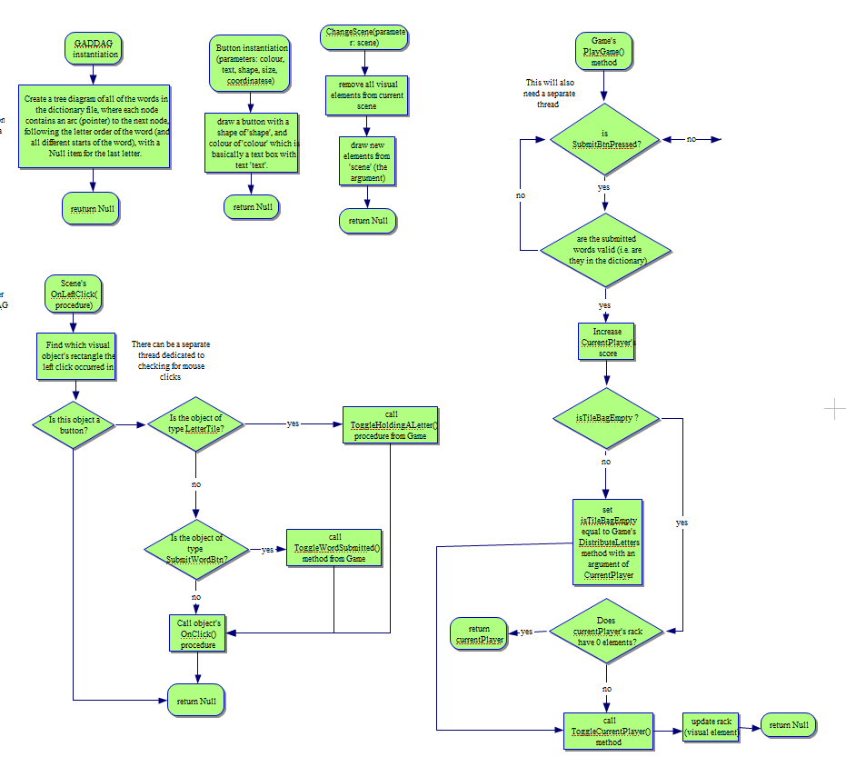

This is the main program. It is what is first executed when the program is run. It shows the main menu as an introduction, and then waits for the user to press a button with which players are created. Then the game starts.

The three VS. X buttons instantiate Player objects (and asks the players for their names to do this), just in different ways. These are then used in the instantiation of the Game object between the two players.

Exits the program

This method takes the players’ scores into consideration along with who has placed down all of their letter tiles to do the final score calculation and then announce a winner based on this information.

The player instantiator creates the player object with its name, its scorekeeping methods (and initial score), and its LetterTiles.

The Rack instantiator creates a list of Null elements, which can later on be changed to LetterTile instances.

The TileBag instantiator creates the TileBag containing LetterTile based on scrabble rules.

The game instantiator sets the game up with the players, the TileBag belonging to the Game, the means by which to check valid words, and then starts the game so the players can play

This method checks if a player had tried to submit a word. If they have, the words are checked if they are valid, and if so, the player’s score is increased, and the players change turns. If not valid, then the user is told this, and they have to submit a new word (or use pass turn, which is handled by a different thread’s workflow)

The OnLeftClick method checks where the user has clicked and then checks whether the coordinates at which the user clicks are contained within the boundaries of a button. If so, that button’s OnClick method is called.

The special cases of clicking on a LetterTile and on SubmitWordBtn are handled slightly differently.

The GADDAG structure just helps me with word validity checking.

The button instantiator creates a visual shape of the button which the user can interact with

This method changes the current scene. It involves clearing the current scene and drawing the new scene.

## Test Plans

### Development Testing

|  |  |  |  |  |  |
| --- | --- | --- | --- | --- | --- |
| **Test**  **Num** | **Type** | **Data** | **Expected result** | **Actual result** | **Comments/solution** |
| 1 | Invalid | In any of the scenes, if the player clicks on a non-button object (i.e. on the background/text) | Nothing should happen (In reality, the click will be registered, but no action will be taken because of that click) |  |  |
| 2 | Valid | The vs ai button on main menu is clicked | The current scene changes to the next scene where the user is allowed to enter their nickname |  |  |
| 3 | Valid | The vs player button on main menu is clicked | The current scene changes to the next scene where the user is allowed to enter their nickname |  |  |
| 4 | Valid | The online button on main menu is clicked | The current scene changes to the next scene where the user is allowed to enter their nickname |  |  |
| 5 | Valid | The exit game button is clicked | The game exits |  |  |
| 6 | Valid | The ‘x’ button in the top right corner of the game windows is clicked | The game exits |  |  |
| 7 | Invalid | The user right clicks on a button | Nothing should happen (In reality, the click will be registered, but no action will be taken because of that click) |  |  |
| 8 | Valid | Make sure that the user’s nickname is correctly stored | When the user enters their valid nickname on the scene after main menu, it is correctly recorded in the string variable, and not truncated or with extra characters |  |  |
| 9 | Invalid Boundary | The user’s enters a nickname which doesn’t fit in the nickname field | Once the character limit is reached, no more characters are recorded in the string variable responsible for storing their nickname, and no more letters are shown on the screen |  |  |
| 10 | Valid | What happens when the user presses backspace when entering their username | When the user is entering their nickname, they should be allowed to use backspace to delete the last character in their entered nickname |  |  |
| 11 | Valid | Clicking the next button on the nickname entry scene | When clicked, the scene should change to the next scene (which in the case of vs ai is the game scene, in the case of vs player is the next player’s nickname entry scene, and in the case of online is a waiting screen) |  |  |
| 12 | Valid | Whether game times out | While on the waiting screen for online play, if a game isn’t found in a specified amount of time, the waiting should time out, and the scene should be changed back to the menu scene |  |  |
| 13 | Valid | Whether the game starts | After the waiting screen, if a connection is found, then the game object should be instantiated and a game should start, with a change of scene to show for it. |  |  |
| 14a | valid | Tille bag button is pressed | A small pop up should show up on the scene to show the remaining tiles in the bag along with the tiles of the opponent in one list like display |  |  |
| 14b | Valid | Player clicks on close window button (of tilebag window) | Once the player is done looking at the tile bag, they should be able to press the close button to hide the tile bag window visual element |  |  |
| 15 | valid | Pass turn button is pressed | The current player’s turn should be forfeited, with no points, and the current player’s turn should be switched |  |  |
| 16 | Valid | shuffle tiles button pressed | The visual positions of the letter tiles on the player’s rack should be shuffled (along with their coordinates in background code, so that a button click is registered correctly) |  |  |
| 17a | Valid | Swap tiles button is pressed | A pop up window-like thing should show up allowing the user to put tiles from their rack into it |  |  |
| 17b | Valid | Player clicks on close window button (of swap tile window) | If the player changes their mind about swapping their tiles, they can press this button, and the position of their letter tiles should reset, along with hiding thei visual element |  |  |
| 17c | valid | Player clicks on submit swap button (of swap tile window) | New tiles are put into the player’s rack (visually and logically) and the ones which they submitted to the swap are taken away. |  |  |
| 18 | Valid | Resign button clicked | The game announces the other player as a winner in a windows for a few seconds, and then goes back to main menu |  |  |
| 19a | Valid | Submit word button pressed (with a valid word on board) | The current player’s score is incremented according to scrabble rules, and it’s the next player’s turn, unless the current player no longer has any letters left in their rack, in which case a winner is calculated and announced. |  |  |
| 19b | invalid | Submit word button pressed (with an invalid word on board) | A small pop-up apprears telling the user that the word which they entered is invalid, and no further action is taken (i.e. the players aren’t swapped) |  |  |
| 20 | valid | Reset letter button is clicked | The board tiles which gained letter tile links on this turn are unlinked with their letter tiles, and the letter tiles are restored to their old coordinates, visually and logically. |  |  |
| 21 | invalid | During the waiting time between player swaps, the player clicks a button | Nothing should happen (In reality, the click will be registered, but no action will be taken because of that click) |  |  |
| 22 | Valid | Click on board tile (while holding a letter tile) | The letter tile which is held gets visually and logically moved onto the clicked board tile, and the board tile gets a logical connection to the letter tile |  |  |
| 23 | invalid | Click on board tile (while not holding a letter tile) | Nothing should happen (In reality, the click will be registered, but no action will be taken because of that click) |  |  |
| 24 | Valid | Click on letter tile in rack (while not holding another letter tile) | The currently held letter tile is changed to the clicked letter tile |  |  |
| 25 | invalid | Click on letter tile in rack (while holding another letter tile) | The currently held letter tile is changed to the newly clicked letter tile |  |  |

### Post Development Testing

#### End User Testing

|  |  |  |  |  |
| --- | --- | --- | --- | --- |
| **Test Num** | **Data** | **Expected result** | **Actual result** | **Comments** |
| 1 | User clicks on ‘Online’ button | The scene is changed; the user is asked to enter their name. After entering their name and pressing a button to submit it, they are asked to wait for a match. After an opponent is found, the scene changes again to the main game scene. |  |  |
| 2 | User clicks on ‘VS. Player’ button | The scene is changed; the user is asked to enter their name. After entering their name and pressing a button to submit it, the same is repeated for the other player. Once the second player submits, the scene changes again to the main game scene. |  |  |
| 3 | User clicks on ‘VS. AI’ button | The scene is changed; the user is asked to enter their name. After entering their name and pressing a button to submit it, the scene changes again to the main game scene. |  |  |
| 4 | User clicks on ‘Exit Game’ button | The game window disappears |  |  |
| 5 | User clicks on ‘Tile Bag button | A pop-up with all remaining LetterTiles along with the opponent’s LetterTiles shows up |  |  |
| 6 | User clicks on ‘Pass Turn’ button | A pop-up asking the user to confirm their turn pass shows up |  |  |
| 7 | User clicks on ‘Swap Tiles’ button | A pop-up allowing them to choose which tile they want to swap shows up. When they click one of their tiles, an indicator shows up next to it. |  |  |
| 8 | User clicks on ‘Shuffle Tiles’ button | The order of the tiles on the player’s rack is changed |  |  |
| 9 | User clicks on ‘Resign’ button | A pop-up asking the user to confirm resignation shows up |  |  |
| 10 | User clicks on ‘Submit Word’ button | If the word is valid, the user’s score increases, and depending on gamemode (what they chose to play against), the turn changes instantly or after a few seconds. |  |  |
| 11 | User clicks on a LetterTile | The clicked LetterTile changes colour/gets raised/lowered to signify the click |  |  |
| 12 | User clicks on a BoardTile | If a LetterTile was clicked before this click, the said LetterTile moves to here. Otherwise, nothing happens. |  |  |
| 13 | User clicks on cross button to close swap tiles/tile bag pop-up | The pop-up disappears |  |  |
| 14 | User clicks on submit pass turn button | The players change turns. |  |  |
| 15 | User clicks on cancel pass turn button | The pop-up disappears. |  |  |
| 16 | User clicks on submit resign button | A pop-up appears announcing the other player as the winner for a few seconds, after which the scene is changed to the main menu scene. |  |  |
| 17 | User clicks on cancel resignation button | The pop-up disappears. |  |  |
| 18 | User clicks on confirm tile swap button | The LetterTiles which the user submitted get changed with random tiles from the TileBag. |  |  |

#### Robustness Testing

|  |  |  |  |  |
| --- | --- | --- | --- | --- |
| **Test Num** | **Data** | **Expected result** | **Actual result** | **Comments** |
| 1 | Clicking quickly and randomly in random places (monitoring if program can keep up with all actions, or if it just crashes) | Records all clicks as it normally would, and does what it is expected of it to do |  |  |
| 2 | Player resigns game, with a word on the board, and then clicks submit word during the short time they have before the pop-up | The submit word button does nothing and the game announces the other player as the winner regardless. |  |  |
| 3 | A random (unhandled) error causes the game to crash | A try: except: code all around my code would be able to handle this, and inform the user of something going wrong, telling them to restart the game if they want to play again. |  |  |
| 4 | Player tries to click on swap tile button multiple times hoping to open multiple swap pop-ups | Only one pop-up opens, and the player can only make one swap before their turn is switched. |  |  |
| 5 | Player clicks on button multiple times quickly | The button click only does what it’s meant to do as many times as it’s meant to do (e.g. resign only resigns for the current player, whereas submit word might allow the user to try submitting more than once, shuffle button finishes shuffle before registering another shuffle) |  |  |
| 6 | Does the game time out in online play | When player is waiting to find a connection and no one joins, the player is returned to the main menu |  |  |
| 7 | Entering a name that’s too long | Player can only enter a short enough name |  |  |
| 8 | Randomly right clicking elements | Nothing happens |  |  |

#### Whole System Testing

|  |  |  |  |  |
| --- | --- | --- | --- | --- |
| **Test**  **Num** | **Data** | **Expected result** | **Actual result** | **Comments/solution** |
| 1 | Click on LetterTile in rack and then on board tile in rack | The letter tile sticks onto the board tile |  |  |
| 2 | Clicking on buttons during player swaps | Nothing happens |  |  |
| 3 | Clicking reset letter button | button puts the letter tiles back on the rack |  |  |
| 4 | Submit button pressed | If the board configuration registered a valid move, it should be the next player’s turn, and current player’s score is increased. Otherwise, the player should be informed that their move was invalid. |  |  |
| 5 | Resign button clicked | Game ends after announcing other player as winner |  |  |
| 6 | Swap tile button is clicked | New windows shows up where the player can put the tiles which they don’t want to swap out |  |  |
| 7 | Player clicks on submit swap button (of swap tile window) | Selected tiles are swapped with new tiles from the tile bag |  |  |
| 8 | Player clicks on close window button (of swap tile window) | Window closes |  |  |
| 9 | Shuffle button pressed | Letter tiles on their rack are shuffled |  |  |
| 10 | Player pressed pass turn button | Player’s turn ends, and it’s the other player’s turn |  |  |
| 11 | Player clicks on tile bag button | All remaining letters by scrabble rules are displayed |  |  |
| 12 | Click on close window button of tile bag | Window closes |  |  |
| 13 | Does the game start playing in online play | After player finds an opponent, the player is put on the game scene |  |  |
| 14 | Does the name entering system work like you would expect it to in other games | It does work |  |  |
| 15 | Clicking ‘x’ button of game window | Closes game |  |  |
| 16 | The exit game button is clicked | The game exits |  |  |
| 17 | A button (other than exit game) on main menu is clicked | Scene is changed |  |  |

## Pseudocode

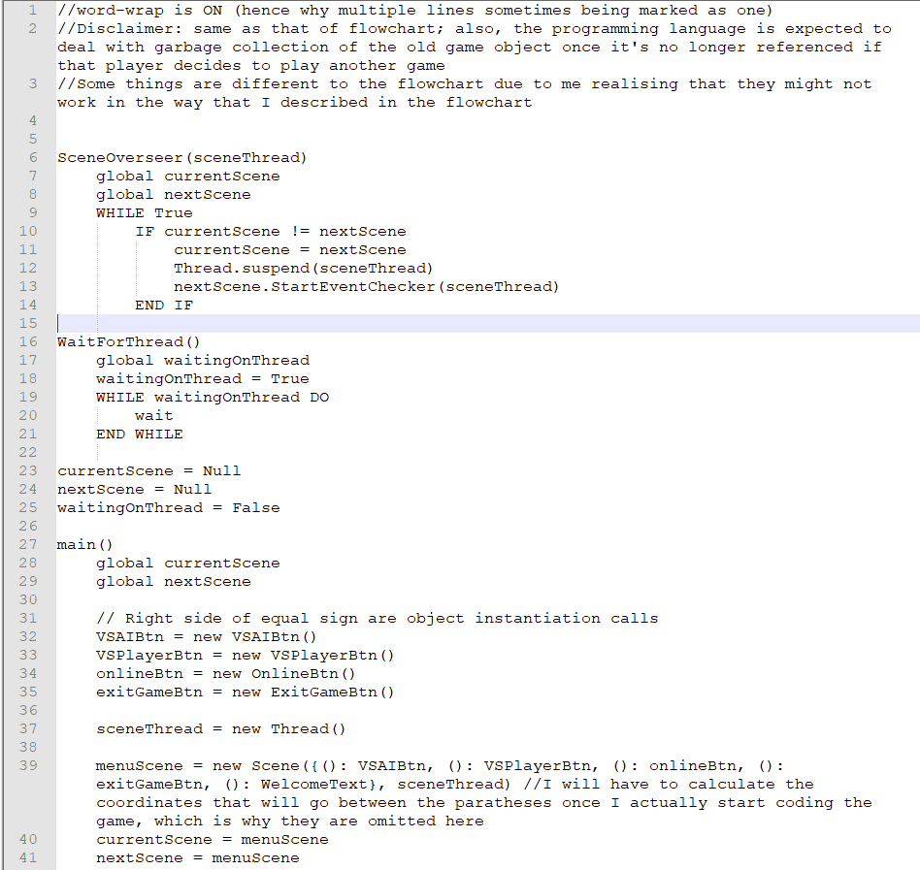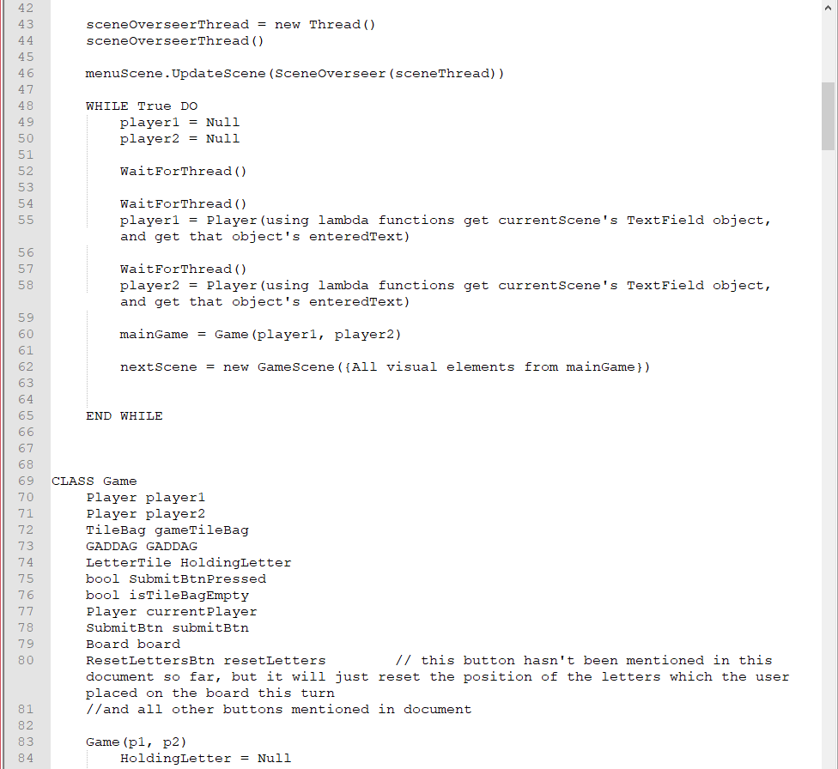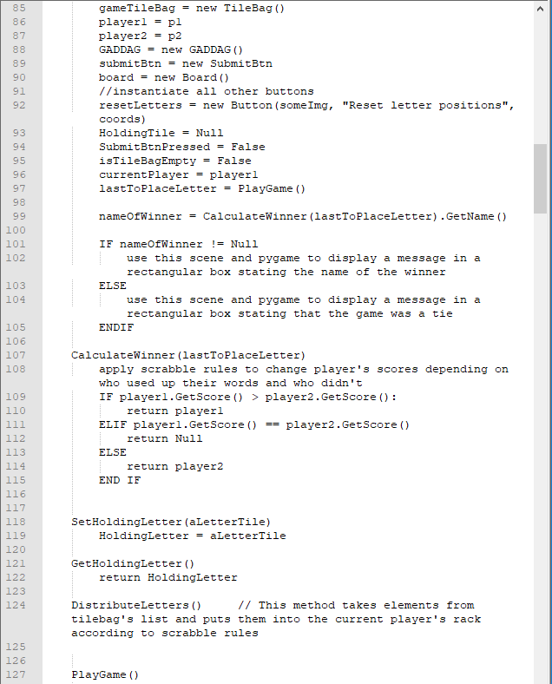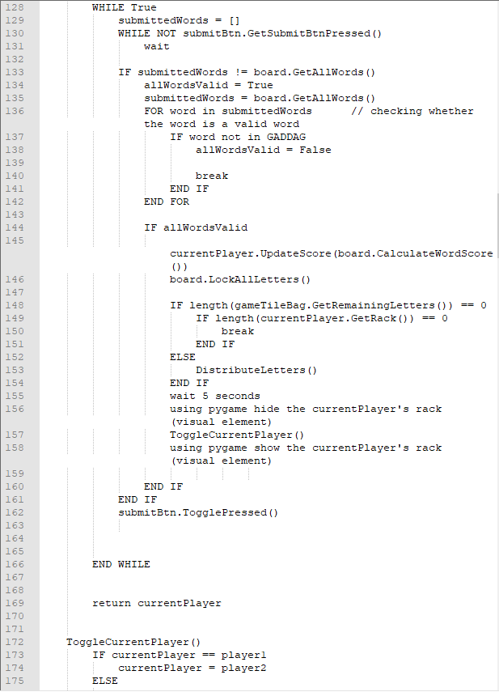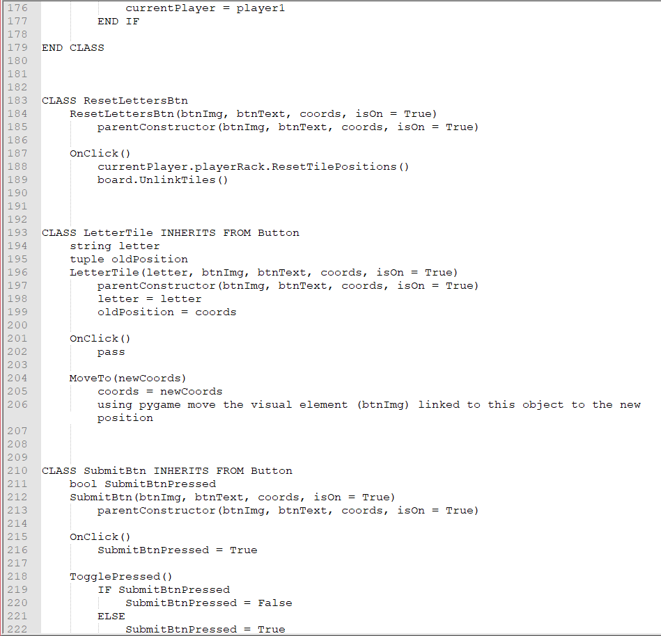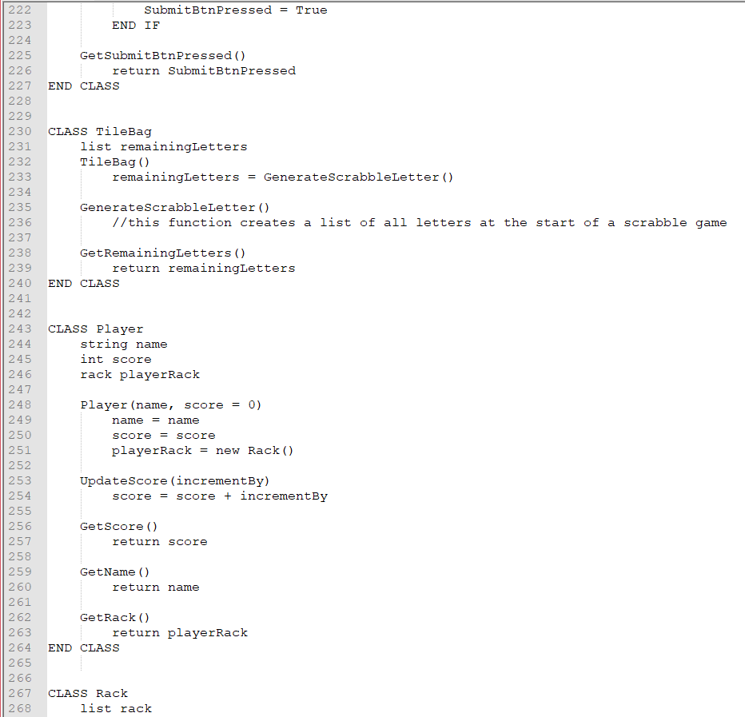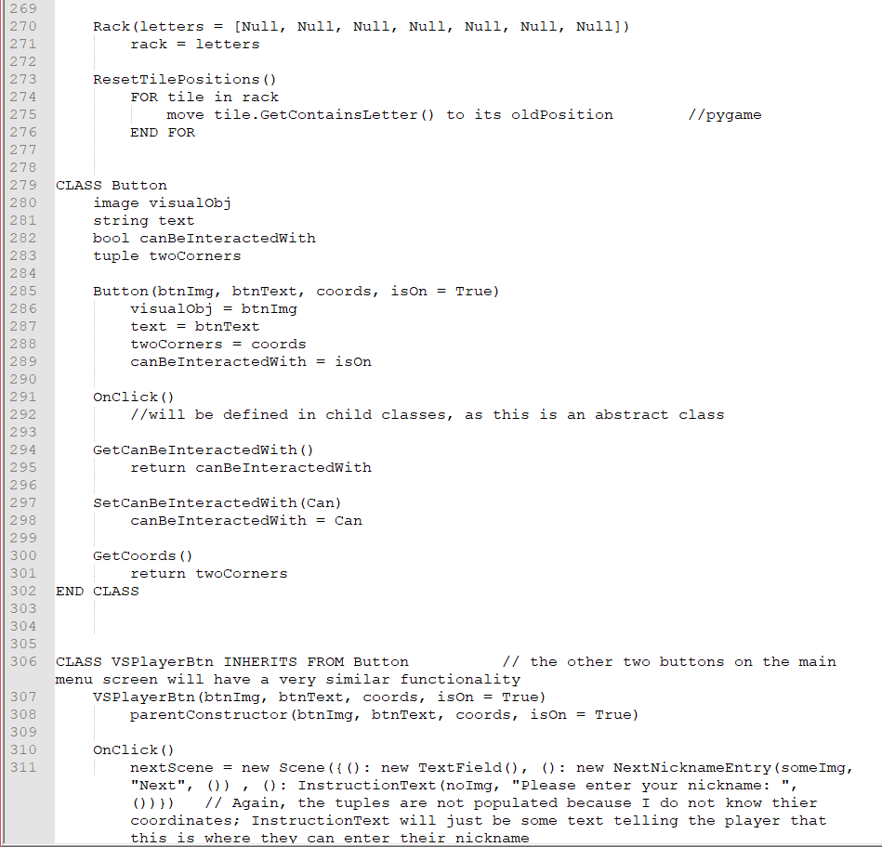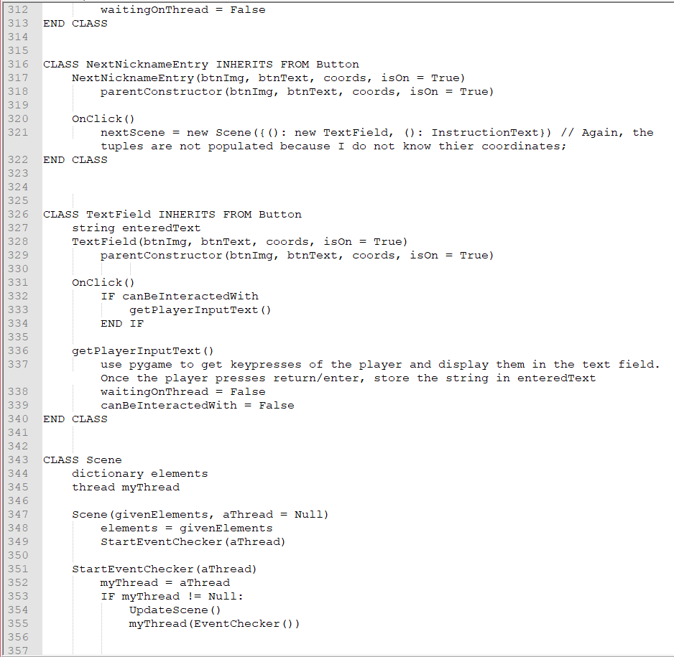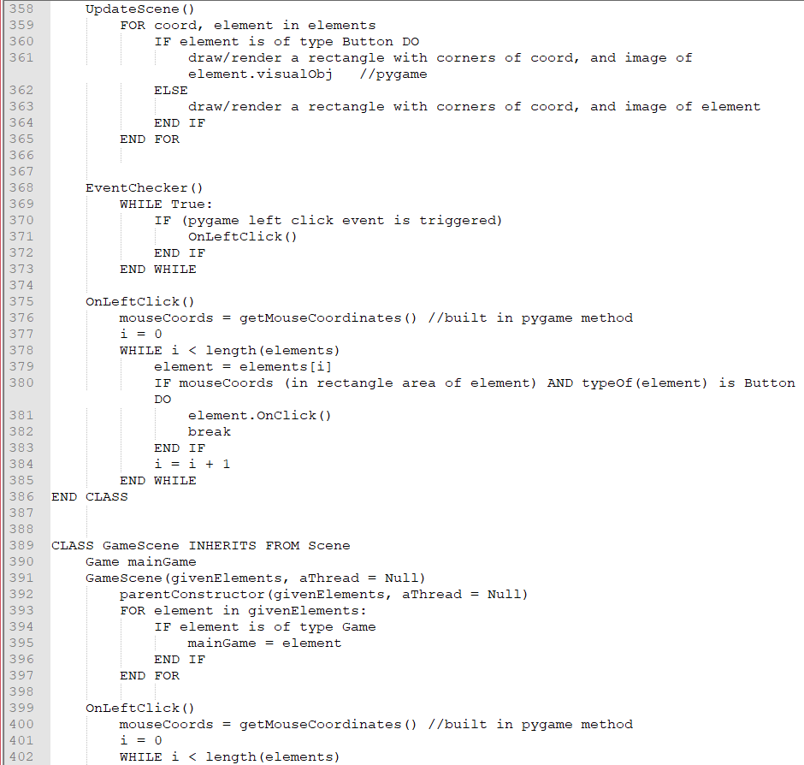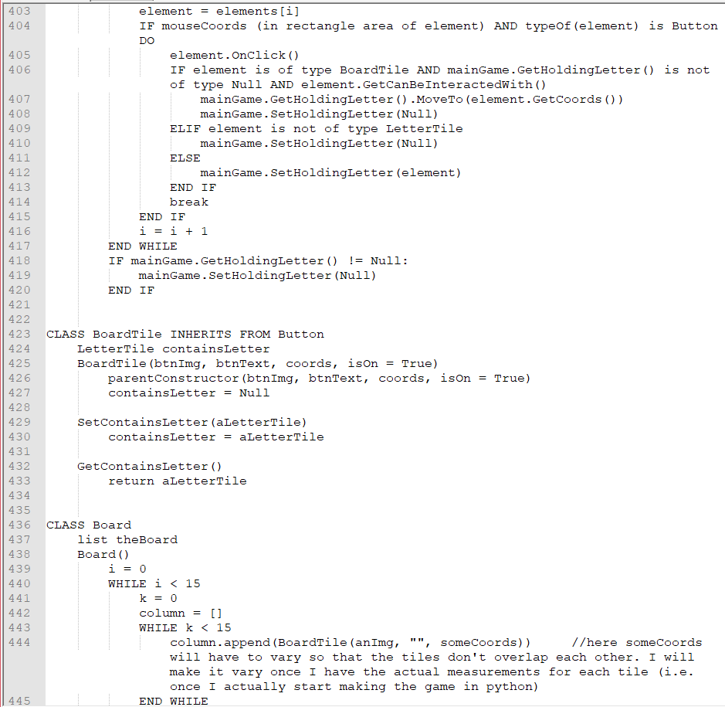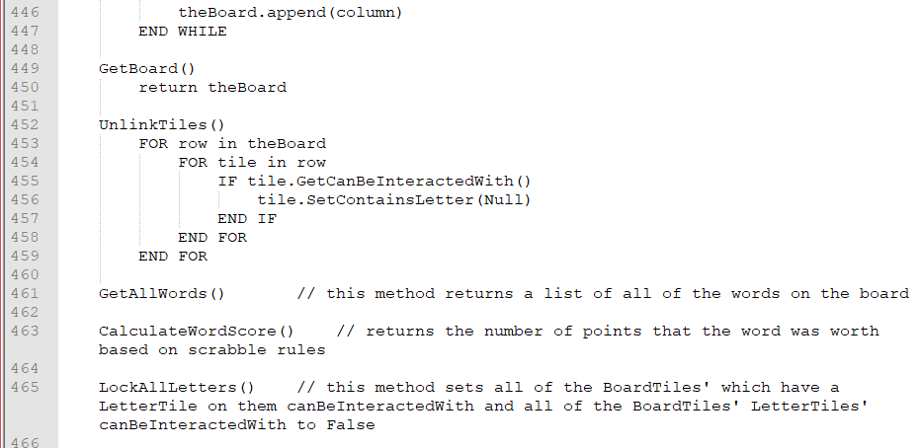

This function is used to control the changing of scenes. It needs to be done using a separate thread so that a scene can be changed whenever is needed.

This is just a generic function that can keep threads working together as intended, instead of one continuing execution before it receives the information it needs from another to continue.

Here I just initialise my variables so that I can more easily use them in the above functions.

The start of my program

Text starting with ‘//’ is a comment

Here I’m making the objects of the first scene, along with the scene itself.

Here I’m setting up all of the scene control; I set the scenes to initially be the main menu, and then call my procedure which takes control of changing scenes. Finally, I actually display the current scene to the user.

This is the main game loop. It creates a game object with the players, depending on which button is pressed (handled by other threads). It then actually displays the game scene to the player.

My game class handles all of the logic events during the game, such as checking whether a word which was played is valid, whose turn it is, finding out the winner, etc.

The PlayGame method just contains the flow of a normal scrabble game, where each player’s turn changes after they play a word or pass, etc.

These methods deal with which LetterTile has been selected, and being able to get it for when that is required.

Here I have all of my different buttons, which all contain a different OnClick procedure, which is why they are all different classes. Their names are well descriptive of what they do.

An object of the TileBag class contains all of the leftover LetterTiles used in a Game object. It also has some other methods to make this easier.

An object of the Player class is instantiated inside of the Game class initialiser. It contains the player’s name, score, remaining letters (as a Rack object), and methods to make management of the above variables easier.

A Rack object would contain the Player’s leftover LetterTiles. It can also deal with the visual reseting of a LetterTile’s position in the cae of the user wants to change a LetterTile.

The Button class is an abstract class which contains some basic button methods, such as whether the button is enabled or disabled, its text, colour/image, and its OnClick method which has to be changed in the class which inherits from it.

These button children are similar to the above ones.

The Scene class deals with most of the visual rendering needs for my game (so it contains the visual elements of all objects that are in it). Each big scene change means a different scene renders its visual object, and the previous one becomes inactive. It also helps me to register mouse clicks.

As the main game scene contains more elements, I decided to make a subclass of scene for it to allow me to add things such as toggling when a player has selected a LetterTile.

BoardTile is a class which allows me to differentiate between LetterTiles which the player holds and those on the board along with tiles on the board which haven’t been filled. It knows its own letter, and an outside class can get it (such as the board to use it in whether the words inputted are valid)

A board object is basically a 2D array of BoardTiles. It has methods to help out in testing if all words after a submission are valid, along with getting the amount of points the words are worth and locking positions of a submitted set of LetterTiles.

## White-box Testing (dry runs)

Disclaimer: As my pseudocode is so long, object oriented, and my program makes use of multiple threads (which is difficult to display on a 2D piece of paper), I have only gone through lines of code which I deem important. This is based on what types of things I haven’t mentioned yet (such as only mentioned scene switching once instead of each time a scene switch is mentioned in my pseudocode) and instead of going through a whole method/function line by line, I might just mention it on passing. Also, the main component of the game isn’t the scene switching, but the actual gameplay between two players one they are on the scrabble board type scene.

With that out of the way, here are my predictions, for what the main thread (the one with which the program initially starts up) does:

(some things may be abstracted)

|  |  |  |  |  |  |  |  |  |  |
| --- | --- | --- | --- | --- | --- | --- | --- | --- | --- |
| **Line** | ***HoldingLetter*** | ***gameTileBag. remainingLetters*** | ***submittedWords*** | ***submitBtn.GetSubmitBtnPressed()*** | ***nameOfWinner*** | ***CurrentPlayer*** | ***CurrentScene*** | **allWordsValid** | **Output** |
| 97 | Null | [list of 86 letter tiles] | - | - | - | Player1 | GameScene | - |  |
| 128 | - | - | - | False | - | - | - | - |  |
| 129 | - | - | [] | - | - | - | - | - |  |
| 130 | - | - | - | - | - | - | - | - |  |
| 131 | changes from letter to letter as User interacts with letter tile buttons (h, e, l, l, o) | - | - | - | - | - | - | - |  |
| 133 | - | - | - | True | - | - | - | - |  |
| 134 | - | - | - | - | - | - | - | True |  |
| 135 | - | - | [“HELLO”] | - | - | - | - | - |  |
| 136 | - | - | - | - | - | - | - | - |  |
| 137 | - | - | - | - | - | - | - | - |  |
| 144 | - | - | - | - | - | - | - | - |  |
| 145 | - | - | - | - | - | CurrentPlayer.score = some new score | - | - |  |
| 146 | - | - | - | - | - | - | - | - |  |
| 148 | - | - | - | - | - | - | - | - |  |
| 149 | - | - | - | - | - | currentPlayer.rack = [some new letters] | - | - |  |
| 153 | - | [list of 81 letter tiles] | - | - | - | - | - | - | Pop-up windows like thing telling player to swap over an counting down 5 or so seconds, which then closes |
| 157 | - | - | - | - | - | Player2 | - | - |  |
| 129 | - | - | - | - | - | - | - | - |  |
| 130 | - | - | - | - | - | - | - | - |  |
| 131 | changes from letter to letter as User interacts with letter tile buttons (h, e, l, l, o) | - | - | - | - | - | - | - |  |
| 133 | - | - | - | True | - | - | - | - |  |
| 134 | - | - | - | - | - | - | - | True |  |
| 135 | - | - | [“HELLO”] | - | - | - | - | - |  |
| 136 | - | - | - | - | - | - | - | - |  |
| 137 | - | - | - | - | - | - | - | - |  |
| 144 | - | - | - | - | - | - | - | - |  |
| 145 | - | - | - | - | - | CurrentPlayer.score = some new score | - | - |  |
| 146 | - | - | - | - | - | - | - | - |  |
| 148 | - | - | - | - | - | - | - | - |  |
| 149 | - | - | - | - | - | currentPlayer.rack = [some new letters] | - | - |  |
| 153 | - | [list of 76 letter tiles] | - | - | - | - | - | - | Pop-up windows like thing telling player to swap over an counting down 5 or so seconds, which then closes |
| 157 | - | - | - | - | - | Player1 | - | - |  |
| . |  |  |  |  |  |  |  |  |  |
| . |  |  |  |  |  |  |  |  |  |
| . |  |  |  |  |  |  |  |  |  |
| 138 | - | [list of 30 letter tiles] | [“asdff”] | True | - | Player1 | - | False |  |
| 144 | - | - | - | - | - | - | - | - |  |
| 162 | - | - | - | - | - | - | - | - | Small pop-up telling the player that their word was invalid |
| . |  |  |  |  |  |  |  |  |  |
| . |  |  |  |  |  |  |  |  |  |
| . |  |  |  |  |  |  |  |  |  |
| 148 | - | [] | - | - | - | - | - | True |  |
| 149 | - | - | - | - | - | - | - | - |  |
| 169 | - | - | - | - | - | - | - | - |  |
| 97 | Null | Null | Null | Null | Null | Null | Null | Null |  |
| 99 | - | - | - | - | Player1.GetName() | - | - | - |  |
| 101-105 |  |  |  |  |  |  |  |  | Pop-up announcing who the winner is (or if it was a tie) |

## Usability Features

What I would like to implement into my code to make the user experience better are the following:

* If the user has entered a word which they are not happy with, they can just press a button and all of the letters would return to their rack, without them having to put them back in one by one. I would do this so that the user is able to more easily play the game, and perform actions quickly. It improves the gaming experience, which is what I as a developer am aiming for. If it isn’t there, then the user might get frustrated and decide to play against themselves on a physical board, as they are able to very quickly remove all letters from the board quickly.
* On the other hand, the user might not want to put all of their letter tiles back on the rack, so I would like to implement a way in which they can put only certain letter tiles back into their rack, without affecting the others. This would speed the game up, as instead of the user having to constantly remove all letters from the board, they can just pick out one of their letter tiles which make the word invalid, and change it, so that if they had made a spelling mistake, they don’t have to put all of their lettertiles down on the board again, which is more error prone, as there is now the same chance to get a letter wrong as before, and they might make the same mistake again, causing them to get frustrated.
* If the user submits a word, there would be a short message telling them whether the word was correct or not, and also if it was correct, how many points they gained from it. I would like to add this feature so that the user is always aware of what is happening in the game, making it easier for them to enjoy the gameplay, and not have to manually keep track of their score, which if they had to do, would be no different to playing on a physical board.
* The score keeping in the top right and top left for each player are always there, so the players can see how many points they have at each time. The reason for this is the same as above: it makes it so that the user can just focus on gameplay instead of manual score keeping.
* If they press the exit game button (either the one in main menu or the one in the top right corner of every window in windows 10), before the game quits, there would be a prompt making sure they haven’t accidentally pressed either of the two buttons, which could lose them progress. This would be implemented so that if the user accidentally presses the exit game button, they don’t lose their progress, as they would have to confirm that they meant to exit the game, by clicking again, on a different part of their screen. If they said no, then the game would continue playing, saving them the time it would take to get a game in the same position as before after an accident.
* An extra feature could get that when the user hovers over a letter tile (either one which has been placed on the board or that is still in their rack), a zoomed in version of it shows up next to their mouse, so that it’s easier for them to see it. This could help the visually impaired or younger children who need to learn the exact correct shape of a letter so that they can write it if they are using my program to learn words. It makes the user experience better as the user is more able to understand and therefore interact with the game.
* When the user is asked to input their nickname, their input always displayed, so that they know what they are entering. This makes it easier for the user to make corrections to their nickname if they entered it incorrectly more easily, as they can see it as they are typing it. If they were unable to see what they are typing, they might not even know that they are typing, which could confuse the user, and might think that the game has crashed as nothing is happening.
* For a local player vs player match, a way of entering how long the swap-over wait time is would be variable, and the user can change it. This would make it so that the players have more time to change seats and not see each others’ tiles if it takes them a longer time. It just allows to user to have more control over the program, which is always nice.
* There could be a ‘hall of fame’ with all of the best scores listed in order on a scene which can be accessed from the main menu. This is not that important of a feature, but it does make the game feel like it has some persistent aspect to it, and it would promote rivalry, and therefore more frequent play, which for a game which runs ads, means more revenue.

## Validation

The best way to test my program is to play it, and see what doesn’t work. Some examples would include:

* Validating that the user cannot access other scenes without navigating through the given buttons, as in some games this can be done by resizing the window or dragging that background. I would be doing this validation so that my program doesn’t look buggy, and so that the scenes are instantiated properly, without any missing elements. This would make sure that the user sees everything they are meant to see, but also only what they are meant to see when they are meant to see it.
* Making sure that the user’s nickname cannot be so long that it gets cut off or it overlaps with other elements in the game. I would do this by not registering further key presses after a certain nickname length has been reached or by just truncating the user’s nickname after they enter it. This would be done so that the user’s experience is not ruined by not being able to clearly see elements of the board because of their nickname being too long.
* Checking that the word which the player plays is an actual word in the dictionary. This has to be done so that the user is only given points on words which are valid, as words with friends works. If the user enters an invalid word, then they would be told that it is invalid, and their turn wouldn’t finish. Without this step, the player could get any amount of points with their letters, which is against the point of the game.
* Making sure that the user cannot place a LetterTile down onto a BoardTile which already contains a LetterTile. This is done so that the player cannot change existing words on the board and be given credit for it. A BoardTile is only ever allowed to contain a maximum of one LetterTile. Otherwise, this could make the previous word invalid, and goes against the game’s rules.
* Validating that once the user picks up a LetterTile, they are not allowed to place it down anywhere else other than on a BoardTile. I would be doing this validation as I don’t want random LetterTiles scattered around my game scene, as this could potentially also cause problems with the dealing out of new LetterTiles, and could also confuse the player if their tiles somehow end up at the edge of the game and are barely visible.
* Making sure that the user isn’t allowed to press submit word (or it does nothing if pressed) if they haven’t put any letters on the board (they are still allowed to pass turn). This is done mainly to make sure that the player doesn’t want to submit no word by accident and lose their turn. If they do want to do this, then they can do it through the pass turn button, which asks for confirmation, making it more user friendly.

# Task 3: Implementation

A foreword: At school, we use Microsoft Windows. At home, I mainly use Linux Ubuntu. This is why some screenshots may be slightly different to one another.

## **Implementation Iteration 1 (v 0.1) – Basic Setup**

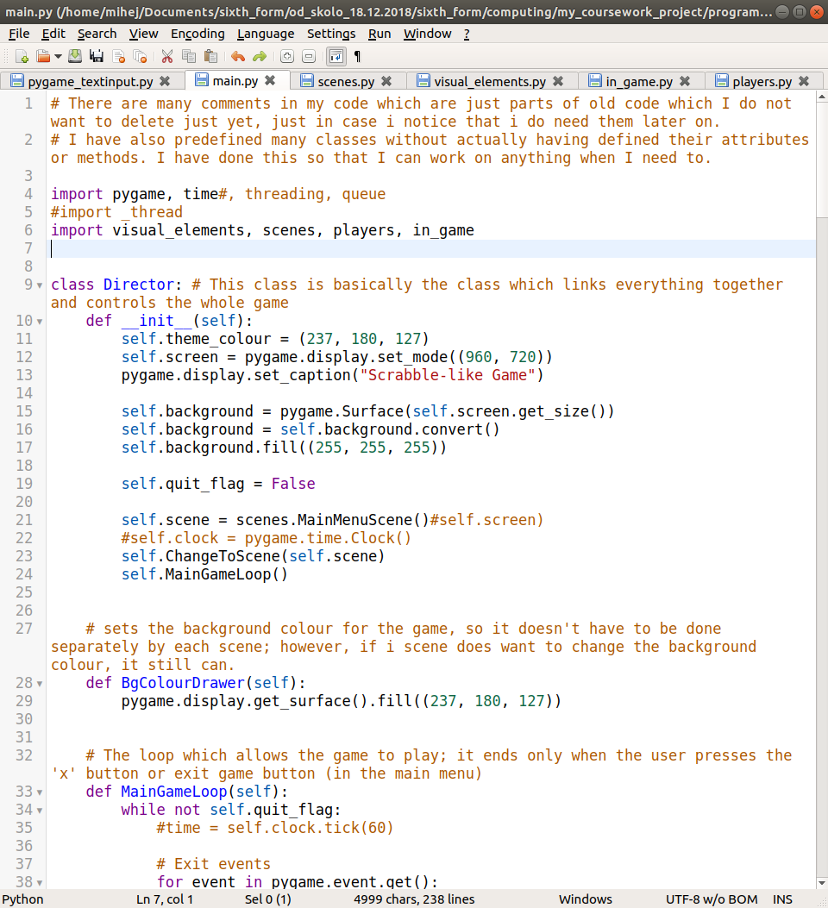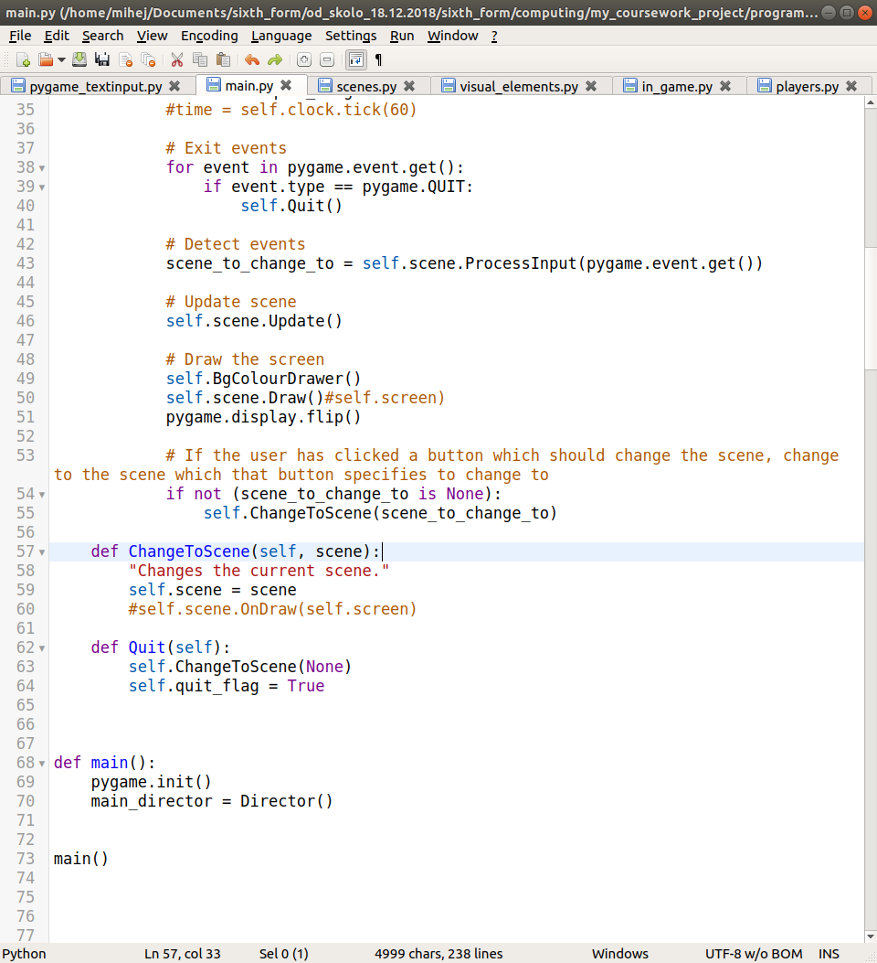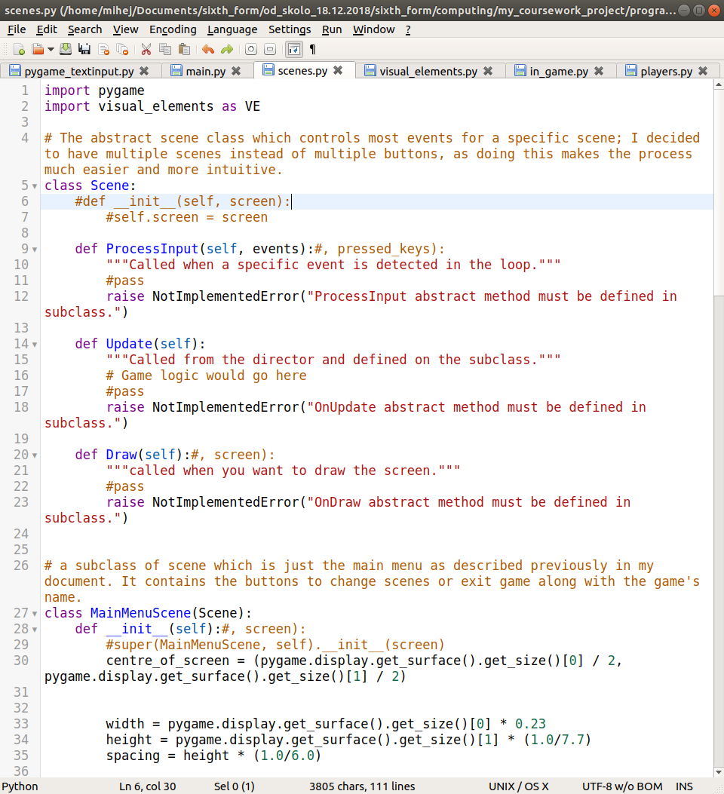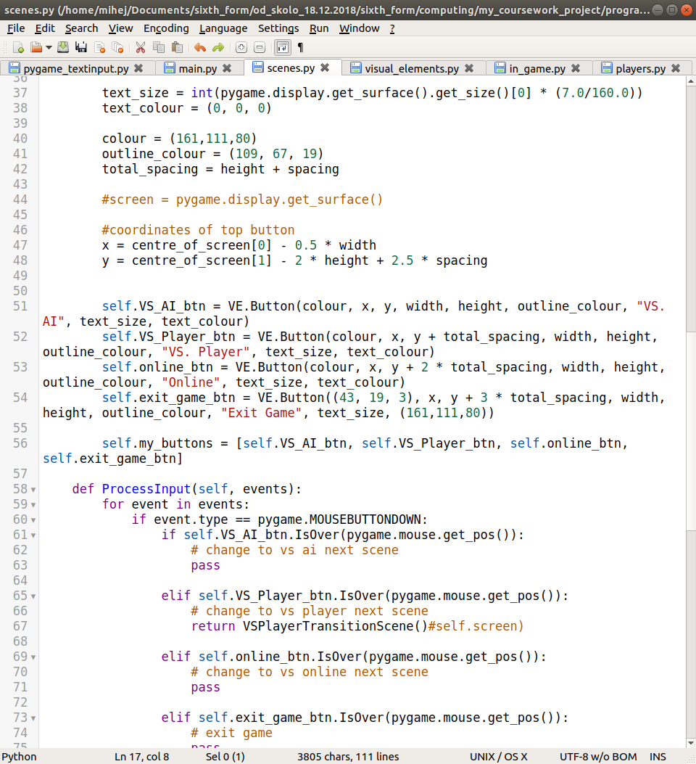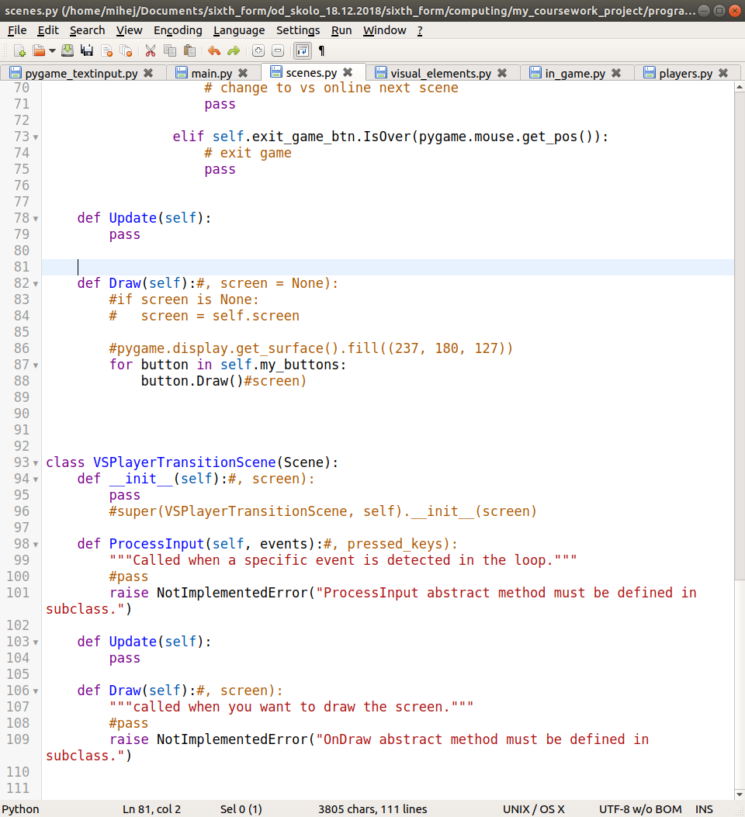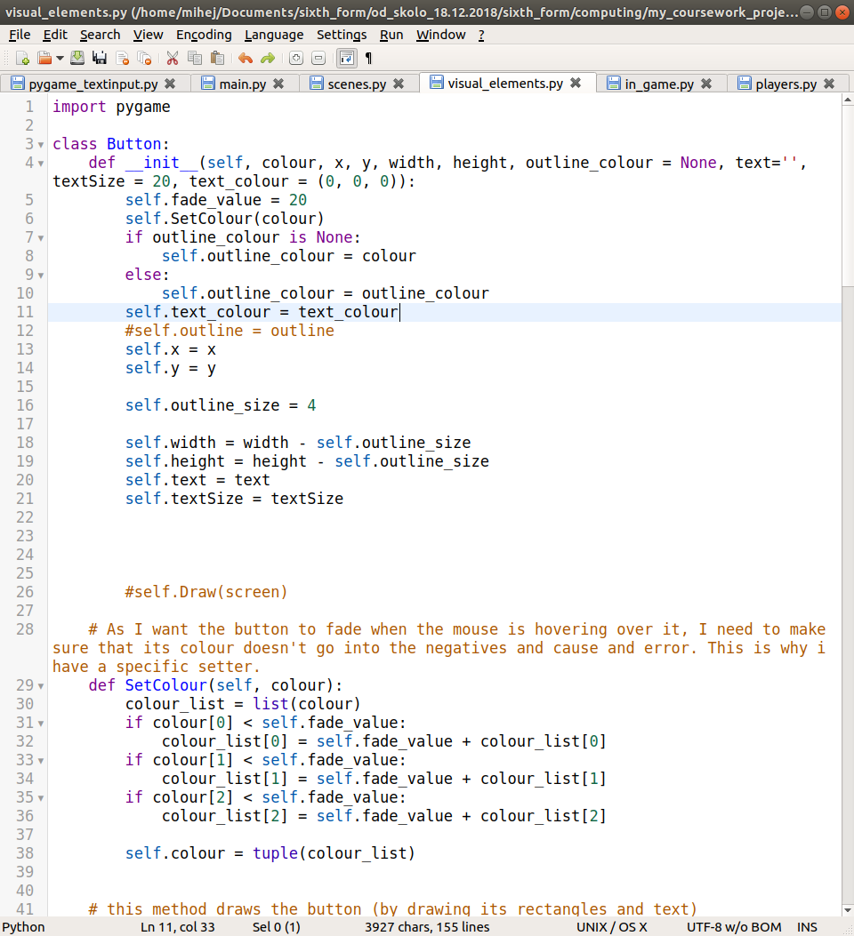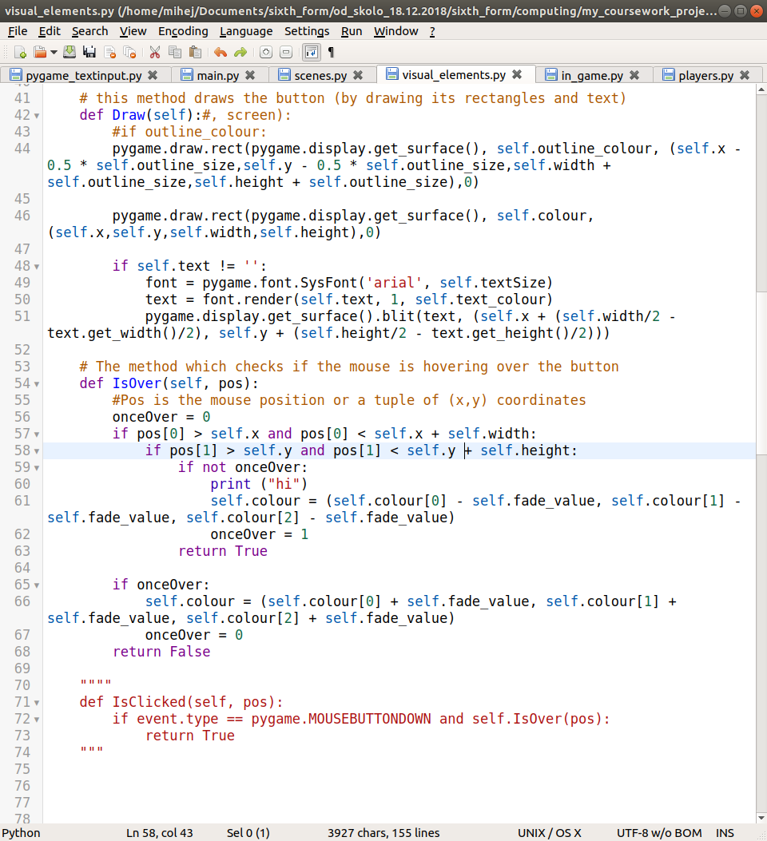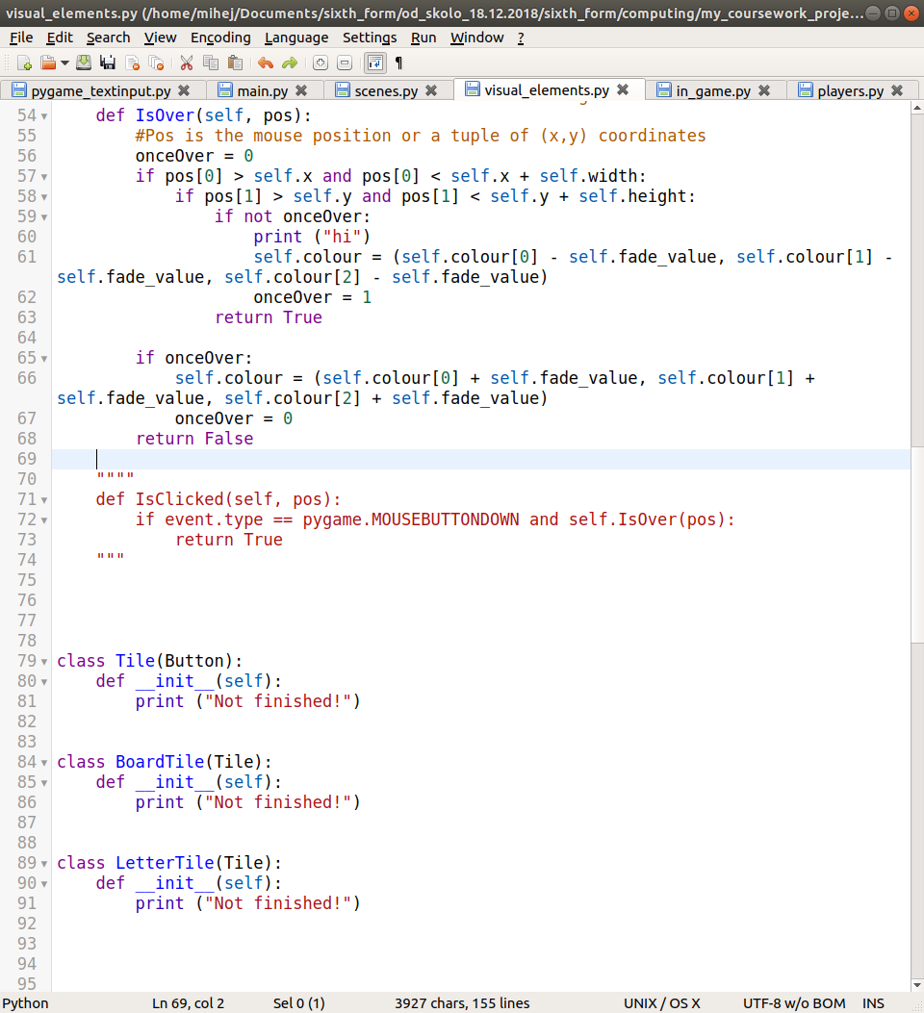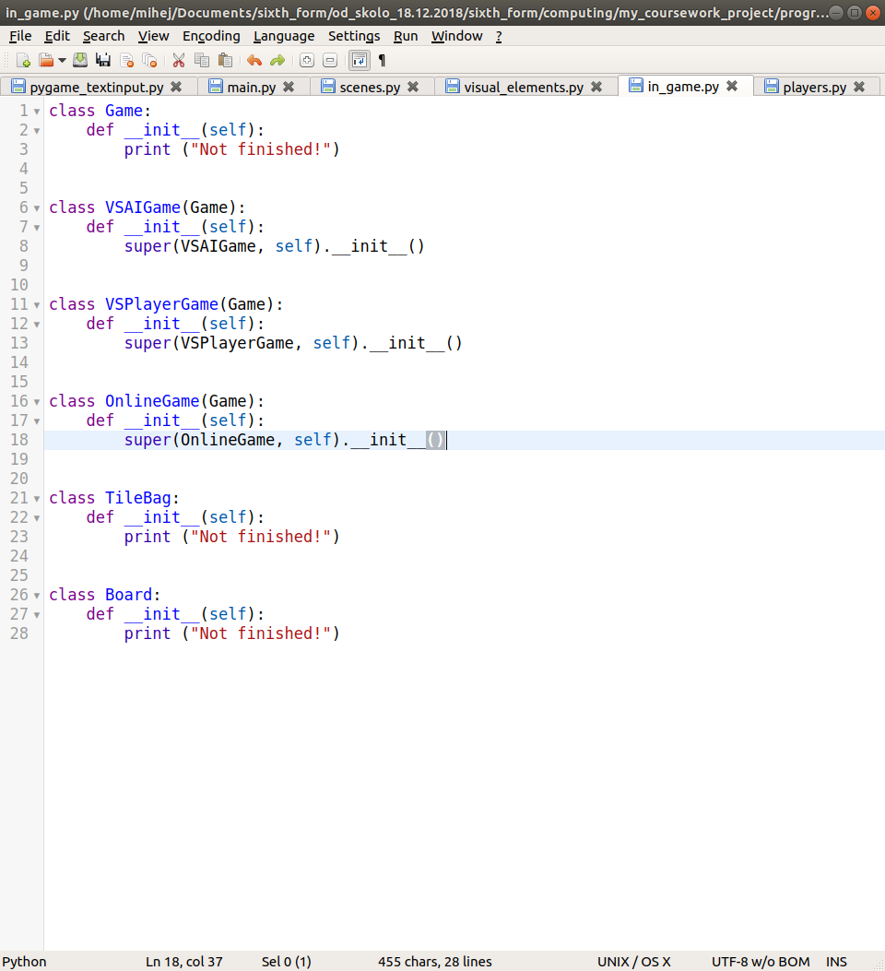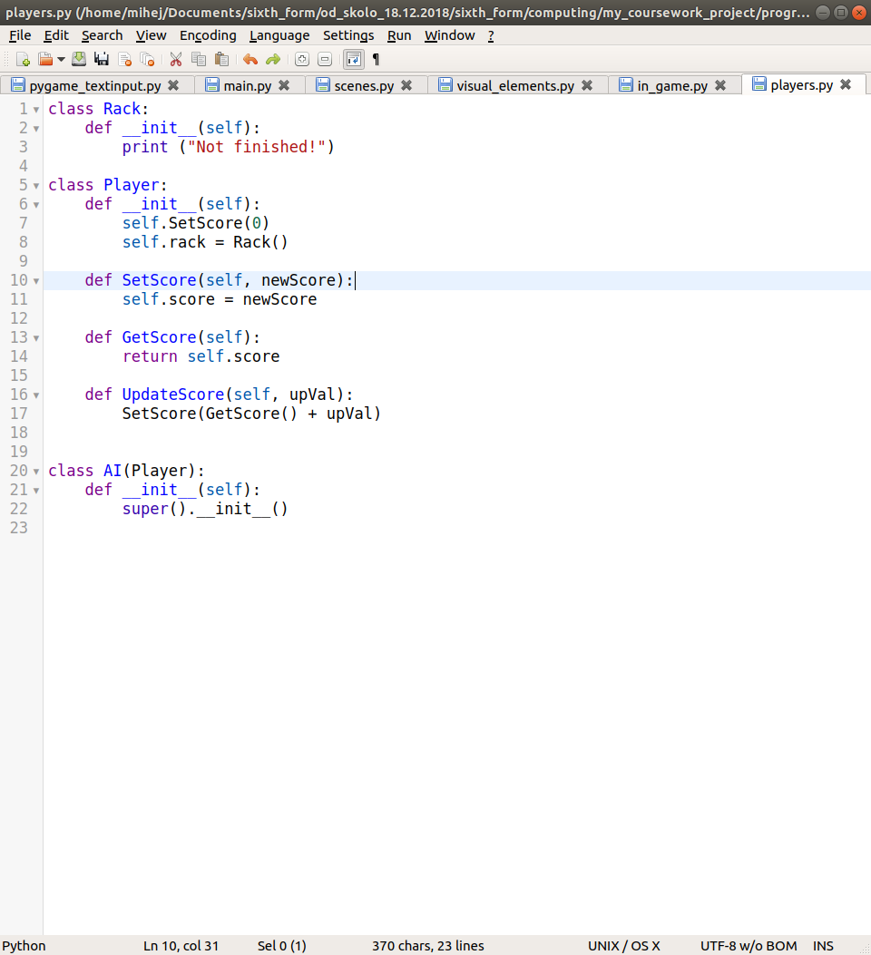

In my first iteration, I just mainly set pygame up with the game loop and made my main menu scene. I need this game loop so that the game does not just end after one pass and all events that the player triggers (such as mouse clicks, button presses etc.) are registered through it. It also allows me to pass arguments (namely events) to my scenes which will handle them separately based on the scene we are on.

One may also notice that I have set up the barebones of some classes. This was done so that I have a general overview of what else I need to develop and so that I can do parts in parallel and think about the details later on.

Currently, as what I have are less than the barebones, there is no validation. All I have is a static, non-interactive picture.

On a side-note, through research I found that it is probably better to use multiple scene classes instead of multiple button classes, and so I will be doing this instead of what has been mentioned in the document before.

**Testing**

There really is not much to test yet, however I have noticed one problem with my program; although I am expecting for the colour to change when I hover over a button, it does not. In addition, when I click on a button, I expect ‘hi’ to be printed to the console, but it is not. This is something I need to work on for my next iteration, which will be aimed at setting up all of my scenes and smooth (without errors) transitioning between them.

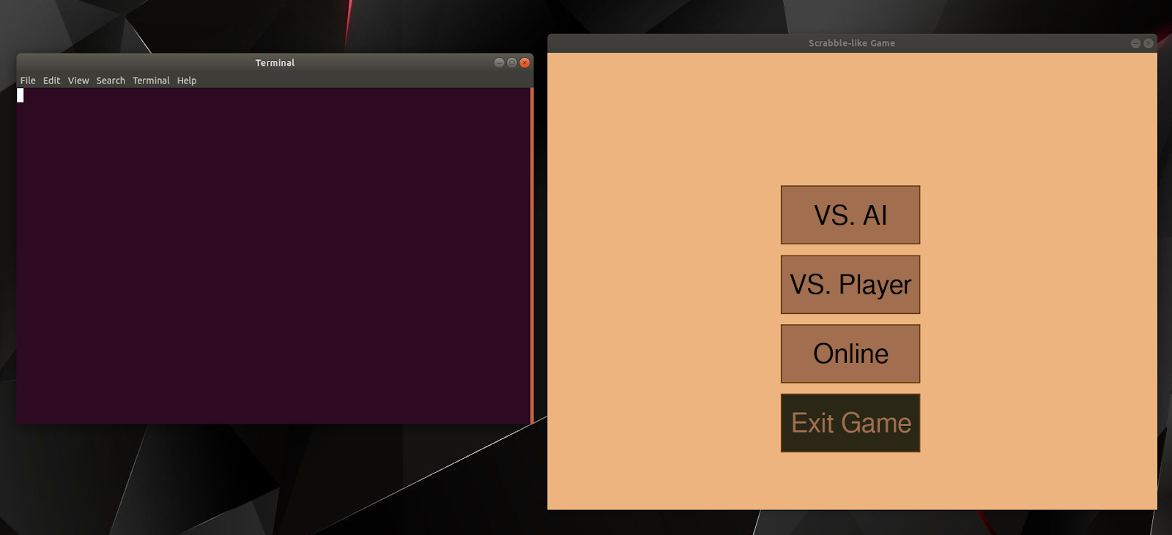

Another minor problem is that when I close the pygame window, instead of a smooth exit, I get errors:

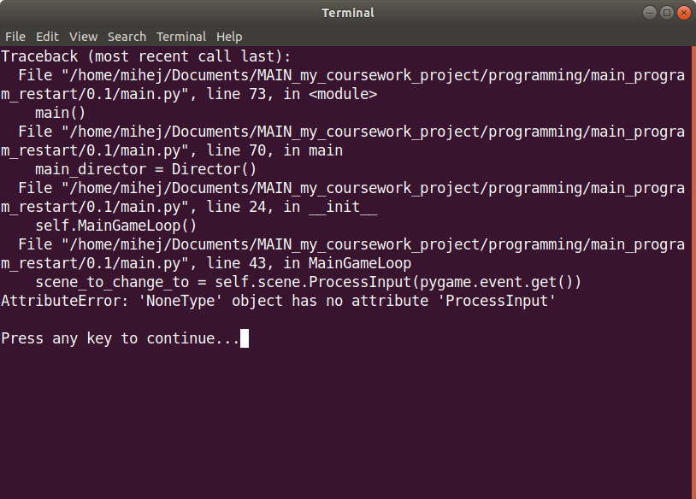

(this is after I press the ‘x’ button of the pygame window)

|  |  |  |  |  |  |
| --- | --- | --- | --- | --- | --- |
| **Test**  **Num** | **Type** | **Data** | **Expected result** | **Actual result** | **Comments/solution** |
| 1 | Invalid | In any of the scenes, if the player clicks on a non-button object (i.e. on the background/text) | Nothing should happen (In reality, the click will be registered, but no action will be taken because of that click) | Nothing happens | N/A |
| 2 | Valid | The VS AI button on main menu is clicked | The current scene changes to the next scene where the user is allowed to enter their nickname | Nothing happens | I still need to implement the VS AI transition scene and then the scene with the actual game on it. This requires me to make a new subclass of scene, similar to how I have done for my MainMenuScene.​ The reason I make new subclasses is because this is how I’ve decided that my code architecture is going to work, and how I’m going to transition in between scenes. The alternative would be to have only one scene class, and a parent button class, from which every button would inherit its attributes, and would need to have its ‘OnCLick’ method edited. But because there are more buttons than scenes, this is less convenient. |
| 3 | Valid | The vs player button on main menu is clicked | The current scene changes to the next scene where the user is allowed to enter their nickname | Nothing happens | I still need to implement the vs player transition scene and then the scene with the actual game on it. This requires me to make a new subclass of scene, similar to how I have done for my MainMenuScene. The reason I make new subclasses is because this is how I’ve decided that my code architecture is going to work, and how I’m going to transition in between scenes. The alternative would be to have only one scene class, and a parent button class, from which every button would inherit its attributes, and would need to have its ‘OnCLick’ method edited. But because there are more buttons than scenes, this is less convenient. |
| 4 | Valid | The online button on main menu is clicked | The current scene changes to the next scene where the user is allowed to enter their nickname | Nothing happens | I still need to implement the online transition scene and then the scene with the actual game on it. This requires me to make a new subclass of scene, similar to how I have done for my MainMenuScene. The reason I make new subclasses is because this is how I’ve decided that my code architecture is going to work, and how I’m going to transition in between scenes. The alternative would be to have only one scene class, and a parent button class, from which every button would inherit its attributes, and would need to have its ‘OnCLick’ method edited. But because there are more buttons than scenes, this is less convenient. |
| 5 | Valid | The exit game button is clicked | The game exits | Nothing happens | Needs to do a similar function to clicking on the ‘x’ button in the top right corner. I still have not implemented functionality for this button. Ways of solving this and justifications for it will be discussed later on in the program. |
| 6 | Valid | The ‘x’ button in the top right corner of the game windows is clicked | The game exits | Game exits, but with errors | I need to find a way to exit MainGameLoop without triggering a call to a scene’s methods. The best way is probably to just not change the current scene to None in my Quit method. The error arises because I am trying to call a method using an object of type None, which is not possible. So, if we don’t change the current scene to None, then we can call the method, and no error will arise. |
| 7 | Invalid | The user right clicks on a button | Nothing should happen (In reality, the click will be registered, but no action will be taken because of that click) | Nothing happens | N/A |
| 8 | Valid | Make sure that the user’s nickname is correctly stored | When the user enters their valid nickname on the scene after main menu, it is correctly recorded in the string variable, and not truncated or with extra characters | Nothing happens | N/A |
| 9 | Invalid Boundary | The user’s enters a nickname which doesn’t fit in the nickname field | Once the character limit is reached, no more characters are recorded in the string variable responsible for storing their nickname, and no more letters are shown on the screen | Nothing happens | N/A |
| 10 | Valid | What happens when the user presses backspace when entering their username | When the user is entering their nickname, they should be allowed to use backspace to delete the last character in their entered nickname | Nothing happens | N/A |
| 11 | Valid | Clicking the next button on the nickname entry scene | When clicked, the scene should change to the next scene (which in the case of VS AI is the game scene, in the case of vs player is the next player’s nickname entry scene, and in the case of online is a waiting screen) | Nothing happens | N/A |
| 12 | Valid | Whether game times out | While on the waiting screen for online play, if a game isn’t found in a specified amount of time, the waiting should time out, and the scene should be changed back to the menu scene | Nothing happens | N/A |
| 13 | Valid | Whether the game starts | After the waiting screen, if a connection is found, then the game object should be instantiated and a game should start, with a change of scene to show for it. | Nothing happens | N/A |
| 14a | valid | Tile bag button is pressed | A small pop up should show up on the scene to show the remaining tiles in the bag along with the tiles of the opponent in one list like display | Nothing happens | N/A |
| 14b | Valid | Player clicks on close window button (of TileBag window) | Once the player is done looking at the tile bag, they should be able to press the close button to hide the tile bag window visual element | Nothing happens | N/A |
| 15 | valid | Pass turn button is pressed | The current player’s turn should be forfeited, with no points, and the current player’s turn should be switched | Nothing happens | N/A |
| 16 | Valid | shuffle tiles button pressed | The visual positions of the letter tiles on the player’s rack should be shuffled (along with their coordinates in background code, so that a button click is registered correctly) | Nothing happens | N/A |
| 17a | Valid | Swap tiles button is pressed | A pop up window-like thing should show up allowing the user to put tiles from their rack into it | Nothing happens | N/A |
| 17b | Valid | Player clicks on close window button (of swap tile window) | If the player changes their mind about swapping their tiles, they can press this button, and the position of their letter tiles should reset, along with hiding their visual element | Nothing happens | N/A |
| 17c | valid | Player clicks on submit swap button (of swap tile window) | New tiles are put into the player’s rack (visually and logically) and the ones which they submitted to the swap are taken away. | Nothing happens | N/A |
| 18 | Valid | Resign button clicked | The game announces the other player as a winner in a windows for a few seconds, and then goes back to main menu | Nothing happens | N/A |
| 19a | Valid | Submit word button pressed (with a valid word on board) | The current player’s score is incremented according to scrabble rules, and it is the next player’s turn, unless the current player no longer has any letters left in their rack, in which case a winner is calculated and announced. | Nothing happens | N/A |
| 19b | invalid | Submit word button pressed (with an invalid word on board) | A small pop-up appears telling the user that the word which they entered is invalid, and no further action is taken (i.e. the players aren’t swapped) | Nothing happens | N/A |
| 20 | valid | Reset letter button is clicked | The board tiles which gained letter tile links on this turn are unlinked with their letter tiles, and the letter tiles are restored to their old coordinates, visually and logically. | Nothing happens | N/A |
| 21 | invalid | During the waiting time between player swaps, the player clicks a button | Nothing should happen (In reality, the click will be registered, but no action will be taken because of that click) | Nothing happens | N/A |
| 22 | Valid | Click on board tile (while holding a letter tile) | The letter tile which is held gets visually and logically moved onto the clicked board tile, and the board tile gets a logical connection to the letter tile | Nothing happens | N/A |
| 23 | invalid | Click on board tile (while not holding a letter tile) | Nothing should happen (In reality, the click will be registered, but no action will be taken because of that click) | Nothing happens | N/A |
| 24 | Valid | Click on letter tile in rack (while not holding another letter tile) | The currently held letter tile is changed to the clicked letter tile | Nothing happens | N/A |
| 25 | invalid | Click on letter tile in rack (while holding another letter tile) | The currently held letter tile is changed to the newly clicked letter tile | Nothing happens | N/A |

From now on, I am also only going to be using parts of the table that are related to the changes which I have made in the last iteration, as there are many tests which would have stayed the same due to the size of my program and number of tests.

At this point in my implementation, because there isn’t really much which the user can do, there isn’t any validation which I can do on input from the user, which is why I did not talk about validation. As I keep developing my program, I will have more parts which the user will be able to interact with, and therefore will need to have more validation.

## Between Iteration

I have managed to make the hovering behaviour to be detected, however now when I hover over a button, the colour which the button gets changed to negative values in the colour tuple, making it invalid and crashing my program. I need to look into a fix for this:

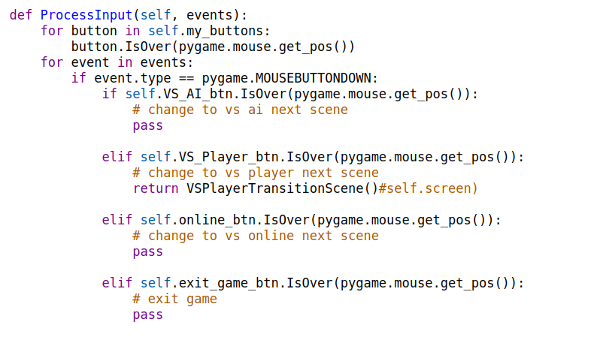

(I have a debugging step allowing me to see the colour tuple of each button on each loop cycle)

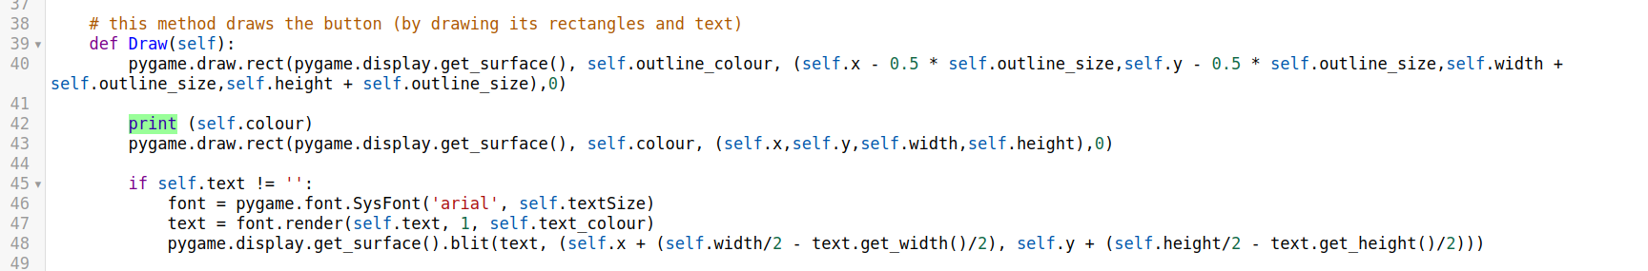

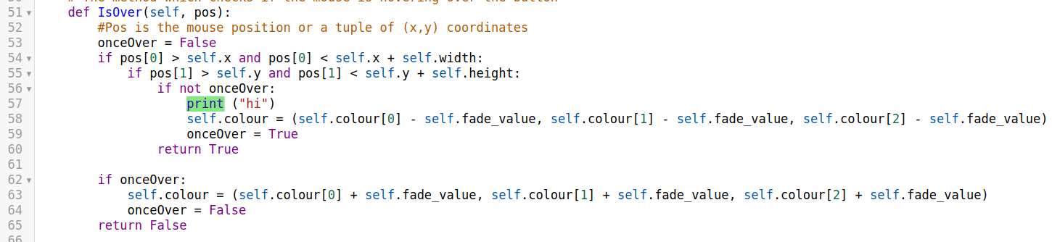

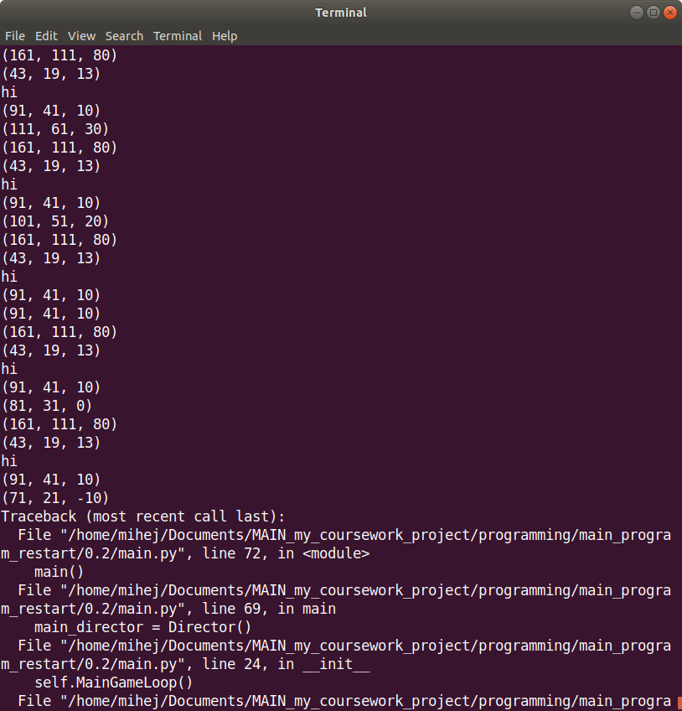

This was a logical error; each time I entered the method, the onceOver variable would renew its status without affecting anything. All I had to do was make it an instance variable with a default value of zero and remove the line in the method which sets its value to zero at the start.

## Implementation Iteration 2 (v 0.2) – Scene changes

Since the last iteration, I have changed the way my code is organised. I have put each class in their own file, making it much easier for me to navigate through my code. This is also how many large-scale projects are made, so I thought that I would try to incorporate a similar style.

Validation done will be mentioned at the relevant place (i.e. where it can be demonstrated)

Firstly, this is what my main function looks like:

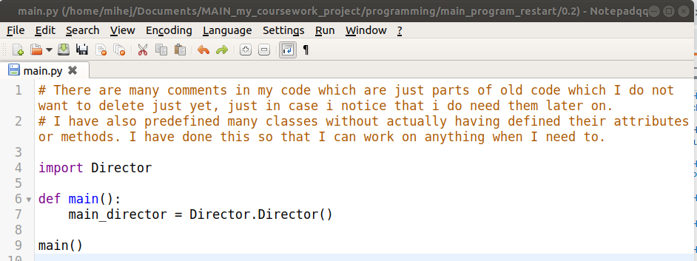

Instead of initialising pygame in main, I do it in Director, meaning I don’t have to import it here. This makes more sense, as all I want this program to do is to get into the OOP as quickly as possible. I can want total control in my Director instance.

Then, this is what my Director class looks like:

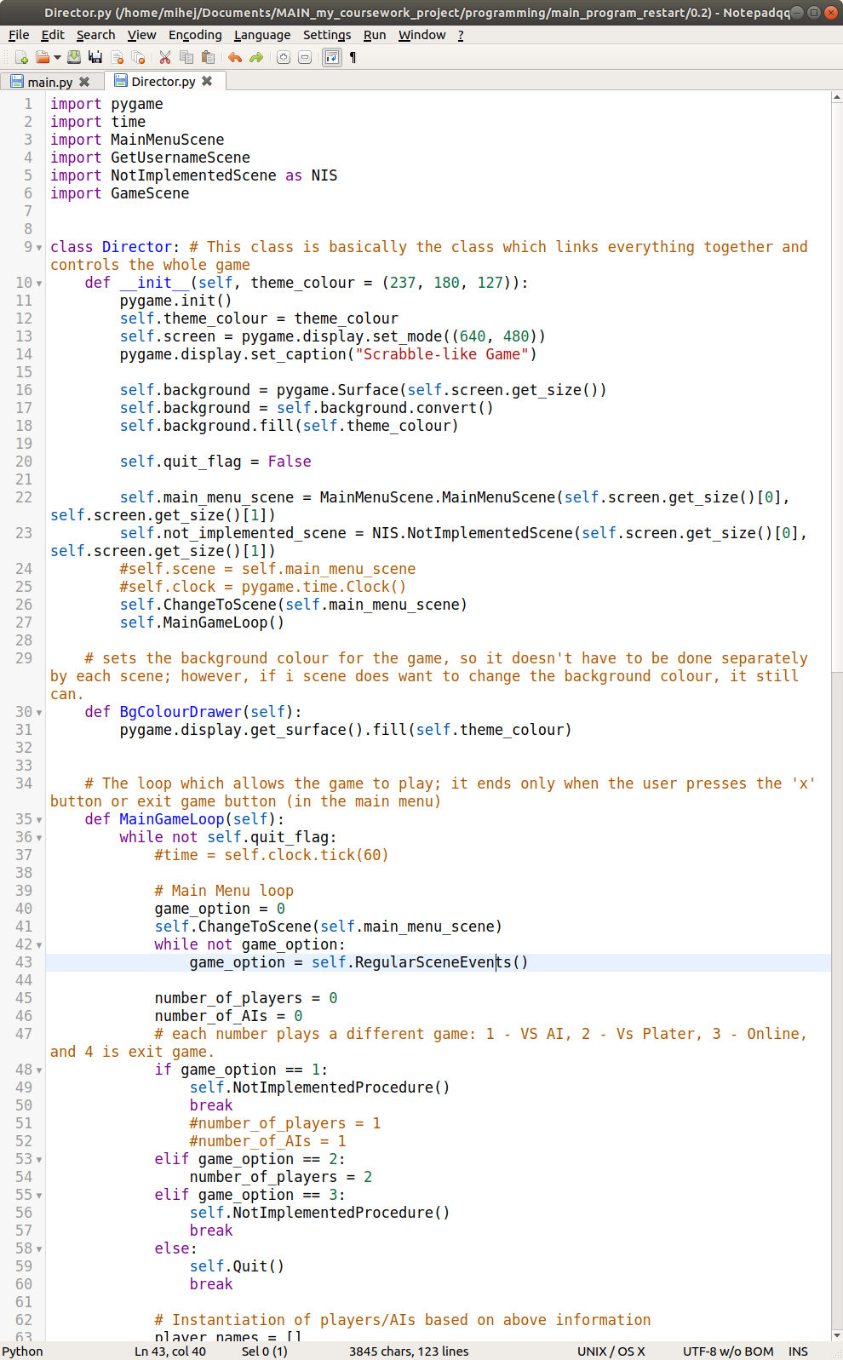

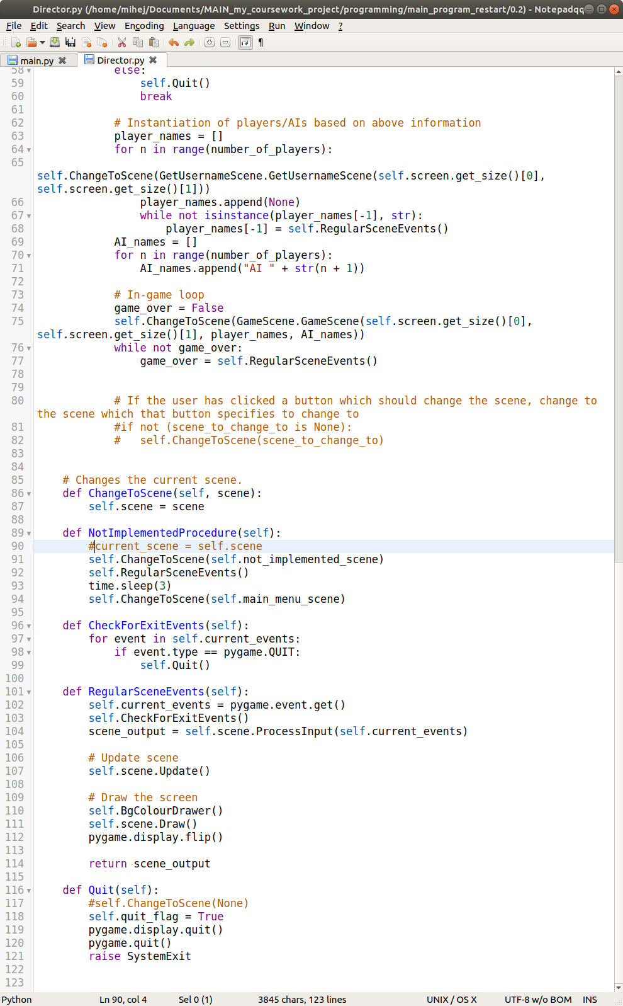

As visible, it has grown by quite a bit.

This is due to the me wanting to change where things are handled; for example, instead of a button having influence over the next scene (through the scene it’s on), I changed this so that director ‘directs’ what the next scene is, based on the output of the scene. To make this easier, I also implemented the RegularSceneEvents() and CheckForExitEvents() procedures. The first one makes it so that after I change to a scene, I can easily start up its events in one line instead of having to repeat myself. It returns any output that might be required/given by the current scene every frame. The second procedure is me just moving a few lines from the MainGameLoop() to a separate place in case I want to use it somewhere else. It also makes it easier to find where errors occur, as the stack can display which line of which file the error occurred in, and because each file is its own class, I can straight away know which class the error could have occurred in.

A Quit() procedure was also added so that I can easily exit my pygame program without any errors. This was the easiest way to exit the game without having to worry about any deconstruction of pygame objects and memory reallocation, which is left to garbage collection and pygame.

The NotImplementedProcedure() procedure is not a necessary one, however it allows me to easily tell the user that a part of the game has not been implemented yet. I still need to figure out a better way of using this, as currently my MainGameLoop() continues to do what it was doing even after the three seconds are up from this message (which is not the point of this scene), meaning I have to fully exit the game for this to not cause problems (i.e. errors), making it more user friendly, as the user won’t have to deal with looking at errors which make the program look unprofessional.

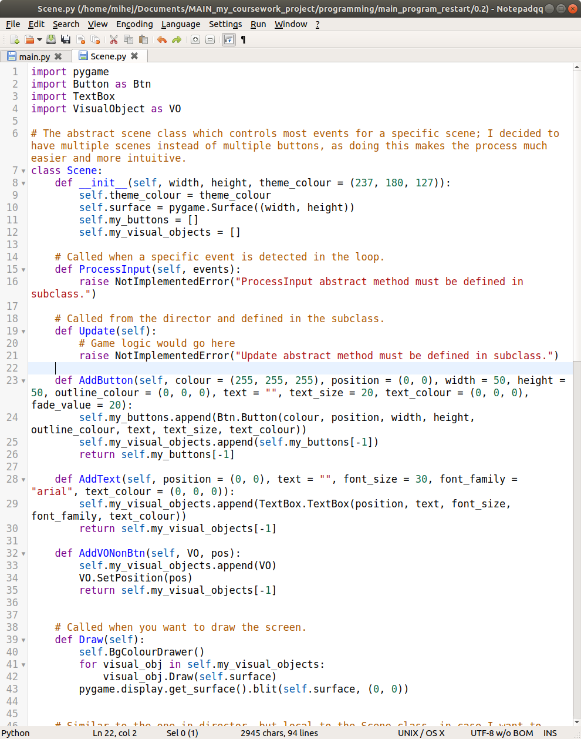

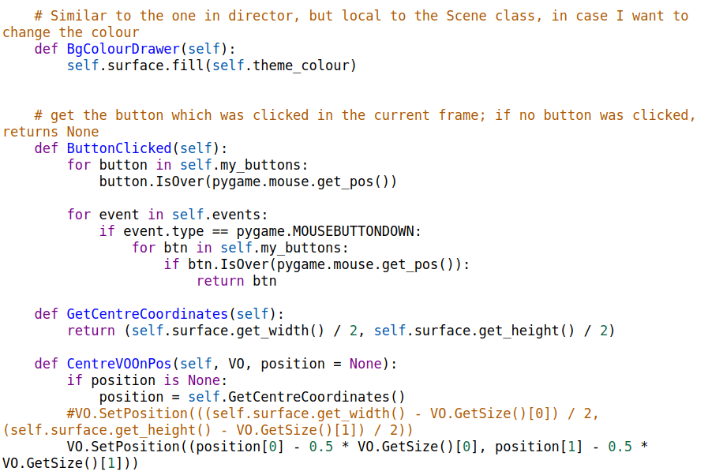

Next, my Scene class received an upgrade:

The initialiser requires the width and height so that it can make a surface which is the same size as the display. This helps me to put everything on this surface before it is displayed, so that there is no way for some elements to be loaded and others not at an instance in time, which would look bad.

The my_buttons and my_visual_object attributes are used when the scene needs to be drawn onto the display for easy access, and also the buttons are used for easy iteration for button clicks. So instead of having to draw each button out separately and repeat myself, I can just iterate through the two lists, and draw what’s in them.

The Draw() procedure got an overhaul as well. Instead of just being an abstract method, all of my scenes use it for easily displaying everything that’s on them. This is where object are used. (On a side note, buttons are also visual objects, but are a special case, which is why there is a separate list for them; a user needs to be able to interact with them, whereas other visual objects aren’t necessarily interactable).

AddButton(), AddText() and AddVONonBtn() all do a similar thing. AddButton() creates a button on the scene, and adds it in the above-mentioned lists; AddText() creates text on the scene, and adds it in the my_visual_objects list; AddVONonBtn() adds any visual object to the scene (and the objects list).  
AddText() might actually be slightly redundant with AddVONonBtn(), but it allows for easier text creation on a scene.

The ButtonClicked() method returns the button which was clicked in the last frame (None also being a valid return value). As only one button can ever be clicked on a scene, this makes checking for which button was clicked much easier, and it’s easier to deal with what needs to be done because the button was clicked.

GetCentreCoordinates() is just a method to help me put objects in the right position.

CentreVOOnPos() allows me to put an object’s centre at certain coordinates instead of positioning its top-left corner.

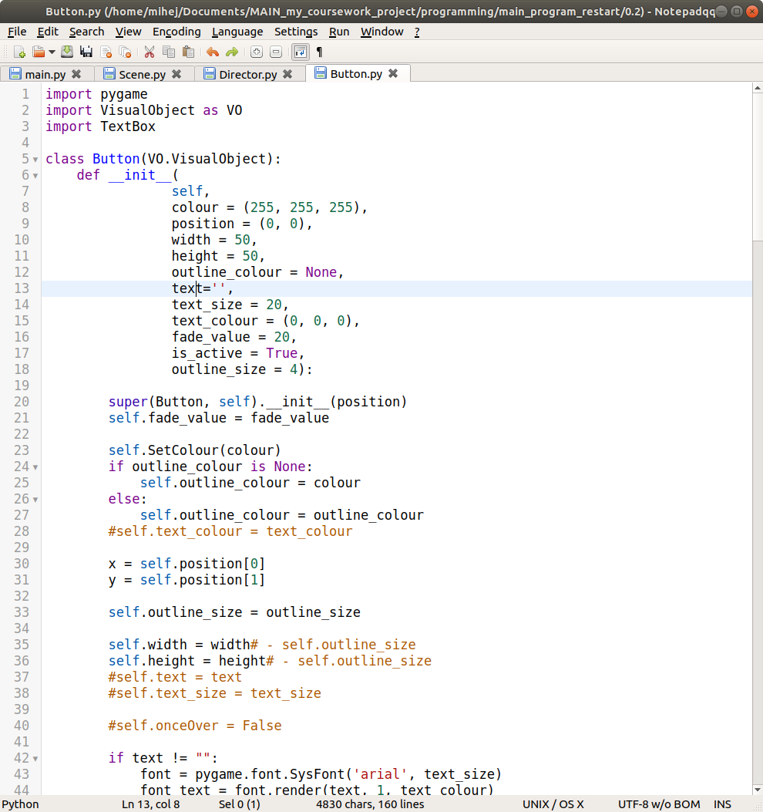

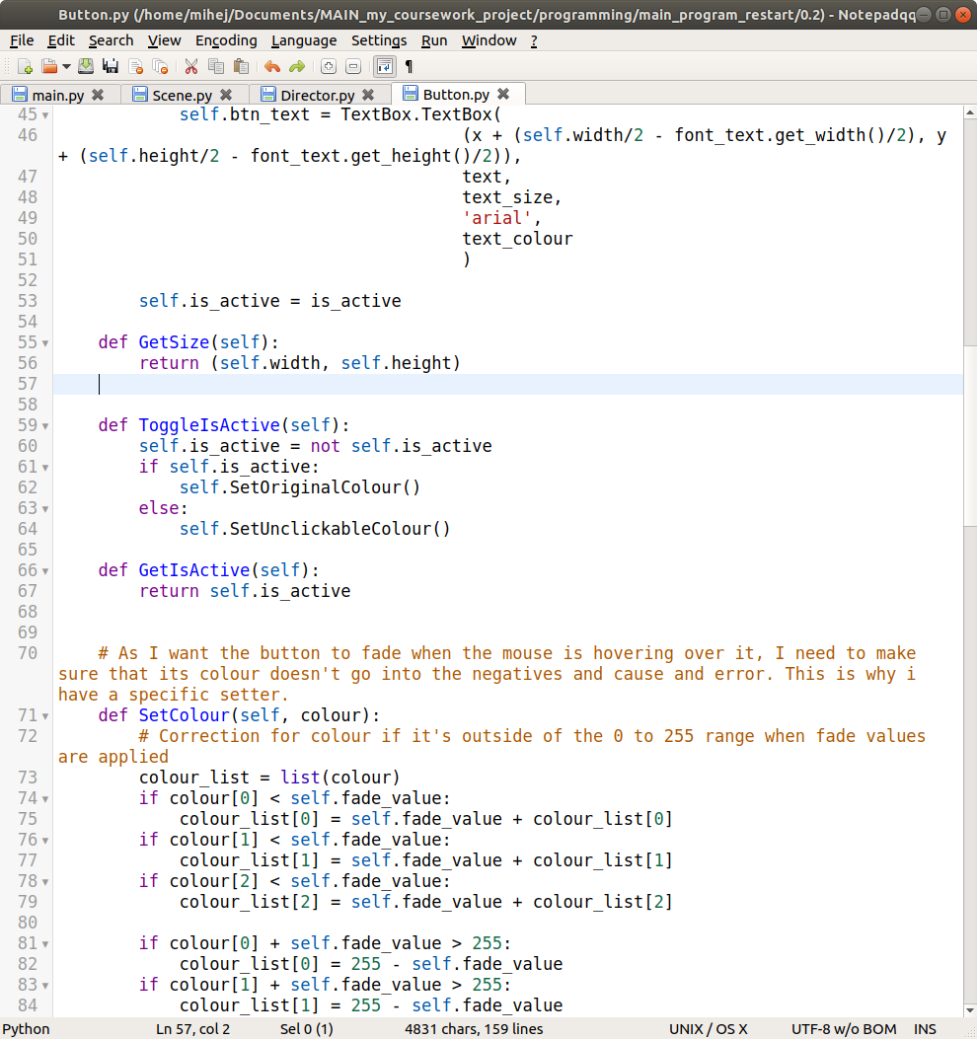

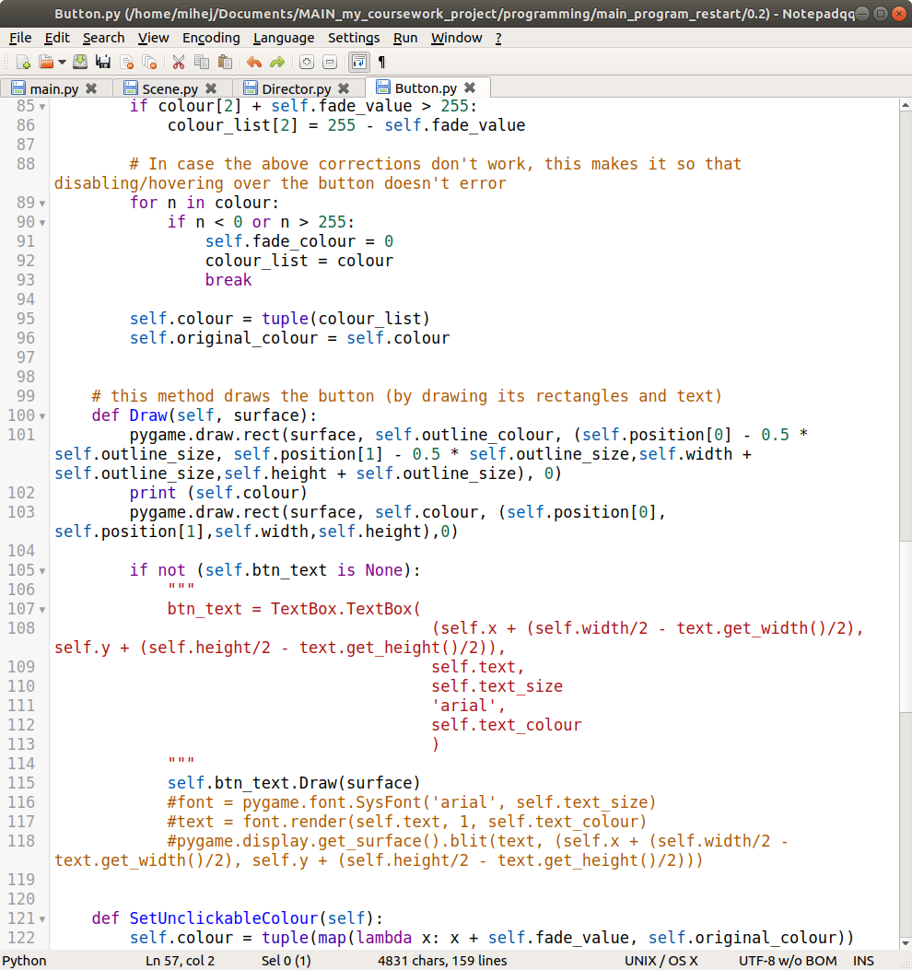

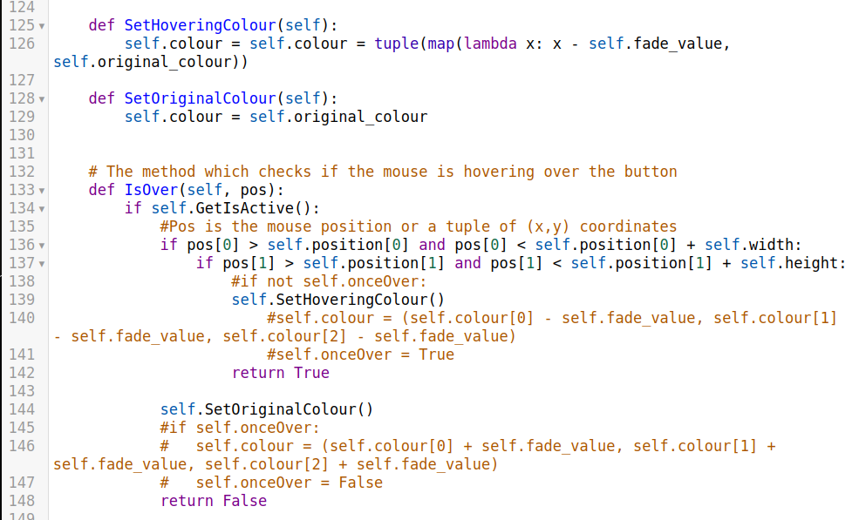

I have moved some variables that were unchangeable from the constructor into the constructor’s default arguments just making it easier to reuse the code.

I have also changed the way that colour change occurs when the user is hovering over a button. Instead of doing it explicitly in the hovering method, I use another method to handle it. This is why I have a few extra variables, and the SetHoveringColour(), SetOriginalColour() and SetUnclickableColour() methods. There are also some remnants of other ways I tried to solve this problem, but this seemed to be the best, again because it makes the code easier to maintain and more reusable. Otherwise, if I combined the code into one method, it would be more difficult to see what is going on in the code and the flow of the code.

Above I mentioned the SetUnclickableColour() method. I decided to add the functionality of a button to not be clickable, which will come in useful once I start using buttons as my tiles, as I won’t want the already placed tiles to be movable from the board. To go along with this, I also added the ToggleIsActive() method, which changes the button’s activeness, and its colour to reflect this. There is also the GetIsActive() method, which will allow me to see if a button is active or not. This will be useful later on when I am designing the board.

The SetColour() method received an upgrade so that its fade colour doesn’t cause an error to occur going either way (i.e. over 255 or under 0 in hex values). This just makes initialisation of buttons more convenient.

The GetSize() method is just used when I need to get the button’s visual size. It’s more a quality of life (QOL) method.

I have introduced a new class: TextBox. I will cover the details of it below. I just wanted to mention it here, as the constructor uses it to create the btn_text instance variable, which uses it. This class’s Draw() method is used in the button class’s draw method on line 116 instead of what is now commented out (and will be deleted in the next iteration). Making a separate method to handle parts of the program is good practice, as it means the one doesn’t have to go through code searching for parts which do the same thing, and can instead only change code in one place.

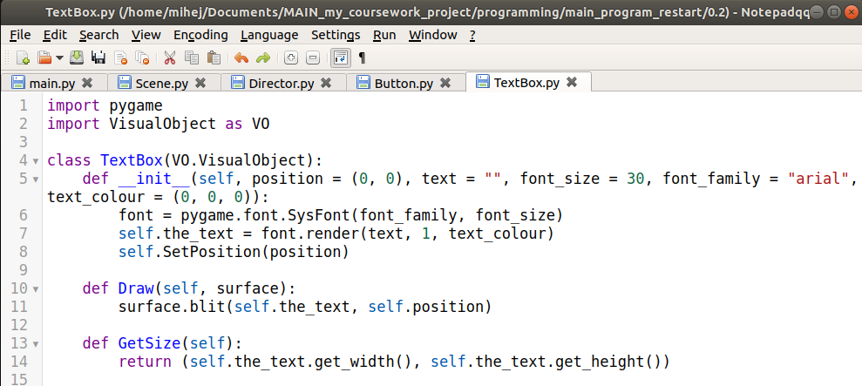

As mentioned above, I have introduced a new class which allows me to more easily put text onto a scene, but is also used in buttons for the text.

This also allowed me to put text on the main menu scene (which I will show after I have looked through all of my code).

I think that the methods are quite self-explanatory and there isn’t much to understanding them.

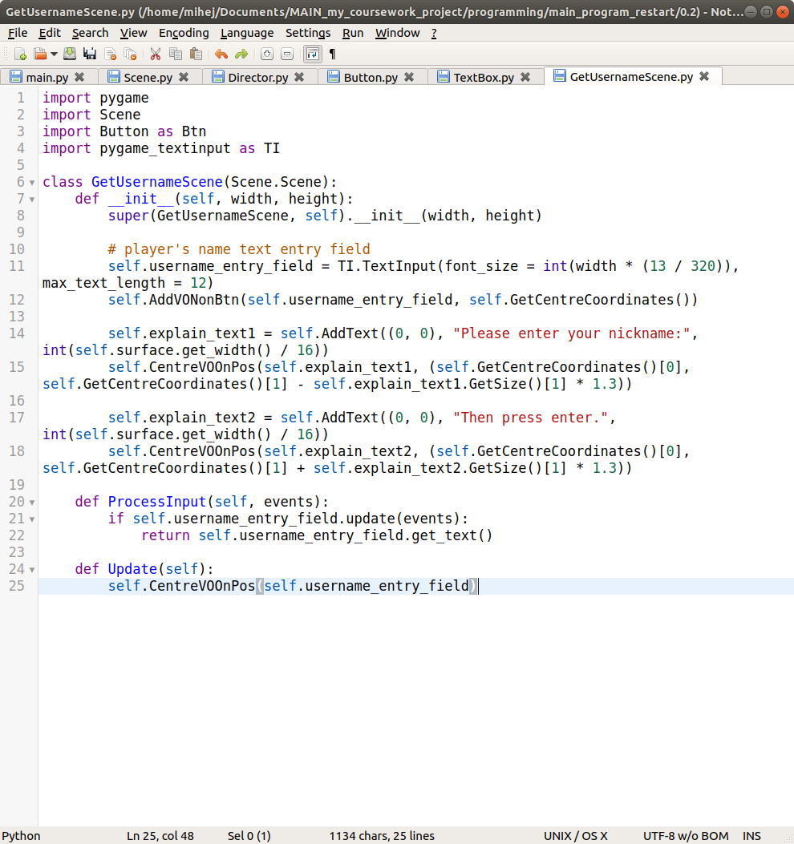

This is the new scene I have created. It is the scene in which the user is asked to enter their nickname, which will be used in the player object instantiation process. It makes use of the pygame_textinput module which I found and downloaded under an MIT license (and also edited it a bit so it can do what I require):

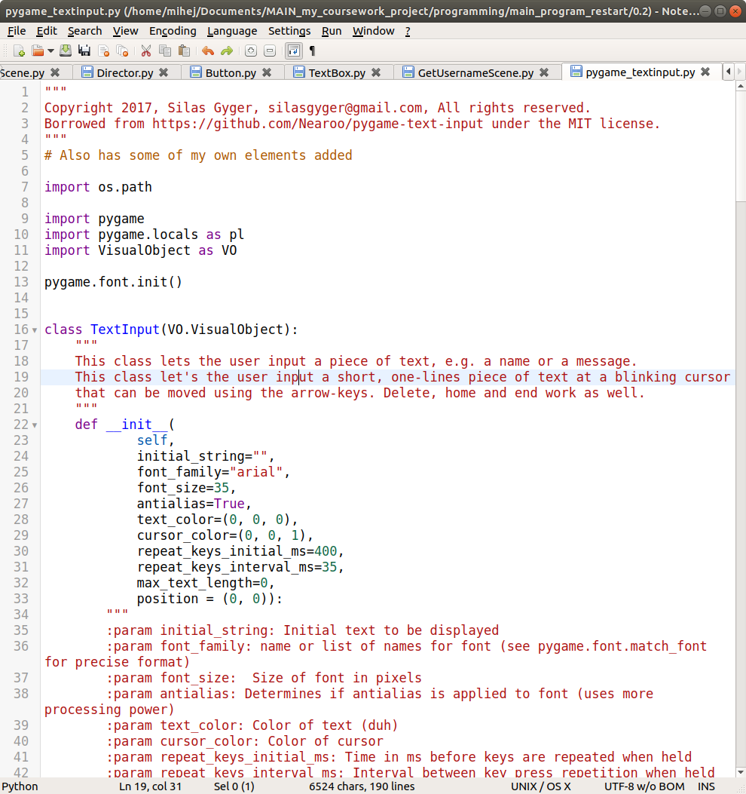

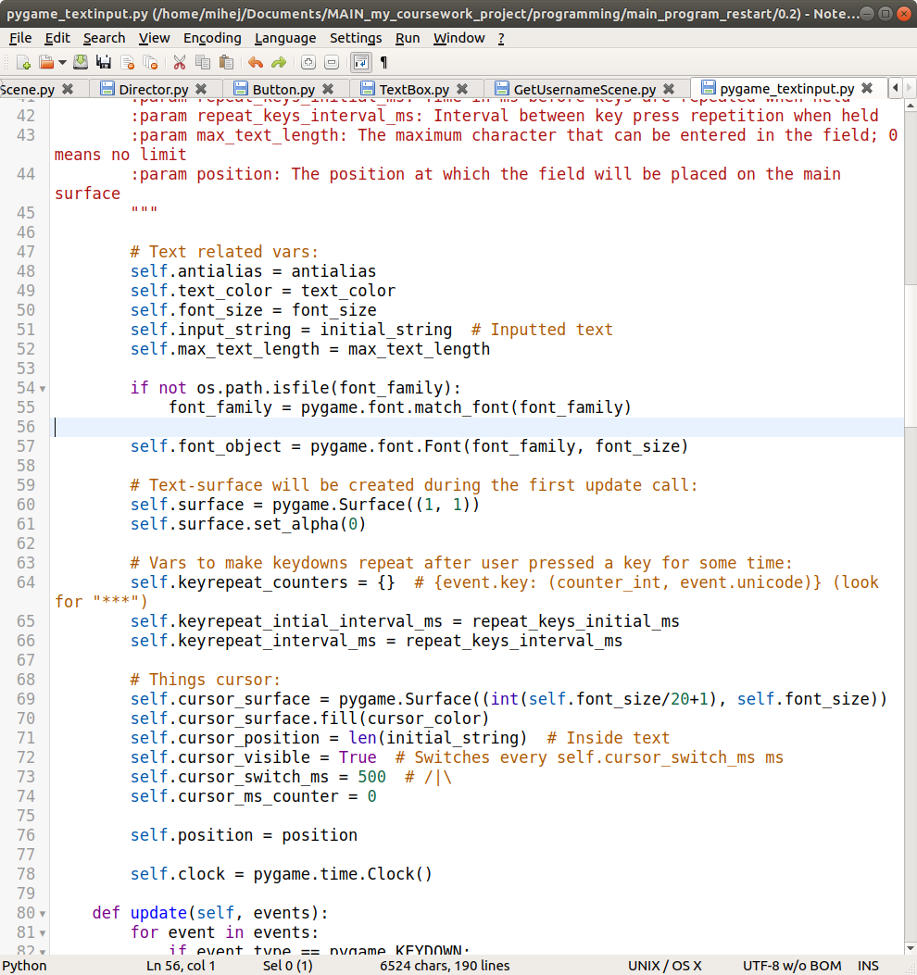

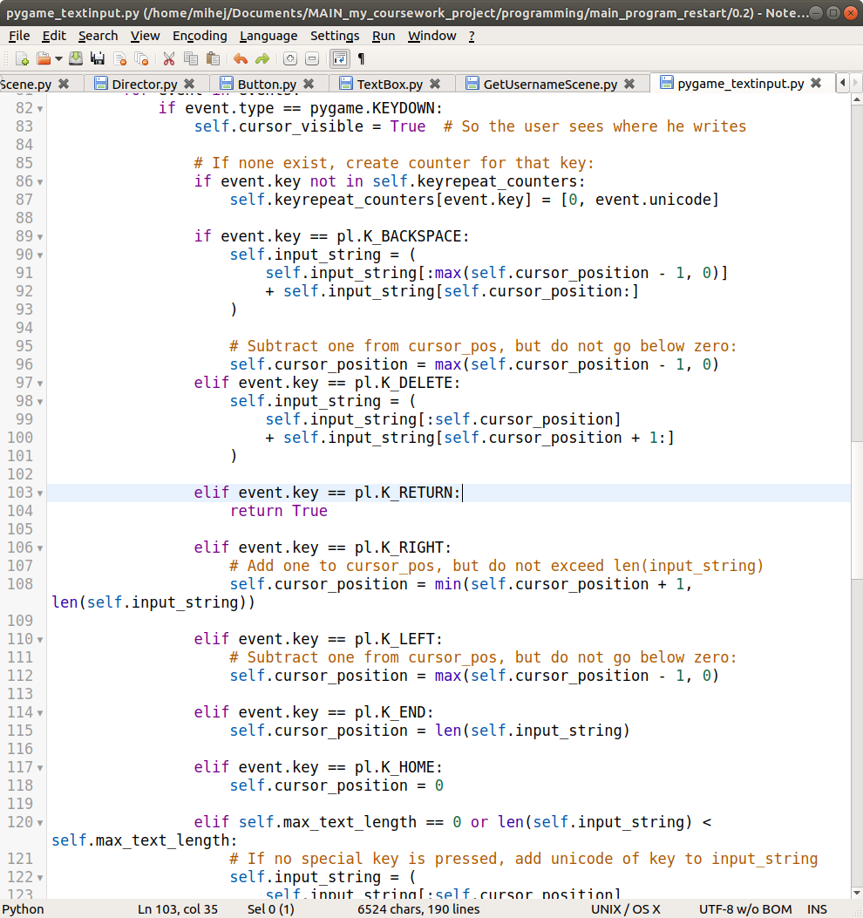

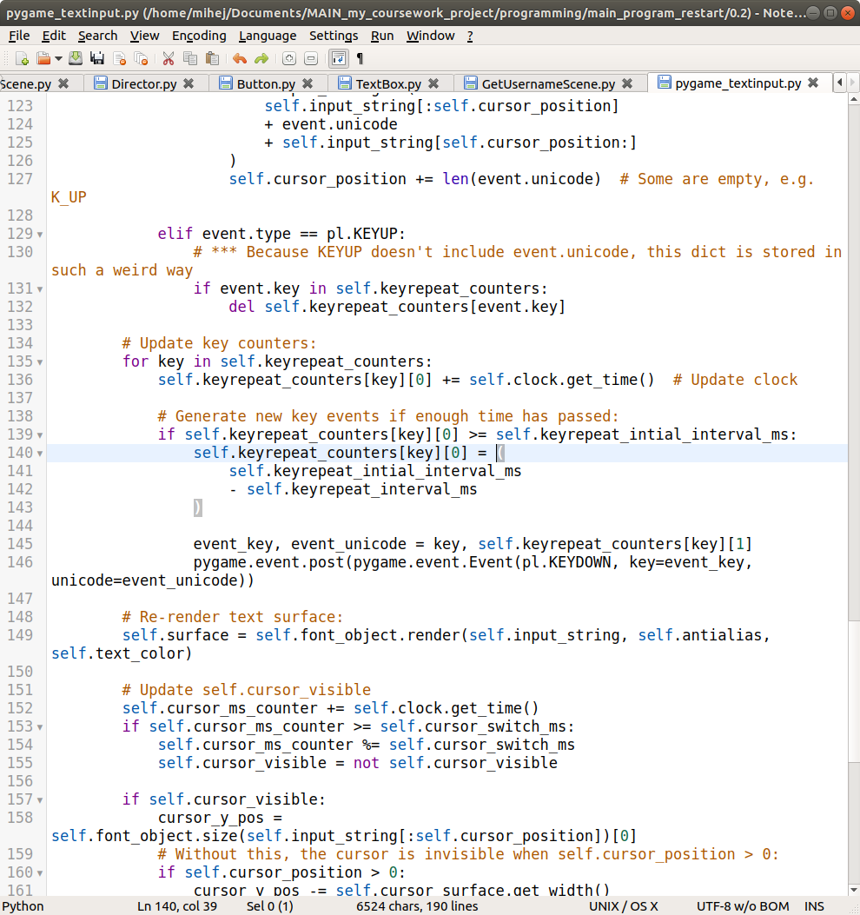

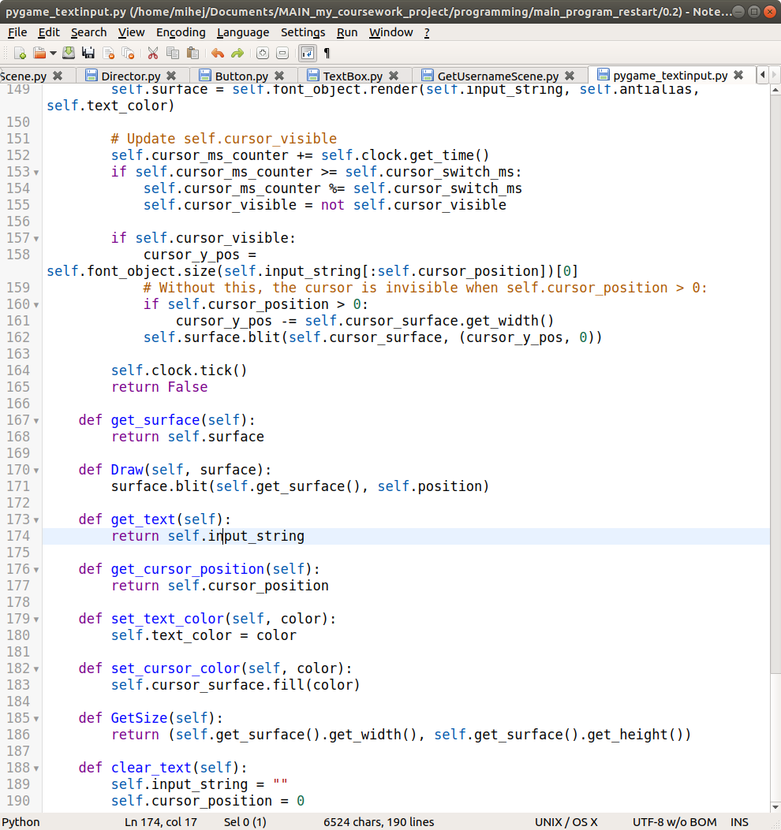

As per default, the output from the scene comes from the ProcessInput() method of the scene, and this time the Update() method is not blank. I decided that each time the user enters a character, the surface of the text field is centred on the centre of the screen. This means that the centre of the field is always centred to the centre of the screen.

I have also limited the length of the text that the user can enter to 12, making it easier to deal with the size predictions for text, and fulfilling the validation requirement of having a text length limit. This means that the user cannot enter a nickname which is too long and overlaps other parts of the game, making the game either unplayable at worst, or look bad in the best-case scenario. A different way of dealing with this would be to shrink the text, however long it is, into a set amount of space, however this is not an elegant solution, as it would mean that if the nickname is too long, then the user might not be able to even read the nickname, which we don’t want.

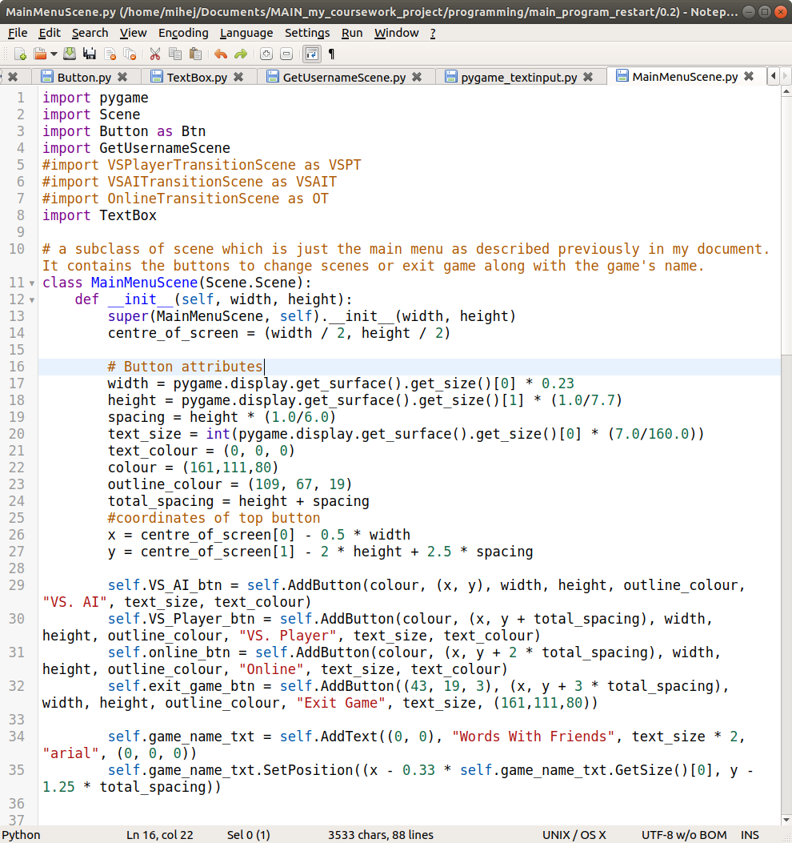

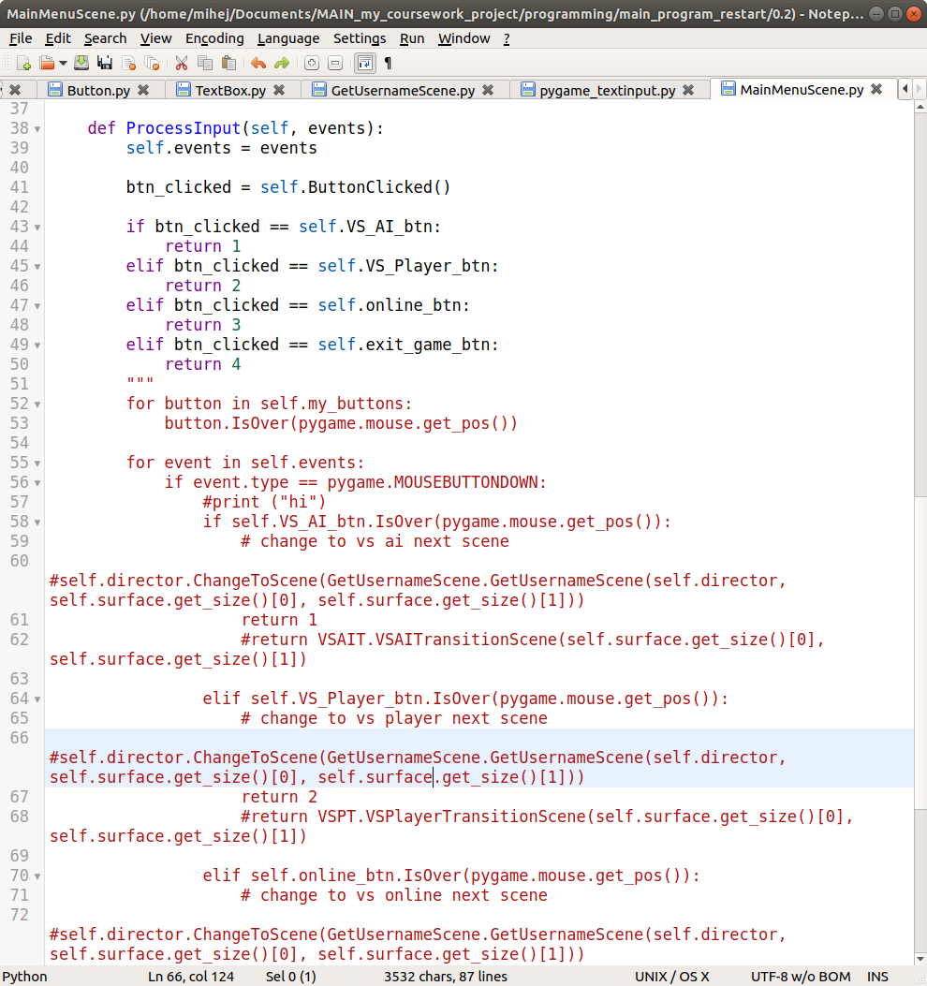

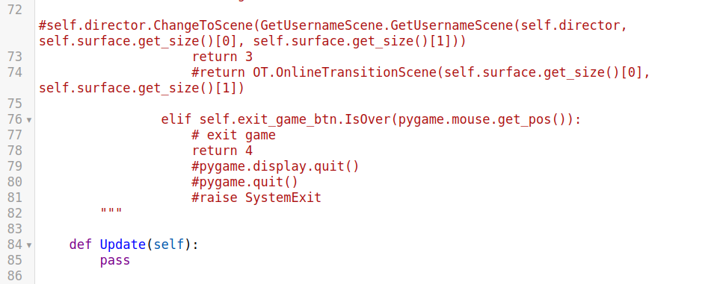

Probably the most attention-grabbing part of this class is the big red commented out section. That part is all what was before I implemented the ButtonClicked() method of the Scene class, and has now been improved by being compressed. Instead of having all of the code written out in one place, I have split it up into multiple different methods, making it easier to maintain.

The other new addition is the "Words With Friends" text, which I used the previously mentioned class for.

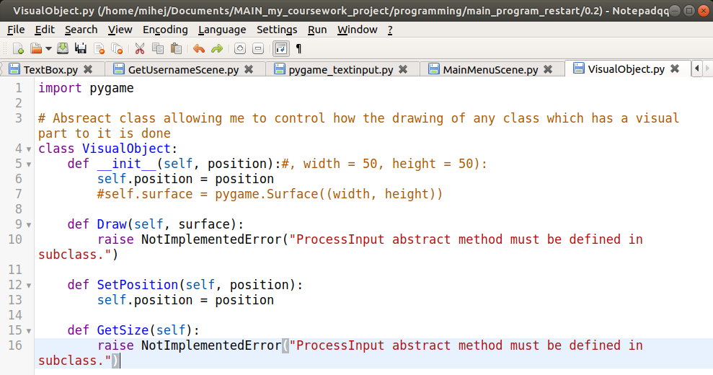

The changes to this class are that now every visual object knows its position. I plan on adding a getter for it alongside the already implemented setter. This allows me to easily move a visual object from one place to another (as the draw method draws it at the current position).

GetSize() is an abstract method as different visual objects could have differently defined sizes (for example a hexagon compared to a rectangle).

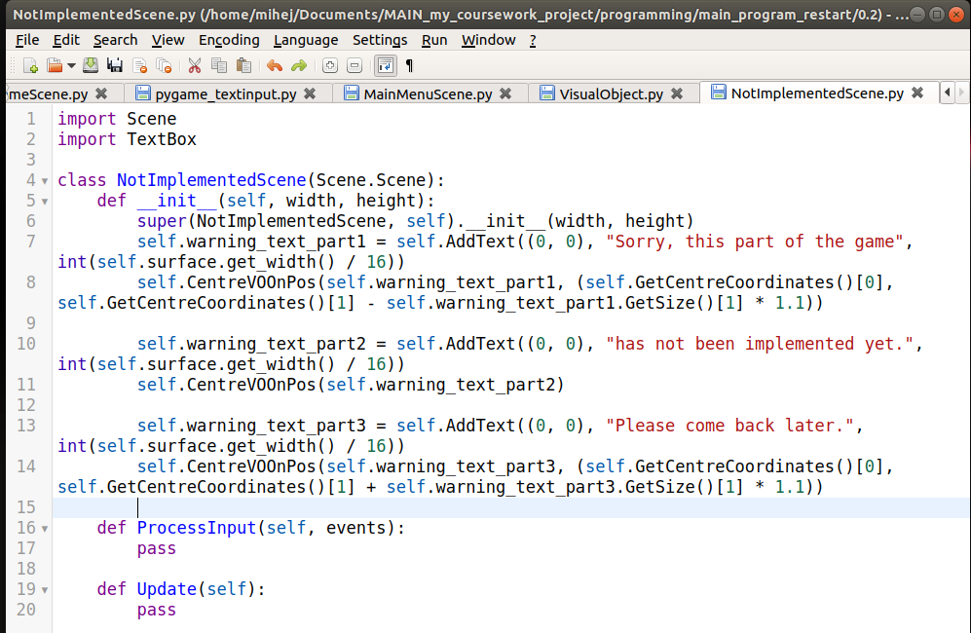

When I was going through the changes of the Director class, I mentioned the NotImplementedProcedure() method. This is the scene that the user is taken to when that procedure is triggered. It just makes the game more user friendly, as the user doesn’t have to see and error message; they instead see well-formatted visual output for their action.

All it contains is some text informing the user of what has happened.

The rest of the classes I will mention here are unfinished, but have been moved to their own file, and have therefore technically been changed, which is why I will cover them:

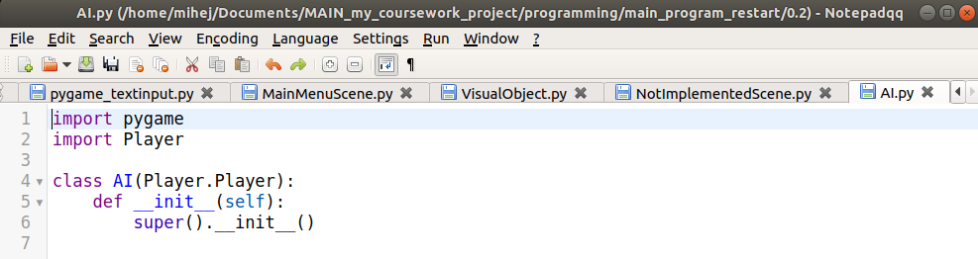

This is the class which will act as the AI if the player wants to play against an AI, and not another physical player.

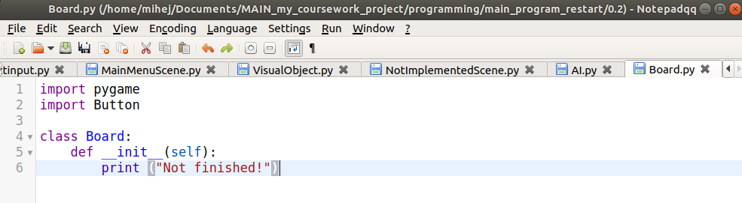

This is the class which will be the holder of all LetterTiles/BoardTiles required in a game of scrabble. It will probably be the graphical representation of it, if I do decide to use this as a class.

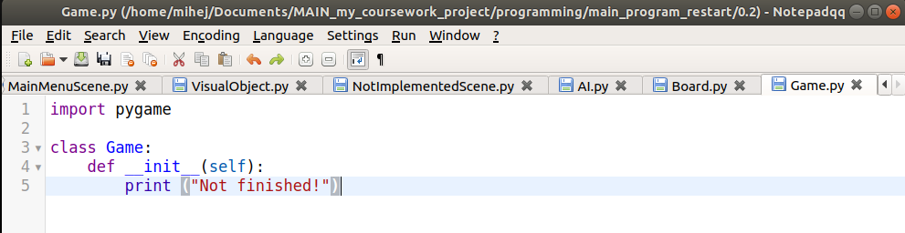

This is going to be the logical aspect of the game (the game when two people are actually playing scrabble, and there is a board, a rack etc.).

Also on a side note, the importing of things has not been finalised, so there might be some things which I am importing that I don’t use.

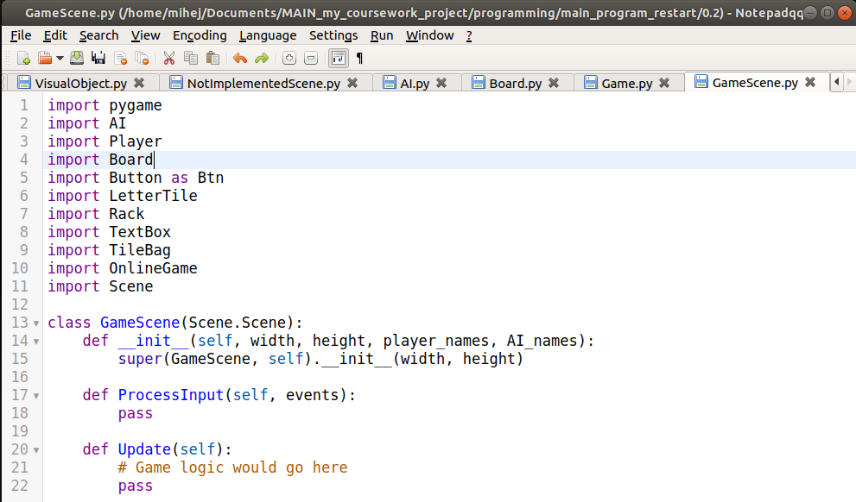

This is going to be the scene which shows the user the game they are playing. It is going to act as an interface between the logical representation of a Game object and the visual one.

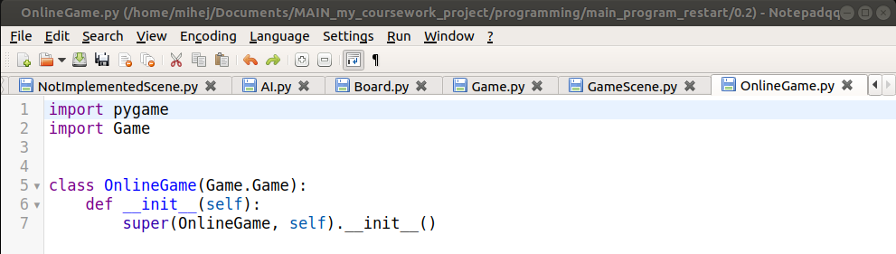

This might be (‘might’ because I haven’t researched/planned how I can make an online game yet, as this is not the main feature of my program) required for my online play feature if I do decide to go through with it. It will act as the interface for the players to be able to play over a network.

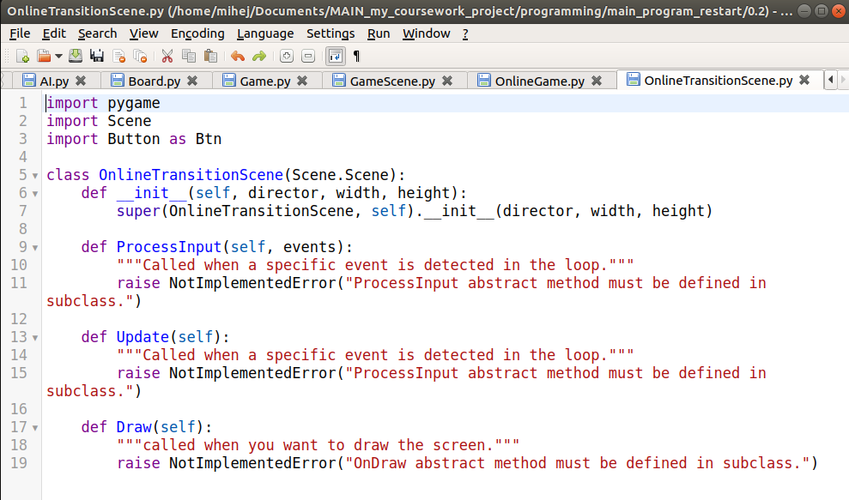

similar consideration as above, but this would be the scene which gets the usernames of the two players and somehow connects them (and times out if it can’t)

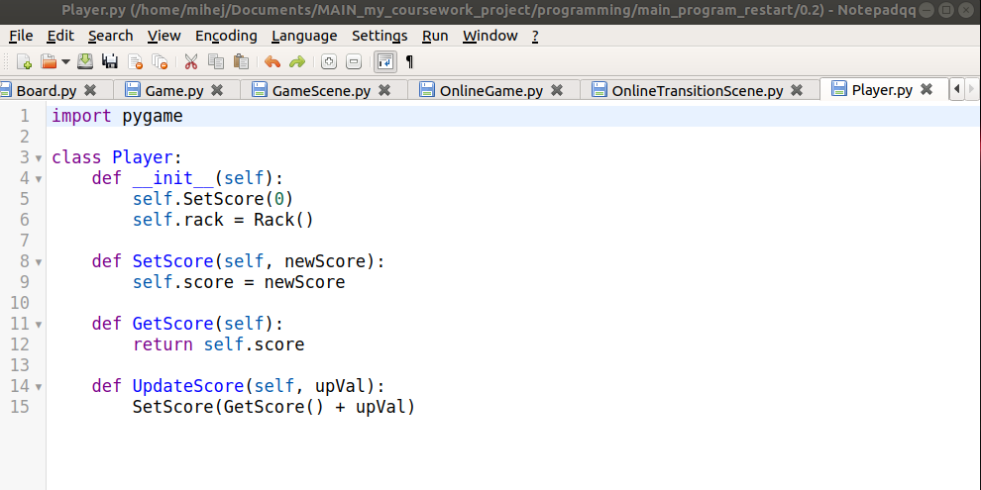

This is the class which will store all of the things which a player might remember in an actual game of scrabble (this includes things such as their score, their letters, etc.).

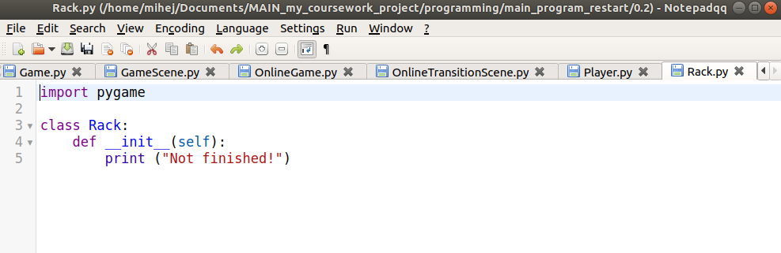

This will be used similarly to how the board class would be used.

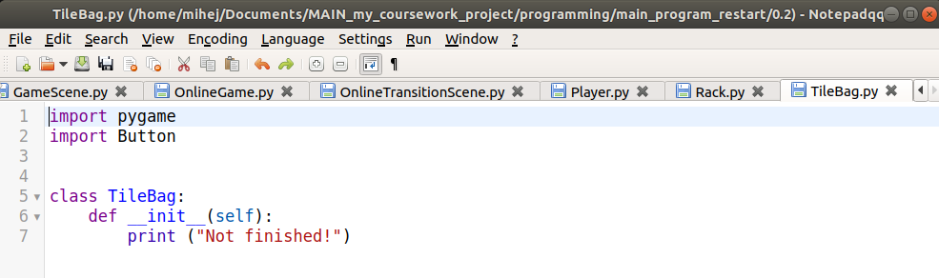

This class will help with the dealing out of letter tiles, the showing of which tiles are left in the bag to the two players (by presenting lists, which will have to be different, due to the bag only showing which other letters are left other than the ones you are holding and the ones on the board, which includes your opponent’s letters).

Now onto a run-through of what the game looks like currently:

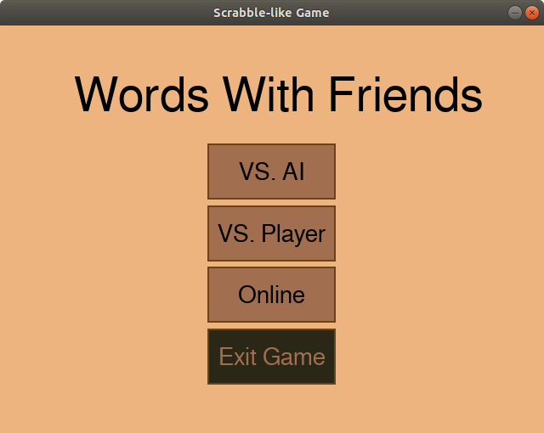

This is the main menu. If I hover over a button, it becomes darker:

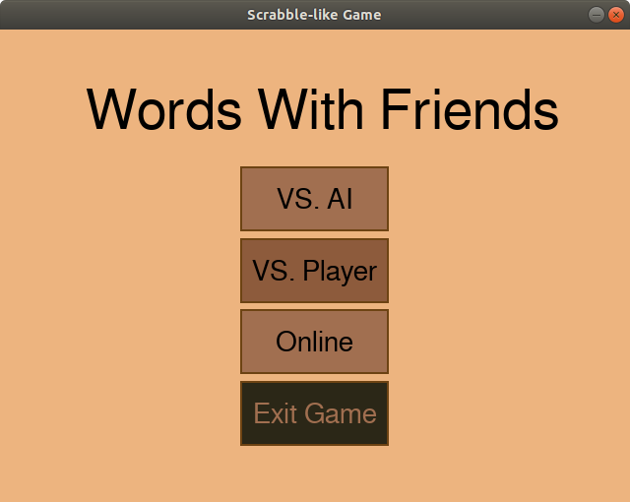

(notice the second button being darker)

When I press the “VS. Player” button, the scene changes, and I am put onto a scene which asks me to enter my nickname, and restricts it from being longer than 12 characters (if it attempt to enter more characters, nothing happens):

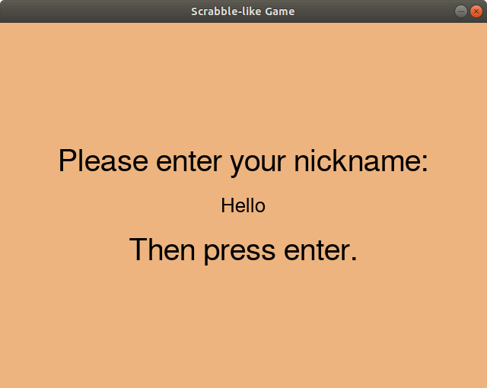

(the text which says ‘hello’ in the user entered text. This is where I have done validation, as this text cannot be longer than 12 characters long, which I did because if there was no limit, it might overlap with other parts of the game and look bad.)

Once I press enter as I am prompted, the screen changes once again, to another one of the same scene:

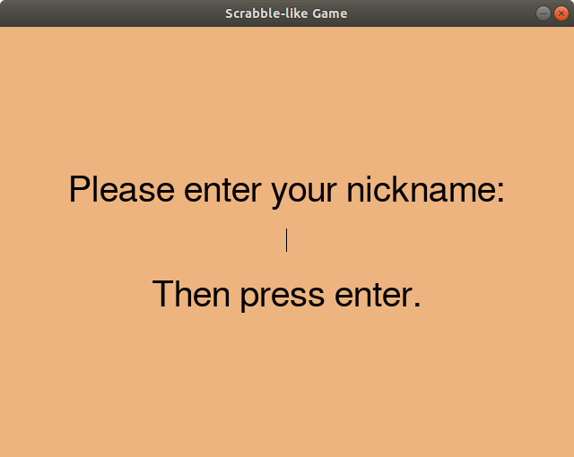

Here once I press enter, I am met with

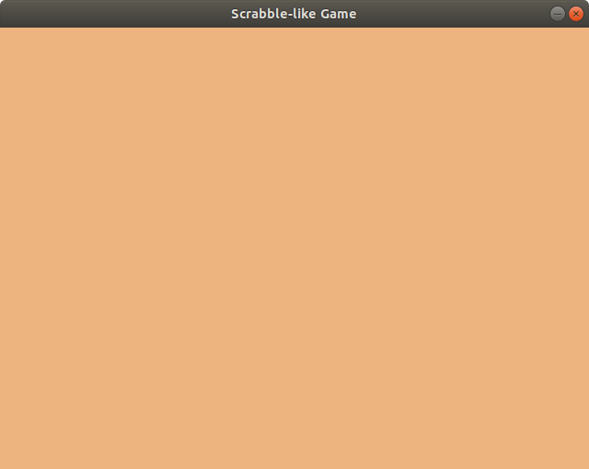

This is the current state of the GameScene() class, and is working as intended. I am now going to restart the program to show the other options.

Pressing the ‘Exit Game’ button exits this time, with not errors: (I have removed the print colour line in my button class for this; that was just a debugging step)

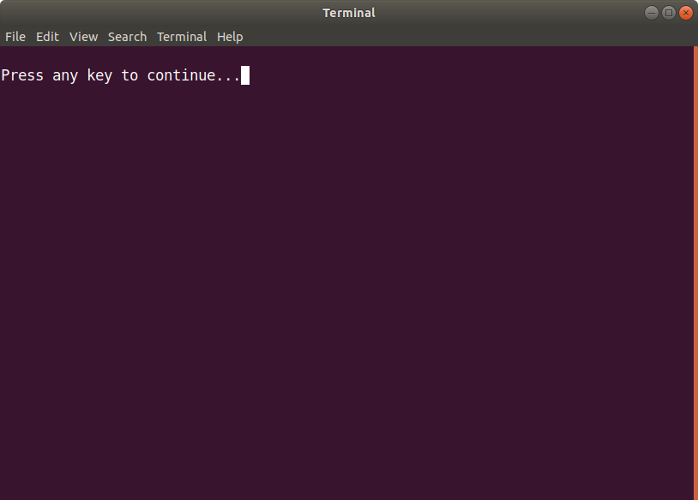

(this screenshot is of the console after the button has been pressed)

When I press the ‘VS. AI’ or ‘Online’ buttons, I get the following:

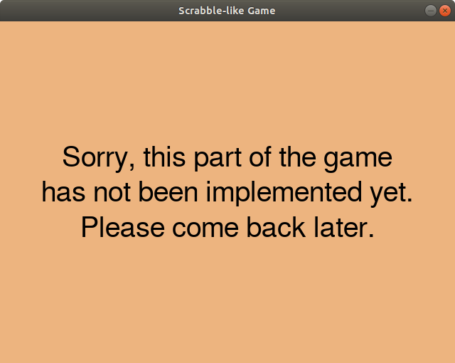

After which the game exits without any errors.

**Testing**

|  |  |  |  |  |  |
| --- | --- | --- | --- | --- | --- |
| **Test**  **Num** | **Type** | **Data** | **Expected result** | **Actual result** | **Comments/solution** |
| 2 | Valid | The VS AI button on main menu is clicked | The current scene changes to the next scene where the user is allowed to enter their nickname | I am redirected to a scene telling me that this has not been implemented yet | I still need to implement the VS AI transition scene and then the scene with the actual game on it. This requires me to make a new subclass of scene, similar to how I have done for my MainMenuScene.​ The reason I make new subclasses is because this is how I’ve decided that my code architecture is going to work, and how I’m going to transition in between scenes. The alternative would be to have only one scene class, and a parent button class, from which every button would inherit its attributes, and would need to have its ‘OnCLick’ method edited. But because there are more buttons than scenes, this is less convenient. |
| 3 | Valid | The vs player button on main menu is clicked | The current scene changes to the next scene where the user is allowed to enter their nickname | Working as intended. | N/A |
| 4 | Valid | The online button on main menu is clicked | The current scene changes to the next scene where the user is allowed to enter their nickname | I am redirected to a scene telling me that this has not been implemented yet | I still need to implement the online transition scene and then the scene with the actual game on it. This requires me to make a new subclass of scene, similar to how I have done for my MainMenuScene. The reason I make new subclasses is because this is how I’ve decided that my code architecture is going to work, and how I’m going to transition in between scenes. The alternative would be to have only one scene class, and a parent button class, from which every button would inherit its attributes, and would need to have its ‘OnCLick’ method edited. But because there are more buttons than scenes, this is less convenient. |
| 5 | Valid | The exit game button is clicked | The game exits | Working as intended. | N/A |
| 6 | Valid | The ‘x’ button in the top right corner of the game windows is clicked | The game exits | Working as intended. | N/A |
| 8 | Valid | Make sure that the user’s nickname is correctly stored | When the user enters their valid nickname on the scene after main menu, it is correctly recorded in the string variable, and not truncated or with extra characters | Working as intended | N/A |
| 9 | Invalid Boundary | The user enters a nickname which doesn’t fit in the nickname field | Once the character limit is reached, no more characters are recorded in the string variable responsible for storing their nickname, and no more letters are shown on the screen | Working as intended | N/A |
| 10 | Valid | What happens when the user presses backspace when entering their username | When the user is entering their nickname, they should be allowed to use backspace to delete the last character in their entered nickname | Working as intended | N/A |
| 11 | Valid | Clicking the next button on the nickname entry scene | When clicked, the scene should change to the next scene (which in the case of VS AI is the game scene, in the case of vs player is the next player’s nickname entry scene, and in the case of online is a waiting screen) | Instead of a next button, I decided to just ask the user to press the enter key. Otherwise, working as intended. | N/A |

## Prototype Iteration 1

In the current stage of my program, there isn't really much a regular user could make use of, because they can't actually' play a game. However, I still went ahead with asking for feedback on the menu system, as many games make use a menu system, and almost every person has met one, meaning they can evaluate it at least to some degree as a standalone feature.

As my requirements don't have anything specific to a main menu. I just went off of what the users said.

The feedback I received was the following:

- When a button is pressed, it might look better to change its colour to something even darker, to tell the user that they aren't just hovering over the button, but that they have also clicked the button. As this is more of a visual feature of my game, it is not high up on my priorities, so if I have time, I will implement it.

- The buttons might look better if they have rounded corners. As pygame, to my knowledge, doesn't allow for drawing rounded corner rectangles, the only way to achieve this would be by having an image for each button, which I would have to create myself. The pay-off on investment in this is very low, and so it is also very low down on my list of priorities to implement.

- The last main feature that my user would like to see is that if a part of the game is not implemented, instead of exiting after the ‘not implemented screen’, the game is still open. This is high up on my list of priorities, as even just for testing, it gets annoying to have to re-open the game each time I purposely click a button which would lead me to an unimplemented case, or do it accidentally. After all, if a real game has a feature which is not implemented yet, it wouldn't just close down after telling you that that part is not implemented.

In conclusion, my users would like to see the main menu look better graphically, and make sure it doesn’t close the program on something that can be handled. Although all of these are doable, the graphics would take too long and the pay-off would be too low for it, so unless more users later on mention that they would like these features, they are unlikely to be implemented. The last point about the game not exiting on a stage that has not been implemented is definitely something I would like to work on.

## Implementation Iteration 3 (v 0.3) - Finishing graphics

In this iteration, I have completely finished and polished the graphical aspect of my game. This means that on the surface, my game looks complete, and if someone was not paying much attention to someone interacting with the game, they might say it is finished. I have completed the GameScene class which contains all of the elements a user is going to be interacting with when they are actually playing the game (this involves buttons the board, their rack etc.). The reason I did this is so that the user can have a good experience in playing the game, and instead of doing everything via a console, they can do it with a GUI. It also allows me to now focus on just the logic of the game without having to worry at all about how it is going to affect the looks of the game, as I have completely separated the logical and visual part of my game.

Validation will be shown in appropriate places as before.

Firstly, let’s start from the top: the Director received a minor change, where instead of checking if a certain selection has been made to trigger the ‘NotImplementedScene’ (see line 55 in previous iteration of Director), whenever an error "Section of game not implemented yet" is raised, the ‘NotImplementedScene’ event is triggered. Also, as pygame implements its own wait procedure, I no longer require the time module, and have changed that one line to reflect this realisation.

Here is the part of Director which was changed:

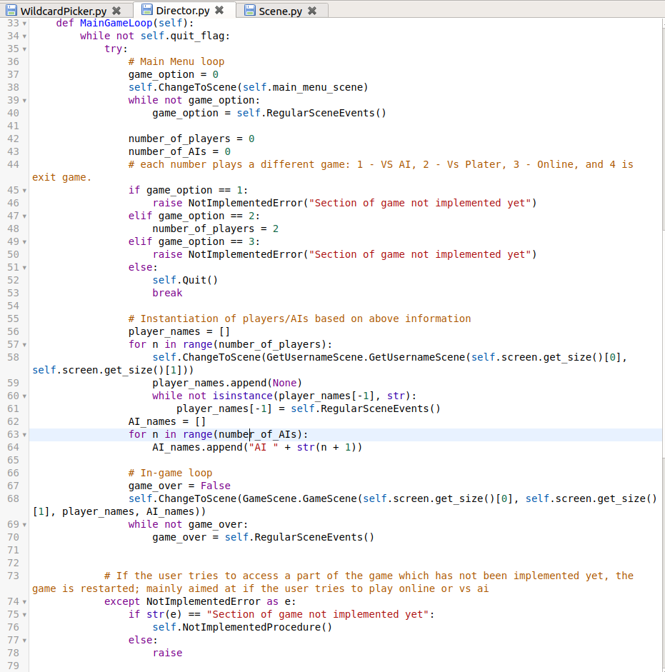Notice the try: except: . This is what allows me to do it this way. Also, in the previous iteration on line 70, instead of iterating through the AIs, I was iterating through the players. I also changed this.

Next, I fully implemented the GameScene class. This just like all of the other scenes inherits from the Scene class, but is a special class as it allows the user to play the game.

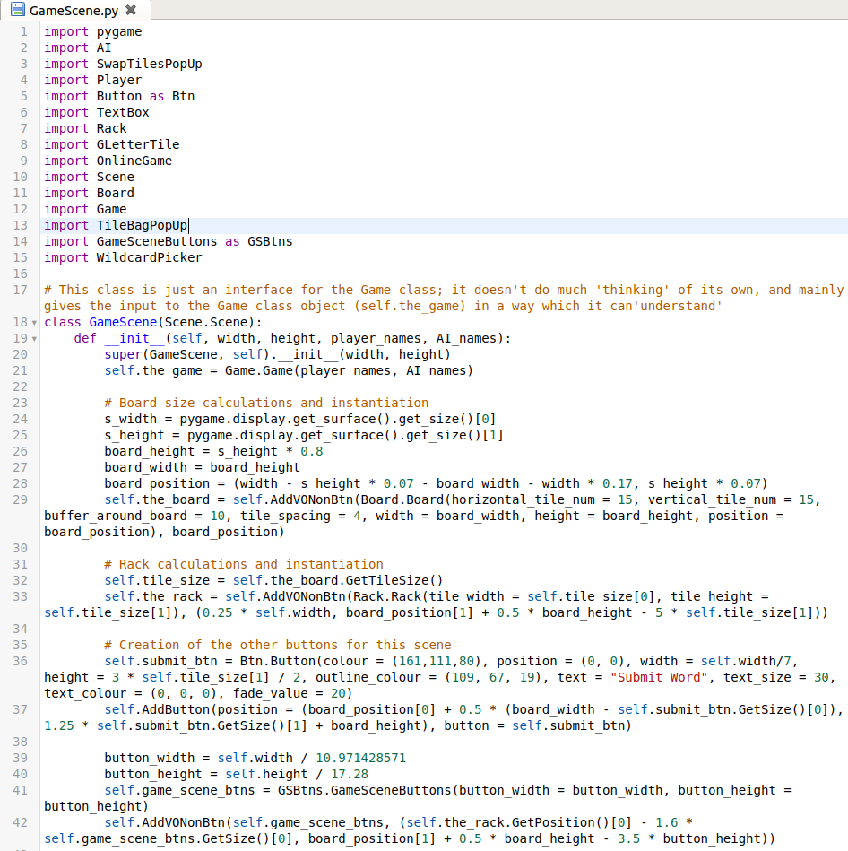

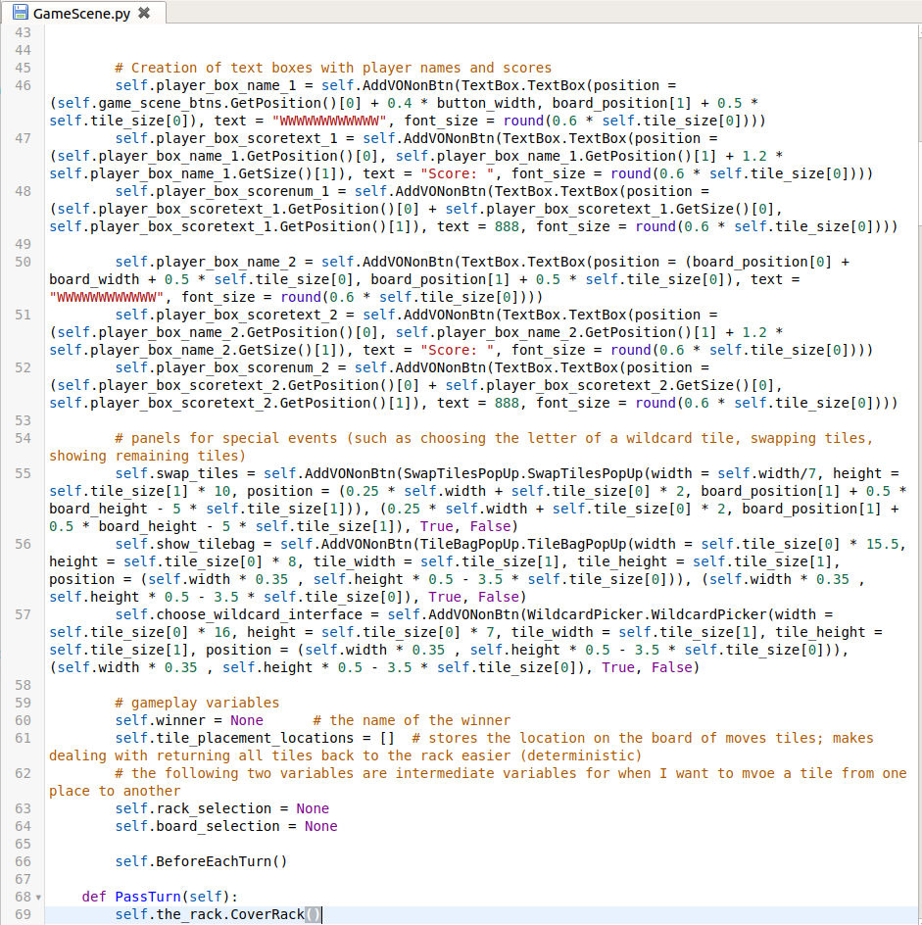

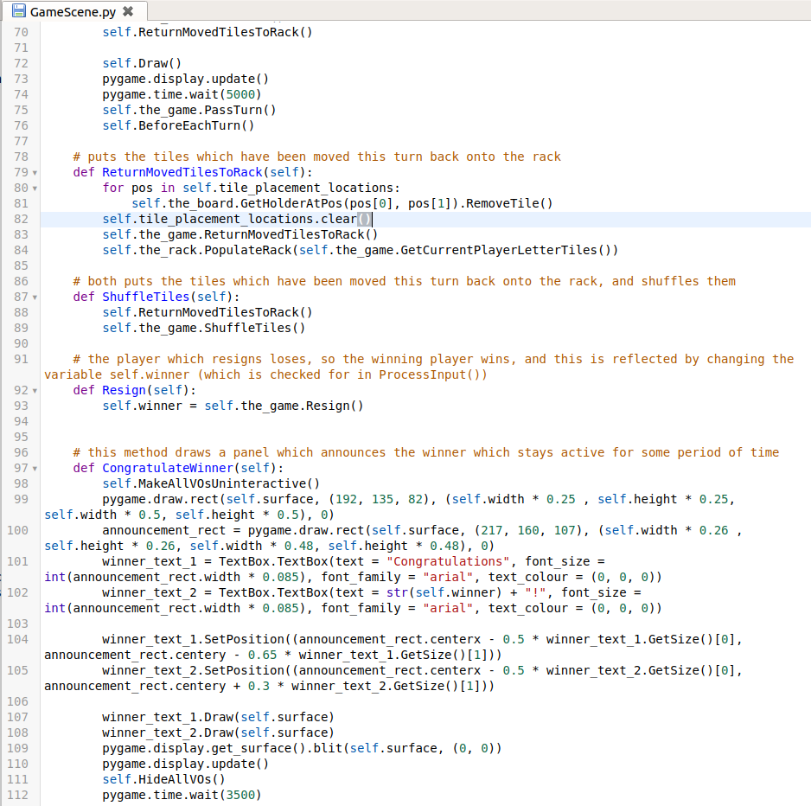

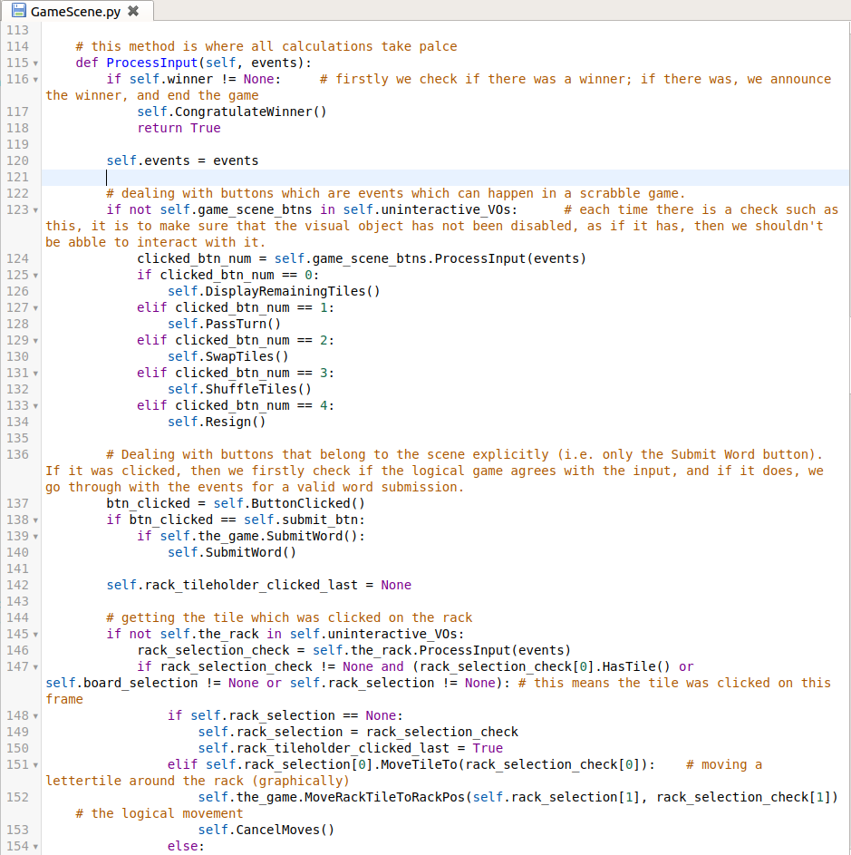

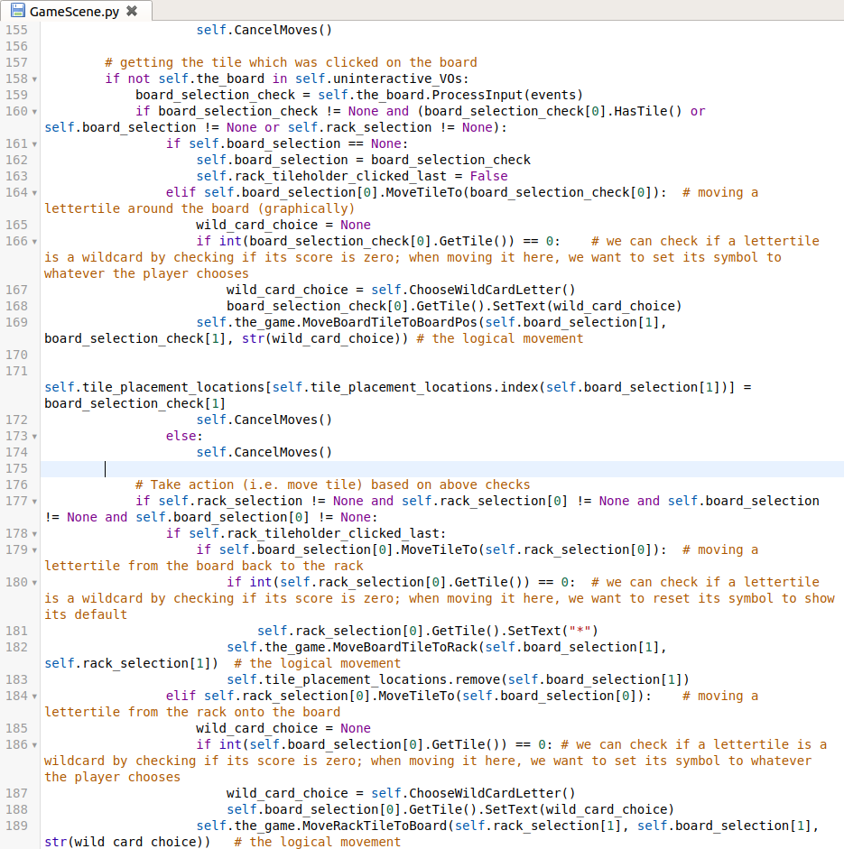

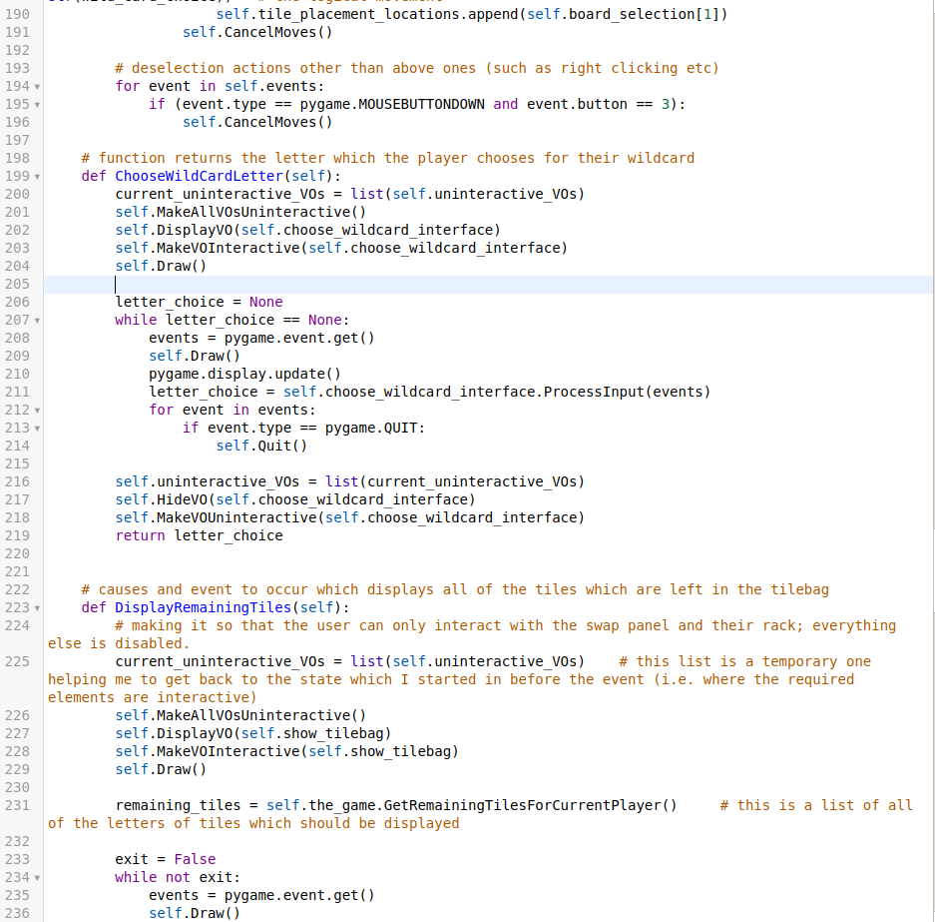

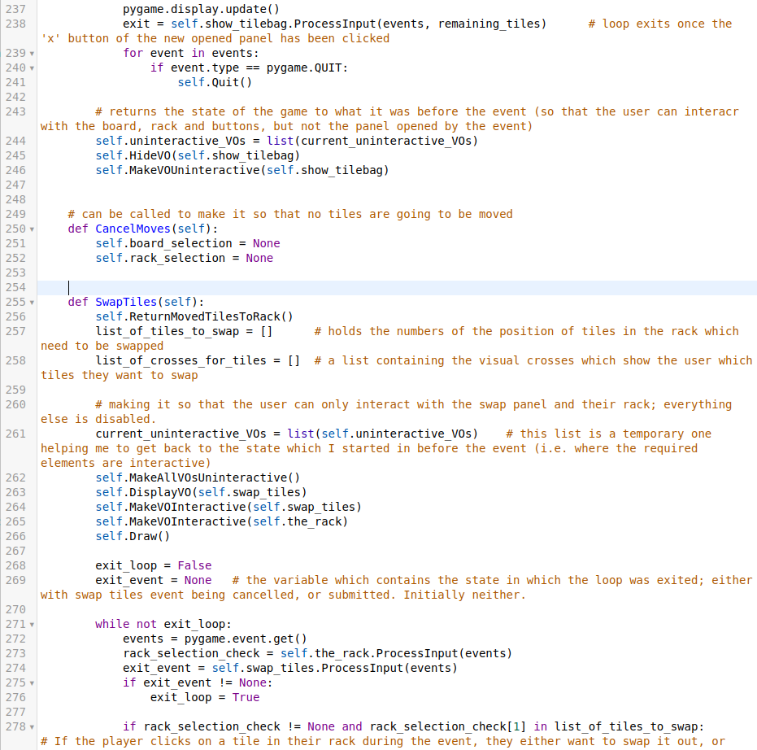

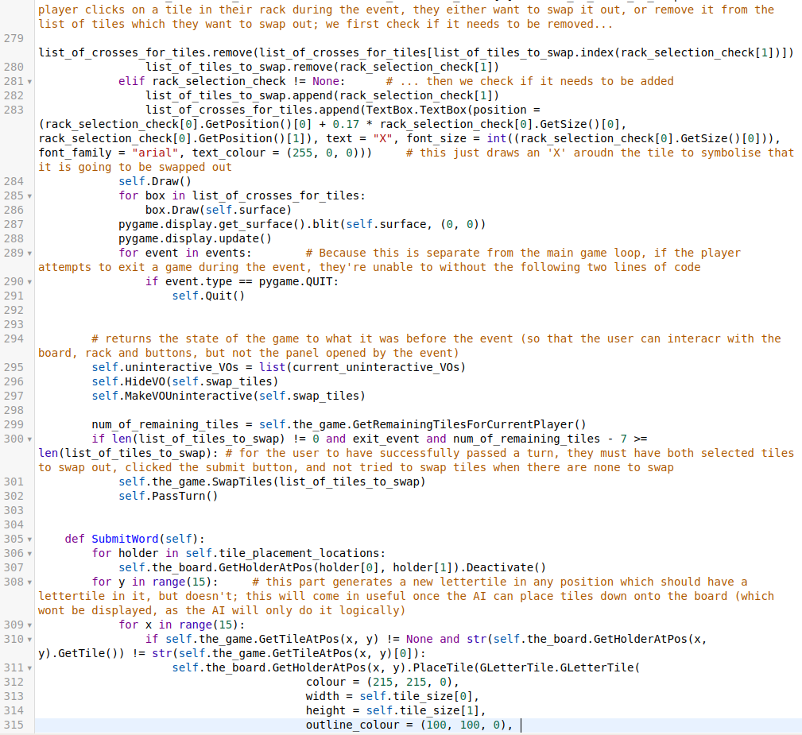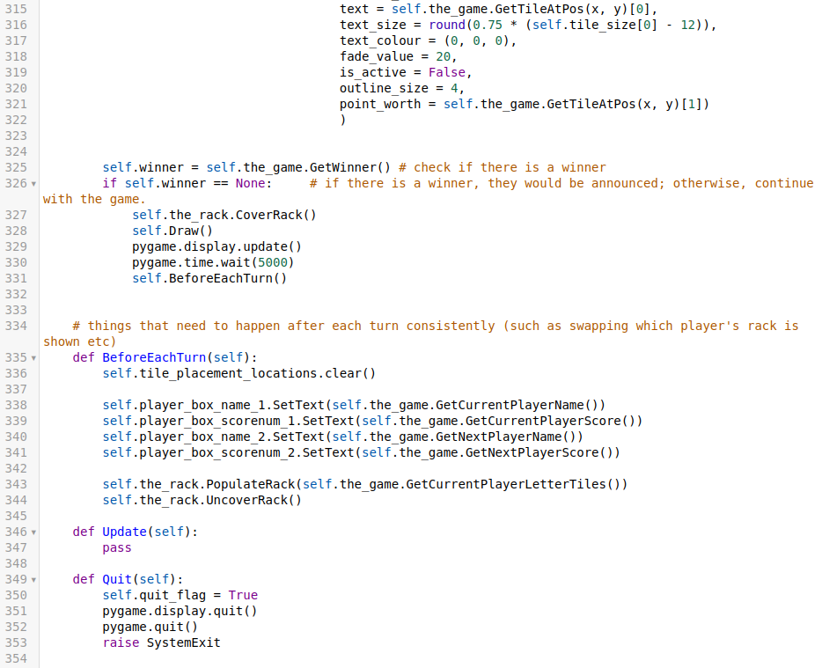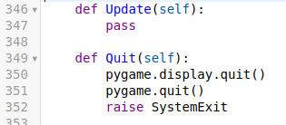

In GameScene is where I have done some validation.  
The user should not be able to place a tile down in a location which is not on the board (or their rack). To achieve this, I have made it so that when they click on a tile and then anywhere else other than a TileHolder in their rack or the board, nothing happens.

The user also cannot interact with tiles using any mouse button other than the left click, but they can cancel a selected tile by right clicking, and only right clicking.

When the user is in an event (such as choosing the letter for their wildcard tile, opening the TileBag to see the remaining tiles, or swapping tiles) they cannot interact with the board/button panel or move tiles from their rack anywhere. These will be clearer once I can demonstrate my game being played.

If the user attempts to click submit on the swapping tiles event but has not selected any tiles to swap, nothing happens.

If the user attempts to put a tile in a location on the board which already contains a lettertile, they are unable to.

I have yet however to implement validation checking for words. This is likely to come later on in my iterations, as it requires checking of validity of words, which is most easily done with GADDAG. It will also be handled through the Game class, so this class is finished with respect to that.

To successfully implement the GameScene class, I required a board. I decided that the easiest way to add a board to my game was to make a class for it which can handle itself and events (such as being clicked on similarly to how a scene might).

The board class is only a visual representation of the logical background. Similarly to the GameScene, it doesn’t actually do much calculations or have much logic by itself; that will be handled by output from the Game class.

This is it:

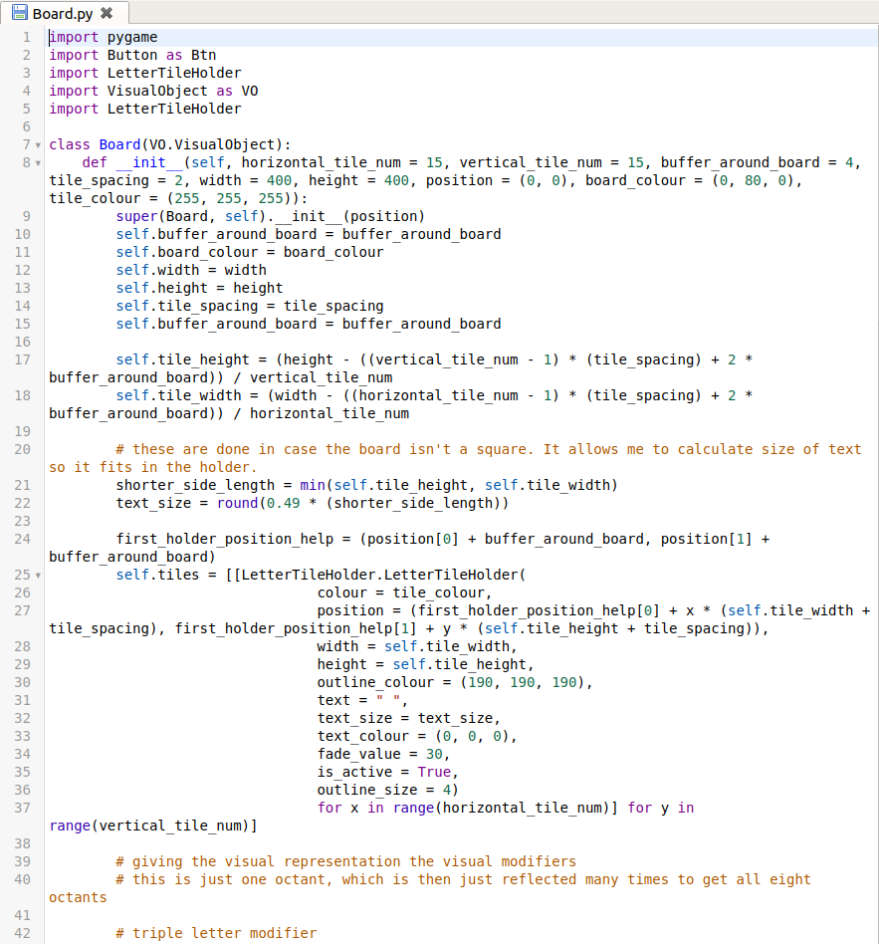

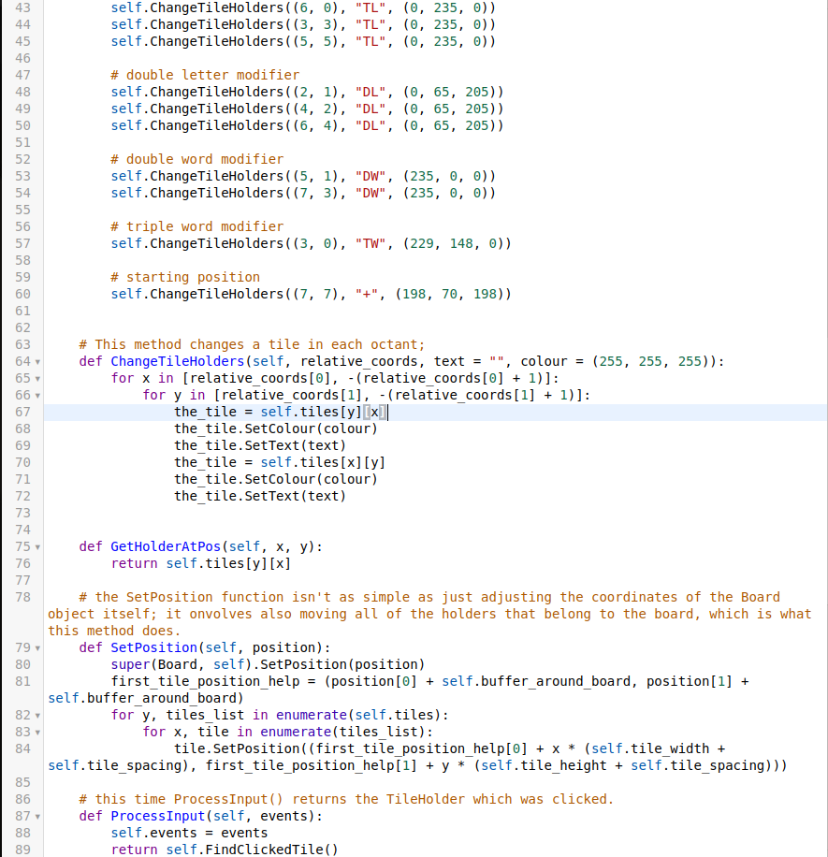

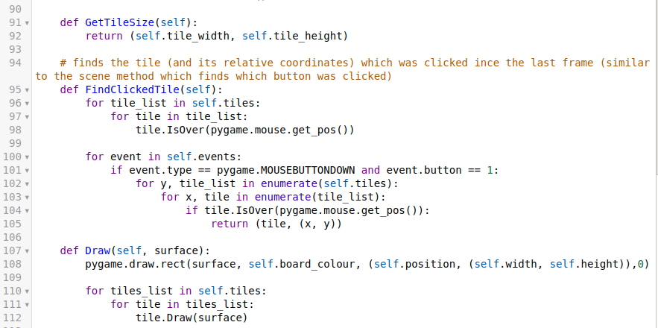

As you might notice, I have also decided that TileBag doesn’t deserve its own class, as python can make use of dictionaries.

Next, I added and changed a few minor things in my button class to make it easier to use:



This changes the text displayed on the button. This becomes useful once we get to the tiles – instead of having to instantiate completely new tile objects each turn, I can save some memory and processing time by only changing the text of each time. My method makes that possible. If we were to instantiate a new tile object each time (instead of just changing the text in the tile), it would take more time and memory, which is just inefficient use of resources.

Similarly, this also required me to add a setter for text in my TextBox class:

where self.text is just what the textbox is displaying.

Another minor change to Button is my alteration of the Draw method, so that the outline’s size is the size of the button, instead of it being treated as a surrounding part, which allows a button to be larger than the values passed for width and height of the button:

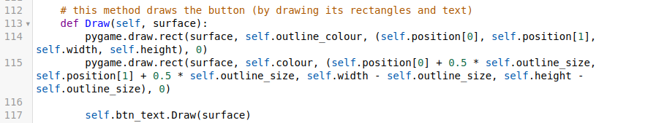

Also, instead of checking for whether text was passed in, if no text was passed in, a TextBox object is still created by button, but it just contains the default argument (“”). This allows me to change it later on if required, instead of having it be a None type, in which case trying to call string methods on it would cause a crash:

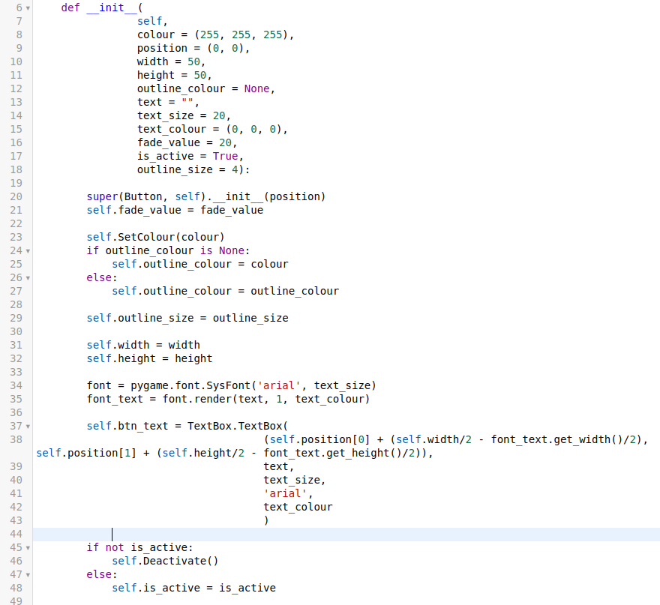

This is why the Draw() method now always draws the text.

As you might have noticed, the last four lines of the constructor also hint at new methods: the Activate() and Deactivate() methods. In my previous iteration, I realised that if the button was initialised as being deactivated, then its colour wouldn’t reflect this. That is why there are the extra four lines in the constructor. The methods themselves just make it so that the button no longer works if it is deactivated, and there is also a colour change to reflect that the button is active or has been deactivated, and is also much easier to control using them:

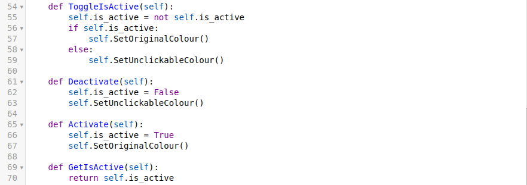

And the checking is still done in the IsOver() method:

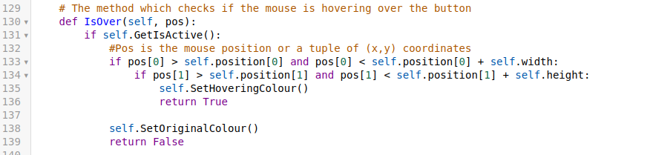

Similarly to the board class, because the button class contains its own visual object (the TextBox), I had to alter its SetPosition() method so that it changes the position of both rectangles and the textbox object inside it:



Because my GameScene class working depends on my Game class at least partly working, I also made progress in my Game class. My game class, apart from checking if a word which has been submitted is valid, is complete.

This is the Game class:

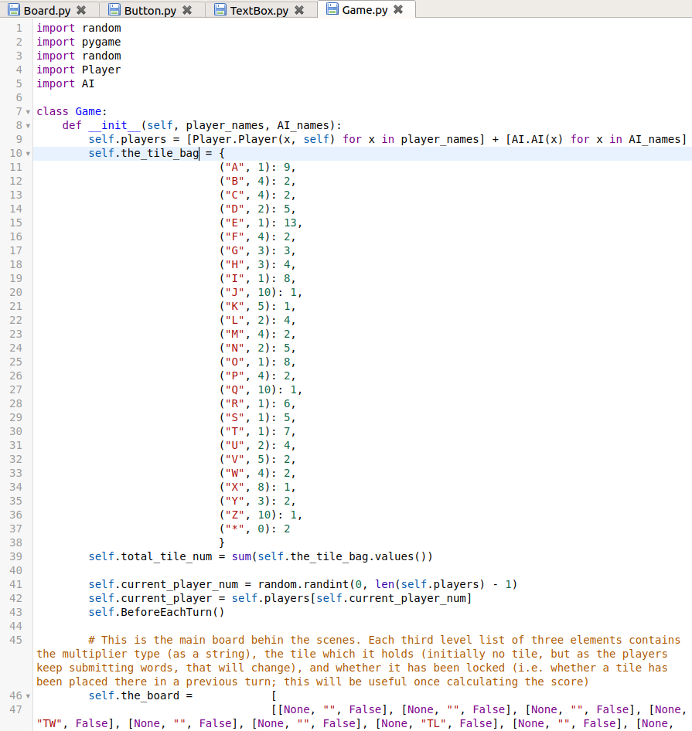

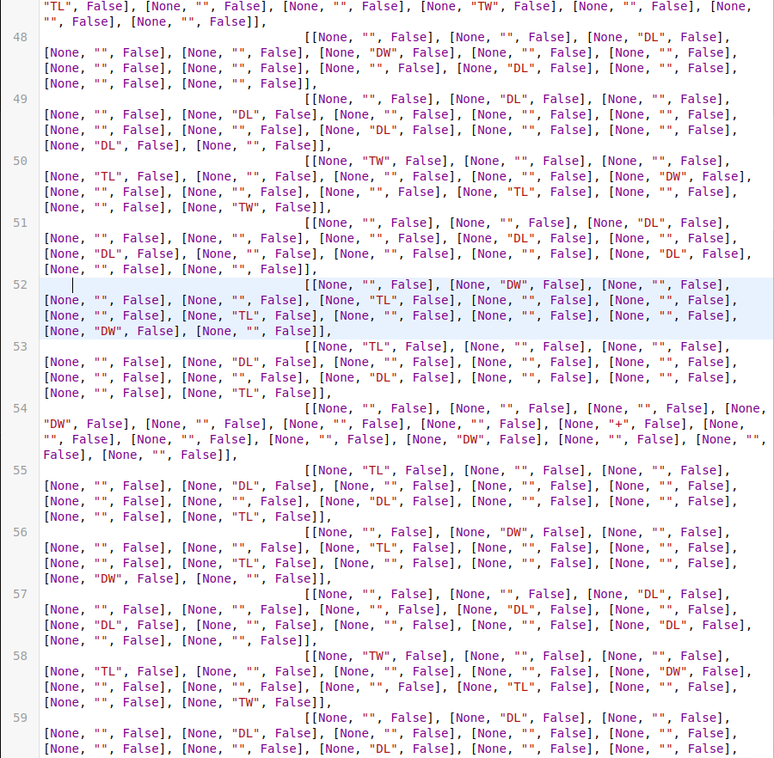

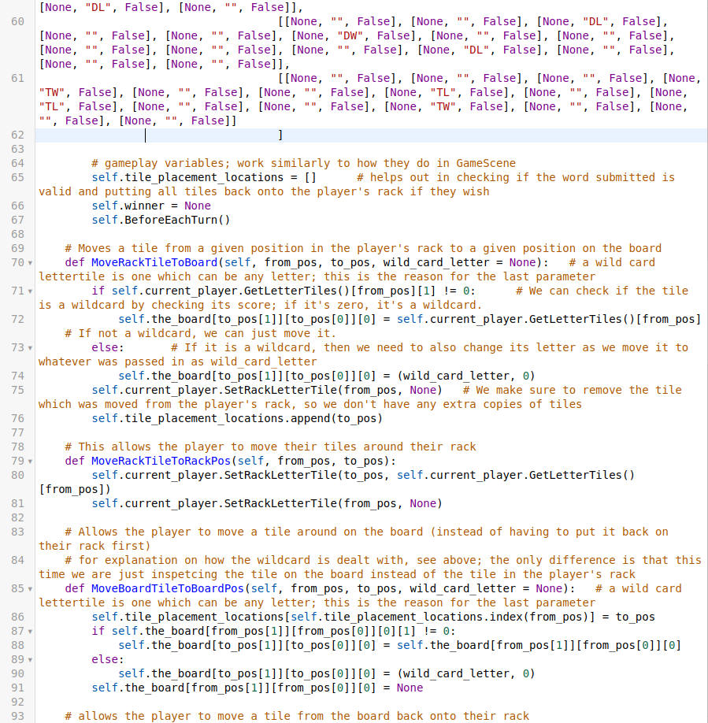

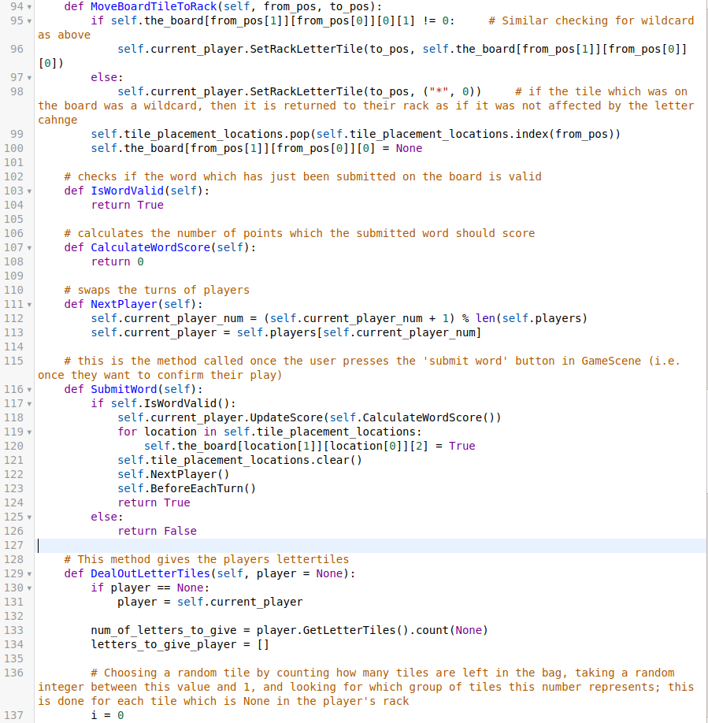

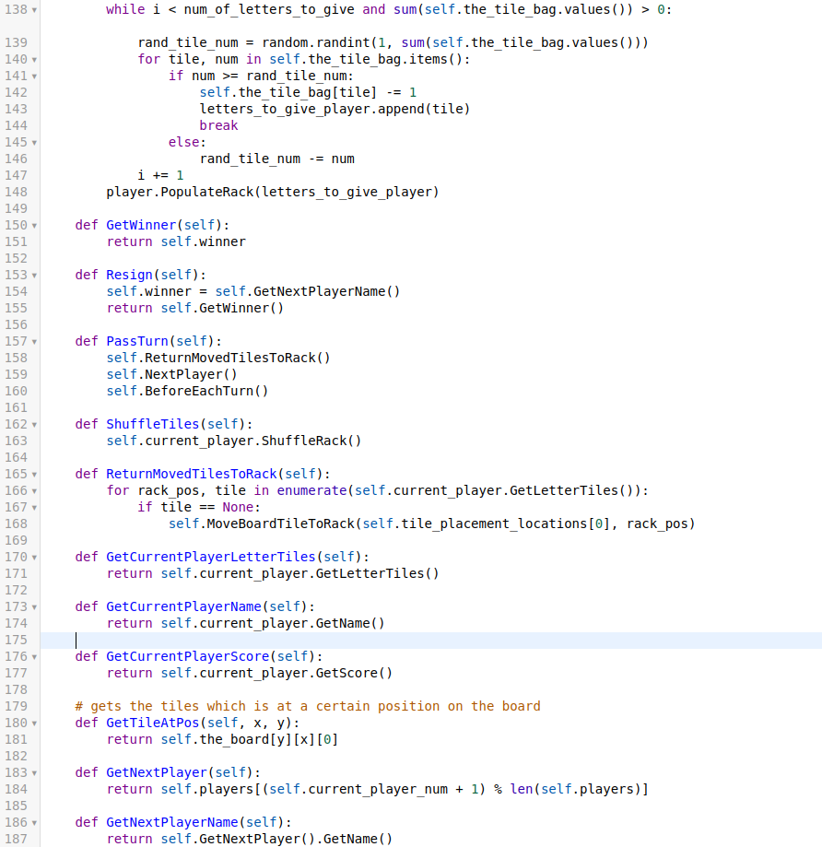

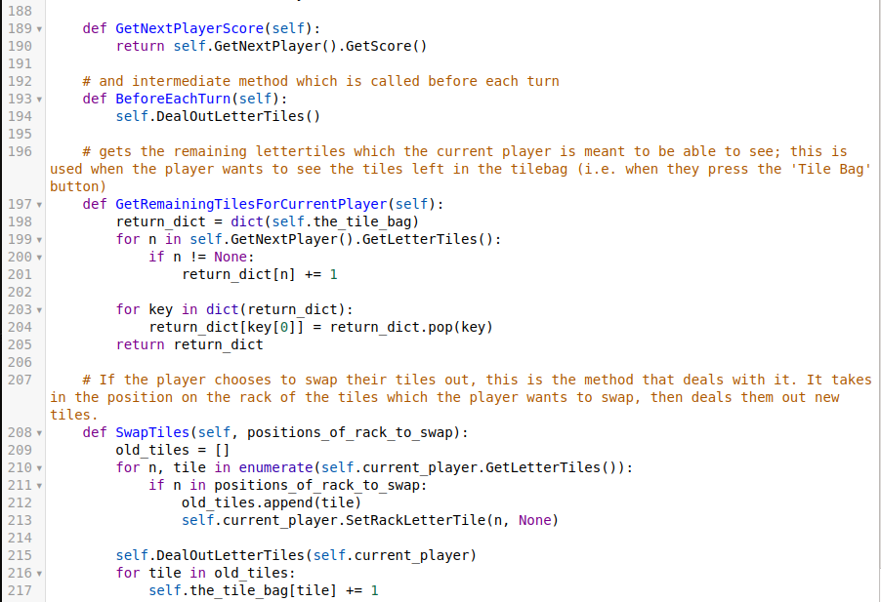

Similarly to the relationship between the Game class and GameScene class, I needed to make the Player class to allow the Game class to function correctly. It stores the names of each player, their scores and their racks. It contains methods to retrieve the required ones:

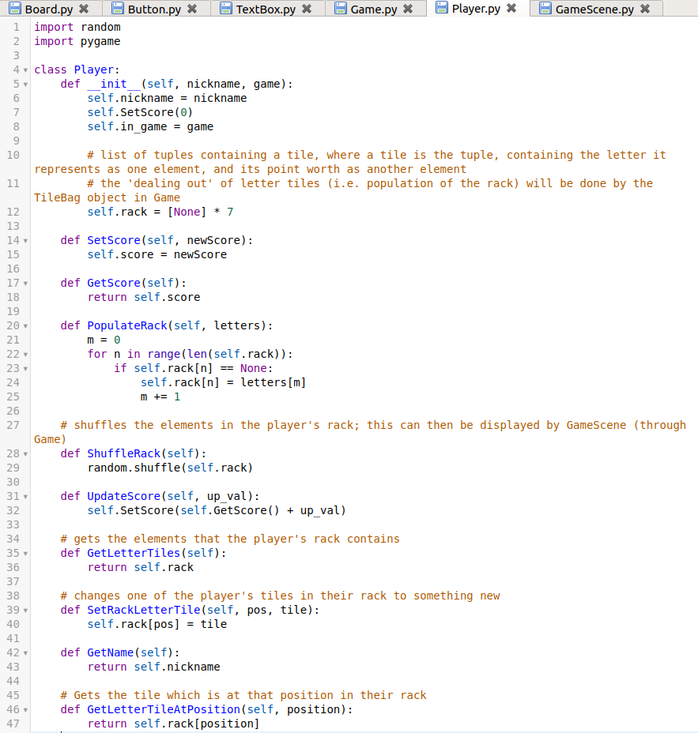

After covering player, we need some way to present the player’s rack; this is where the Rack class comes into play. An instance of it is initialised in GameScene. Its main function is to show the tiles which the player’s whose turn it is has, along with giving output of which tile was clicked in the last frame:

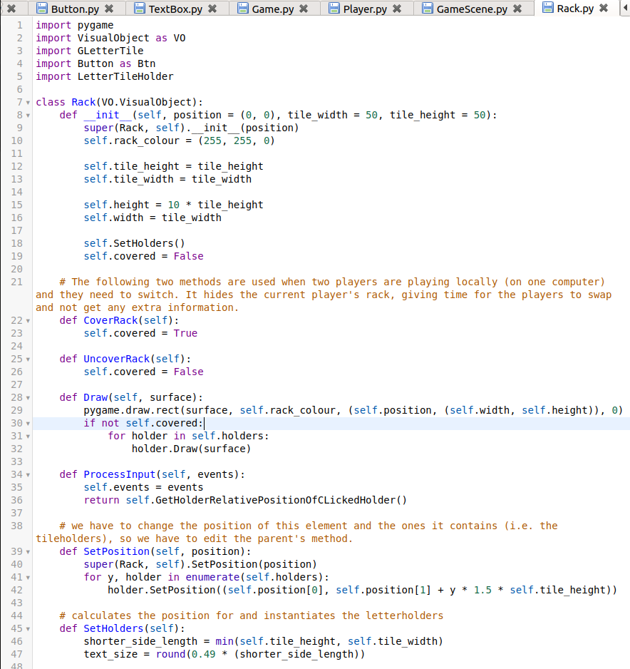

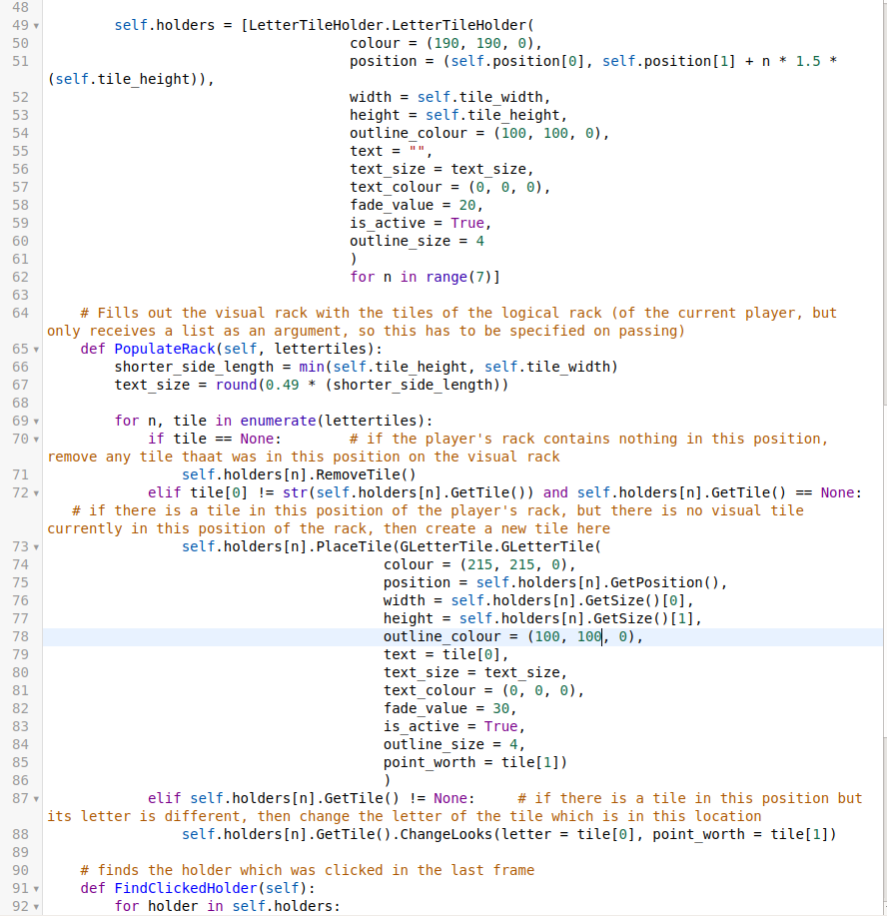

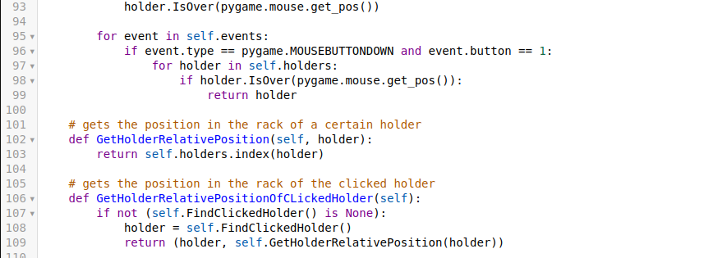

Next I should explain how the logical tiles are represented visually. Each tile is a GLetterTile. This is basically a button with an extra textbox for its score.

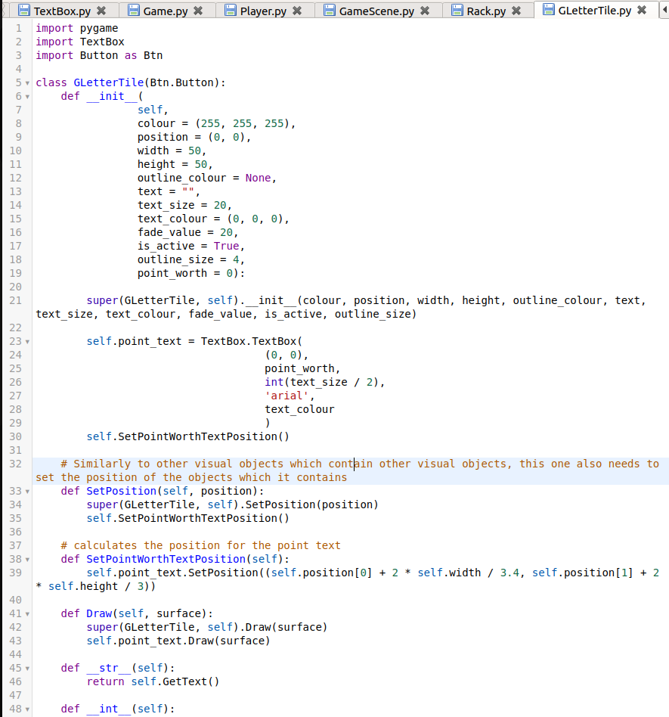

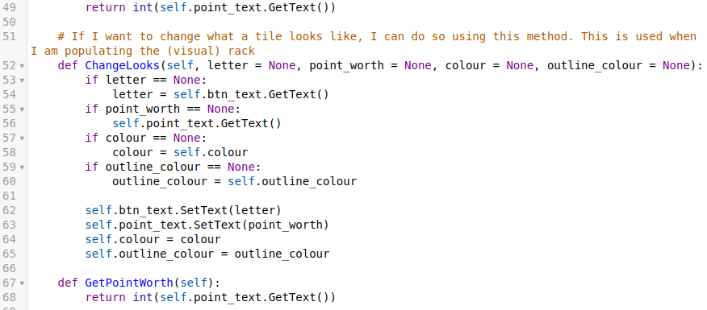

Tiles aren’t directly interacted with, as they need to be seated somewhere (either on the player’s rack, or on the board). To make sure that they can’t be moved around randomly, I have implemented the LetterTileHolder class. This is basically a merging of my two ideas of rack holders and board holders in my planning section:

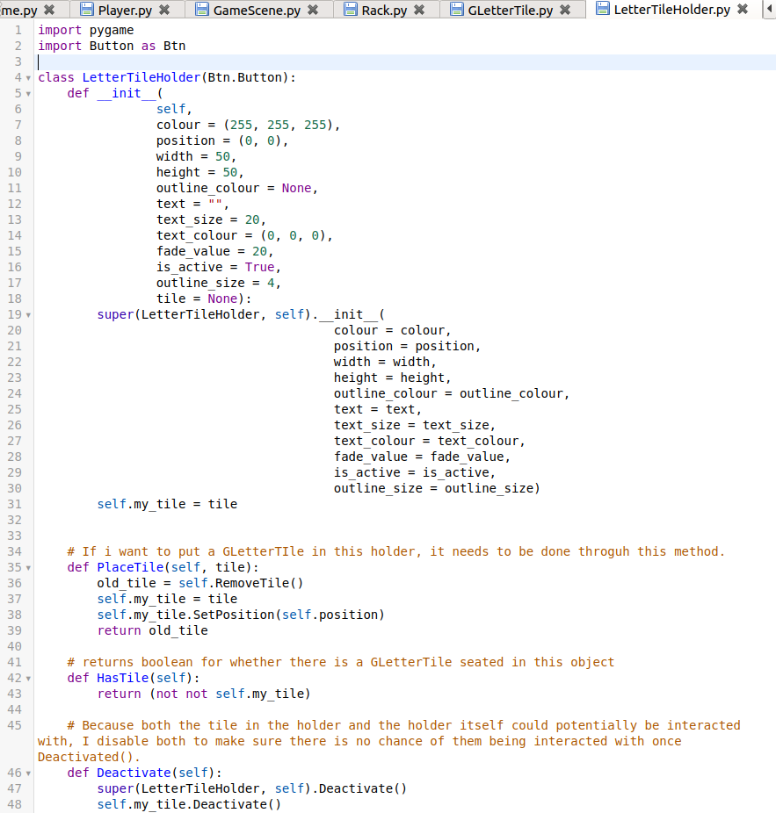

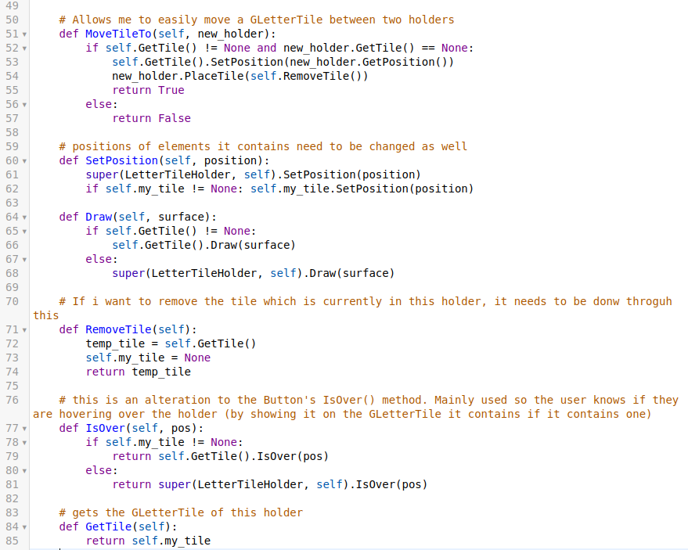

I also made a few changes and added a few more features to the Scene class:

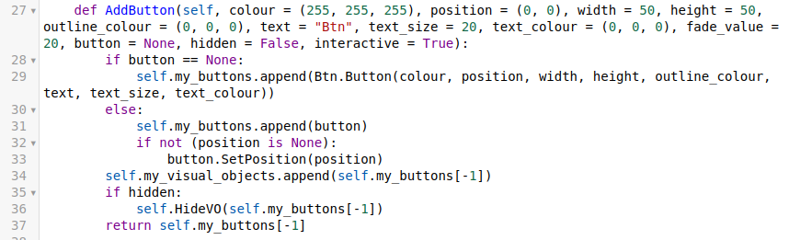

When adding a button, the I have the choice of either giving it an instantiated button object, or the attributes for one.

Both AddButton and AddVONonBtn received two extra parameters: hidden and interactive. When an object is hidden, it is not displayed, but it can still be interacted with (for example if a button was hidden, if I click in the location where the button should be, I would still interact with it, although I wouldn’t be able to see it). A non-interactive object is one which even if it is displayed, you can’t interact with it (i.e. if there are buttons on it, it won’t return any output). \the following methods are the ones which I use to control these:

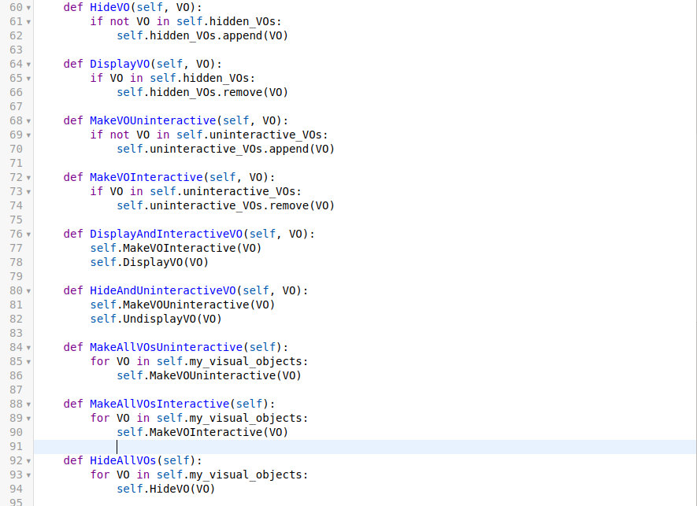

To allow these to work, I also have hidden_VOs and uninteractive_VOs instantiated in the Scene’s constructor.

The following methods have been changed to reflect this change:

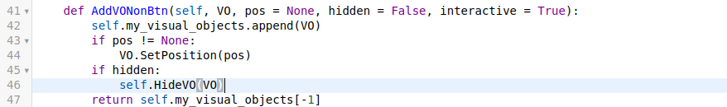

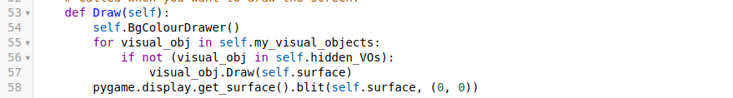

While on the topic of small changes, my TextBox class now knows its own position, just like all of the remaining visual objects which I have (which means it doesn’t require me to pass in the position for draw each time):

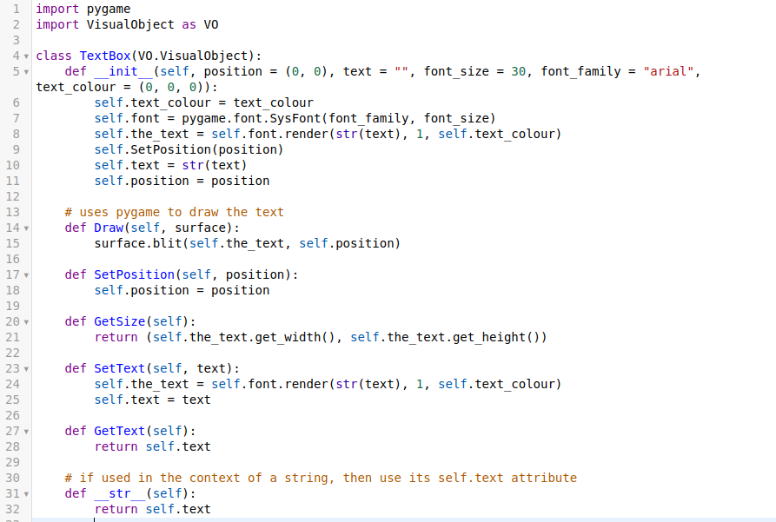

I mentioned the wildcard event earlier on, but didn’t elaborate on the class which handles the panel. This is the WildcardPicker class. Many of the methods it contains are similar to ones which have been explained somewhere in my implementation, so I won’t go into much detail:

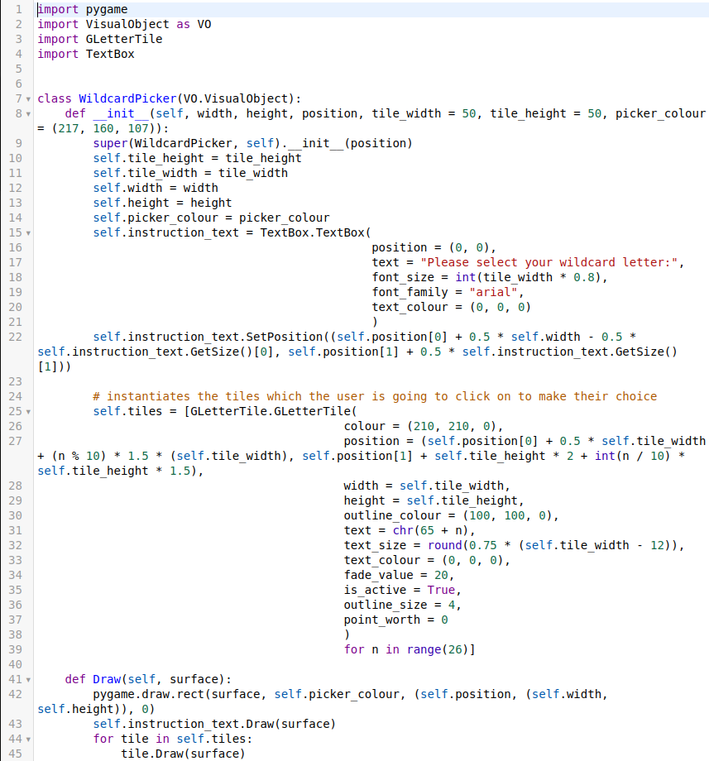

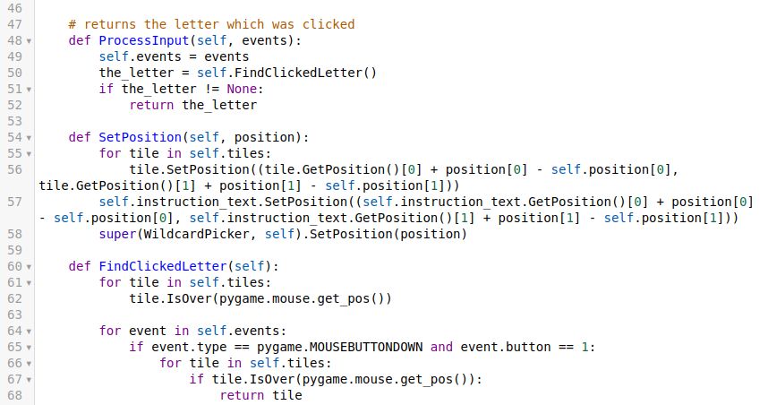

To make the last two buttons (which are not functional, i.e. ‘Swap Tiles’ and ‘Tile Bag’) on the GameScene functional, I also implemented two more classes: SwapTilesPopUp and TileBagPopUp.

The TileBagPopUp class is a panel which can be given the remaining tiles (from the Game class) and it displays the information about remaining tiles visually.

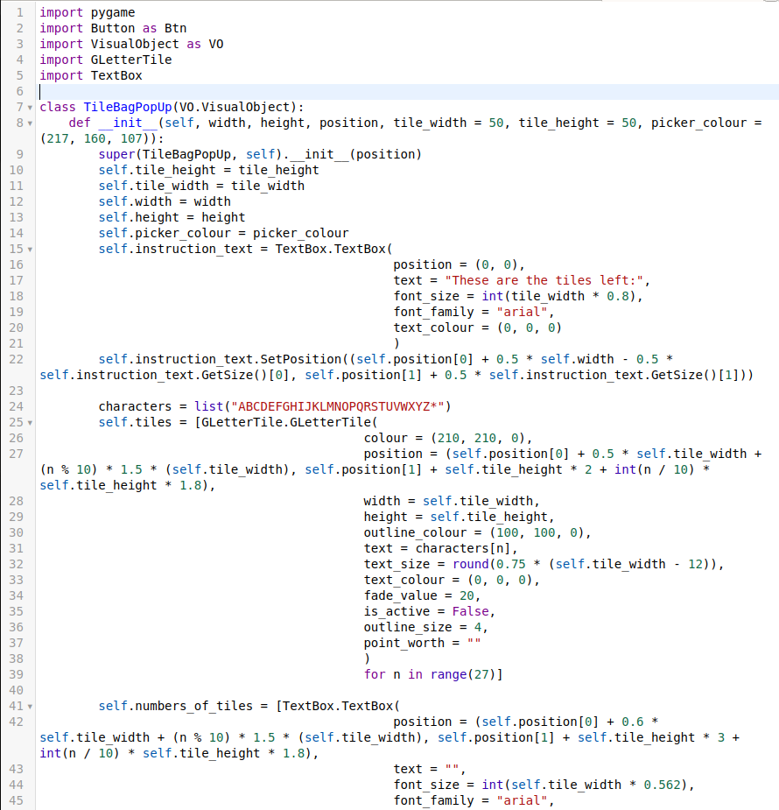

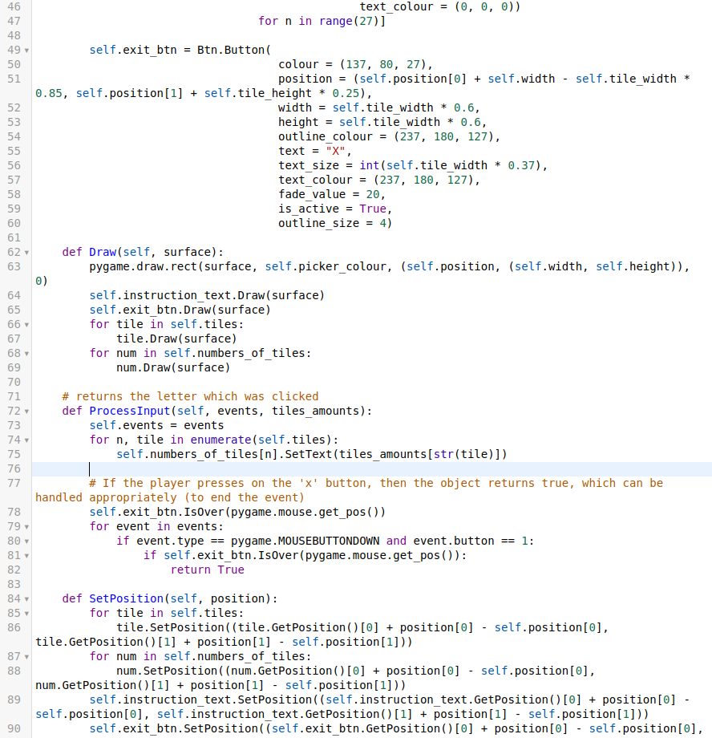



Lastly, if the player decides that they want to swap tiles out, the panel from a SwapTilesPopUp object is used. The output of the class’s ProcessInput() is a boolean which stands for which button was pressed (either ‘submit’ or ‘cancel’), which is handled in the GameScene class.

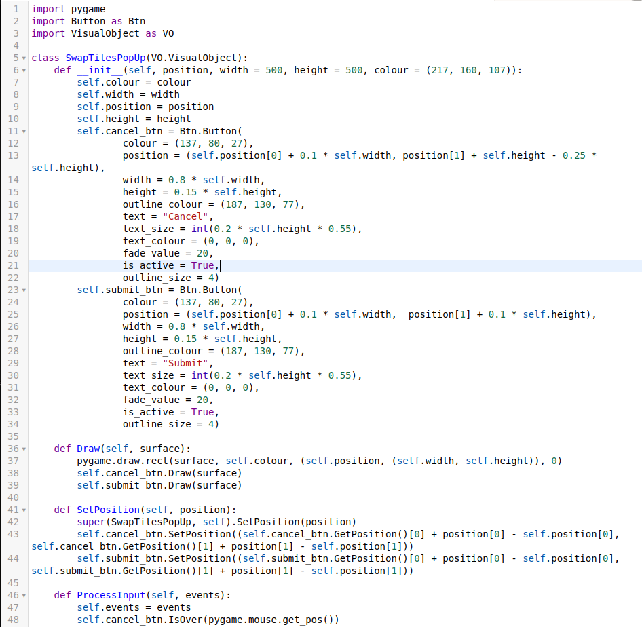

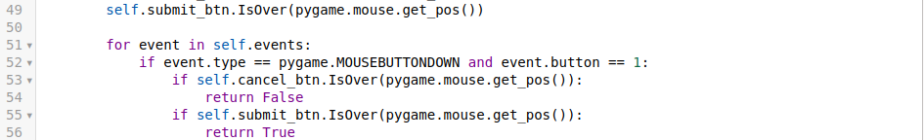

With all of the code out of the way, this is what my game looks like (once we navigate through the menu with ‘VS. Player’ and enter ‘1’ and ‘2’ as player names):

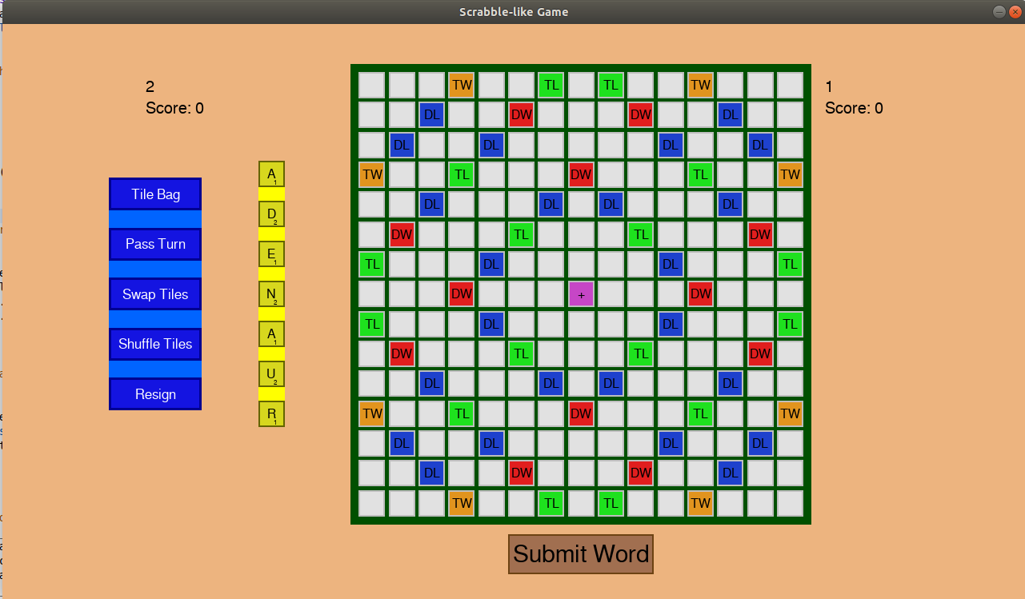

Just like any other button, all of the buttons (including the tiles and tile holders) get darker when the cursor is over them.

When I press submit, the rack gets hidden for 5 seconds:

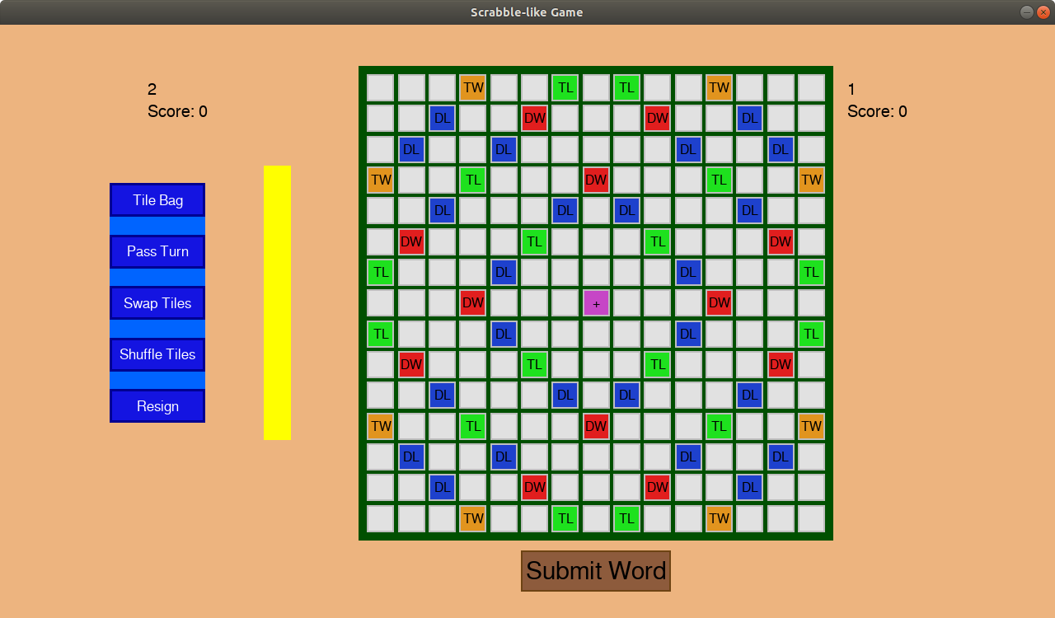

and the two players swap after 5 seconds. Currently I can click on the submit button without placing any words down or placing down invalid words because I have not implemented this logic yet, as mentioned above.

When we click on the ‘Tile Bag’ button, the following happens:

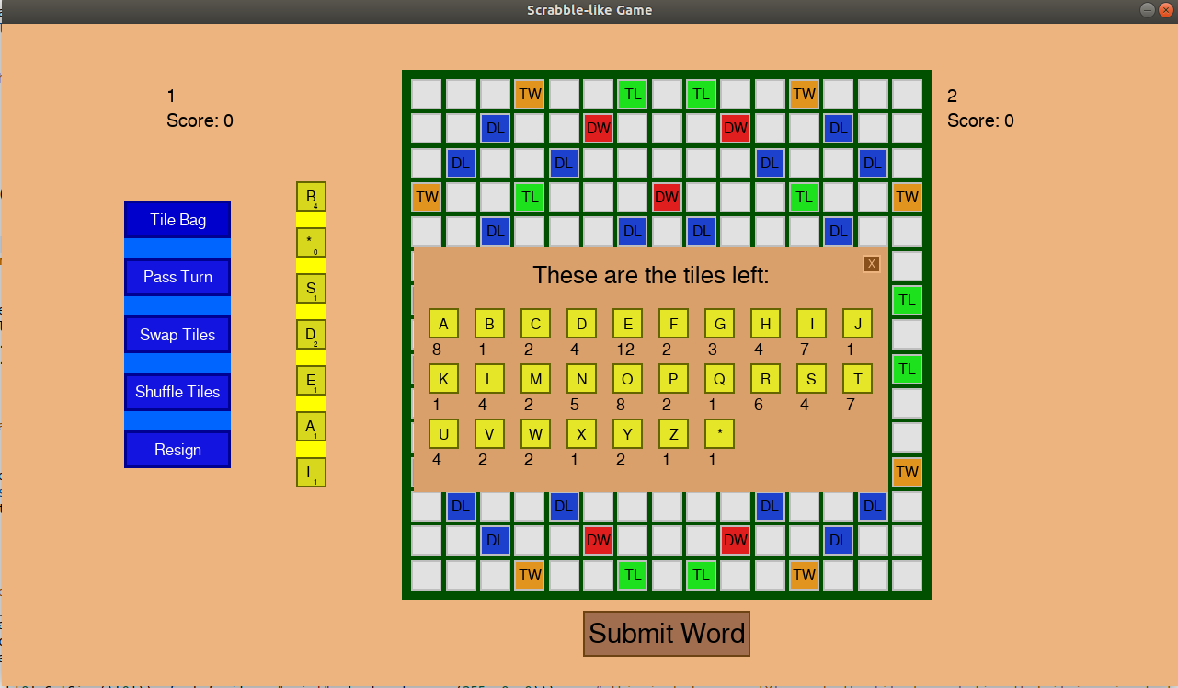

And then I can press the button in the top right corner to exit (which also gets darker when the cursor is over it)

If I click on ‘pass turn’, the players swap without anything else taking place (same as shown above using the ‘Submit Button’).

Going on ‘Swap Tiles’:

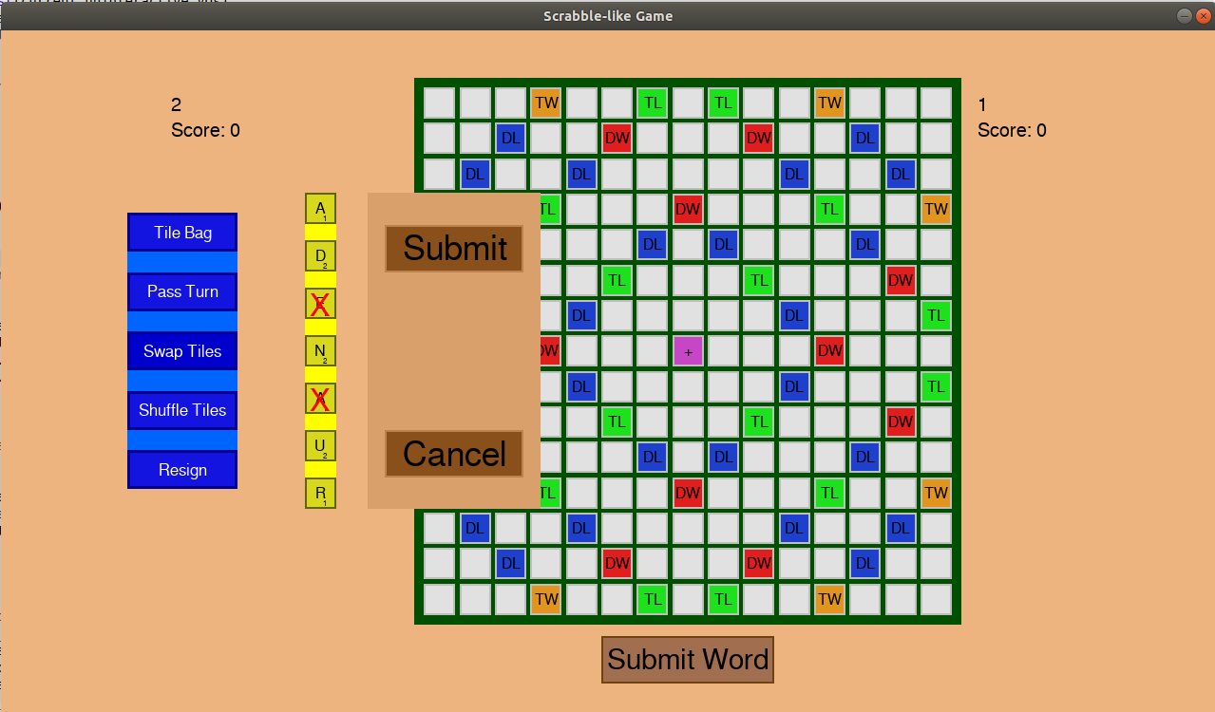

(the tiles with a cross over them are the selected ones for the swap). If I press cancel here, the crosses disappear, and nothing else happens. If there were tiles on the board when I pressed swap tiles, they would have been forced back onto the rack before the panel shows up. Pressing submit would swap the two tiles out and then pass turn.

‘Shuffle Tiles’ returns all of the tiles which are on the board onto the rack (if there are any), and then mixed the order of tiles up.

And finally, resign ends the game, congratulating the winner, and bringing us back to the main menu:

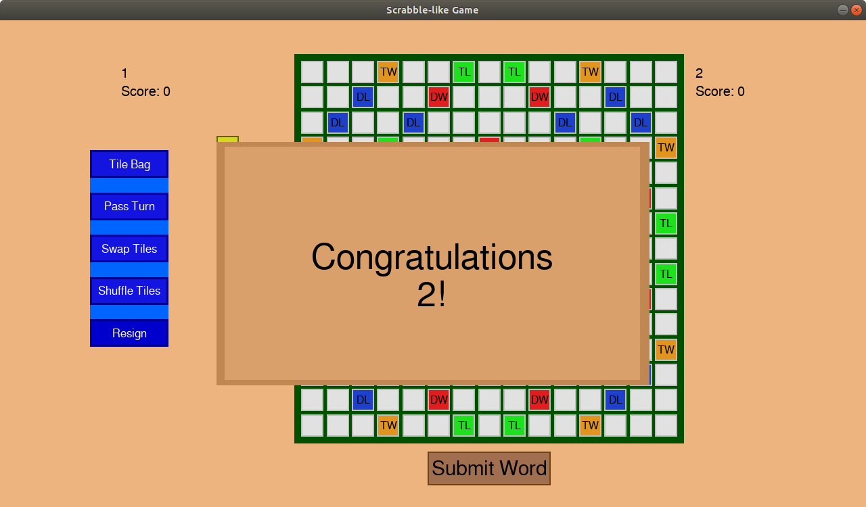

(during any of the events, the user cannot interact with anything they aren’t meant to; even on the congratulation screen, they can’t interact with anything)

## Prototype Iteration 2

For this iteration, I also decided that it is good enough to ask users for their feedback, especially before I decide that the visual aspect of my game is finished. I told my tester that the game doesn’t check if a word is valid, and so they did not consider that as a criticism. While running through my checklist of features for my game with my tester, the following points stood out:

- Although not specifically stated, it seemed more natural to try to drag and drop the tiles than to click and click. As this is not that user experience breaking, if I have time, I might work on it. Otherwise, I think that as long as the method is functional, it should be fine.

- I received feedback that perhaps once I select a tile from the rack, the tile should at least be somehow marked that it has been selected so that the user knows which tile they have selected. This feature should not be difficult to implement, and I might consider it for my next iteration.

- You can’t resize the window like a normal window. This is a problem with pygame in general; there is no way to resize a window while it’s open. So sadly, this will probably not be worked on.

- The GUI looks nice. This is good, as it took a while to set it up as it is and get it to work, so I would consider it a success.

- Seeing as all of the buttons work, the user is able to shuffle the tiles on their rack, pass turn, peek at tiles remaining in the bag, resign and submit a word.

- The remaining aspects of my criteria either have not been considered or are successful.

Given this feedback, I think that I am on a good track to meeting most of my user’s requirements. Features such as making it obvious which tile has been selected should not be difficult to implement, and I plan on doing it in my next iteration. The features which I thought I could meet but cannot (such as window resizing) will have to be scrapped due to limitations of the environment. If this was a real project, I would probably use a game engine such as Unity which would already have such features built it. However as I have to make a game from scratch, I am satisfied with what I have.

Given the good feedback, if I do decide to add any extra graphical elements, I will do my best to keep the standard at the same level or above the current one.

|  |  |  |  |  |  |
| --- | --- | --- | --- | --- | --- |
| **Test**  **Num** | **Type** | **Data** | **Expected result** | **Actual result** | **Comments/solution** |
| 7 | Invalid | The user right clicks on a button | Nothing should happen (In reality, the click will be registered, but no action will be taken because of that click) | Nothing happens | I decided to improve on this, so that the user still cannot right click on a button, however right clicking (anywhere) cancels their selection of a tile. |
| 13 | Valid | Whether the game starts | After the waiting screen, if a connection is found, then the game object should be instantiated and a game should start, with a change of scene to show for it. | Working as intended | N/A |
| 14a | valid | Tile bag button is pressed | A small pop up should show up on the scene to show the remaining tiles in the bag along with the tiles of the opponent in one list like display | Working as intended | N/A |
| 14b | Valid | Player clicks on close window button (of TileBag window) | Once the player is done looking at the tile bag, they should be able to press the close button to hide the tile bag window visual element | Working as intended | N/A |
| 15 | valid | Pass turn button is pressed | The current player’s turn should be forfeited, with no points, and the current player’s turn should be switched | Working as intended | N/A |
| 16 | Valid | shuffle tiles button pressed | The visual positions of the letter tiles on the player’s rack should be shuffled (along with their coordinates in background code, so that a button click is registered correctly) | Doesn’t seem to shuffle tiles on the first click | The graphical interface is probably not synchronised with the logical part of my game. I will need to fix this. |
| 17a | Valid | Swap tiles button is pressed | A pop-up window-like thing should show up allowing the user to put tiles from their rack into it | Working as intended | N/A |
| 17b | Valid | Player clicks on close window button (of swap tile window) | If the player changes their mind about swapping their tiles, they can press this button, and the position of their letter tiles should reset, along with hiding the visual element | Working as intended; instead of being called close window, it is just called cancel instead. | N/A |
| 17c | valid | Player clicks on submit swap button (of swap tile window) | New tiles are put into the player’s rack (visually and logically) and the ones which they submitted to the swap are taken away. | Working as intended | N/A |
| 18 | Valid | Resign button clicked | The game announces the other player as a winner in a windows for a few seconds, and then goes back to main menu | Working as intended | N/A |
| 20 | valid | Reset letter button is clicked | The board tiles which gained letter tile links on this turn are unlinked with their letter tiles, and the letter tiles are restored to their old coordinates, visually and logically. | I decided that a discrete button for this is not required, which is why I added this functionality to the shuffle tiles button, which works as intended (inclusive of this functionality) | See shuffle tiles row |
| 21 | invalid | During the waiting time between player swaps, the player clicks a button | Nothing should happen (In reality, the click will be registered, but no action will be taken because of that click) | Working as intended | N/A |
| 22 | Valid | Click on board tile (while holding a letter tile) | The letter tile which is held gets visually and logically moved onto the clicked board tile, and the board tile gets a logical connection to the letter tile | Working as intended | N/A |
| 23 | invalid | Click on board tile (while not holding a letter tile) | Nothing should happen (In reality, the click will be registered, but no action will be taken because of that click) | Working as intended | N/A |
| 24 | Valid | Click on letter tile in rack (while not holding another letter tile) | The currently held letter tile is changed to the clicked letter tile | Working as intended | N/A |
| 25 | invalid | Click on letter tile in rack (while holding another letter tile) | The currently held letter tile is changed to the newly clicked letter tile | The current selection gets cancelled (and then the user click again to select); Working as intended | Although it is not exactly the way that I specified that it will be done in, I am satisfied with the current result, as it makes sense. |

## Implementation Iteration 4 (v 1.0) – finishing player vs. player

For this iteration, I firstly looked at my user feedback and decided to make improvements to my program based on what my user wanted. This was to display which tile they have selected in some meaningful way; this was only a minor change, but makes the program better, as the user gets feedback based on their actions.

I then moved onto the most important part of the game: checking whether the user’s input is actually valid. It required me to check that all potential words submitted in this turn are valid; this problem breaks down into firstly making sure that the user places either only one tile, places tiles down only in one row or only in one column. Next, I had to make sure that these tiles are connected to the centre tile, either directly, or through other tiles. And lastly, I had to make sure that all of the words which were submitted were actually valid words (i.e. in my dictionary file). If the user’s input passes all of this validation, then their input is valid, and they successfully submit their word. Otherwise, after pressing submit word, nothing happens, which signifies that one of these validation stages has failed, according to the rules of Words With Friends.

The next and last thing (other than some minor bug fixes/improvements) that I needed to do to finish my game was to make sure that once a valid word has been submitted, the player who submits it gets credited the correct amount of points for the word they submitted, again just following the rules (and my interpretation of said rules) of Words With Friends (found on <https://www.zyngawithfriends.com/wordswithfriends/support/WWF_Rulebook.html> on 29.01.2019).

Firstly, the code that was altered in GameScene to improve my game based on user feedback is the following:

In the constructor,



This variable ‘is of type’ GLetterTile. Whenever I select a tile to move around, it firstly gets stored in this, and then deactivated, which changes its appearance, and has the wanted effect of not the user not being able to click it again (which would deselect it if they accidentally double clicked it). To allow for this, In ProcessInput() I added



And also in CancelMoves()

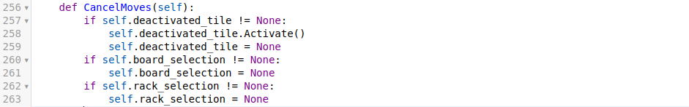

the tiles I reactivated, and no longer marked as being deactivated (i.e. no longer stored as the self.deactivated_tiles variable).

Next, because checking for winner has to be done at the end of each turn, and my code checks for such changes at the start of each turn (BeforeEachTurn()), I decided to rework this method into a AfterEachTurn() method, as otherwise the if there is a winner, they would be announced after the players change turns (after the 5 seconds pause) which doesn’t look nice. This required changes in the PassTurn() method:



In the SubmitWord() method:

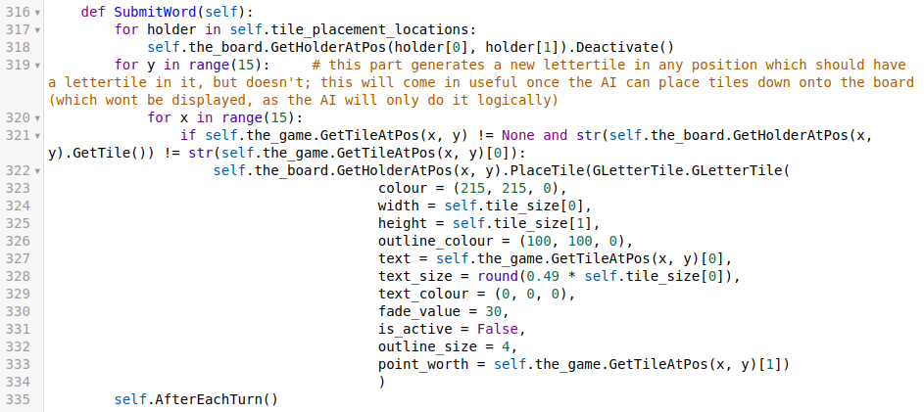

And the change of BeforeEachTurn() into AfterEachTurn(), along with merging it with parts which used to be at the end of SubmitWord() and PassTurn(); a similar thing was done in the Game class (which I will outline later on when I get into the changes of Game):

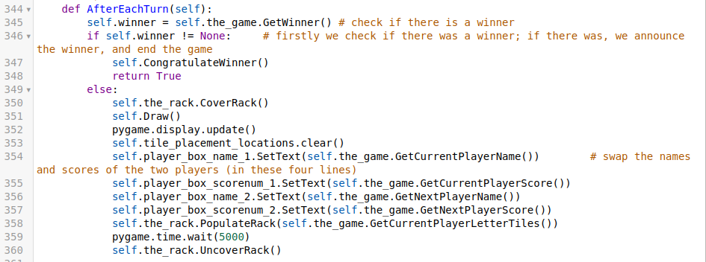

While testing my program out, I also realised that if I select a tile, and then shuffle my tiles, the selection persists on the same tile, which is shown by the tile being deactivated. This was unwanted, and so to fix it, I added a call to the CancelMoves() method inside of the ShuffleTiles() method:

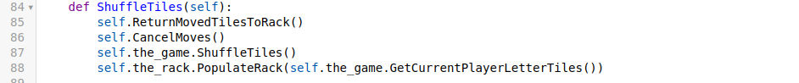

There were occasions on which my game would crash, and I wasn’t sure why, so I decided to investigate this. The problem turned out to be that a TextBox object somehow ended up with a GLetterTile as its text attribute, and when narrowing down on what causes this, I found out that my WildCardPicker ProcessInput() method returns a GLetterTile instead of a string, so I fixed this:

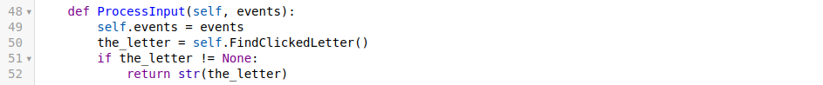

Another oversight I found out while testing was that if the ‘Tile Bag’ button is pressed when there aren’t instances of every tiles passed into its constructor, it either crashes or the wrong numbers are displayed. This was because I relied on every letter being passed in. To fix this, instead of self.tiles and self.numbers_of_tiles being lists, I made then dictionaries, with the letters as keys, and the tiles and numbers of tiles as the values, respectively. This allowed me to display zero instances of a tile correctly:

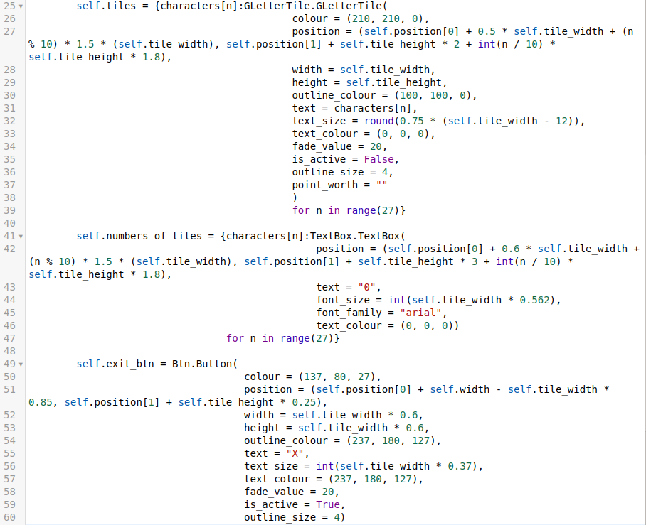

And to accommodate for this change, I also needed to change the SetPosition(), Draw() and ProcessInput() methods so that instead of iterating through a list (or enumerated list), I iterated through dictionaries:

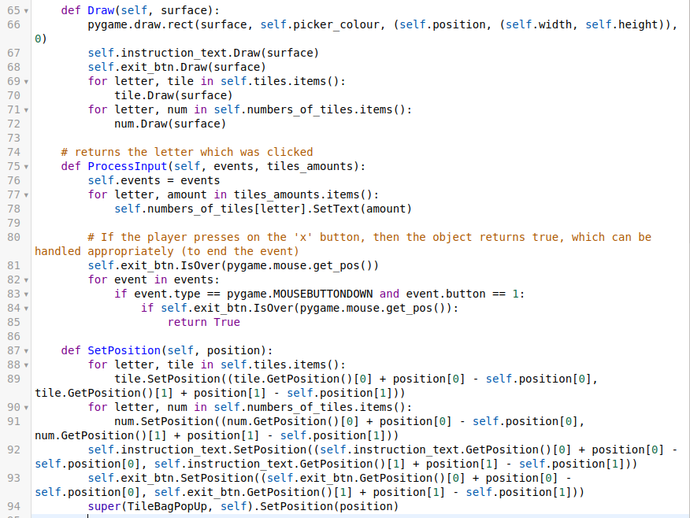

And finally we can now go through the main changes: those in my Game class.

As mentioned previously, I changed this class’s BeforeEachTurn() method to a AftereEachTurn() method:

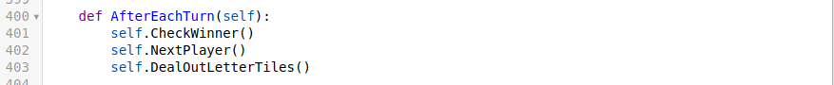

which is called at the end of PassTurn(), and inside SubmitWord().

In the constructor I have an extra variable:



The CheckWinner() method makes use of this variable:

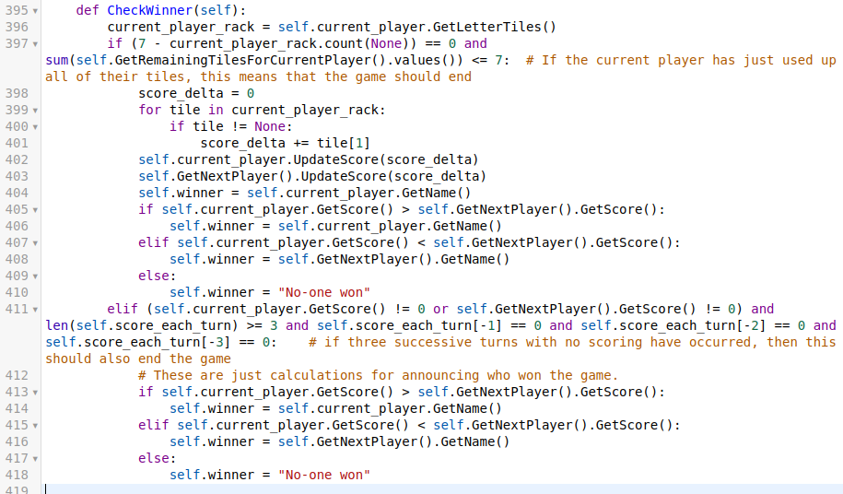

The SubmitWord() method now looks like this:

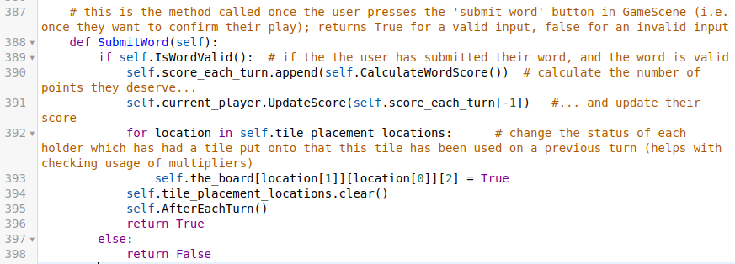

And the way we check if a word is valid is the following:

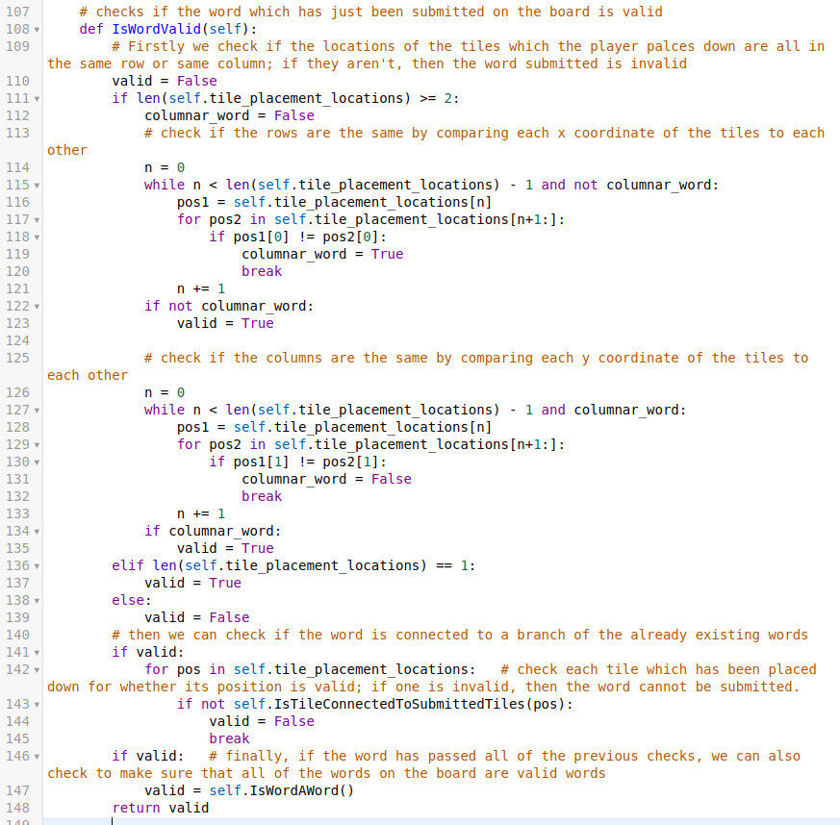

And the way we check if the words on the board are actual valid words:

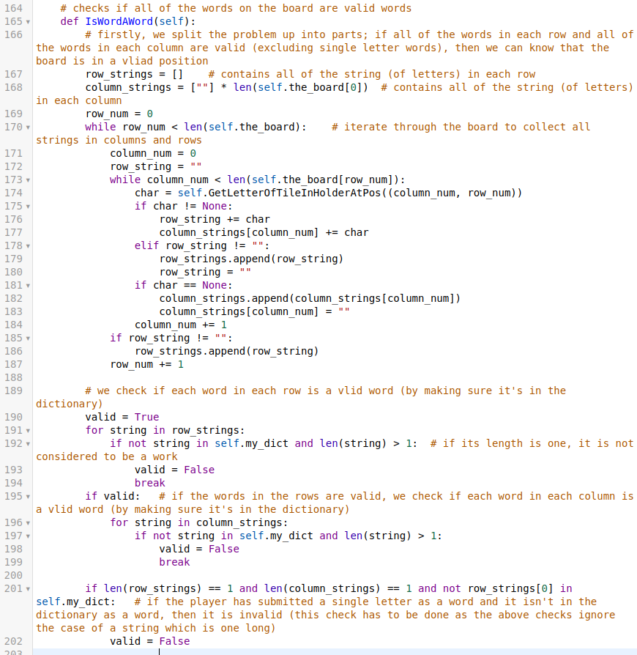

After we see that the word the player submitted was valid, we need to calculate the amount of points they should get for it. We do this using

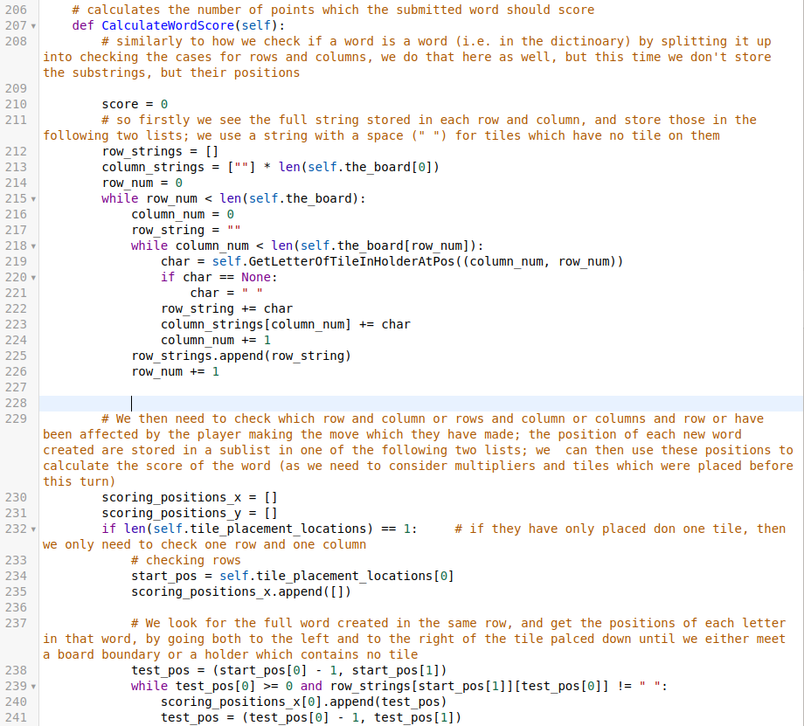

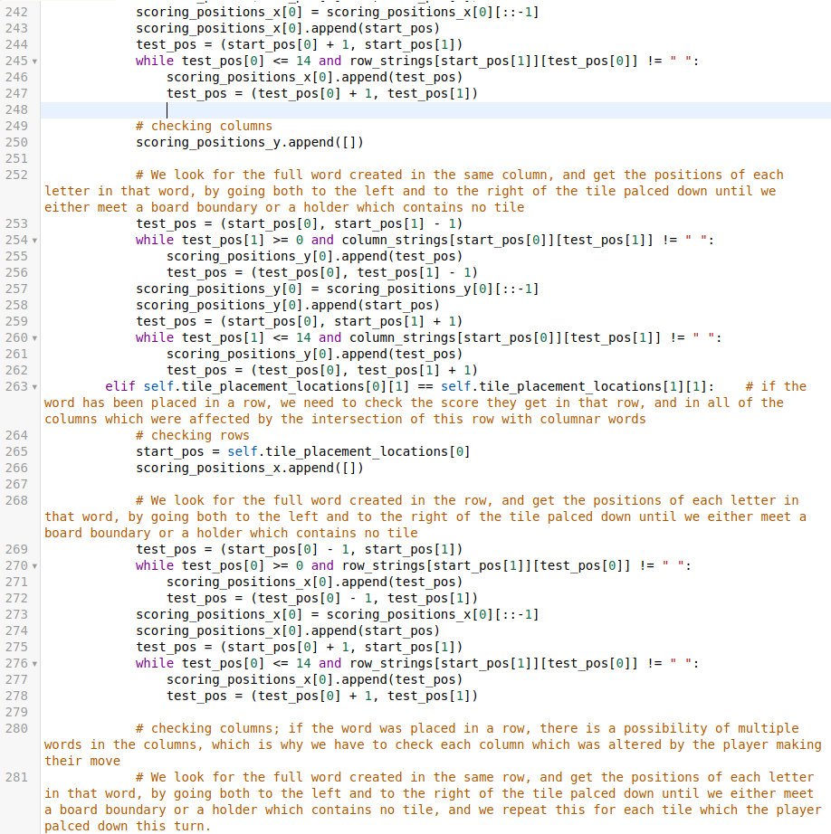

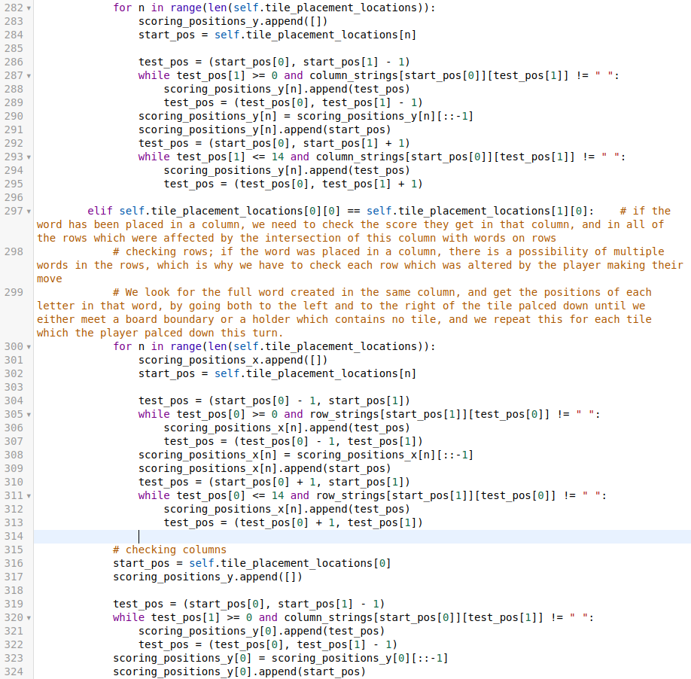

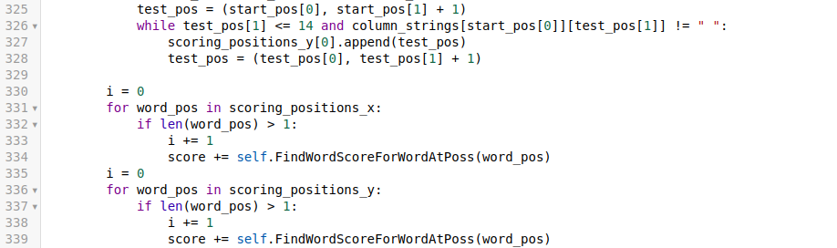

On line 331 and 336, we can finally start making use of the two lists we create to calculate the score of each word which the player made on that turn. The function which does this is

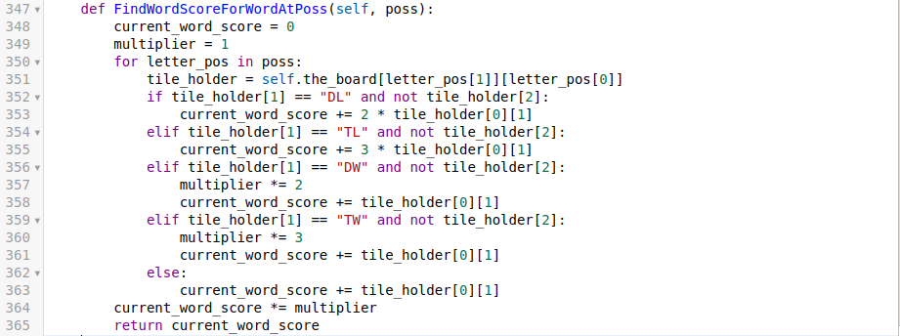

for each letter in the list of positions for the word, we check if it has a multiplier and take action based on that.

The Player class’s PopulateRack() method received a small change to make sure that my program doesn’t error out as well:

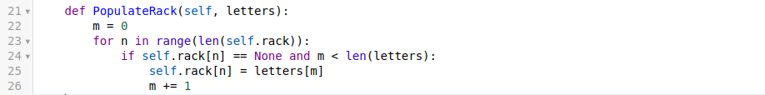

the variable ‘m’ just makes sure that I am not accessing indices of the letters list which don’t exist, as the letters list can be shorter than the length of the player’s rack (especially near the end of the game when the letters in the tile bag are less than 7)

Visually, the game is the exact same as before, it’s just that now all of the inputs are validated, so I won’t include any gameplay images, as for the reader the change means nothing if the code has not been looked at.

As this can be considered a complete game, I am going to include all of the tests.

|  |  |  |  |  |  |
| --- | --- | --- | --- | --- | --- |
| **Test**  **Num** | **Type** | **Data** | **Expected result** | **Actual result** | **Comments/solution** |
| 1 | Invalid | In any of the scenes, if the player clicks on a non-button object (i.e. on the background/text) | Nothing should happen (In reality, the click will be registered, but no action will be taken because of that click) | Working as intended | N/A |
| 2 | Valid | The VS AI button on main menu is clicked | The current scene changes to the next scene where the user is allowed to enter their nickname | I am redirected to a scene telling me that this has not been implemented yet | I still need to implement the VS AI transition scene and then the scene with the actual game on it. This requires me to make a new subclass of scene, similar to how I have done for my MainMenuScene. |
| 3 | Valid | The vs player button on main menu is clicked | The current scene changes to the next scene where the user is allowed to enter their nickname | Working as intended. | N/A |
| 4 | Valid | The online button on main menu is clicked | The current scene changes to the next scene where the user is allowed to enter their nickname | I am redirected to a scene telling me that this has not been implemented yet | I still need to implement the online transition scene and then the scene with the actual game on it. This requires me to make a new subclass of scene, similar to how I have done for my MainMenuScene. |
| 5 | Valid | The exit game button is clicked | The game exits | Working as intended. | N/A |
| 6 | Valid | The ‘x’ button in the top right corner of the game windows is clicked | The game exits | Working as intended. | N/A |
| 7 | Invalid | The user right clicks on a button | Nothing should happen (In reality, the click will be registered, but no action will be taken because of that click) | Working as intended. | I decided to improve on this, so that the user still cannot right click on a button, however right clicking (anywhere) cancels their selection of a tile. |
| 8 | Valid | Make sure that the user’s nickname is correctly stored | When the user enters their valid nickname on the scene after main menu, it is correctly recorded in the string variable, and not truncated or with extra characters | Working as intended | N/A |
| 9 | Invalid Boundary | The user enters a nickname which doesn’t fit in the nickname field | Once the character limit is reached, no more characters are recorded in the string variable responsible for storing their nickname, and no more letters are shown on the screen | Working as intended | N/A |
| 10 | Valid | What happens when the user presses backspace when entering their username | When the user is entering their nickname, they should be allowed to use backspace to delete the last character in their entered nickname | Working as intended | N/A |
| 11 | Valid | Clicking the next button on the nickname entry scene | When clicked, the scene should change to the next scene (which in the case of VS AI is the game scene, in the case of vs player is the next player’s nickname entry scene, and in the case of online is a waiting screen) | Instead of a next button, I decided to just ask the user to press the enter key. Otherwise, working as intended. | N/A |
| 12 | Valid | Whether game times out | While on the waiting screen for online play, if a game isn’t found in a specified amount of time, the waiting should time out, and the scene should be changed back to the menu scene | Nothing happens | This still needs work if I decide to make my game online |
| 13 | Valid | Whether the game starts | After the waiting screen, if a connection is found, then the game object should be instantiated and a game should start, with a change of scene to show for it. | Working as intended | N/A |
| 14a | valid | Tile bag button is pressed | A small pop up should show up on the scene to show the remaining tiles in the bag along with the tiles of the opponent in one list like display | Working as intended (for the implemented parts) | N/A |
| 14b | Valid | Player clicks on close window button (of TileBag window) | Once the player is done looking at the tile bag, they should be able to press the close button to hide the tile bag window visual element | Working as intended | N/A |
| 15 | valid | Pass turn button is pressed | The current player’s turn should be forfeited, with no points, and the current player’s turn should be switched | Working as intended | N/A |
| 16 | Valid | shuffle tiles button pressed | The visual positions of the letter tiles on the player’s rack should be shuffled (along with their coordinates in background code, so that a button click is registered correctly) | Working as intended. | N/A |
| 17a | Valid | Swap tiles button is pressed | A pop up window-like thing should show up allowing the user to put tiles from their rack into it | Working as intended | N/A |
| 17b | Valid | Player clicks on close window button (of swap tile window) | If the player changes their mind about swapping their tiles, they can press this button, and the position of their letter tiles should reset, along with hiding the visual element | Working as intended; instead of being called close window, it is just called cancel instead. | N/A |
| 17c | valid | Player clicks on submit swap button (of swap tile window) | New tiles are put into the player’s rack (visually and logically) and the ones which they submitted to the swap are taken away. | Working as intended | N/A |
| 18 | Valid | Resign button clicked | The game announces the other player as a winner in a window for a few seconds, and then goes back to main menu | Working as intended | N/A |
| 19a | Valid | Submit word button pressed (with a valid word on board) | The current player’s score is incremented according to scrabble rules, and it’s the next player’s turn, unless the current player no longer has any letters left in their rack, in which case a winner is calculated and announced. | Working as intended. | N/A |
| 19b | invalid | Submit word button pressed (with an invalid word on board) | A small pop-up appears telling the user that the word which they entered is invalid, and no further action is taken (i.e. the players aren’t swapped) | Nothing happens | The logical part is working as intended, so I will implement a prompt to the user if I have enough time; not a vital part of the gameplay. |
| 20 | valid | Reset letter button is clicked | The board tiles which gained letter tile links on this turn are unlinked with their letter tiles, and the letter tiles are restored to their old coordinates, visually and logically. | I decided that a discrete button for this is not required, which is why I added this functionality to the shuffle tiles button, which works as intended (inclusive of this functionality) | See shuffle tiles row |
| 21 | invalid | During the waiting time between player swaps, the player clicks a button | Nothing should happen (In reality, the click will be registered, but no action will be taken because of that click) | Working as intended | N/A |
| 22 | Valid | Click on board tile (while holding a letter tile) | The letter tile which is held gets visually and logically moved onto the clicked board tile, and the board tile gets a logical connection to the letter tile | Working as intended | N/A |
| 23 | invalid | Click on board tile (while not holding a letter tile) | Nothing should happen (In reality, the click will be registered, but no action will be taken because of that click) | Working as intended | N/A |
| 24 | Valid | Click on letter tile in rack (while not holding another letter tile) | The currently held letter tile is changed to the clicked letter tile | Working as intended | N/A |
| 25 | invalid | Click on letter tile in rack (while holding another letter tile) | The currently held letter tile is changed to the newly clicked letter tile | The current selection gets cancelled (and then the user click again to select); Working as intended | Although it is not exactly the way that I specified that it will be done in, I am satisfied with the current result, as it makes sense. |

## Prototype Iteration 3

As my game was completely playable for two players in the same room, I decided that it is a very good points to test my program, as I can see what a user might want to see in a polished program, and given enough time, I can implement all of the features which users might want. Another reason was to see if the user interacts with my game in such a way that I have not thought of in my testing table which could cause my program to crash.

Since the last prototype testing, not much has changed visually, so the user isn’t fully aware of the changes at first glance. However when the start playing the game, they are now less likely to encounter an error causing the program to crash, and the tiles which they place down now are checked for being valid, which makes the game more enjoyable, as they don’t have to manually check if each word they submit if in a valid position or keep track of score; after all, this is why a programmatic approach was chosen for this game in the first place, so that the user doesn’t have to do those thing manually.

According to my requirements specification:

- 1. This has been met in its entirety.

- 2. Is partly met – the user cannot play against an AI, but everything is met.

- 3. The player can choose who they want to play against, but as two out of three of these are not implemented, they have a limited choice (basically no choice); therefore this has yet to be met, and I need to work on an AI, so that the user has at least one extra choice.

- 4. As previously stated, the AI has not been implemented yet, and so this requirement has not been met either.

- 5. I talked about this requirement in my previous iteration as well; sadly, pygame does not allow for dynamic window resizing, and so this will have to stay not implemented.

- 6. Same as AI points before.

- 7. There is a GUI, making it much more convenient and enjoyable for a user to play my game. I don’t have any sounds, and so having a sound menu is irrelevant; as colour scheme changes don’t affect gameplay much, I haven’t implemented this yet. One of the people that I asked to test my program did suggest that I change the background, as they didn’t like the background colour. I might do this in later iterations once there is nothing else left to do.

- 8. This has been met in its entirety.

- 9. This has been met in its entirety.

- 10. Implemented for players, but not for AI.

- 11. This has been met in its entirety.

- 12. This has been met in its entirety.

One of the other users of my program suggested that I make it clear whose turn it is, by simply putting another text message above the left displayed username. This shouldn’t be too difficult to do, and I might do it for the next iteration.

The same user commented that they would like to see a pop-up show up telling them that their word was invalid if submit didn’t work. As this is part of even my testing table, this is also likely to be implemented soon to satisfy the needs of the user.

A third user made a suggestion that I can have a completely different game-mode which is scrabble on a timer: a player only has a certain amount of time to make a move. Otherwise, their turn is forfeited, similar to how Hearthstone (game by Blizzard entertainment) turns work. This was never a plan I had, so it very low down in my list of priorities. However, if other users make a similar suggestion, I might implement it.

As I was watching the users play my game, I again noticed that they wanted to drag-and-drop the tiles onto other holders. This was never commented on, and I think does make more sense on a PC, however if I were to play this on a touch phone with a smaller screen, it might be difficult for someone to see where they are placing the tile down. I am going to take the fact that no comments were made on this as the user doesn’t mind it being two clicks to move a tile.

So, things which I want to implement in the next iteration, in order of importance to the user and my criteria, are: any situations which are causing errors/crashes/unexpected behaviour (if I run across any, as there are currently none); invalid word message; who the current player is note; AI; theme colour change; drag-and-drop tile movement; timed turns game-mode.

## Implementation Iteration 5 (v 1.1) – finishing player vs. player

In this iteration, I decided to just improve the minor things which I got as feedback from my prototype testing. These were the ‘making it obvious who the current player is’ and ‘invalid word message’. The reason for doing this is to satisfy the needs of the user.

There is no extra validation of testing that I need to do, as these two additions are completely graphical, and their logic doesn’t need testing. The testing table is the exact same as the previous iteration.

All of the changes in code were in the GameScene class:

In the constructor,



and in ProcessInput(),

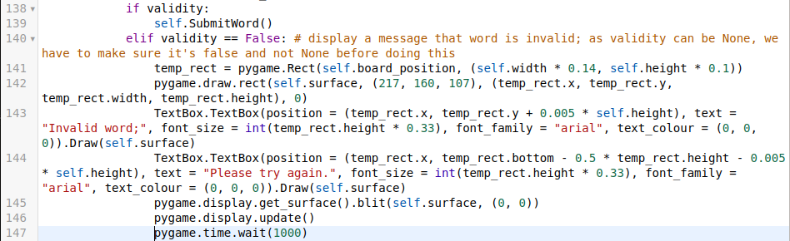

The changes to my game are:

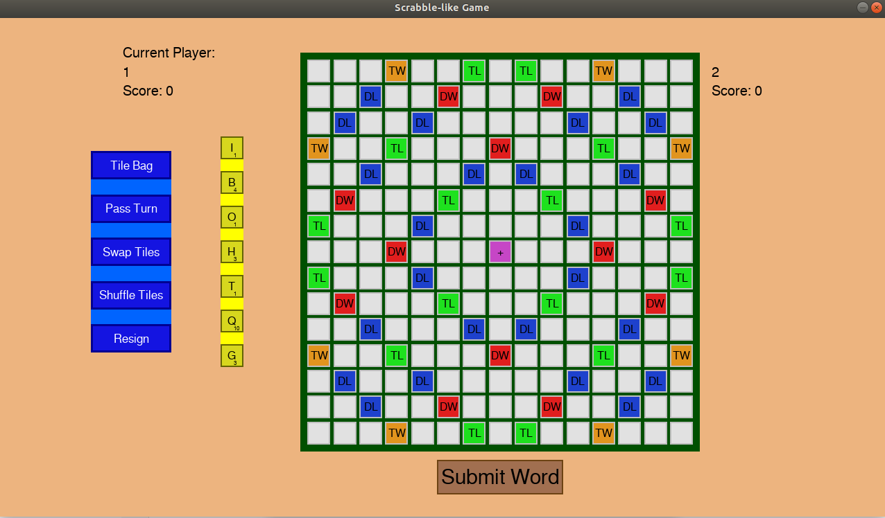

(notice the extra text above the 1)

And when I press the ‘submit word’ button with an invalid word on the board (or no word at all):

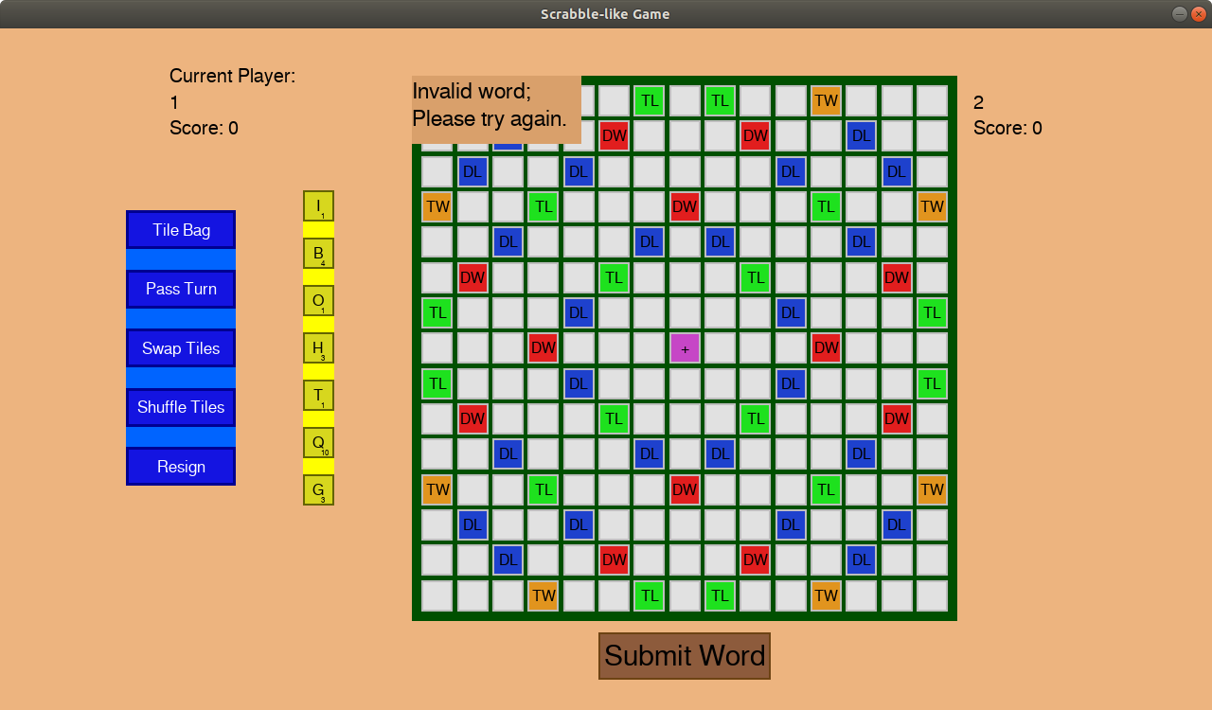

which disappears after a second.

As in this iteration I have not added extra functionality to the game which the user has control over, I have had no need to consider any validation, as what the user can interact with has stayed the same; they’re just receiving more feedback.

## Implementation Iteration 6 - GADDAG Iteration

I required the GADDAG structure to make my AI efficient (and with it I can make checking if a word is valid in my Game class even faster if I decide to). As I was looking at the game as a whole, I didn’t make testing criteria for GADDAG, so this iteration will not be in as much detail as the above ones, due to being a sub-problem of a sub-problem (the AI). I also cannot give this to a user to test, as it has no GUI, and a user wouldn’t even know its use, unless they have met it before.

Throughout my screenshots you will be able to see print statements and other lines of code, either commented or not. This is how I tested if my program does what I expected it to do at that stage.

The code looks like so:

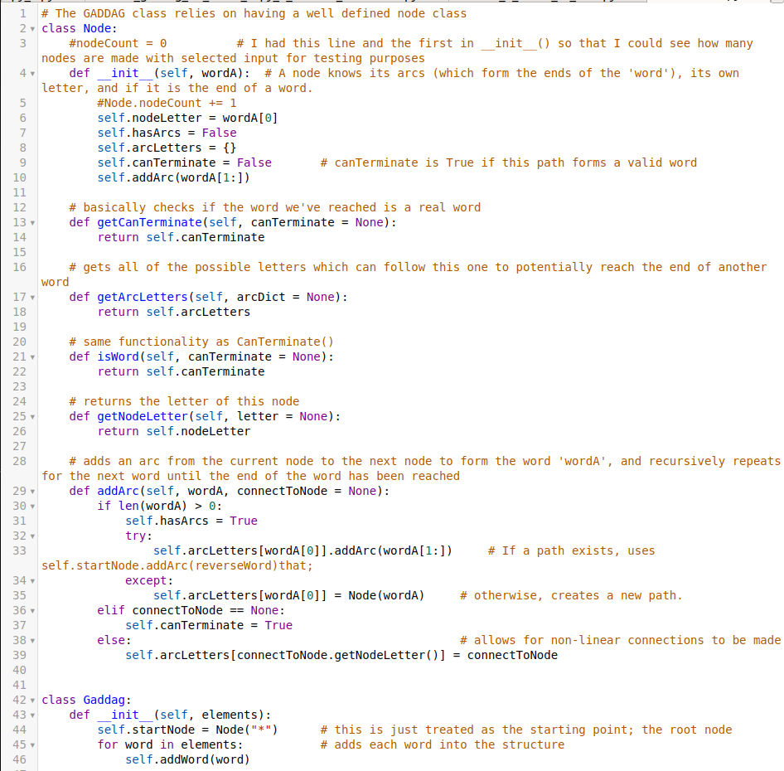

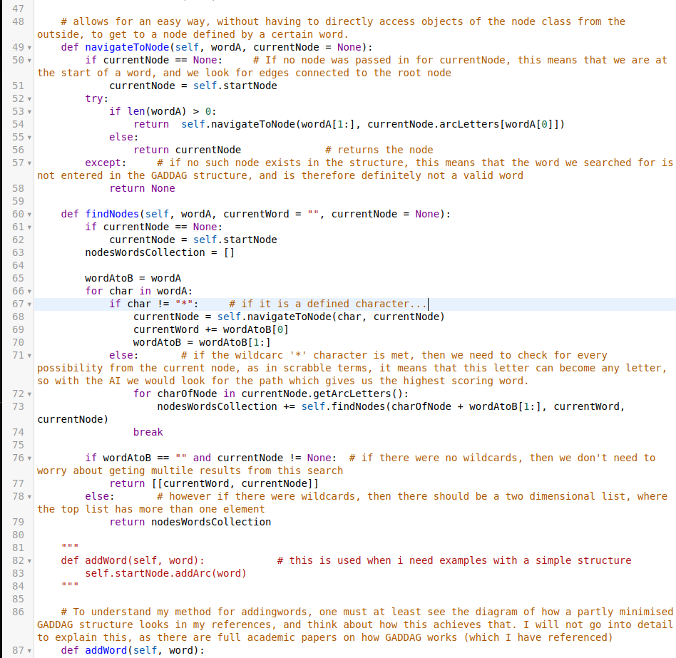

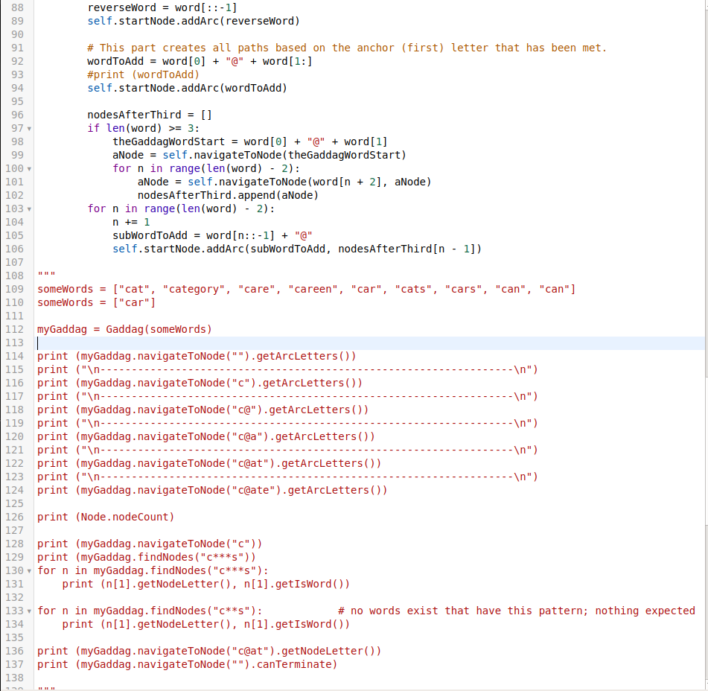

## Implementation Iteration 7 (v 1.2) - AI development

The main goal of this iteration was to fully implement an AI into my game, and it turned out successful.

To achieve this, I had to make use of almost every logical part of my game which I had coded, and some of the previously coded parts required a bit of rethinking (such as how does the AI know when it is its turn, or how are its tiles actually displayed onto the visual board, which was partly done before in one of the iterations).

In my testing table in the last iteration which included it, the main thing that stood out was that the AI was missing. This is why in the previous iteration I implemented the GADDAG structure, which is a core component to be able to develop a successful AI.

Now, onto the actual changes/additions made:

Starting with the Node class, I changed the addArc() method, as it was not doing what I had wanted it to do (which I discovered once I tried testing if it counts words which are long as valid which should be valid, such as ‘olpxe@sion”, and they were not). So, I just made it a simple method:

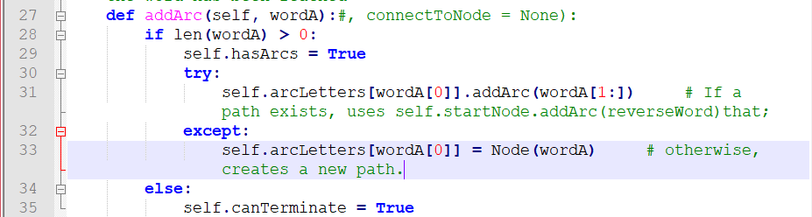

And instead of implementing the minimisation of GADDAG logic in the noe, I implemented it into the GADDAG’s addWord() method:

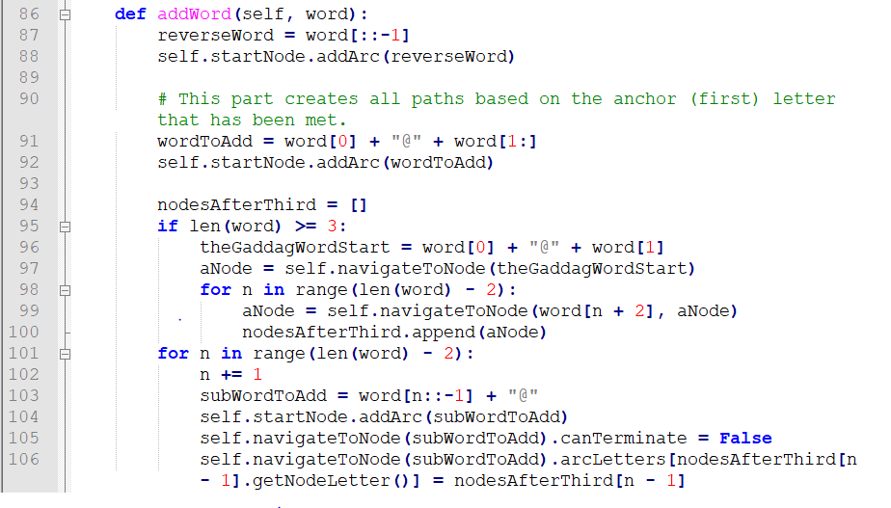

(the change is in the for loop: instead of expecting the addArc() method from node to handle the connection, the addWord() method deals with it itself)

I also added another method for easier checking if a word is valid using GADDAG:

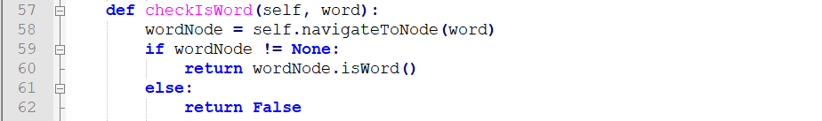

Once I got in the position where my GADDAG structure was working in the exact way which I required it to, I started making use of it in places such as my Game class for checking if a word is valid:

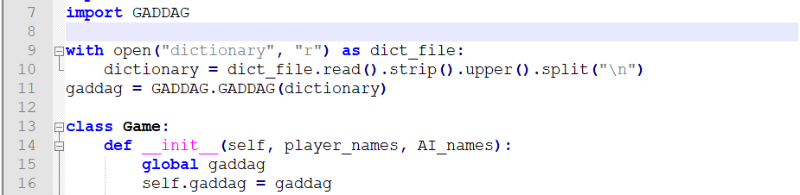

This is a global variable which I create in my Game.py file. The reason I made it global was because it was the easiest way to make it load as soon as the game is started (i.e. as soon as the Game file is imported).

With an object of the class now set up, I was able to start making use of it; instead of checking if a word is ‘in’ my dictionary list, I ‘checkIsWord()’ed using GADDAG. So, assuming python’s search using ‘in’ is linear (i.e. has a O(n), where n is the length of the list of words, which can be a maximum of 172,820), mine is much faster, as it has a O(n), where n is the length of the word, which can only be a maximum of 15. The speed increase of this is 10,000 in the worst case, which can be felt when playing the game (but not using screenshots).

The code for this in Game is:

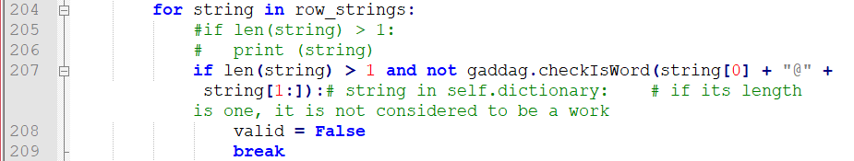

(line 207)

I also implemented a getter for current player in Game:



And the AfterEachTurn() method has an extra step for the AI:

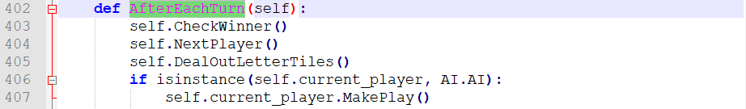

This means that after doing all of the normal things after a turn, if it’s the AI’s turn, let the AI make a play (this method will be covered later on).

In GameScene I had to change the order that things are done in to accommodate for the AI’s play. The first thing is that in the constructor, if there is an AI in the game, then we call the AfterEachTurn() method (which also got altered), for the case where the AI gets to go first. This allows for the AI’s placed down tiles to be visually displayed onto the board:



As mentioned above, the AfterEachTurn() method got altered:

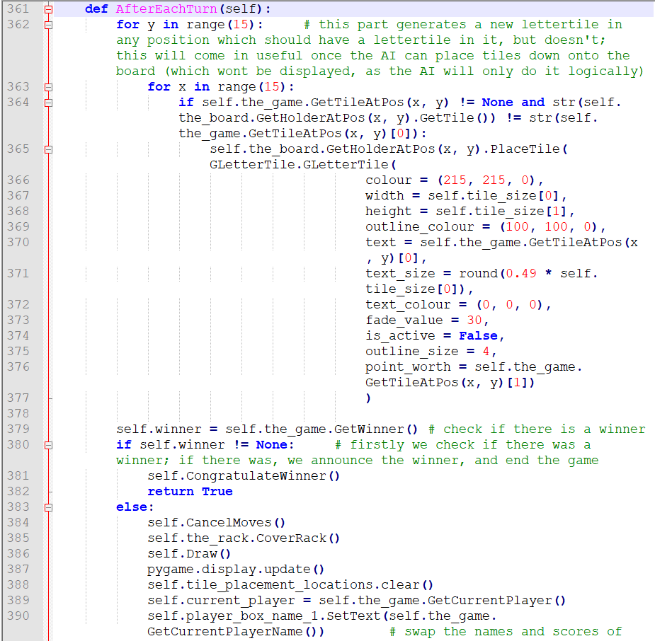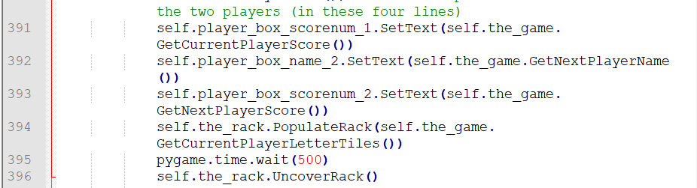

Instead of updating tiles in the SubmitWord() method, I moved that to here (the very first loop in the above screenshot).

And so, SubmitWord() also got changed:



This means that once the player submits a word which is valid, the deactivate the tiles which were just placed, then we call the AfterEachTurn() method.

Also, there was an oversight by me for when the user clicks on a tile, and then clicks on the shuffle tiles button which made it so that the clicked tiles would persist through the shuffling or worse, word swapping, and would not be interactive. To fix this, I included an extra line at the end of ReturnMovedTilesToRack():



Now that the basic things are covered, I enabled this scene in director, by changing it so that instead of going to the not implemented scene, I:



And now finally the best part: the AI itself. I will do my best to explain the logic behind it visually instead of exclusively through words. I will do this by playing against myself, where I will have control over both players. Firstly, here is the code, whose lines I will be referring to in my explanation:

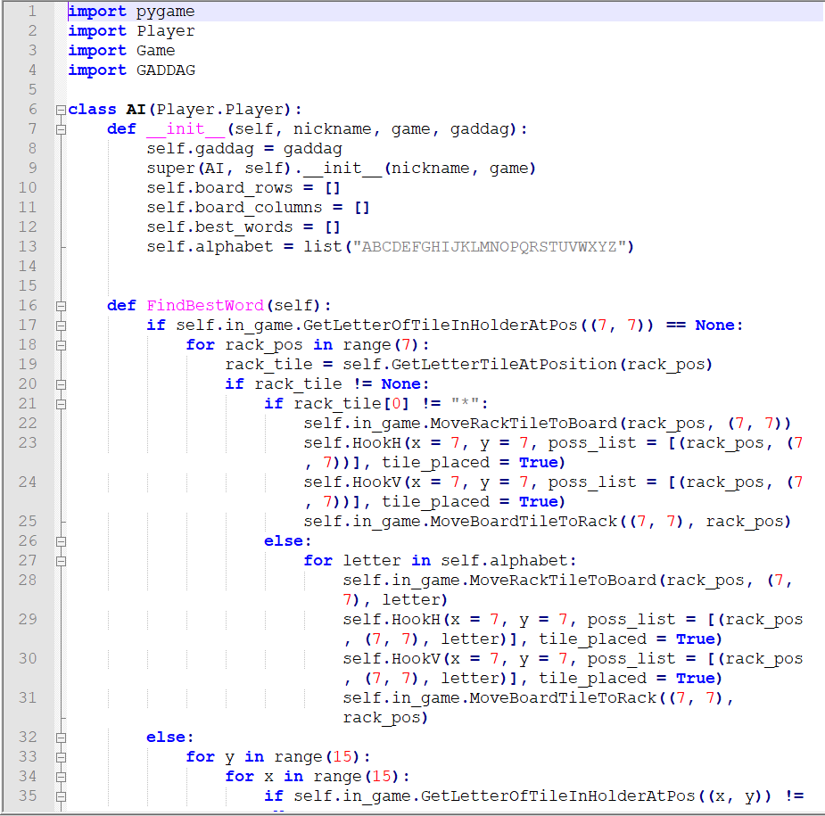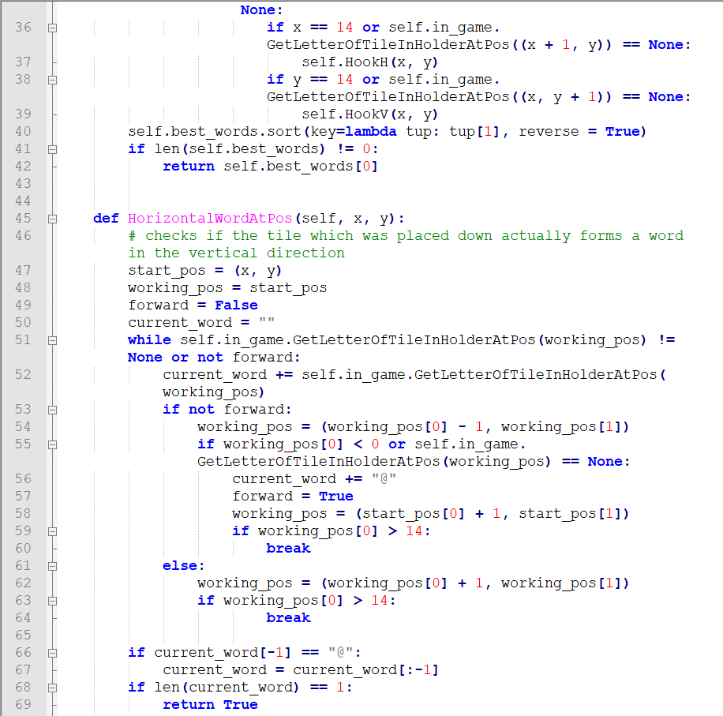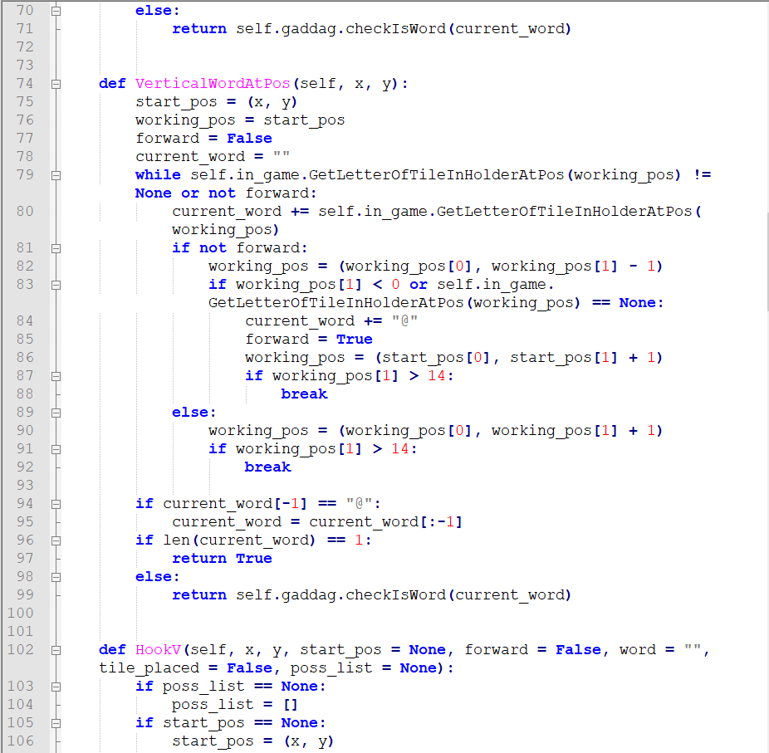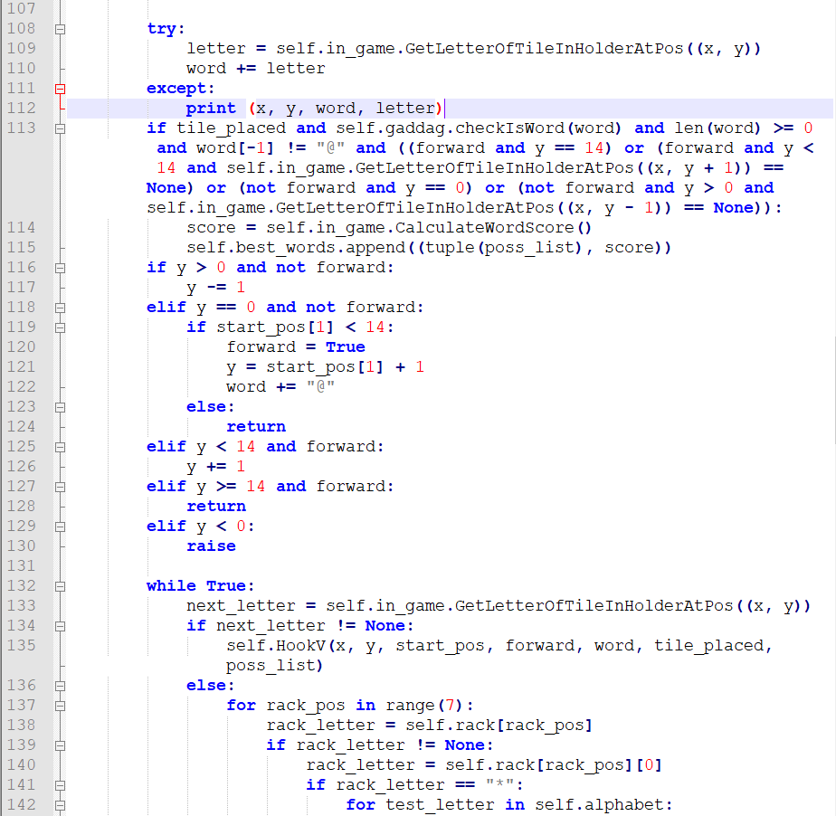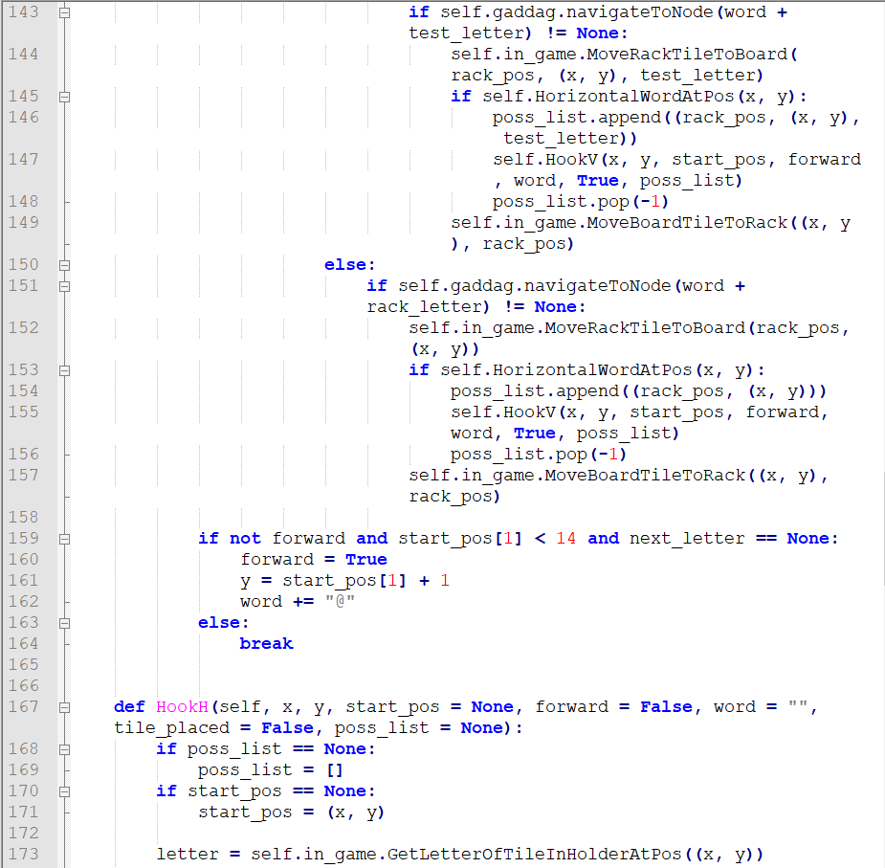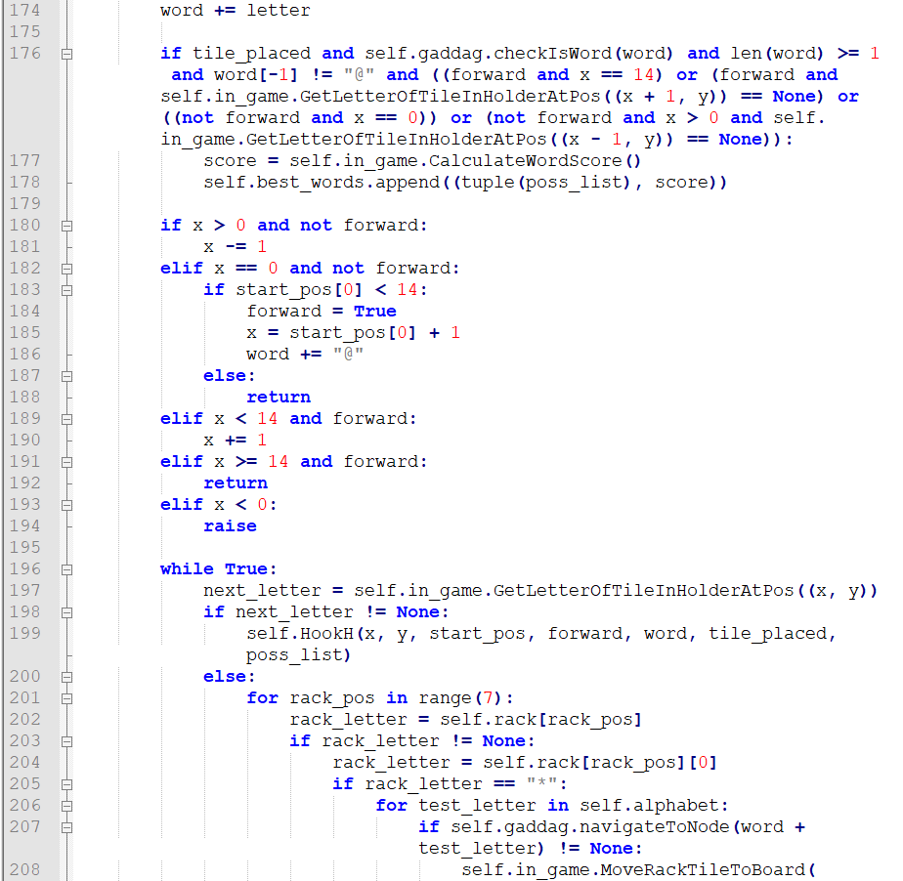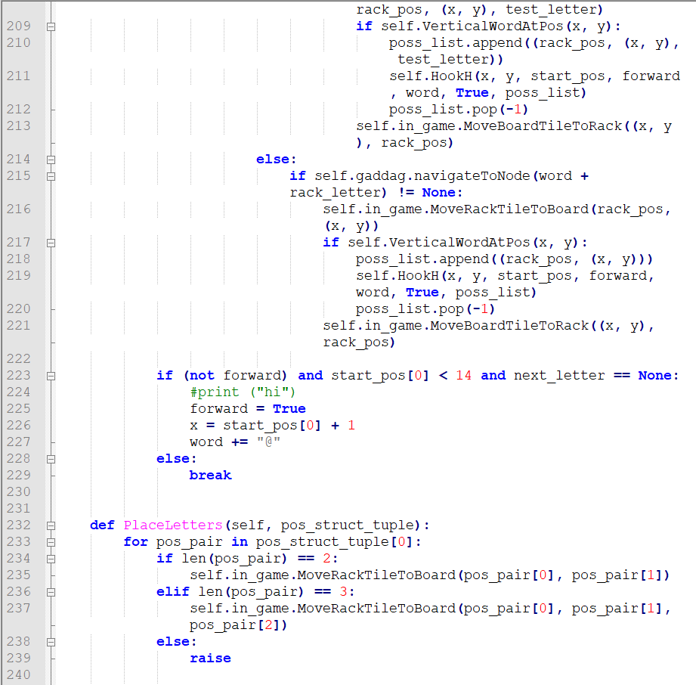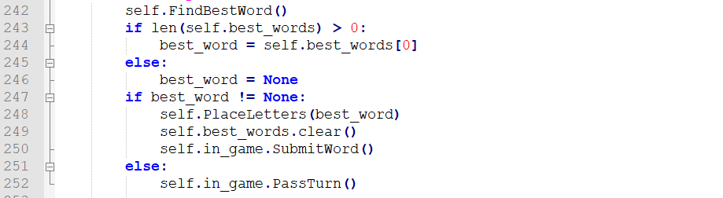

Along with having the same parameters as a player, AI also has the extra parameter of ‘gaddag’. All this is is an instance of a GADDAG class, and the reason I pass it in is because instantiating a GADDAG object takes quite long, meaning I only really want to be doing it once for the duration of my game.

Board_rows and board_columns were going to be used, but turned out that they were not used, and I just forgot to get rid of them in my code for this screenshot. They can be ignored.

The best_words variable holds tuples of words which can be played (in a format which I will explain later) in descending order based on the amount of points the word would give if played.

The last variable in the constructor is the alphabet variable. This just helps me when dealing with checking through possibilities of a word involving a wildcard.

The interesting part starts when it is the AI’s turn. As mentioned above when covering the changes to the Game class, if it is the AI’s turn, the AI’s MakePlay() (line 241) method is called. This method populates the best_words list, and if it contains at least once element, it plays that word. Otherwise it passes its turn.

The way we find a best word is using the FindBestWords() method, on line 16. The first thing we check is whether the AI needs to make a move which goes through the centre of the board or if the central piece is filled, by checking if there is a tile placed down in position (7, 7) (line 17). If there is no piece placed down there, then we test all possible ways in which we can place a word which puts a letter on that tile. Otherwise, if the central holder has a tile in it, then we test where we can ‘hook’ onto to place a word down.

I will firstly explain the otherwise case, because once this is understood, the case where there is no tile on (7, 7) will be easier to explain. So, we go through all tiles on the board, cell by cell, in each row:

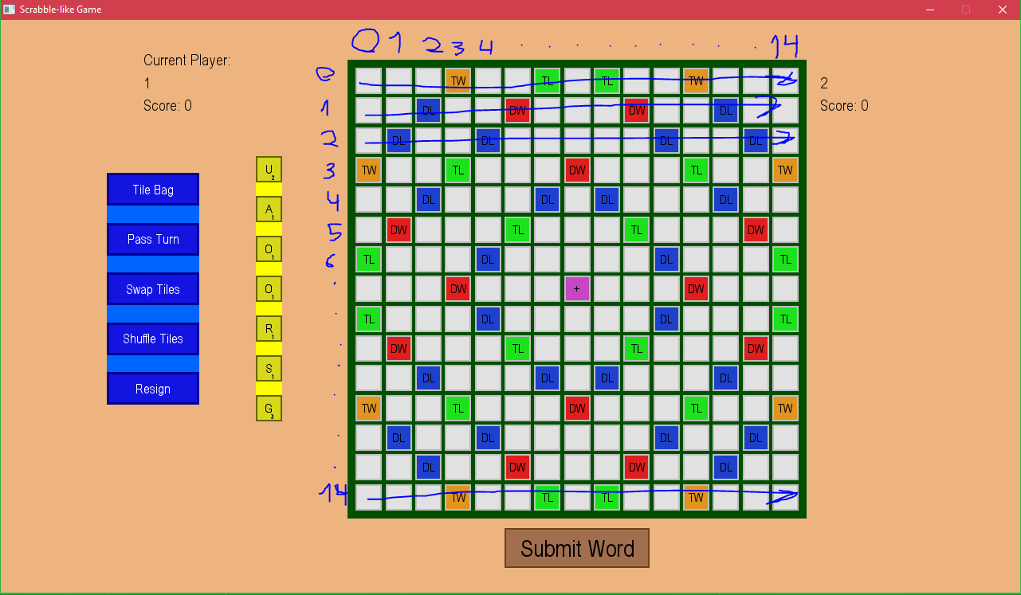

With ‘y’ representing the vertical numbers, and ‘x’ the horizontal numbers.

Let the following board be the board which the AI sees:

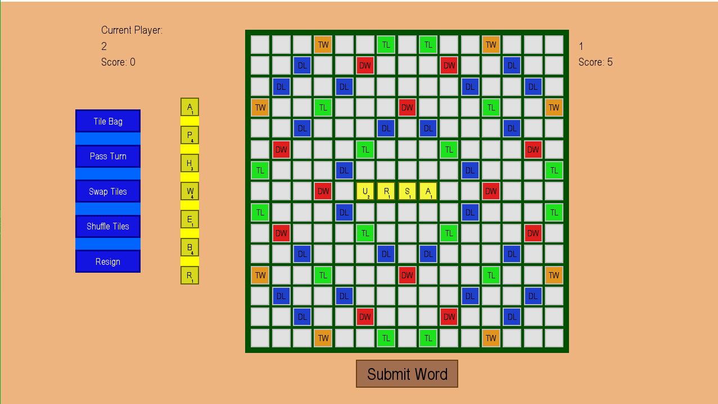

It goes through the holders, in the previously mentioned order, and checks whether there was a tile placed down on it. It does this until it runs into a holder which does have a LetterTile placed down on it. Therefore, in the example, the first instance of this, would be when y = 7, and x = 5 (the letter ‘U’). The most efficient way to not repeat our checking is to only ‘hook’ onto the end of words. The AI can know if the tile which are at the current x and y coordinates is the last tile of the word by checking for whether it’s at the right edge of the board or if the tile holder to the right of it is empty for horizontal words, or if the tile is at the bottom edge or there is no tile underneath it in the tile holder for a vertical word. In the example with the ‘U’, the horizontal test will fail, but the vertical test will pass, as it is at the end of a vertical word, and so the AI can try ‘hooking’ onto this letter to form a new word. We do this using the HookV() method (or hook vertical; the HookH() method is hook horizontal, and works very similarly to the HookV() method, so I will only explain one, and will allow the reader to extrapolate how the other one works).

The HookV() method (line 102) takes in the arguments of the positions on the board at which the tile we are wanting to hook onto is located. So, in our example, we enter it with x = 5 and y = 7. The ‘start_pos’ argument contains the coordinates at which the initially started hooking. If they aren’t passed in, then we assume that the current ‘x’ and ‘y’ are these. The Boolean ‘forward’ tells us if we are trying to place letters forwards or backwards (where up and left are backwards, or forward = False, and down and right are forwards, or forward = True). The argument ‘word’ should contain the word which has been formed so far (this will be in a format understandable by GADDAG, not a plain word). The ‘tile_placed’ arguments is another Boolean which keeps track of whether a tile has been placed. If no tile has been placed, then the AI has not actually placed anything down, and so we don’t have to check if the word placed down is valid or not (as it is not valid, saving us time). And the last parameter, ‘poss_list’, when the method receives an argument for it, it contains the pair of position on rack of lettertile which was moved and the position which the lettertile was moved to on the board, as a tuple of two elements, the first of which is an integer, and the second is a tuple of two integers. If this list does not exist, then we instantiate it. Otherwise we make use of the current one.

If we are hooking onto a lettertile, we can assume that that lettertile is in a valid position, meaning our word will contain the letter which we are hooking onto. In our example, when we are hooking onto ‘U’, we can assume that it is valid (which it obviously is, as otherwise we would not have been able to submit the word ’ursa’). Therefore, we can concatenate this letter onto ‘word’ (line 110).

Now, because we might have formed a word, we check if we actually have formed a word. The way we do this is by checking if we have placed a tile down, checking if the word which we have formed is actually a valid word (is in the dictionary), its length is greater than 0, its last character is not an ‘@’ symbol (which is the delimiter for going forwards; this is more of a failsafe check. It should never actually happen), and there is no lettertile placed down directly before (if going backwards) or directly after (if going forwards) the current position which we are looking at (because if there is, the partial word mghit be valid, but the whole word might not be; for example, we might have formed the word ‘and’, but to the right of it there are the letters ‘so’. ‘and’ is valid, however ‘andso’ is not a valid word, so we don’t want it to be counted as a valid word). Then, if this criteria is passed, then we can calculate the score which this word would get us, and then we append a tuple of the current state of the ‘poss_list’, along with the score, to the ‘best_words’ list. Later on, once we find all possible words and see which one would get us the highest score, we can easily place down the word which gives the greatest score, using methods which we have already implemented in the Game() class, using these exact values. In our case, this test is failed on the very first check of ‘tile_placed’ which will be false, as no tile has been placed; ‘U’ already existed when we hooked onto it.

The next step is to calculate which position to look at next. If we are not at the top edge and are going backwards, then we can move one tile holder up with our coordinates (i.e. decrement ‘y’ by one); if we are at the top edge, and the start position isn’t at the bottom edge, then we can move forwards. This requires us to go one in front of the starting position (i.e. ‘start_pos’). The reason that we concatenate an ‘@’ to word is because of how GADDAG stores words. If we are not at the bottom edge and going forward, then we want to go forwards by one; if we are at the bottom edge and going forward, then we need to terminate (as we can’t form any words off the board); if our y position is less than 0, then something has gone horribly wrong, so we raise an error (this has never happened, but is more there so that if it crashes on this line, I know why it crashes).

Now that we have calculated the coordinates of the next holder, we can move to it. If there is already a lettertile on it (line 134), then we hook onto it, with the just calculated arguments. Otherwise, if there is no lettertile on that holder, we need to try to place one down and form a word. The way this is done is by a depth first search using our rack lettertiles and GADDAG:

We go through each tile position in our rack (line 137) (positions instead of actual tiles, as it’s easier to place down tiles using their position than using the actual tile, because of the way the move tile methods in game were coded), and if there is actually a lettertile in that position on our rack, then we get the letter which that tile represents, and if it is a wildcard, we do the same process as if it wasn’t a wildcard for each letter which it can possibly be (using the alphabet list we made in the constructor), and if it wasn’t a wildcard letter and the word which it would form is a valid path in our GADDAG (i.e. it has a chance of forming a word eventually) (line 151), then we try placing it down in the newly calculated position on the board, and if the horizontal row which is affected by this doesn’t have any conflicting words by us taking this action (line 153), then we append to ‘poss_list’, and we HookV() onto that just placed down tile. Once that HookV() call terminates, we remove the last entry from the ‘poss_list’, as it is no longer valid at this level of recursion. Finally, we put the tile from the board back onto our rack, and importantly, back into the same position it came out of. Just before exiting the while loop on line 223, there is another check done. This checks whether we have attempted to go forwards in our word yet, as so far the above talked about code would only generate words which are formed before the hook tile. If we have not attempted to go forwards yet, then we attempt to go forwards, again by adding and ‘@’ to ‘word’, and setting the position to one after the start position, and treating the situation as if it is normal. Next time we run into this if statement, we break out of the loop, as forward is marked as forward.

Visually, what this looks like, is the following:

The AI attempts to place down the letter ‘A’ in front of ‘U’:

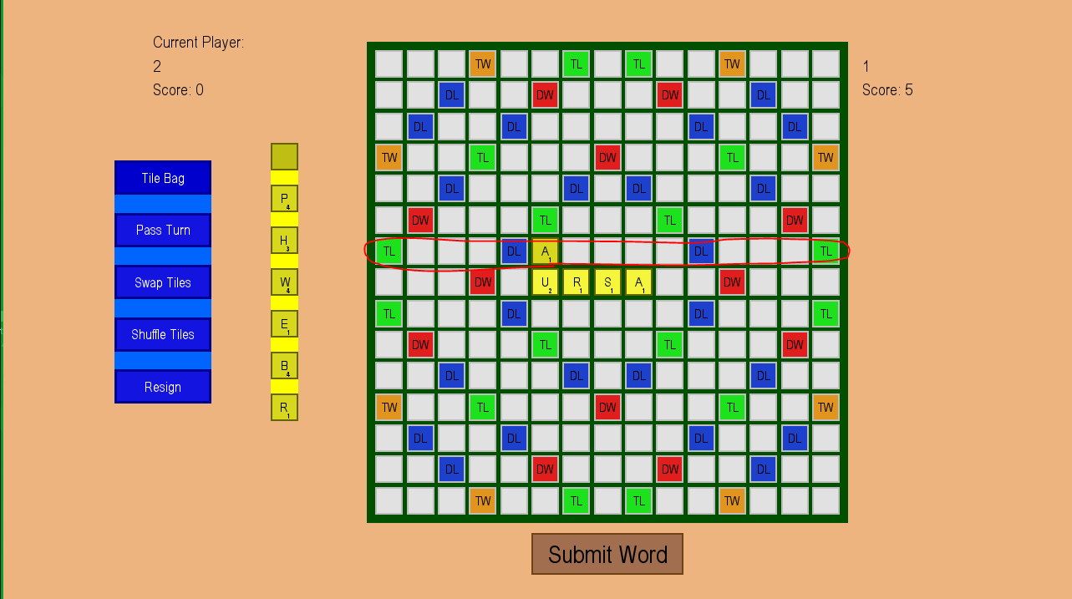

If ‘UA’ (not ‘AU’) has the possibility of forming a word, then we check if the words formed in the circled row are all still valid. If they are valid, then we continue with the search recursively. If we run into a word, we append it onto our ‘best_words’ list and continue (as covered above).

We check if the circled row is valid is using the HorizontalWordAtPos() method (line 45). The way this is done is by looking at both side of the tile which was just placed down. We traverse to the left, concatenating any letter we run across. Once we reach either the edge or an empty holder, it means that we now want to check the right of the just placed down tile, so we append an ‘@’, and go to one tile after the starting position, and concatenate the remaining tiles to the right, again until we come across either the right edge or an empty tileholder. Once we have ‘collected’ all of these, if there is an ‘@’ at the end, we remove it, as it means that there was nothing to the right of the tile which was placed down, and we have to adjust it so that GADDAG accepts it. Next, if the word which was formed has a length of one, then it is instantly accepted, as it means that the tile which was just placed down doesn’t cause any new words to be formed in that row. Otherwise, we just check if the word which was formed is in our dictionary, and the result depends on that (line 71).

Now, coming back to lines 17 – 31, if the AI needs to place a tile down on the central holder. The way this is dealt with is by placing down each tile in the player’s rack, and hooking onto that. It is again, done both with HookV() and HookH(). Also, similarly to in HookV(), if the AI tries to place down a wildcard on the central holder, it needs to be dealt with separately, again by going through the alphabet list.

So, now that the AI has found all of the possible words which it can place down and sorted them in descending order based on their score (after line 242), (let’s assume that there was at least one word found) we need to place the best word down. This is actually quite easy with the list of values which we generated. We can call our PlaceLetters() method with the argument of our best word, and starting on line 232, we place the tiles down using methods which we defined in previous iterations. We do however need to be careful and differentiate between wildcard letters and non-wildcard letters. If they are not wildcards, then they are placed down only with two arguments to MoveRackTileToBoard(), whereas when it is a wildcard, we also need to tell it which letter we want the wildcard to become, so we also pass that in.

A different possible approach for the AI to find all valid words it can place down would be to go through the dictionary, and for each word, try to fit it on the board in every possible position which is a valid one, according to my previously coded methods. This method is not deterministic, and its big O is exponential (with an increase in board size), which means it would take quite a long time for the AI to be able to find all valid words, due to having to check each location, vertically and horizontally a number of times as there are words in the dictionary. This could be slightly optimised using regular expression, however it would still not be deterministic, and much slower than my current solution; the solution of using a DAG structure would significantly speed up this process, and even use less memory than my solution, however it would still be non-deterministic and would take long, due to having to check prefixes of words.

As this part of my implementation was about the AI, which the user has no control over, I have had no need to consider any validation, as what the user can interact with has stayed the same.

I will just insert a screenshot of the near ending state of the game when the AI is allowed to play all turns by itself (I just pass turn):

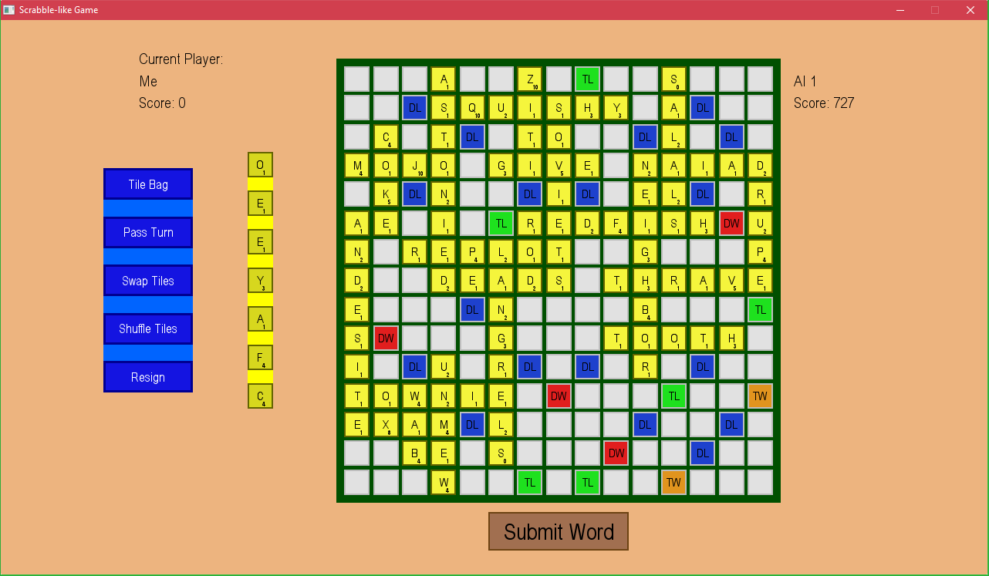

And all of these words are in my dictionary file (which can again be found on Zynga’s rulebook webpage for ‘words with friends’)!

Now that the full game is complete, I am again going to include all tests:

|  |  |  |  |  |  |
| --- | --- | --- | --- | --- | --- |
| **Test**  **Num** | **Type** | **Data** | **Expected result** | **Actual result** | **Comments/solution** |
| 1 | Invalid | In any of the scenes, if the player clicks on a non-button object (i.e. on the background/text) | Nothing should happen (In reality, the click will be registered, but no action will be taken because of that click) | Working as intended | N/A |
| 2 | Valid | The VS AI button on main menu is clicked | The current scene changes to the next scene where the user is allowed to enter their nickname | Working as intended | N/A |
| 3 | Valid | The vs player button on main menu is clicked | The current scene changes to the next scene where the user is allowed to enter their nickname | Working as intended. | N/A |
| 4 | Valid | The online button on main menu is clicked | The current scene changes to the next scene where the user is allowed to enter their nickname | I am redirected to a scene telling me that this has not been implemented yet | I still need to implement the online transition scene and then the scene with the actual game on it. This requires me to make a new subclass of scene, similar to how I have done for my MainMenuScene. |
| 5 | Valid | The exit game button is clicked | The game exits | Working as intended. | N/A |
| 6 | Valid | The ‘x’ button in the top right corner of the game windows is clicked | The game exits | Working as intended. | N/A |
| 7 | Invalid | The user right clicks on a button | Nothing should happen (In reality, the click will be registered, but no action will be taken because of that click) | Working as intended. | I decided to improve on this, so that the user still cannot right click on a button, however right clicking (anywhere) cancels their selection of a tile. |
| 8 | Valid | Make sure that the user’s nickname is correctly stored | When the user enters their valid nickname on the scene after main menu, it is correctly recorded in the string variable, and not truncated or with extra characters | Working as intended | N/A |
| 9 | Invalid Boundary | The user enters a nickname which doesn’t fit in the nickname field | Once the character limit is reached, no more characters are recorded in the string variable responsible for storing their nickname, and no more letters are shown on the screen | Working as intended | N/A |
| 10 | Valid | What happens when the user presses backspace when entering their username | When the user is entering their nickname, they should be allowed to use backspace to delete the last character in their entered nickname | Working as intended | N/A |
| 11 | Valid | Clicking the next button on the nickname entry scene | When clicked, the scene should change to the next scene (which in the case of VS AI is the game scene, in the case of vs player is the next player’s nickname entry scene, and in the case of online is a waiting screen) | Instead of a next button, I decided to just ask the user to press the enter key. Otherwise, working as intended. | N/A |
| 12 | Valid | Whether game times out | While on the waiting screen for online play, if a game isn’t found in a specified amount of time, the waiting should time out, and the scene should be changed back to the menu scene | Nothing happens | This still needs work if I decide to make my game online |
| 13 | Valid | Whether the game starts | After the waiting screen, if a connection is found, then the game object should be instantiated and a game should start, with a change of scene to show for it. | Working as intended | N/A |
| 14a | valid | Tile bag button is pressed | A small pop up should show up on the scene to show the remaining tiles in the bag along with the tiles of the opponent in one list like display | Working as intended (for the implemented parts) | N/A |
| 14b | Valid | Player clicks on close window button (of TileBag window) | Once the player is done looking at the tile bag, they should be able to press the close button to hide the tile bag window visual element | Working as intended | N/A |
| 15 | valid | Pass turn button is pressed | The current player’s turn should be forfeited, with no points, and the current player’s turn should be switched | Working as intended | N/A |
| 16 | Valid | shuffle tiles button pressed | The visual positions of the letter tiles on the player’s rack should be shuffled (along with their coordinates in background code, so that a button click is registered correctly) | Working as intended. | N/A |
| 17a | Valid | Swap tiles button is pressed | A pop up window-like thing should show up allowing the user to put tiles from their rack into it | Working as intended | N/A |
| 17b | Valid | Player clicks on close window button (of swap tile window) | If the player changes their mind about swapping their tiles, they can press this button, and the position of their letter tiles should reset, along with hiding the visual element | Working as intended; instead of being called close window, it is just called cancel instead. | N/A |
| 17c | valid | Player clicks on submit swap button (of swap tile window) | New tiles are put into the player’s rack (visually and logically) and the ones which they submitted to the swap are taken away. | Working as intended | N/A |
| 18 | Valid | Resign button clicked | The game announces the other player as a winner in a windows for a few seconds, and then goes back to main menu | Working as intended | N/A |
| 19a | Valid | Submit word button pressed (with a valid word on board) | The current player’s score is incremented according to scrabble rules, and it’s the next player’s turn, unless the current player no longer has any letters left in their rack, in which case a winner is calculated and announced. | Working as intended. | N/A |
| 19b | invalid | Submit word button pressed (with an invalid word on board) | A small pop-up appears telling the user that the word which they entered is invalid, and no further action is taken (i.e. the players aren’t swapped) | Working as intended, with a prompt to the user. | N/A |
| 20 | valid | Reset letter button is clicked | The board tiles which gained letter tile links on this turn are unlinked with their letter tiles, and the letter tiles are restored to their old coordinates, visually and logically. | I decided that a discrete button for this is not required, which is why I added this functionality to the shuffle tiles button, which works as intended (inclusive of this functionality) | See shuffle tiles row |
| 21 | invalid | During the waiting time between player swaps, the player clicks a button | Nothing should happen (In reality, the click will be registered, but no action will be taken because of that click) | Working as intended | N/A |
| 22 | Valid | Click on board tile (while holding a letter tile) | The letter tile which is held gets visually and logically moved onto the clicked board tile, and the board tile gets a logical connection to the letter tile | Working as intended | N/A |
| 23 | invalid | Click on board tile (while not holding a letter tile) | Nothing should happen (In reality, the click will be registered, but no action will be taken because of that click) | Working as intended | N/A |
| 24 | Valid | Click on letter tile in rack (while not holding another letter tile) | The currently held letter tile is changed to the clicked letter tile | Working as intended | N/A |
| 25 | invalid | Click on letter tile in rack (while holding another letter tile) | The currently held letter tile is changed to the newly clicked letter tile | The current selection gets cancelled (and then the user click again to select); Working as intended | Although it is not exactly the way that I specified that it will be done in, I am satisfied with the current result, as it makes sense. |

## Implementation Iteration 8 (v 1.2.1)

From user testing, I received feedback that my AI does not consider the situation when it can add an extra letter to the end of a word, and then form a word in the other axis. For example, if the word ‘hair’ was in the horizontal axis, and the AI had the letters ‘s’, ‘e’, and ‘t’, it would not be able to form the word ‘set’ in the vertical axis. It would instead play the word ‘hairs’. In this iteration, I addressed and fixed this issue by changing a few things in HookH() and HookV():

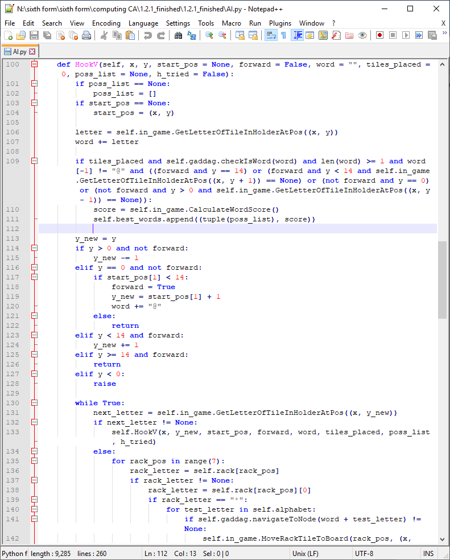

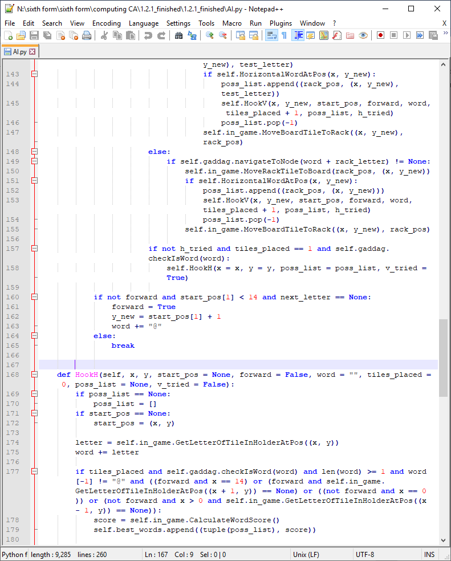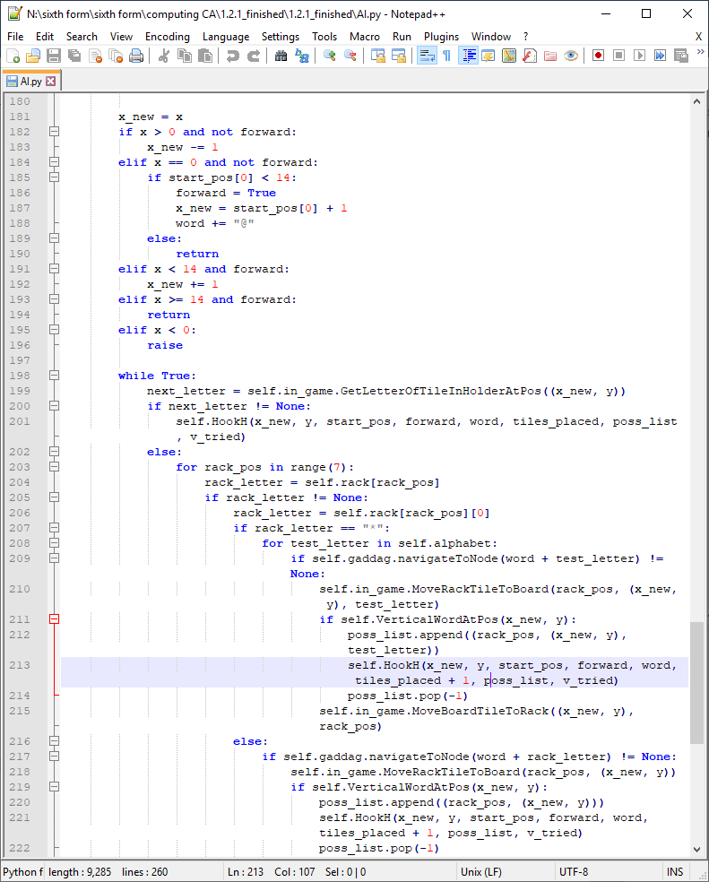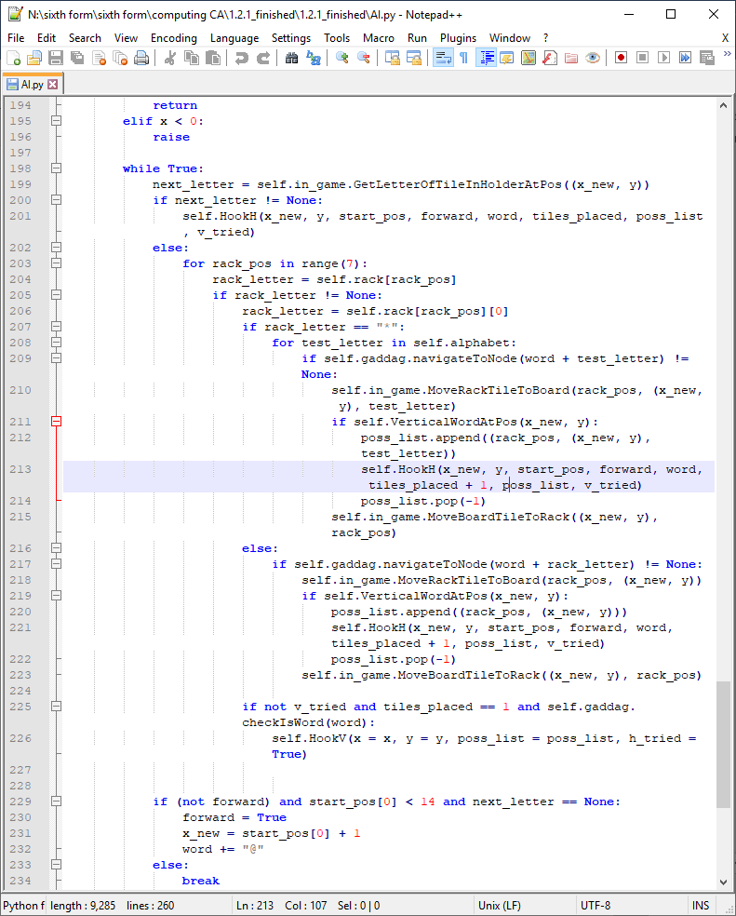

So, instead of just saying whether there was a tile placed down, I count how many tiles were placed down. If only one was placed down, then there is a possibility that the above mentioned case could have occurred. There is also the extra parameter of ‘v_tried’ and ‘h_tried’ which just make sure that no infinite recursion occurs, as if I tried to hook onto that one newly placed tile with the different axis hook, then it might try to hook back onto where it came from, causing infinite recursion. The ‘x_new’ and ‘y_new’ are added in so that I can also have access to the previous x and y values, as these are the ones I would need to hook onto if the are wanting to hook on the other axis.

So, the way it is done, is the addition of line 225 and 226 (and respectively in the other axis method), which check the above, and also that the formed two letter word is actually a valid word. If so, we can try hooking onto the one newly placed lettertile in the other axis, and forming a word there.

As this part of my implementation was about the AI, which the user has no control over, I have had no need to consider any validation, as what the user can interact with has stayed the same.

## Extra note

On a side note, there are things in my program which have not been covered in this development section due to how minor they are (mainly things such as brackets, or small logical errors), which is why I will include my full program in the appendix, so that one can make sure they know the exact code for the working solution.

# Task 4: Post Development Testing

Now that the product is complete and tested using the development testing criteria, I am ready to see whether it passes the post-development criteria, as mentioned in Task 2.

## Post Development Testing Tables

I will be doing all of the following testing against the AI, as it is easier, more convenient and faster, along with testing the AI AND the user in the process. Also, please excuse any inappropriate words it plays, as it has no filter; it only tries to play the best scoring words that it can from a given dictionary.

### End User Testing

|  |  |  |  |  |  |
| --- | --- | --- | --- | --- | --- |
| **Test Num** | **Data** | **Expected result** | **Actual result** | | **Comments** |
| 1 | User clicks on ‘Online’ button | The scene is changed; the user is asked to enter their name. After entering their name and pressing a button to submit it, they are asked to wait for a match. After an opponent is found, the scene changes again to the main game scene. | FAIL: | | Online play was no implemented due to a lack of time. |
| 2 | User clicks on ‘VS. Player’ button | The scene is changed; the user is asked to enter their name. After entering their name and pressing a button to submit it, the same is repeated for the other player. Once the second player submits, the scene changes again to the main game scene. | PASS: | |  |
| 3 | User clicks on ‘VS. AI’ button | The scene is changed; the user is asked to enter their name. After entering their name and pressing a button to submit it, the scene changes again to the main game scene. | PASS: | |  |
| 4 | User clicks on ‘Exit Game’ button | The game window disappears | PASS  (Best I can do to demonstrate this is to hover over the ‘Exit Game’ Button; without a video, there is no way to prove it): | |  |
| 5 | User clicks on ‘Tile Bag button | A pop-up with all remaining LetterTiles along with the opponent’s LetterTiles shows up | PASS: | |  |
| 6 | User clicks on ‘Pass Turn’ button | A pop-up asking the user to confirm their turn pass shows up | Mainly PASS:  (This situation is a continuation of the previous; I clicked the ‘Pass Turn’ button:) | | The turn is passed, however the user is not asked to confirm whether they want to pass. |
| 7 | User clicks on ‘Swap Tiles’ button | A pop-up allowing them to choose which tile they want to swap shows up. When they click one of their tiles, an indicator shows up next to it. | PASS:  Here, the user has clicked on the ‘Swap Tiles’ button:    Then, they have selecte ‘L’, ‘T’ and ‘U’ to swap out:    (The crosses over the letters, along with all other letter, look much nicer, as they are bolder and more centred on Ubuntu; I am not sure why they look so bad on Windows)  When the user clicks cancel, nothing happens:    And if they had clicked submit:    Notice that those three letters were swapped out, the AI took its turn, and now it’s the human’s turn. | |  |
| 8 | User clicks on ‘Shuffle Tiles’ button | The order of the tiles on the player’s rack is changed | PASS:  Following the above screenshots, if the user clicks on the ‘Shuffle Tiles’ button, their rack looks like: | |  |
| 9 | User clicks on ‘Resign’ button | A pop-up asking the user to confirm resignation shows up | Mainly PASS:  There is no pop-up asking the user to confirm their choice after clicking the ‘Resign’ button, however the game does end, the other player wins, and we are returned to the main menu: (this screenshot doesn’t follow on from the previous one) | |  |
| 10 | User clicks on ‘Submit Word’ button | If the word is valid, the user’s score increases, and depending on gamemode (what they chose to play against), the turn changes instantly or after a few seconds. | PASS:  This is before submitting the (invalid) word:    If the user presses the ‘Submit Word’ button, then:    However, if they try to submit a valid word, such as:    Then:    The word is submitted, the player receives the appropriate amount of points for it, the AI takes its turn, and then it’s the human’s turn again. | |  |
| 11 | User clicks on a LetterTile | The clicked LetterTile changes colour/gets raised/lowered to signify the click | PASS:  (Following on from previously)  For example, if the user clicks on the letter ‘D’,    (Notice how the ‘D’ is highlighted, signifying that it has been clicked; in the next click, it can be moved) | |  |
| 12 | User clicks on a BoardTile | If a LetterTile was clicked before this click, the said LetterTile moves to here. Otherwise, nothing happens. | PASS:  (Following on from the previous screenshot:)  Now, after we clicked ‘D’, we place it on the board: | |  |
| 13 | User clicks on cross button to close swap tiles/tile bag pop-up | The pop-up disappears | PASS:  After opening the tile bag:    If we click the top-right ‘x’ button: | |  |
| 14 | User clicks on submit pass turn button | The players change turns. | FAIL | I decided to implement the pass turn mechanic without asking the user for confirmation (see test 6) | |
| 15 | User clicks on cancel pass turn button | The pop-up disappears. | FAIL | I decided to implement the pass turn mechanic without asking the user for confirmation (see test 6) | |
| 16 | User clicks on submit resign button | A pop-up appears announcing the other player as the winner for a few seconds, after which the scene is changed to the main menu scene. | FAIL | I decided to implement the resign button mechanic without asking the user for confirmation (see test 9) | |
| 17 | User clicks on cancel resignation button | The pop-up disappears. | FAIL | I decided to implement the resign button mechanic without asking the user for confirmation (see test 9) | |
| 18 | User clicks on confirm tile swap button | The LetterTiles which the user submitted get changed with random tiles from the TileBag. | PASS | | See test 7 |

### Robustness Testing

|  |  |  |  |  |  |  |  |
| --- | --- | --- | --- | --- | --- | --- | --- |
| **Test Num** | **Data** | **Expected result** | **Actual result** | | | | **Comments** |
| 1 | Clicking quickly and randomly in random places (monitoring if program can keep up with all actions, or if it just crashes) | Records all clicks as it normally would, and does what it is expected of it to do | (Probably a) PASS  (Cannot demonstrate this without a video, but from my limited testing, it doesn’t crash/do anything unexpected) | | | This is one which is more difficult to test, as I would need to get a lot of users to test it, and report if they run into a random crash, which could probably be attributed to this. If I test it myself, I wouldn’t be able to test enough things quickly enough, so it’s difficult to say for sure for this test. | |
| 2 | Player resigns game, with a word on the board, and then clicks submit word during the short time they have before the pop-up | The submit word button does nothing and the game announces the other player as the winner regardless. | PASS:  In the following example, I have only placed the letters down on the board:    Then, I will quickly press ‘Resign, and try to click submit button; after the winner is displayed as being ‘AI 1’, even though I attempts to click the button, nothing happens, and I am returned to:    (Again, without a video, this is difficult to prove) | | | |  |
| 3 | A random (unhandled) error causes the game to crash | A try: except: code all around my code would be able to handle this, and inform the user of something going wrong, telling them to restart the game if they want to play again. | FAIL? | | I have no way of reporting errors, so this would not be very useful. From my testing, I have not run into any kind of random error message, but perhaps if I had enough users for my game, One of them might run into one, and I could just ask them to tell me what they were doing before it happened or read out the red text in the IDLE. | | |
| 4 | Player tries to click on swap tile button multiple times hoping to open multiple swap pop-ups | Only one pop-up opens, and the player can only make one swap before their turn is switched. | PASS:  In the following example, I have clicked the ‘Swap Tiles’ button multiple times:    Then, when I press the ‘Cancel’ button just once:    If I instead clicked the submit button with a letter not selected:    (which is as expected; the turn didn’t change)  And if I did it with a letter selected: | | | |  |
| 5 | Player clicks on button multiple times quickly | The button click only does what it’s meant to do as many times as it’s meant to do (e.g. resign only resigns for the current player, whereas submit word might allow the user to try submitting more than once, shuffle button finishes shuffle before registering another shuffle) | From my experience PASS;  I have no real way to actually prove this, as there are too many buttons to test individually. The test would be similar to test 4. | | | | Similarly to test 1, this requires a larger sample size. |
| 6 | Does the game time out in online play | When player is waiting to find a connection and no one joins, the player is returned to the main menu | FAIL | | | | This part of the game was not implemented |
| 7 | Entering a name that’s too long | Player can only enter a short enough name | PASS  The player’s name can have a maximum length of 12 characters. So, for example if they try to enter any more characters on the following scene:    Nothing happens.  Once they press enter, the game they enter looks like:    Which only proves that although they might try entering a name longer than 12 characters, only the first 12 are registered (see nickname in top-left) | | | |  |
| 8 | Randomly right clicking elements | Nothing happens | PASS  No real way to prove this once again | Unless they had selected a tile beforehand, nothing happens. Otherwise, the tile gets deselected, which is wanted behaviour. | | | |

### Whole System Testing

|  |  |  |  |  |
| --- | --- | --- | --- | --- |
| **Test**  **Num** | **Data** | **Expected result** | **Actual result** | **Comments/solution** |
| 1 | Click on LetterTile in rack and then on board tile in rack | The letter tile sticks onto the board tile | PASS      (I moved the letter ‘A’ onto the board, and it stays there) |  |
| 2 | Clicking on buttons during player swaps | Nothing happens | FAIL  For this, I had to switch over to player vs player mode:  If the ‘Pass Turn’ button is pressed twice quickly in succession, it’s the player who clicked it’s turn:  (Before double clicking the button:)    (After double clicking it:)    There is a similar result if the player ‘1’ clicks pass turn and within the 5 second window to swap over clicks the ‘Tile Bag’ button; player ‘1’’s turn is passed, and once it’s player ‘2’’s turn, the tile bag is open: | I think that this is a problem with how the pygame wait function works. For some reason it still records the actions which are done during the wait period. A similar thing happens if when the user is in the main menu, they click on the ‘Online’ button, and then click in the position of any of the other three buttons – the button which they would have clicked had the main menu been there is clicked. This could probably be fixed by using the ‘time’ module and its sleep method instead of pygame’s wait function, however I only just became aware of this, and don’t think that it’s a major problem. The user might just need to watch out for redundant clicks. |
| 3 | Clicking reset letter button | button puts the letter tiles back on the rack | PASS?    When the user clicks the button: | The functionality was combined with the ‘Shuffle Tiles’ button instead of being a separate button. |
| 4 | Submit button pressed | If the board configuration registered a valid move, it should be the next player’s turn, and current player’s score is increased. Otherwise, the player should be informed that their move was invalid. | PASS    After clicking the button:    (The word is submitted, and the AI automatically makes a move, bringing me back to my turn; importantly, the word ‘FA’, which is valid, was submitted) |  |
| 5 | Resign button clicked | Game ends after announcing other player as winner | PASS  (See test 9 of ‘End User Testing’ above for screenshots) |  |
| 6 | Swap tile button is clicked | New windows shows up where the player can put the tiles which they don’t want to swap out | PASS  (See test 7 of ‘End User Testing’ above for screenshots) |  |
| 7 | Player clicks on submit swap button (of swap tile window) | Selected tiles are swapped with new tiles from the tile bag | PASS  (See test 7 of ‘End User Testing’ above for screenshots) |  |
| 8 | Player clicks on close window button (of swap tile window) | Window closes | PASS; instead of being called close, it’s called cancel  (See test 7 of ‘End User Testing’ above for screenshots) |  |
| 9 | Shuffle button pressed | Letter tiles on their rack are shuffled | PASS  (See test 8 of ‘End User Testing’ above for screenshots) |  |
| 10 | Player pressed pass turn button | Player’s turn ends, and it’s the other player’s turn | PASS  Before clicking pass turn:    After clicking pass turn:    You can observe that I didn’t place a word down (partly by the fact that my letter tiles are all the same) |  |
| 11 | Player clicks on tile bag button | All remaining letters by scrabble rules are displayed | PASS |  |
| 12 | Click on close window button of tile bag | Window closes | PASS  (Continued from above) |  |
| 13 | Does the game start playing in online play | After player finds an opponent, the player is put on the game scene | FAIL | Not implemented |
| 14 | Does the name entering system work like you would expect it to in other games | It does work | PASS  As demonstrated throughout this whole section, the name entering system does work; for screenshots, see test 7 of ‘Robustness Testing’ above. |  |
| 15 | Clicking ‘x’ button of game window | Closes game | PASS  Can’t prove this without a video, as game ceases to exist |  |
| 16 | The exit game button is clicked | The game exits | PASS  Can’t prove this without a video, as game ceases to exist |  |
| 17 | A button (other than exit game) on main menu is clicked | Scene is changed | PASS  As demonstrated throughout the whole section, scenes to change successfully. |  |

## Success Criteria

In case some of the following test criteria from Task 1 were missed, I will discuss them here in more detail:

1. Register when a tile has been placed, and allow the tile to stay in the place where it was placed, unless the user moves it again. This should be shown graphically. Depending on the library I use to make my game graphical, this could be of varying degrees of difficulty, as I will somehow need to make sure that what the user is dragging and dropping visually actually lines up with the code.

* This was successful, but instead of having it to be drag and drop, the movement was done with two clicks.

1. When a player makes a valid move and confirms it, their score should increase, based on how much the tiles they placed down are worth and the bonus squares they are placed on. This also assumes that the word placed down was a valid word.

* This was successful.

1. Once the user clicks on a button to choose whether they want to play against another player or the AI, the game should start. If they chose another player, once their turn ends, it should be the other player’s turn. If they chose to play against the AI, then once their turn ends, they AI should make a move, and then it should be their turn again.

* This was successful.

1. Similarly to above, once they choose to play against the AI, I might allow them to click another button to choose AI difficulty. To alter AI difficulty, hardest would be for the AI to play the highest scoring word on their current turn, and for every easier level they choose, instead of playing the highest scoring word, the AI plays the second, or third highest scoring word.

* This criterion was not met, as there wasn’t enough time to design another scene in which the user can choose difficulty and also implement that in the AI class.

1. When the user resizes the window of the game, the game should shrink (down to a minimum size, set by me) in such a way that every element is still accessible. This could mean that the game will have to either lose its aspect ratio or have black pillars on the sides/top and bottom, which might be frustrating for some users.

* This was not met, as pygame does not allow it.

1. To test if the AI is playing the highest scoring word, I would either have to find a program which definitely plays the highest scoring word, or to just test it by giving it certain letters, where I know what the highest scoring word is. This approach of testing could be difficult as I would firstly need to find a program which already does what I want mine to do, or coming up with a situation where I know all possibilities and seeing if the AI plays the best one.

* This was not met, as the AI I created I suspect to do just this, so it’s difficult to know for sure if it always plays the highest scoring word. However, when given to other people to play against it, nobody has been able to beat it, which is a good sign that it plays quite well, and probably the highest scoring word in a given situation.

1. The success of this would be obvious: the user could interact with everything without actually typing much in, and doing most things in the game by using the graphical interface. How difficult this is depends on the library I decide to use. The limitations of a graphical interface compared to a textual interface is that it requires more coding.

* This was successful.

1. This would mean that if the user selects the ‘pass turn’ button, then they forfeit their turn, and the turn goes to their opponent, just as if they had placed a word down, without any errors. This would also mean that they would have to score no points.

* This was successful.

1. During a player’s turn, there should be a button that they can click, on the GUI which just shuffles all of their letters around on their rack. By shuffling their rack, all that should change should be the order in which the letters on their rack is. This is easily done for a textual based interface by shuffling a list randomly, however for a graphical interface, I might need to refresh the screen after the shuffle so that in the GUI the letters are actually mixed up, although they are the same letters.

* This was successful.

1. When the user places a word down on the board, and tries to submit it, it should be checked whether their word was a valid word by the game. I will know that this is successful by trying to put a word on the board, and then submitting it, and checking the game’s feedback against the dictionary file’s contents. A similar thing should happen for the AI, or the AI should just follow the dictionary file, meaning all of the words it makes are already valid, and not needed to be checked. The limitations to this might be that because the dictionary file is so large, it could take a long time to search through it each time to see if a word is valid. This is why the DAGGAD data structure could come in useful again, as it’s much faster to search through than a pure dictionary file.

* This was successful.

1. There would be a button that the user can click to resign the game. This would give the other player the win, and potentially ask whether the players would want a rematch, or at least put the user on the main menu. This would force a game to end, and because the winning conditions are different than to a normal game (where the players play until one runs out of letters), it would require a different step in checking winning conditions.

* This was successful.

1. The user should be able to click a button which displays all of the letters which are left in the bag (and the opponent’s rack). This list of letters should be quite easy to keep track of, as I will have a bag ‘list’ out of which letters will be drawn, and once a letter is drawn, it is just removed from that list and put into the player’s rack list.

* This was successful.

## Usability Testing

This section considers the wants of the target audience. To get feedback, I have designed a questionnaire, to see how the game is received, how it could be improved, and any other general feedback the user might have. This was done after they were able to play my completed game.

### Questionnaire

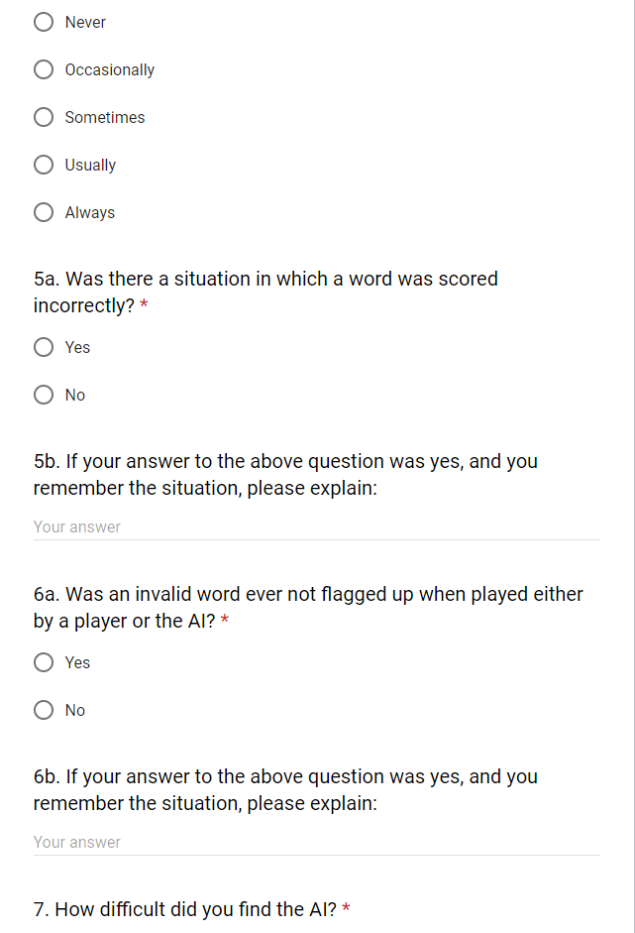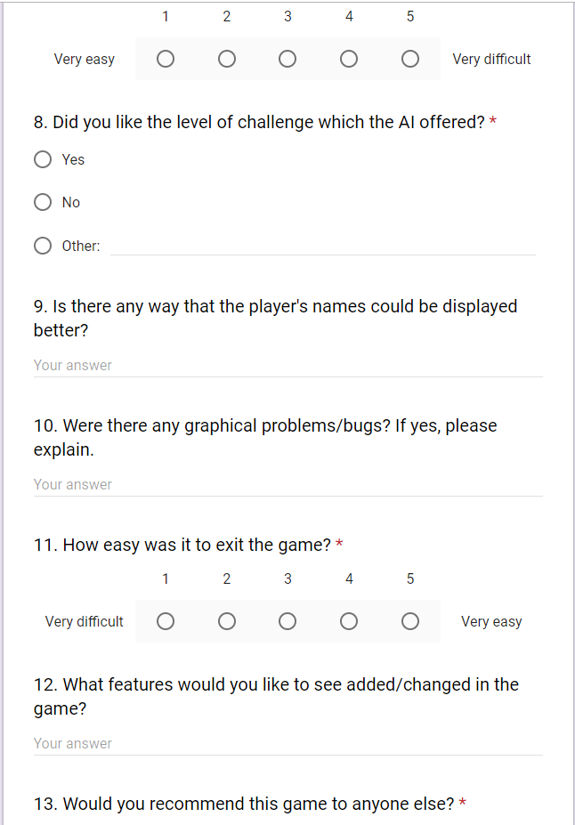 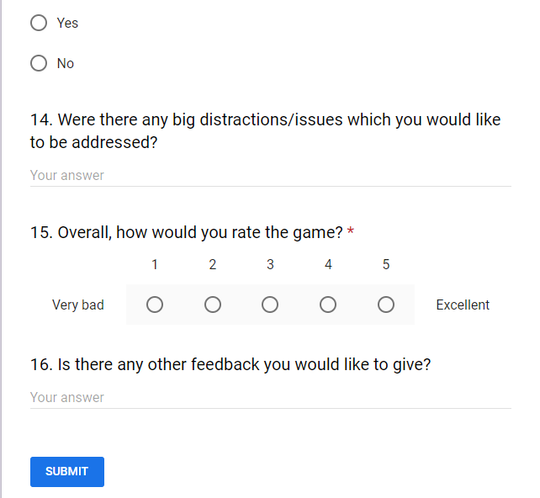

### Questionnaire Results

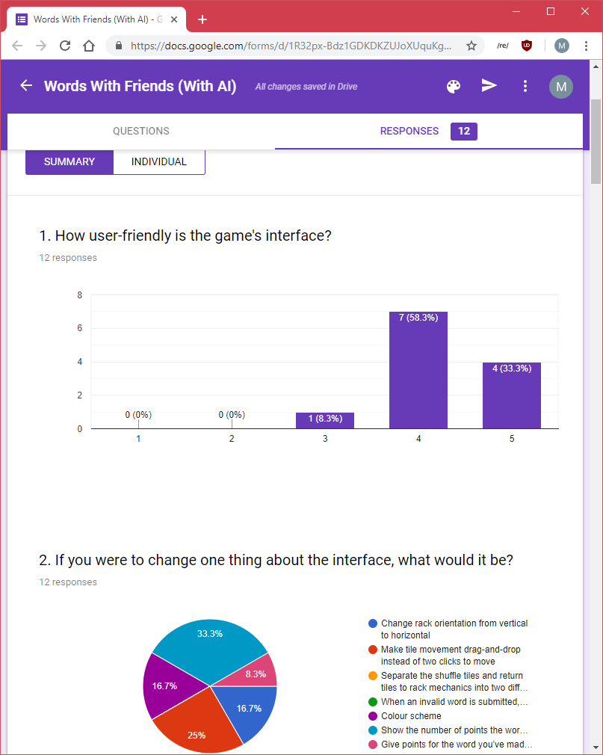

The first question is a general question about what the user though of the game’s user interface. They were able to rate it between 1 for worst, and 5 for best. The overall results show that the interface was decently well designed, as it has a median and mode rating of 4, and a mean rating of 4.25. This is actually better than expected for me, as I thought that the options which pygame offers would be too limited for a good user interface, so I am quite happy with this. If I were to improve the interface, I would not use pygame. However, back to the point of the feedback, it shows us that people in general found the interface well designed.

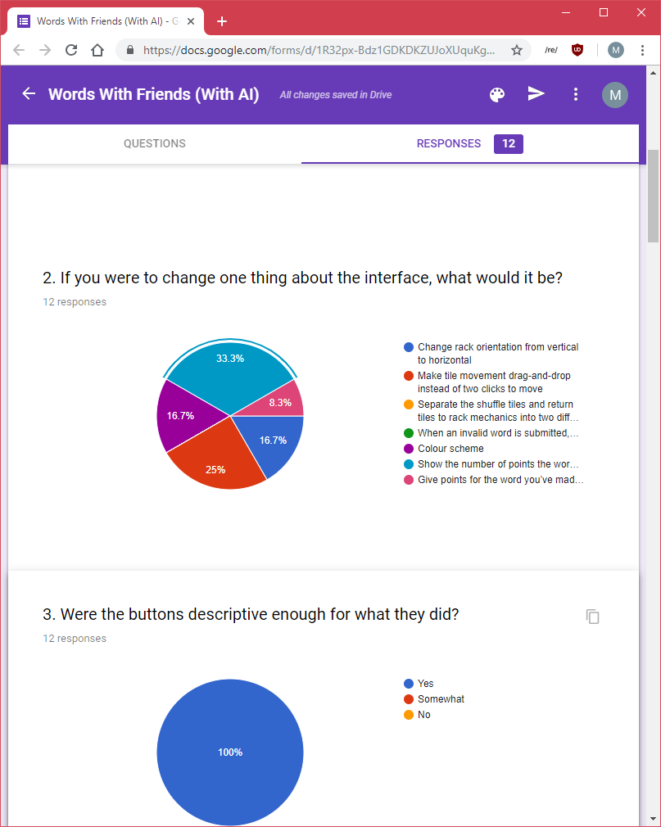

This question was mainly to collect feedback on what people might want to see implemented next in the game, or what they think might be missing from the game the most. As we can see, some of the features which I thought an end user might want to be implemented might not be that important to them, for example telling the player which word is wrong, or separating the shuffle tiles and bringing tiles back to the rack buttons. The most important to the end user was they know how many points the word they are about to submit would be worth, followed by making it easier to interact with the tiles by using drag-and-drop instead of two clicks to get the tiles to where the user wants to get them. The top feature request would not be that difficult to implement, I just had not considered it and my test subjects had no requested it before now, and so I ran out of time to be able to implement it now. The second feature I had given thought to, but because pygame can be frustrating to deal with graphics in, I decided to not do it unless time permits. Sadly, I did also run out of time for that as well. The spread of replies does also suggest that there is no one missing feature which is extremely wanted or missing from the game, which is a good sign, as it means that the core components of the game are there.

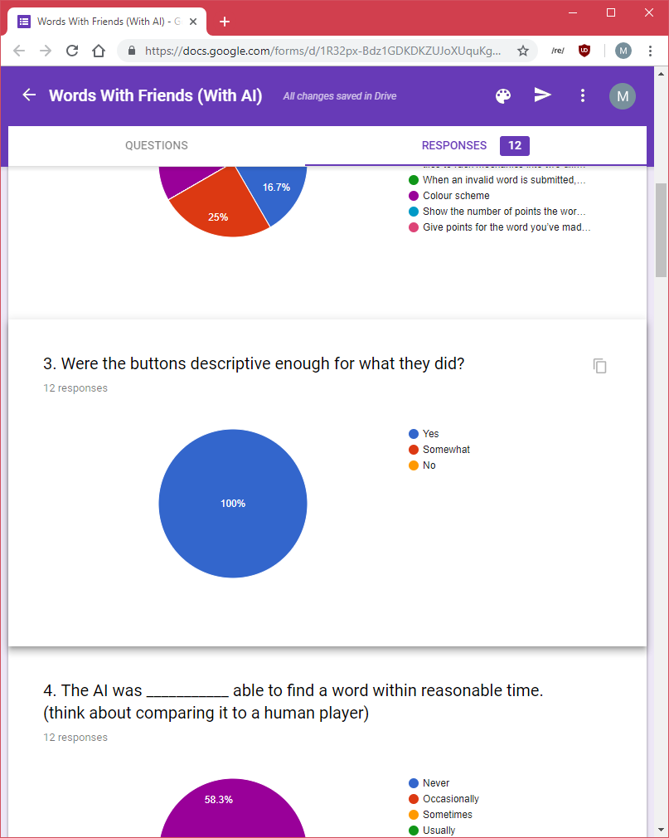

This was a simple question, just to expand on the user interface. The feedback is overwhelmingly positive, so there isn’t really much to say about it.

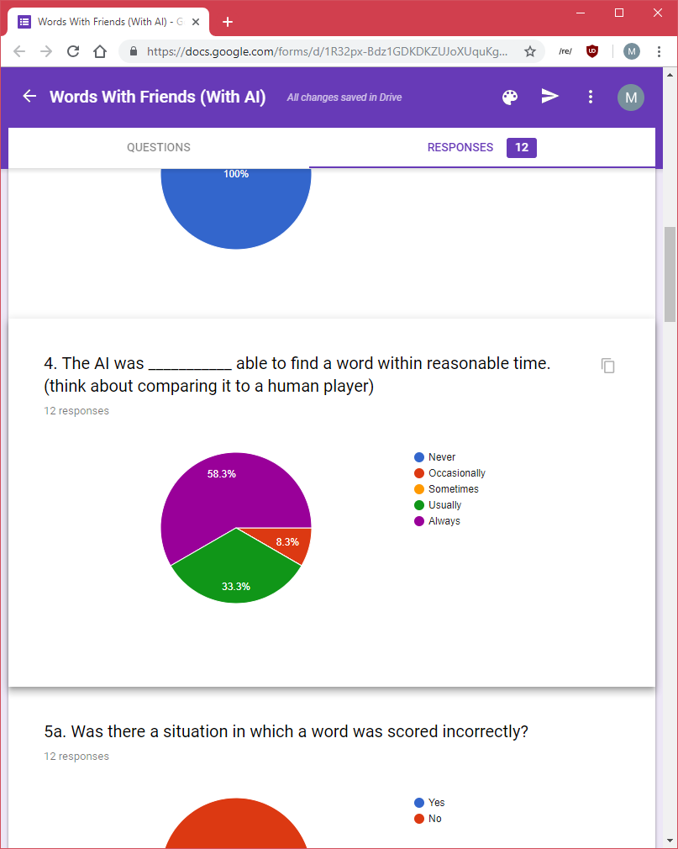

After fully developing the AI, I realised that it can take a few seconds to respond, and I had one situation in which windows even though the program was unresponsive (when in reality the AI was still trying to find the best result, and eventually it did). This question was asked to see whether the users were satisfied with this wait time, or if they would like it decreased. The comparison to a human is probably that it will still make a play faster than a human, in which case the user would probably be pleased with it, which is why I asked the question in the way that I did. From the results, we can see an overall positive response, meaning that even though the AI was developed quickly (as it was getting closer to the deadline) and not fully optimised, the user was satisfied with it.

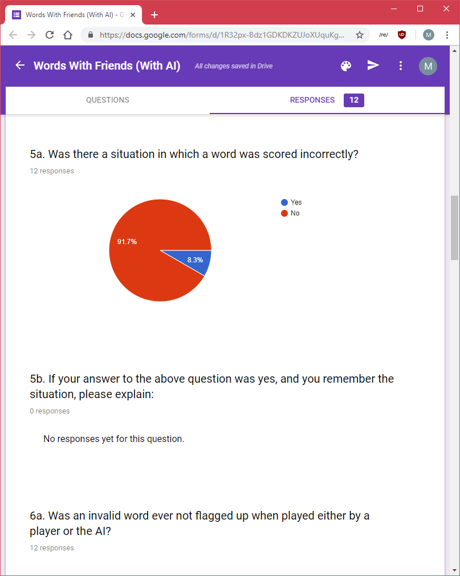

The question here was mainly asked to see if the program is functioning the way that my development tests say that they do. The response here is slightly questionable, as the responder was unable to provide feedback as to when the word was scored incorrectly, so I cannot fix the problem (if it exists, which I doubt it does, as it could have just been a mis-click on their part, or they had not calculated the score correctly). Even with one response being negative, I am quite satisfied with the overall result of the number of no invalid word responses.

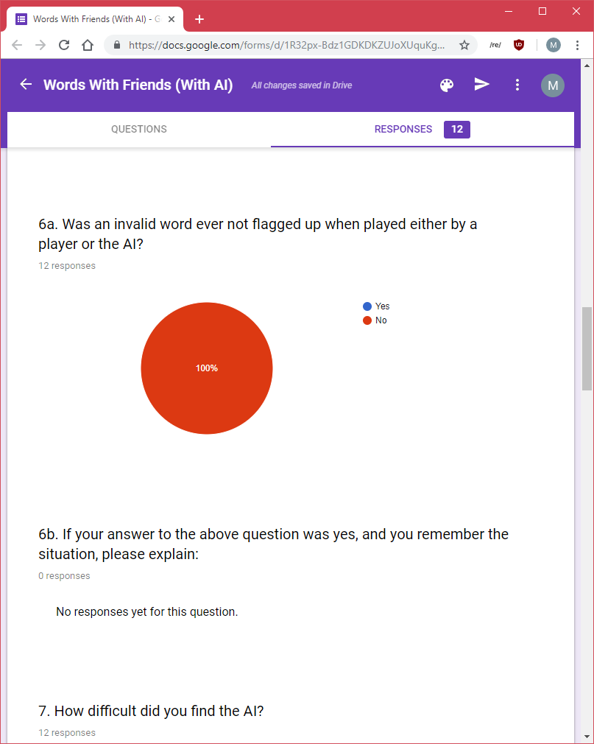

The reason for asking this question is similar to the above one: to see if reality reflects what my development tests say. According to this, yes, they do, and I am quite satisfied with that.

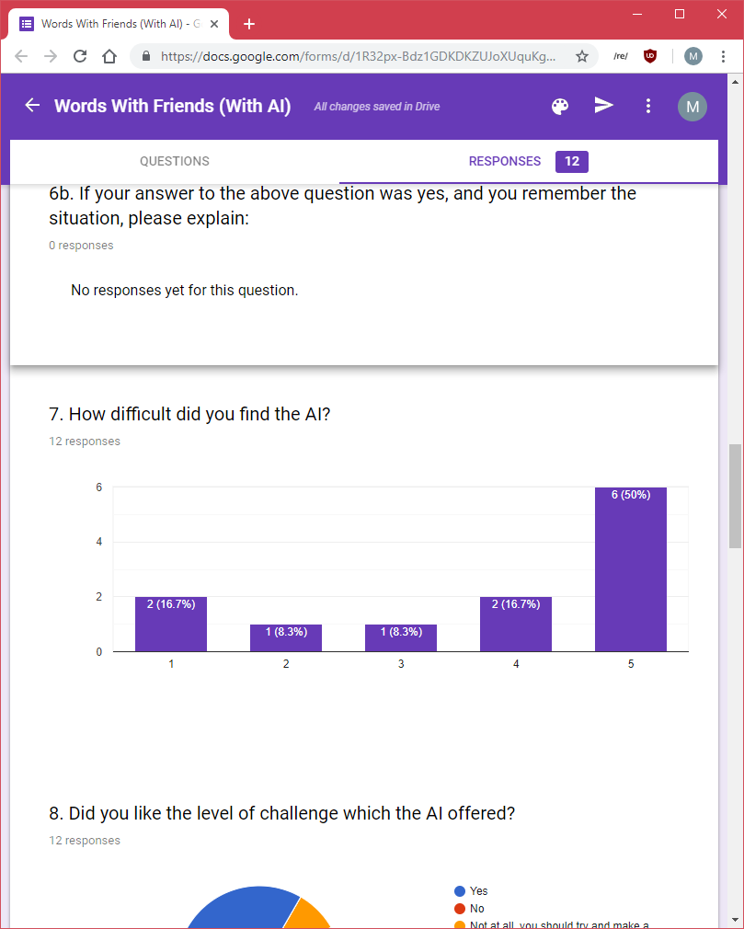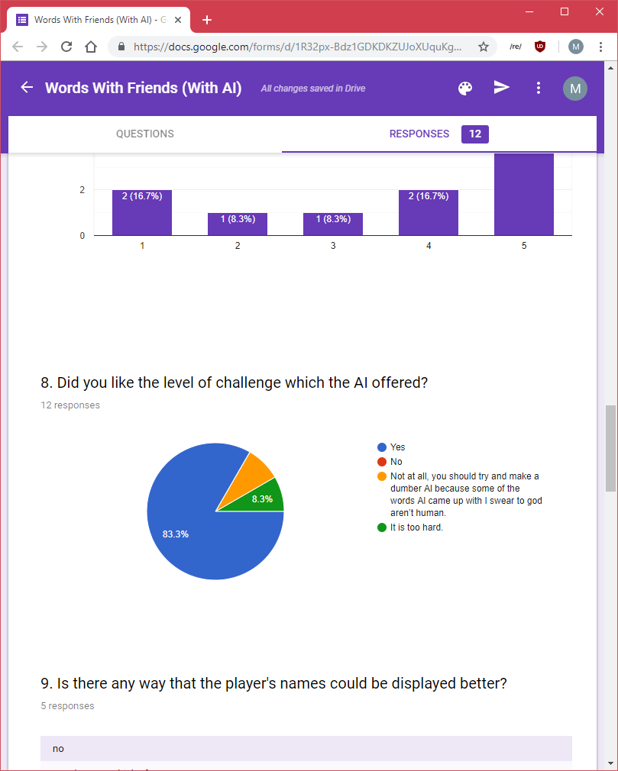

These two questions are related to each other, so I will consider them together. Because the AI plays the highest scoring word it can on its current turn, it would be quite difficult to beat. However, if one though a few moves ahead, it could probably beat it, as the AI is unaware of opening up bonus scores on the board. Overall, I was expecting the AI to be given a score of 4 or 5 in the difficulty rating, which in this case accounts for 66.7% of replies. By just looking at those results, perhaps we might think that the user is dissatisfied with the difficulty of the AI. However, when we look at the outcomes of question 8, we can see that most users were satisfied with the difficulty of the AI, while 16.7% thought it was too difficult. This to me means that most users are satisfied with the difficulty, but some might want to see an easier version, probably such as the one I was planning on developing if I had the time to.

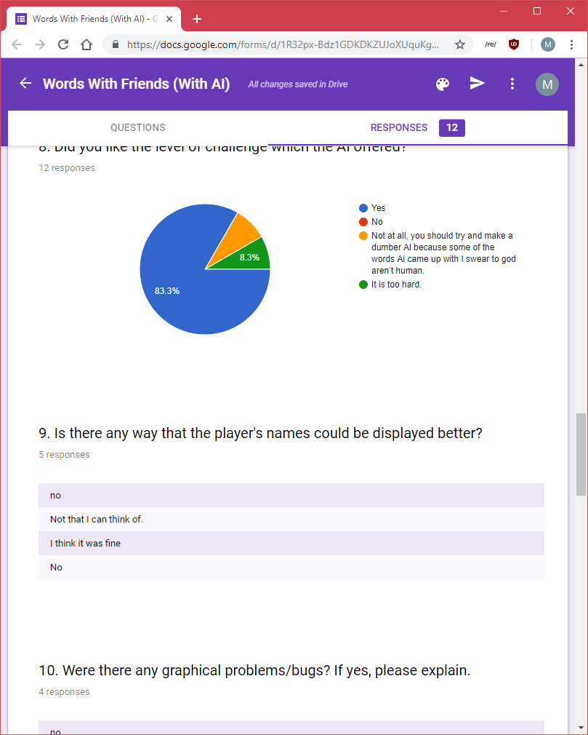

This again was another question to see what the user though of the interface a bit more deeply, and it seems that once again, they liked it. As it was an optional question, if there is no answer, it means that they probably had no complaints.

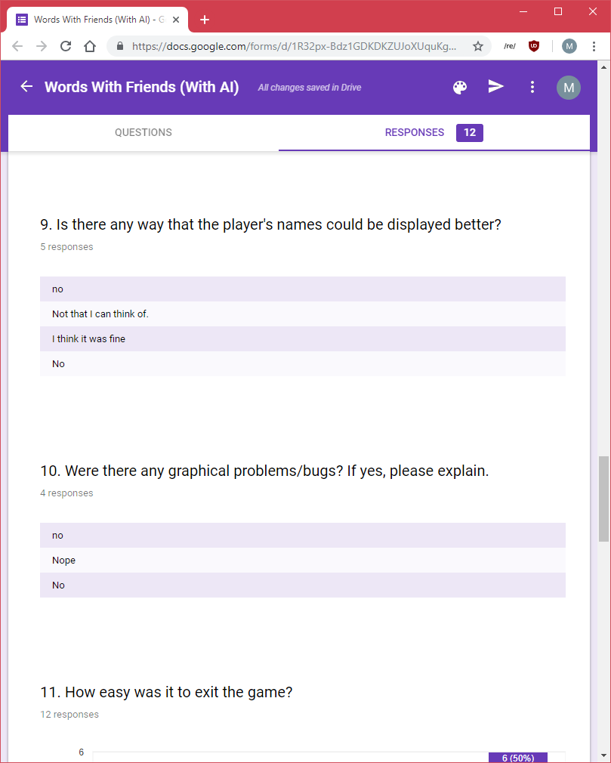

This question was there to make sure that my quality control wasn’t off, and that there are no random glitches which the user ran into that I was unable to catch. The results show an overall positive result, so the game is less likely to have bugs, be it visual or logical. This was another optional question, so no response once again probably meant to complaint.

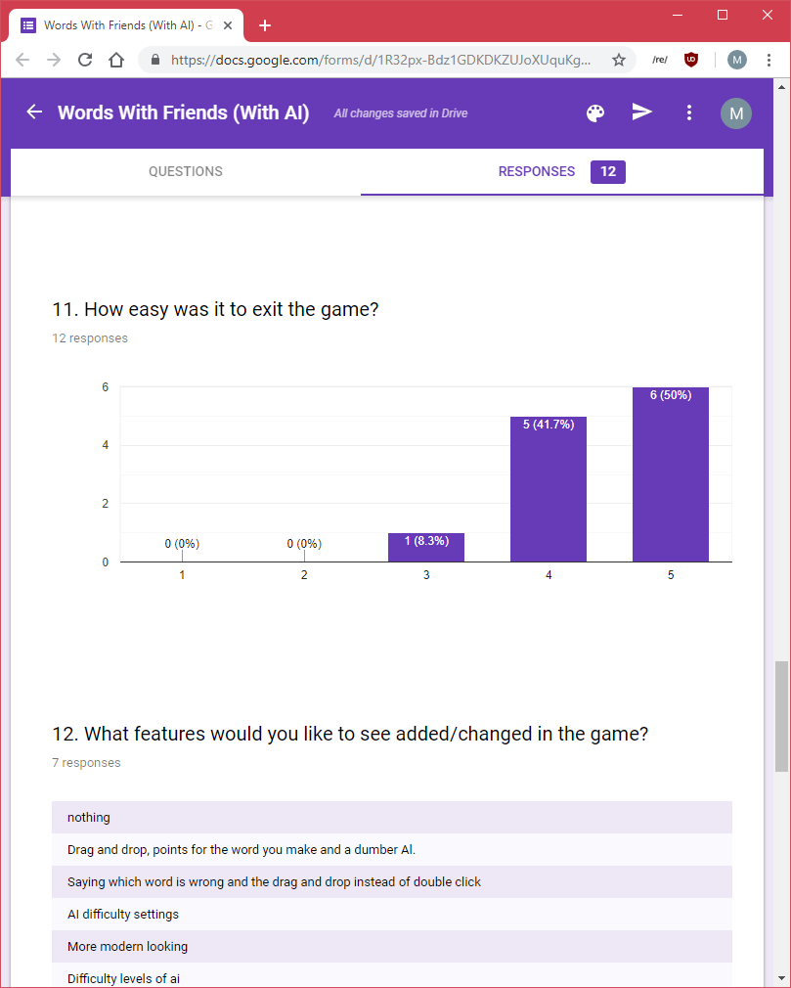

Because I was having problems earlier on in development in exiting the game successfully without any errors, I decided to ask my users what they thought of the currently implemented ways of exiting the game (i.e. whether it is user friendly enough). An overall positive rating suggests that I was able to fix the problems which I was having earlier on, however the not all 5 rating means that it could do with a bit of polishing.

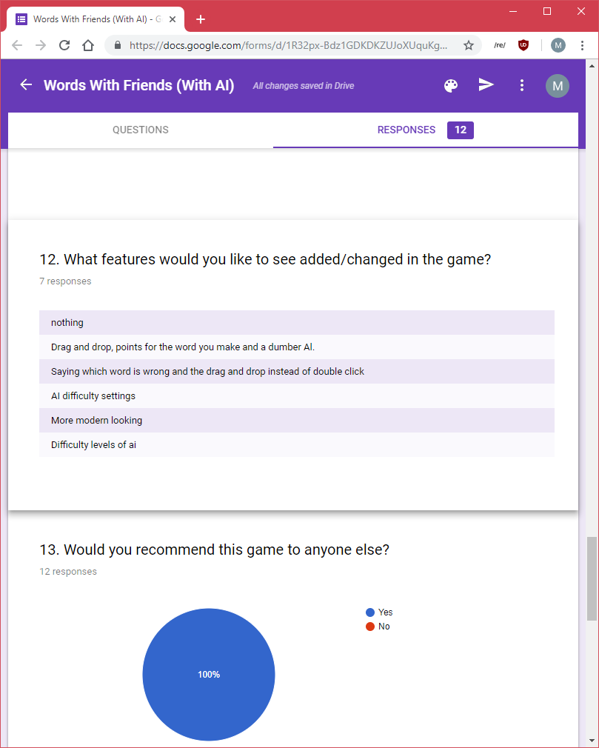

Not to be confused with the second question, which asked only about what can be improved in the interface; in this question I ask the user to tell me what they would like to see in the game as a new feature.

Some of these features (such as ‘AI difficulty settings’) have come up before, and I realise that they do need consideration, and probably should be implemented. The other feedback given is mainly on the interface side, so I will ignore it, as that was asked of the user previously.

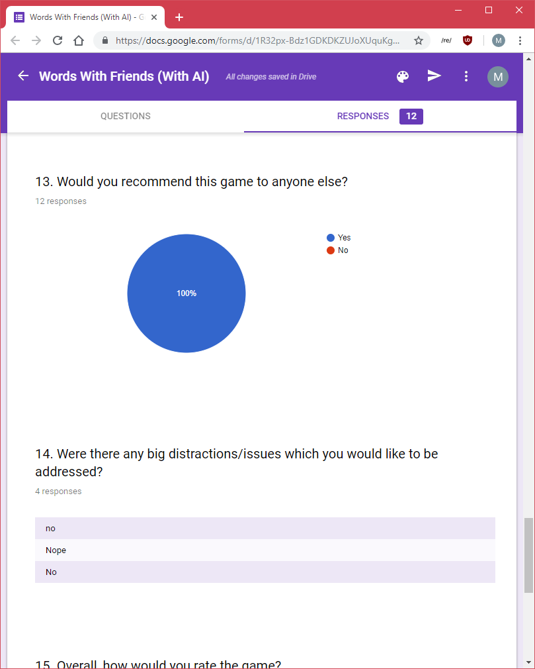

This was a more general question directed at the user to see if they liked the game enough to even consider recommending it, and it seems like they do, which is what every developed is hoping for.

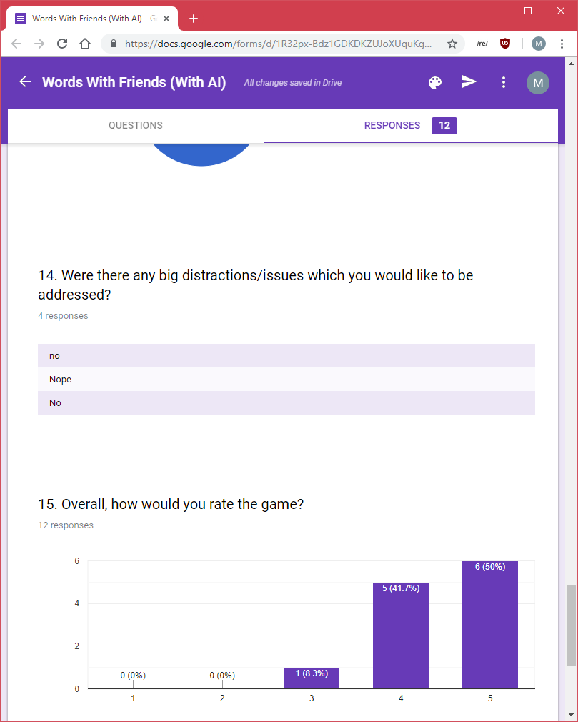

Again a more general question to see if the user thinks there are any problems with the game, and the feedback is all positive, which is good.

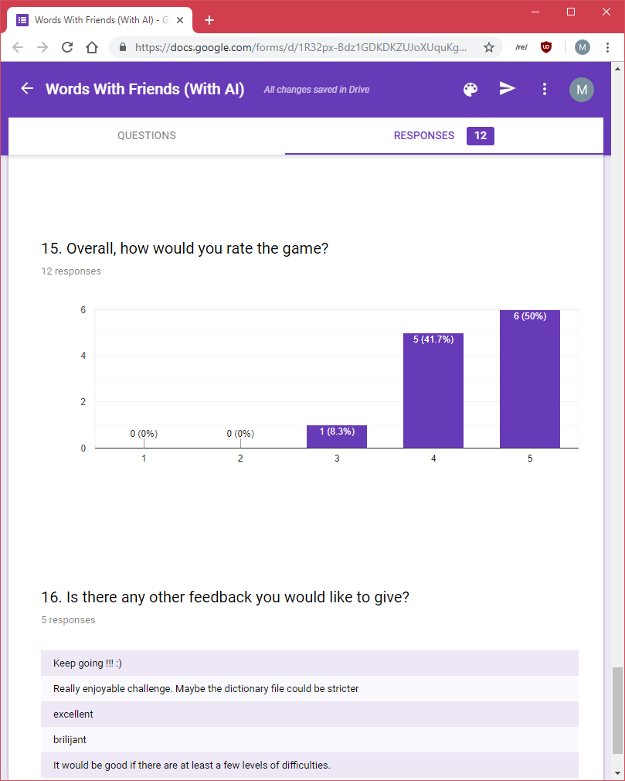

The results here are strangely the same as those on question 11. The question was asked to see what the user though of the game, and the feedback is either positive or neutral, so I am quite satisfied, as it mean that the game is well designed overall.

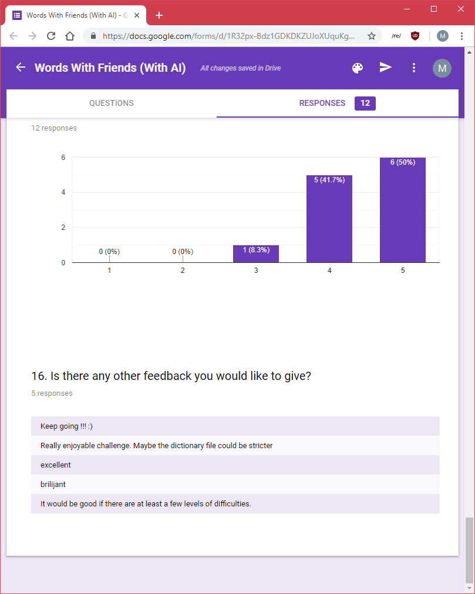

And the final question was another general question to see what the user thinks. Most things mentioned have previously been addressed, except for “the dictionary file could be stricter”. This might refer to the fact that some words which are in the dictionary don’t really look like words, but this is mainly because we don’t come across them as frequently. What I maybe should consider is having an option at the start of the game to ask the user which dictionary to use, which would just switch the dictionary file which the GADDAG structure makes valid words from. Otherwise I don’t think that it’s a massive problem.

### Usability Features

As my game isn’t a game which has a lot of different movements like a 3D game might have, there aren’t really many usability features to talk about. The main ones are the user interface and how the user can interact with it, and how easy it is to play the game. There isn’t much customisation which the user could do, as there isn’t really much that a user might want to change. I will however talk about what I have implemented, and what I could implement.

Firstly, when the user hovers over a button, it changes colour very slightly, signifying that the user is hovering over a specific button. For example, if I hover over the ‘Online’ button:

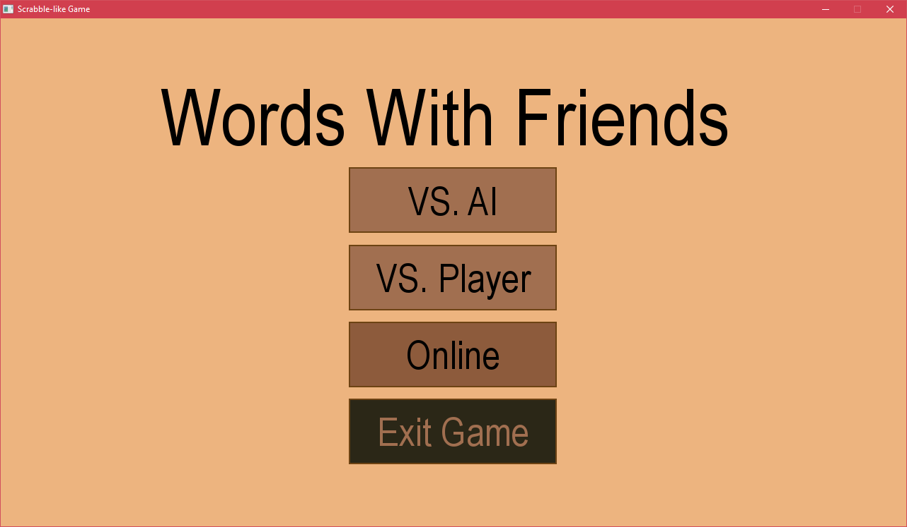

You can notice that its colour is slightly different to the two buttons above it. When I move my mouse off it, it goes back to its original colour.

What I could have improved here is to have made it so that when the button is clicked, it becomes an even deeper colour, to signify that it has been clicked; another thing I could have implemented is to have it so that instead of the action being registered on mouse left click down, it’s registered on mouse left click up, meaning that if the user clicks it, holds down on it, and moves off it, it is not interacted with, which is a favourable way for how a button works in programs in modern software.

Next, when the user is entering their name, they can just press the enter key on their keyboard (either the numpad or non numpad one) to submit their nickname:

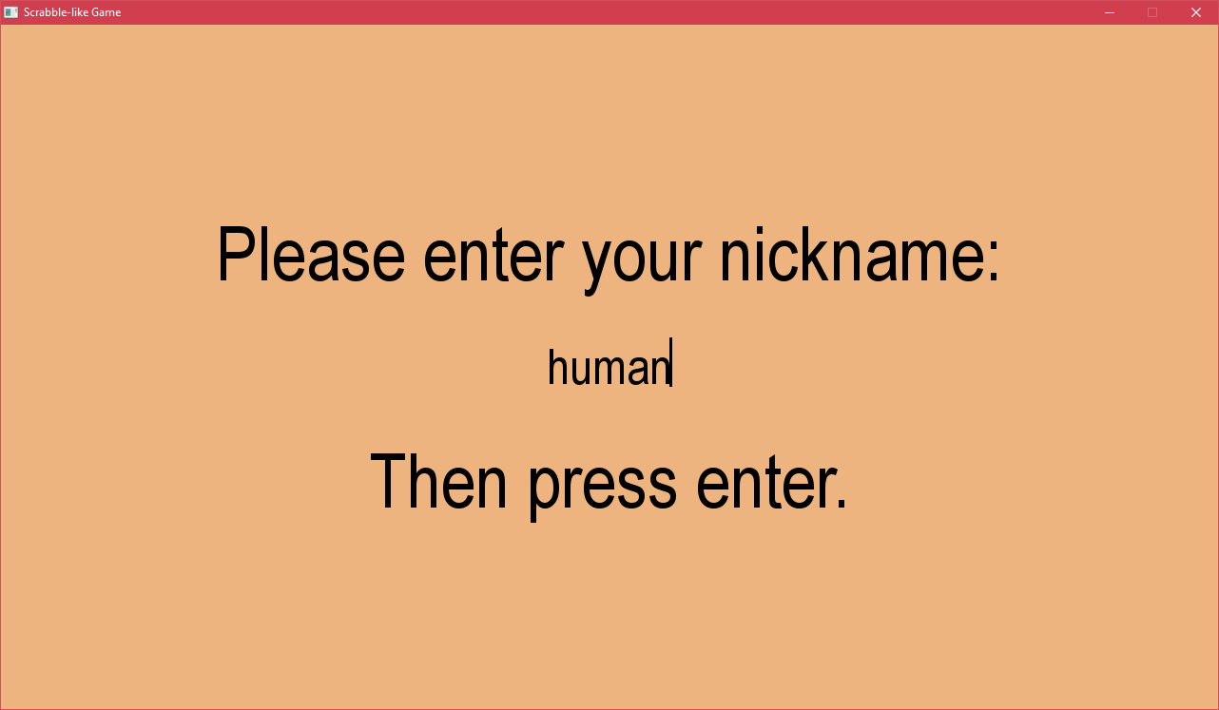

Also, while they are typing their name in, they can see what they are typing, and they can use the backspace button on their keyboard to delete the last character, use delete to delete the character to the right of the cursor, and move around the entered text using their arrow keys:

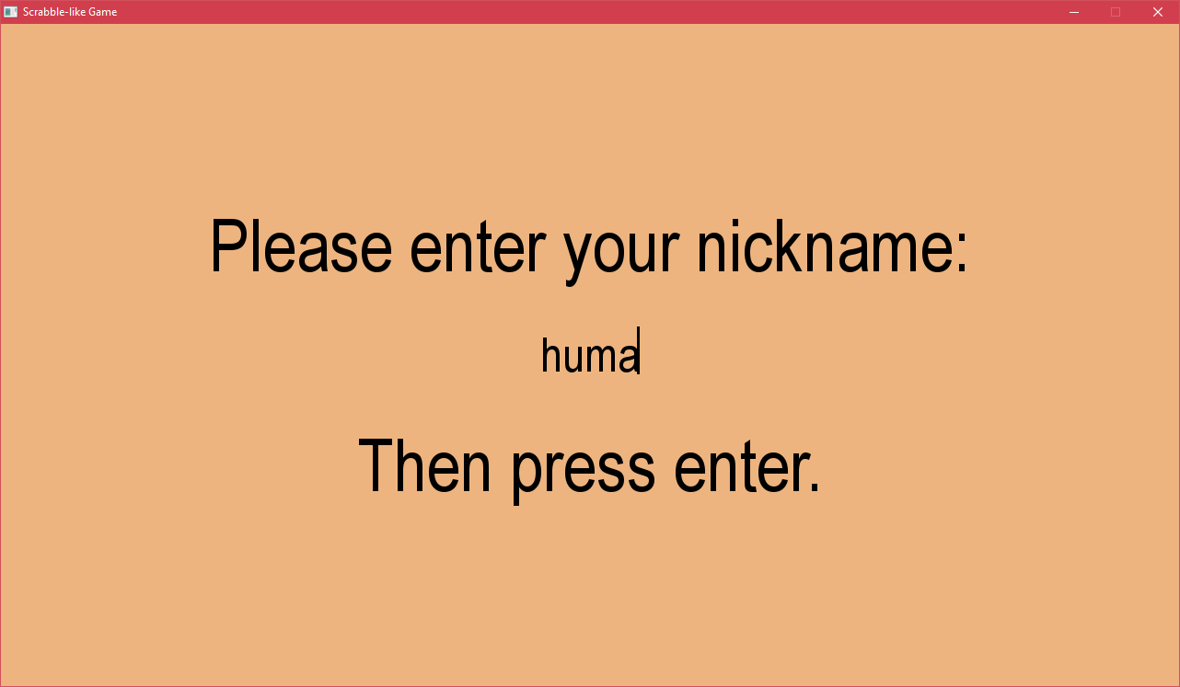

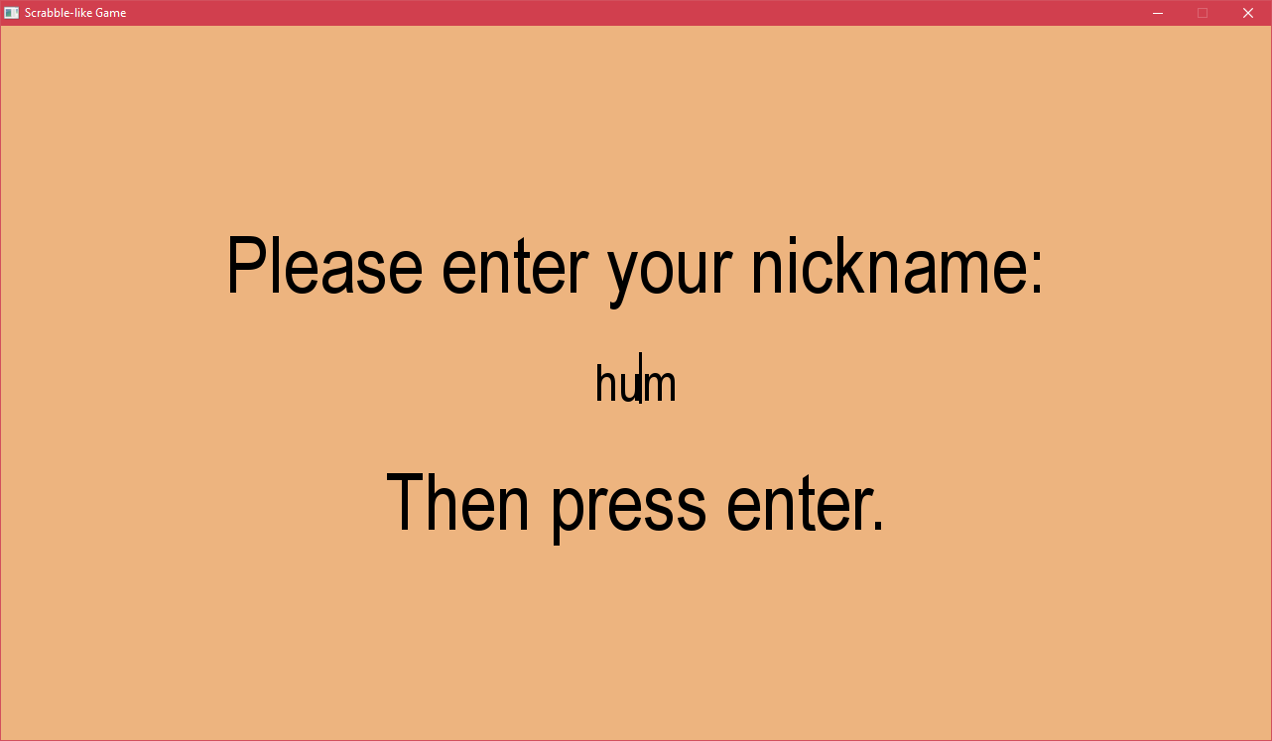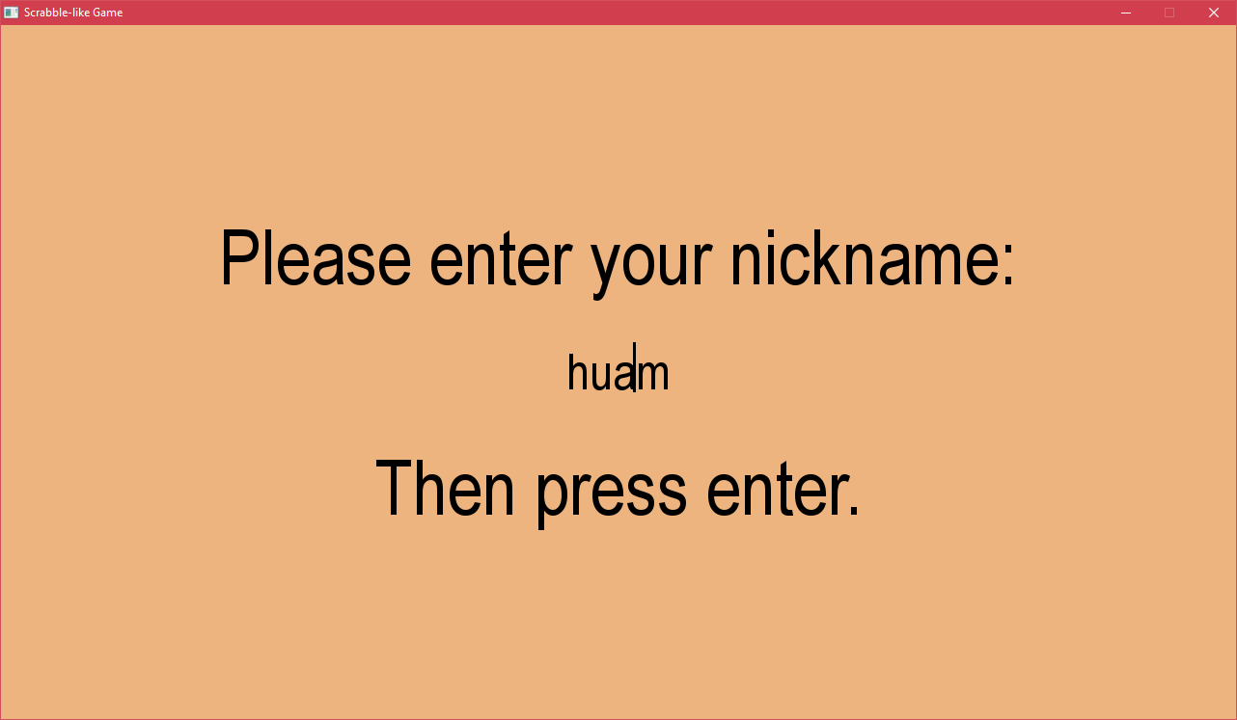

(note that the cursor does blink, but for demonstrational purposes, I’m screenshotting it when it is visible)

What I might want to implement here is also a button which the user could click instead of having to press enter to progress (while keeping enter as a valid option as well). With the current state of my program, this shouldn’t take very long, however I did not see it as a very good use of time, and none of my users seemed to complain about it as shown in the above section, therefore it’s not a huge deal.

The next feature is that the user can edit the words in the dictionary as they wish, to add, remove or change words which are acceptable play (both in player vs player and vs ai mode); this includes the user being able to download their own dictionary file, rename it into ‘dictionary’ and place it in the same directory as the game file (replacing the old ‘dictionary’ file). I would not really put this as a selling point however, because this requires the user to edit a file instead of doing it in-game, which is not very user friendly. I don’t really see any alternatives to this, as displaying the full dictionary file in-game could be both taxing and inconvenient, as it would require me to have at least a basic text editor in-game, but because there are already solutions for text editors, this is just not required. Perhaps a simple solution might be to have an option where the user can type a word in to remove or add to the dictionary, without being able to fully see the whole dictionary file.

The tile bag and scoring systems are also usability features, as it means that the player doesn’t have to manually keep score of the word which is played and count the letters which were played each time to strategise, making the game more enjoyable for them, as it is less taxing on the mind.

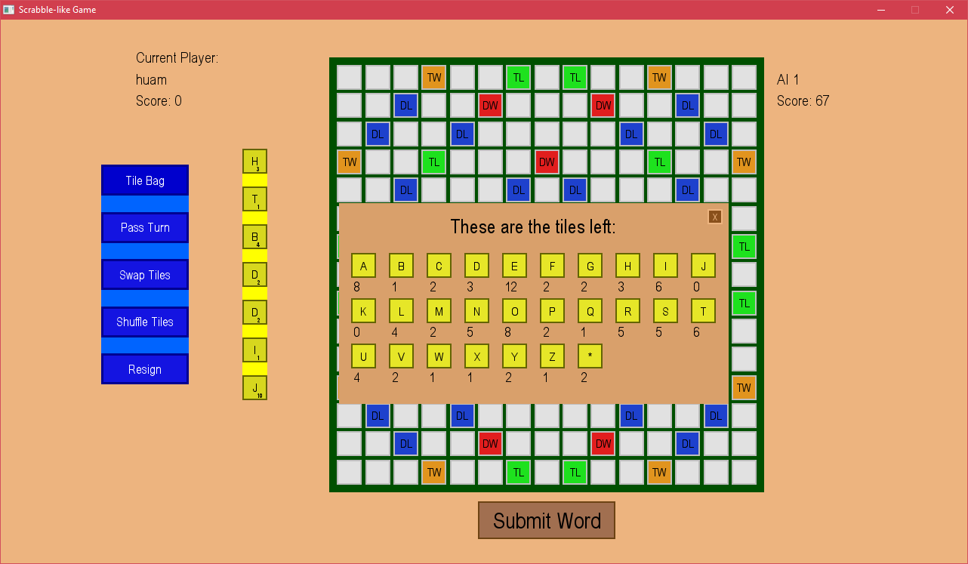

What perhaps could be improved is to show the amount of points each tile is worth in the tile bag, but this didn’t seem to show up as an issue in the questionnaire, therefore it probably isn’t a big deal.

A set of features which I might want to implement is customisation, such as having sounds for placing tiles down, allowing the user to choose which sound they would like for this, and volume control; being able to choose the background/theme colour. These features would require me to work much closer with the user to see what kinds of options they would like, as otherwise I might choose settings which I think are great, but the final user completely disagrees. This is another reason why they were not implemented in the game. However, for a real project, one would probably need to work much closer with their customer to make sure that the look and feel of the program is as close to what they want as possible.

# Task 5: Evaluation of Solution

## Success Criteria

According to my requirements, the game should meet the below mentioned criteria, which I will evaluate based on above mentioned evidence.

1. Register when a tile has been placed, and allow the tile to stay in the place where it was placed, unless the user moves it again. This should be shown graphically. Depending on the library I use to make my game graphical, this could be of varying degrees of difficulty, as I will somehow need to make sure that what the user is dragging and dropping visually actually lines up with the code.

* This was successful, but instead of having it to be drag and drop, the movement was done with two clicks. This means that for the core use of this function, this success criterion has been met. However, after looking at how users interact with the game and according to the feedback I received in the questionnaire, users would like this feature to be implemented differently. They would like to be a drag and drop option, like I had initially planned out to do it. This is because this method is more intuitive. Therefore I would count this criterion as **partially completed**, due to the game being playable the way it is, but not very user friendly.

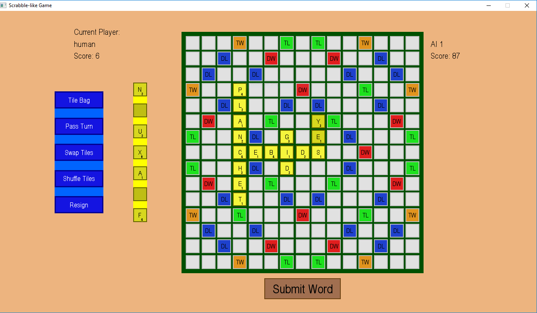

As visible, the current player has placed down the word ‘yes’ and it stays there.

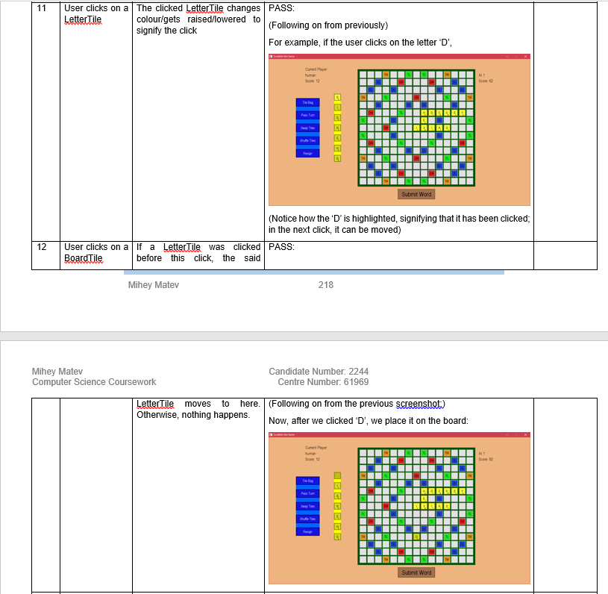

1. When a player makes a valid move and confirms it, their score should increase, based on how much the tiles they placed down are worth and the bonus squares they are placed on. This also assumes that the word placed down was a valid word.

* This was successful, as shown in my post development testing: all words which are submitted are checked against a dictionary to make sure they are valid words; their score is calculated (including bonus tiles), and added onto the current player’s score value. This functionality works exactly as I had first planned on it working, however some users (in questionnaires/during development user feedback stages) have mentioned that they would like to see whether the word/s which they are making are valid before submitting them, and also potentially how many points they would get for that point (once again before submitting the word/s). Although this is a feature which ‘Words with Friends’ has, I had not thought of implementing it, and I can that a user might want it if they are too lazy to count up which word would give them the best score out of all of the possible ones. After all, my program was meant to allow the user to be lazy, and not have to do such manual work. Hence, I will count this criterion as **partially complete**.

From the above example, when the player submits their word (and then the AI) the score is incremented:

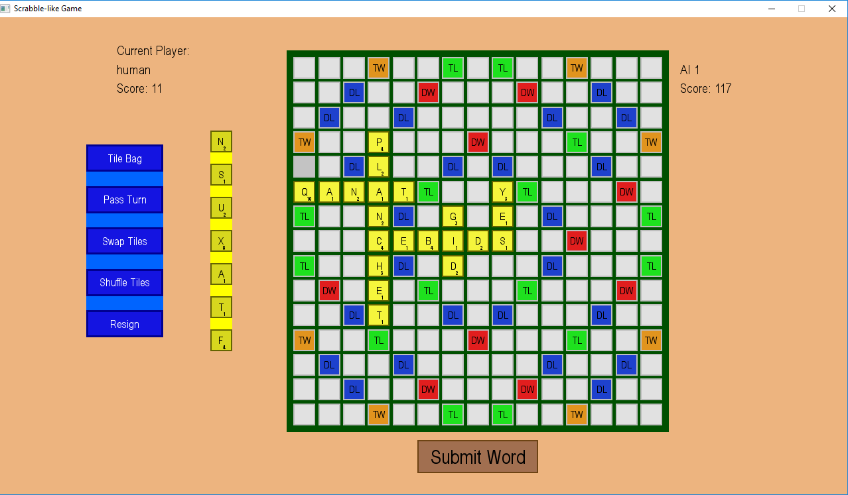

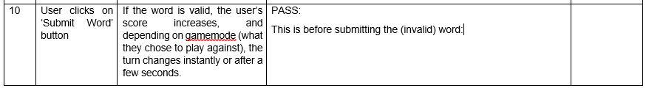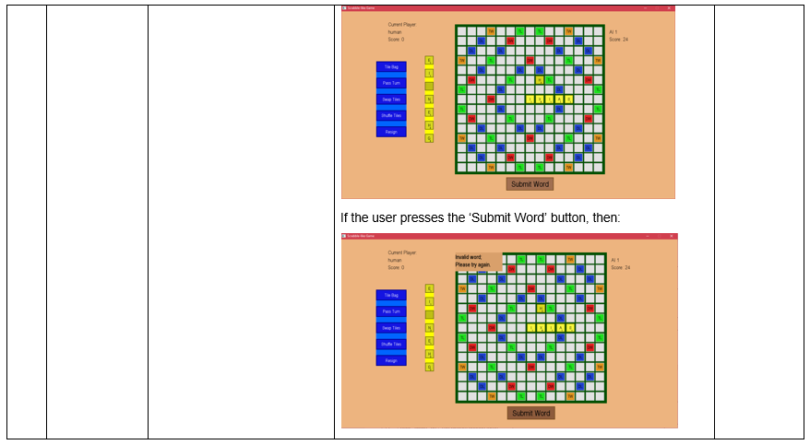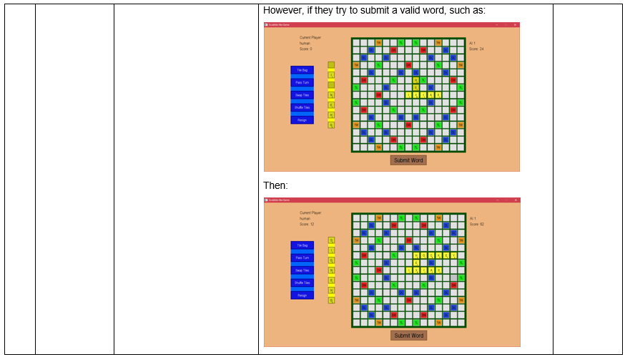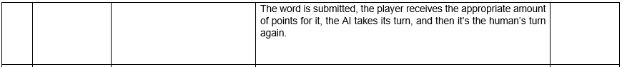

1. Once the user clicks on a button to choose whether they want to play against another player or the AI, the game should start. If they chose another player, once their turn ends, it should be the other player’s turn. If they chose to play against the AI, then once their turn ends, they AI should make a move, and then it should be their turn again.

* This was overall successful, and the users of my game had no complaints about it. When I made my initial criterion, I did not consider making online play, and so I did not put it in here. Seeing as none of my users complained about not having online play (in the questionnaire, prototype testing or just general user feedback between iterations), I will count this criterion as **fully met**, as the user is able to choose to play against the AI or another player in the same physical location as them. On a side note, I think that my user base found AI most entertaining, and did not really pay much consideration to online or vs. player, which might be something to consider for further development as something to focus more on than the other game modes.

The two examples above show the functionality working in vs AI mode. The following example shows it working in player vs player:

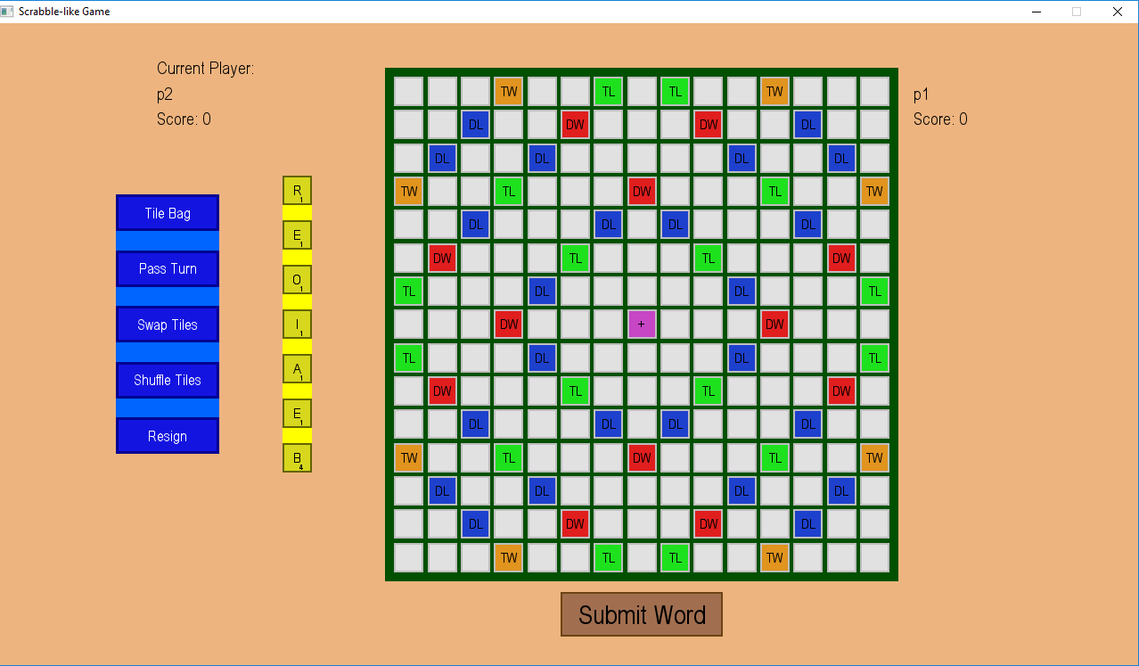

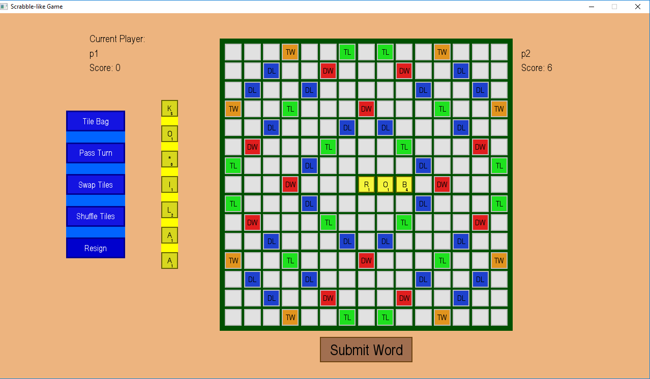

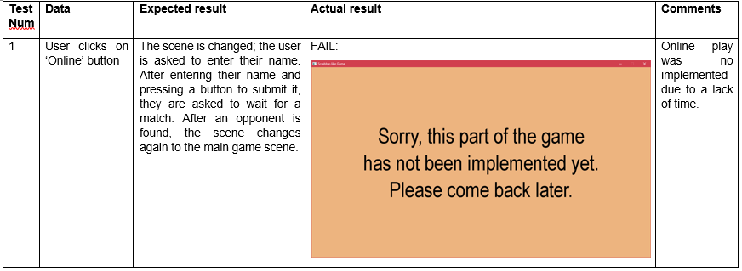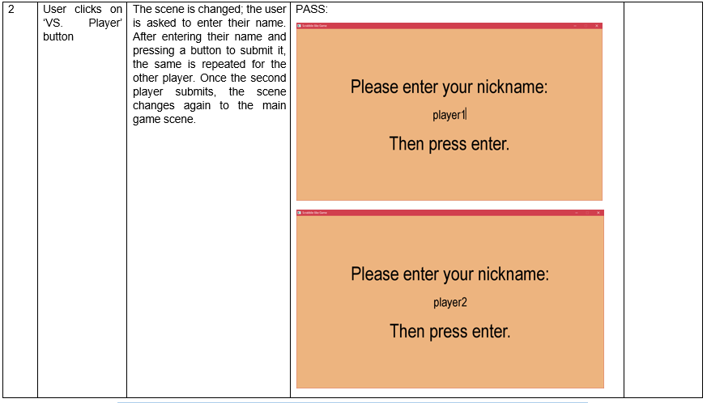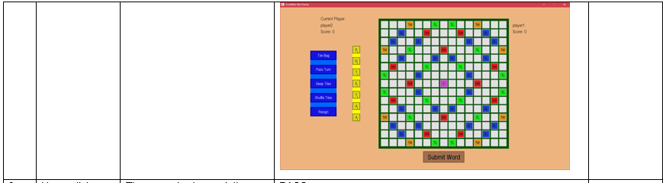

1. Similarly to above, once they choose to play against the AI, I might allow them to click another button to choose AI difficulty. To alter AI difficulty, hardest would be for the AI to play the highest scoring word on their current turn, and for every easier level they choose, instead of playing the highest scoring word, the AI plays the second, or third highest scoring word.

* This criterion was not met, as there wasn’t enough time to design another scene in which the user can choose difficulty and also implement that in the AI class. The criterion required that the user would be able to choose what word ranking the AI played (i.e. the highest scoring, second highest scoring etc.). This would allow the user to perhaps win more games against the AI, which makes everyone feel better than losing all of the time. This showed up as a requested feature in the questionnaire, meaning that users would like to see this implemented, as most of them find the current AI too strong to beat, because it is able to play such long and high scoring words. Therefore, this criterion has **not been met** at all, and would need further development.

1. When the user resizes the window of the game, the game should shrink (down to a minimum size, set by me) in such a way that every element is still accessible. This could mean that the game will have to either lose its aspect ratio or have black pillars on the sides/top and bottom, which might be frustrating for some users.

* This was not met, as pygame does not allow it, but it was not a feature which the end user seemed to be requesting, and is therefore not a huge issue. This criterion has **not been met**, however the only way to have this feature implemented would have been to work in a different programming language or with a different module, and so I will not discuss this point in my further development.

1. To test if the AI is playing the highest scoring word, I would either have to find a program which definitely plays the highest scoring word, or to just test it by giving it certain letters, where I know what the highest scoring word is. This approach of testing could be difficult as I would firstly need to find a program which already does what I want mine to do, or coming up with a situation where I know all possibilities and seeing if the AI plays the best one.

* This was **not met**, as the AI I created I suspect to do just this, so it’s difficult to know for sure if it always plays the highest scoring word. However, when given to other people to play against it, nobody has been able to beat it, which is a good sign that it plays quite well, and probably the highest scoring word in a given situation. I also think that I have considered every possible situation and made it so that it can consider special cases to place lettertiles down. As developing something which could test my AI would mean coding my AI (which I have been unable to find another example implementation of), I will consider this criterion as being met. (for further development – checking program could do a brute force trial placing down of each word (in the dictionary) in each position, and if it is in a valid position, get its score)

1. The success of this would be obvious: the user could interact with everything without actually typing much in, and doing most things in the game by using the graphical interface. How difficult this is depends on the library/module I decide to use. The limitations of a graphical interface compared to a textual interface is that it requires more coding.

* This was successful; the criterion basically just requires that the user is not interacting with my game through a console window, which has obviously been met, and there is evidence for it in previous sections. All of the interactions that the user does with my game are through the UI, and does not involve the console at all. Therefore, **this criterion has been met**.

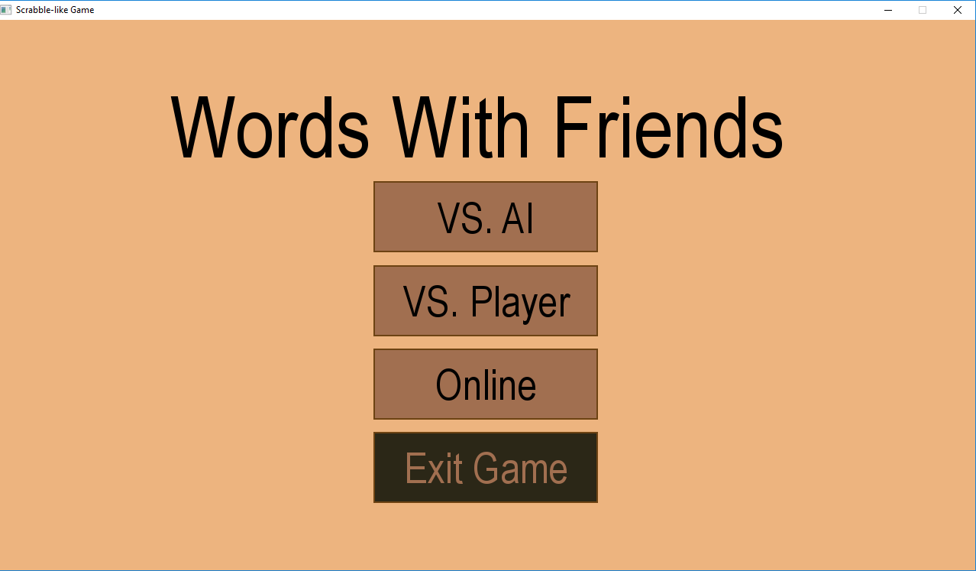

I have demonstrated this from almost all screenshots which I have shown, and here is one more.

1. This would mean that if the user selects the ‘pass turn’ button, then they forfeit their turn, and the turn goes to their opponent, just as if they had placed a word down, without any errors. This would also mean that they would have to score no points.

* This was successful, and my userbase seemed to have no problems with it. It probably would have been nicer if once the user pressed the button they were asked once again for confirmation in case they accidentally pressed the button, however from my testing and observation this did not seem very likely. Therefore, I will consider this criterion as **met**, and if perhaps users do have an issue with it, I might look into it for further development.

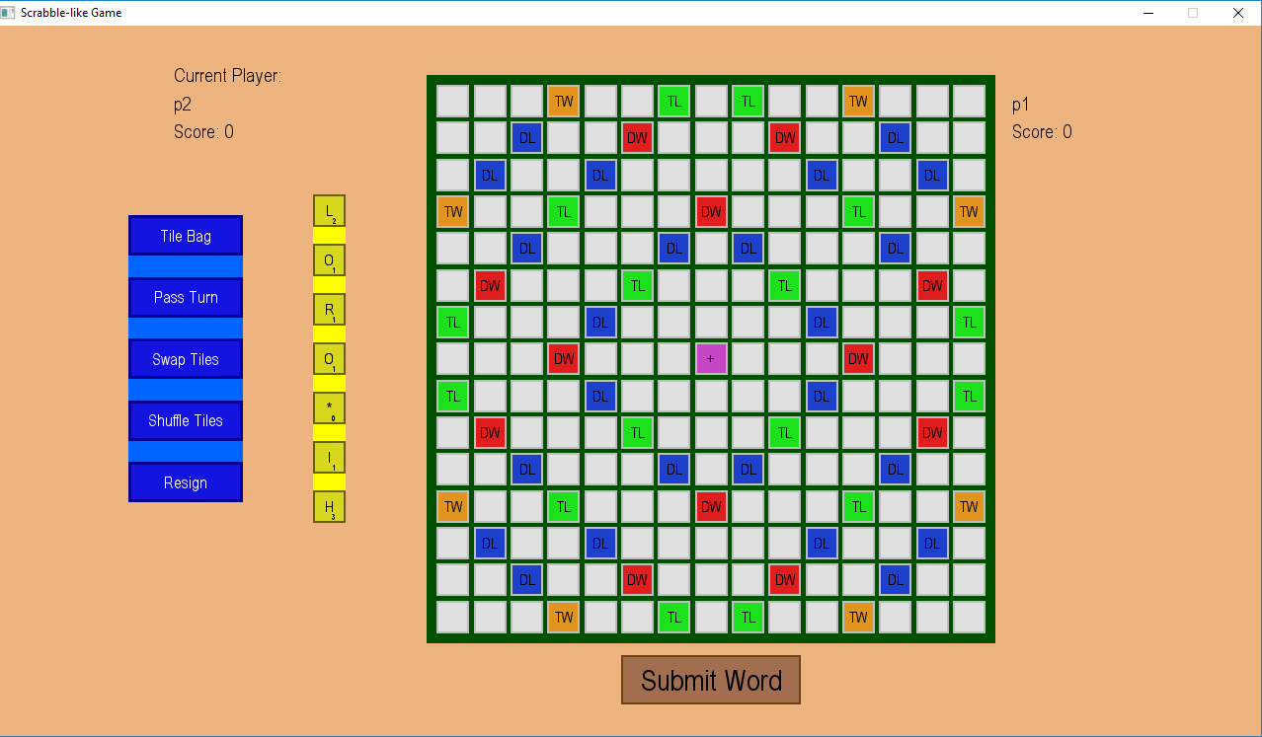

After pass turn:

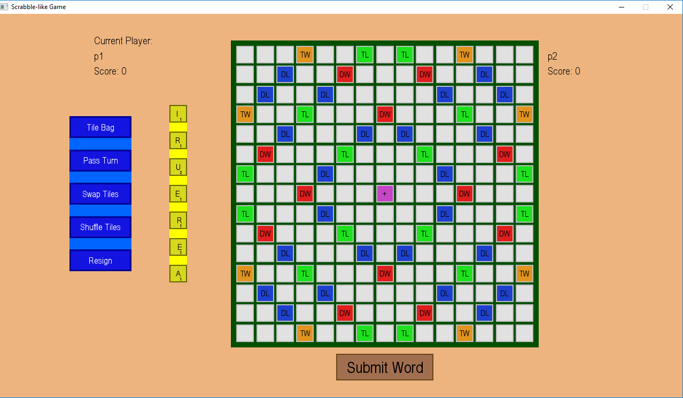

Notice that the two players changed.

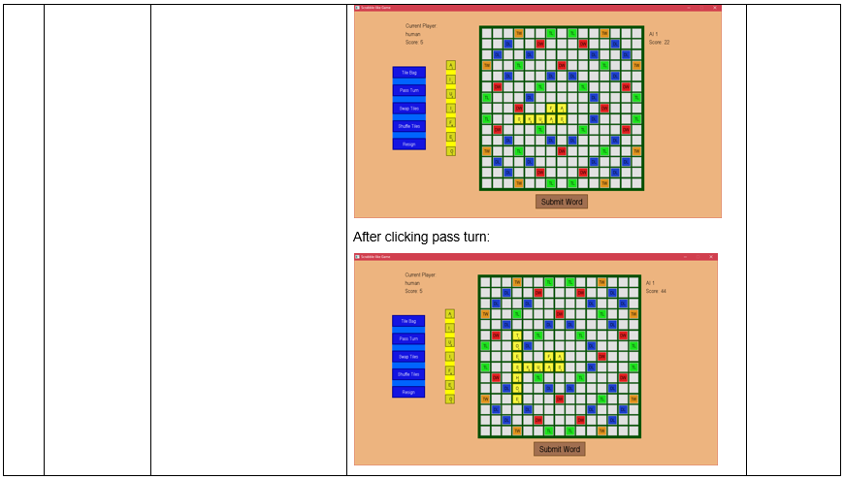

1. During a player’s turn, there should be a button that they can click, on the GUI which just shuffles all their letters around on their rack. By shuffling their rack, all that should change should be the order in which the letters on their rack is. This is easily done for a textual based interface by shuffling a list randomly, however for a graphical interface, I might need to refresh the screen after the shuffle so that in the GUI the letters are actually mixed up, although they are the same letters.

* This was successful. The solution in the end involved shuffling the logical list, and then basically passing it to the visual part of my game as it is, which handled it by either creating new lettertile objects if they didn’t exist in the appropriate tile slot, or just changing the characters of the lettertile. Users seemed to be satisfied with this, even though I would have perhaps liked to have an animation showing the movement of the tiles instead of an instant shuffling, as it could sometimes look as if the tiles were not shuffled although they were. However, seeing as the userbase seemed to have no issue with it, I will consider this as being **met**.

Before shuffle:

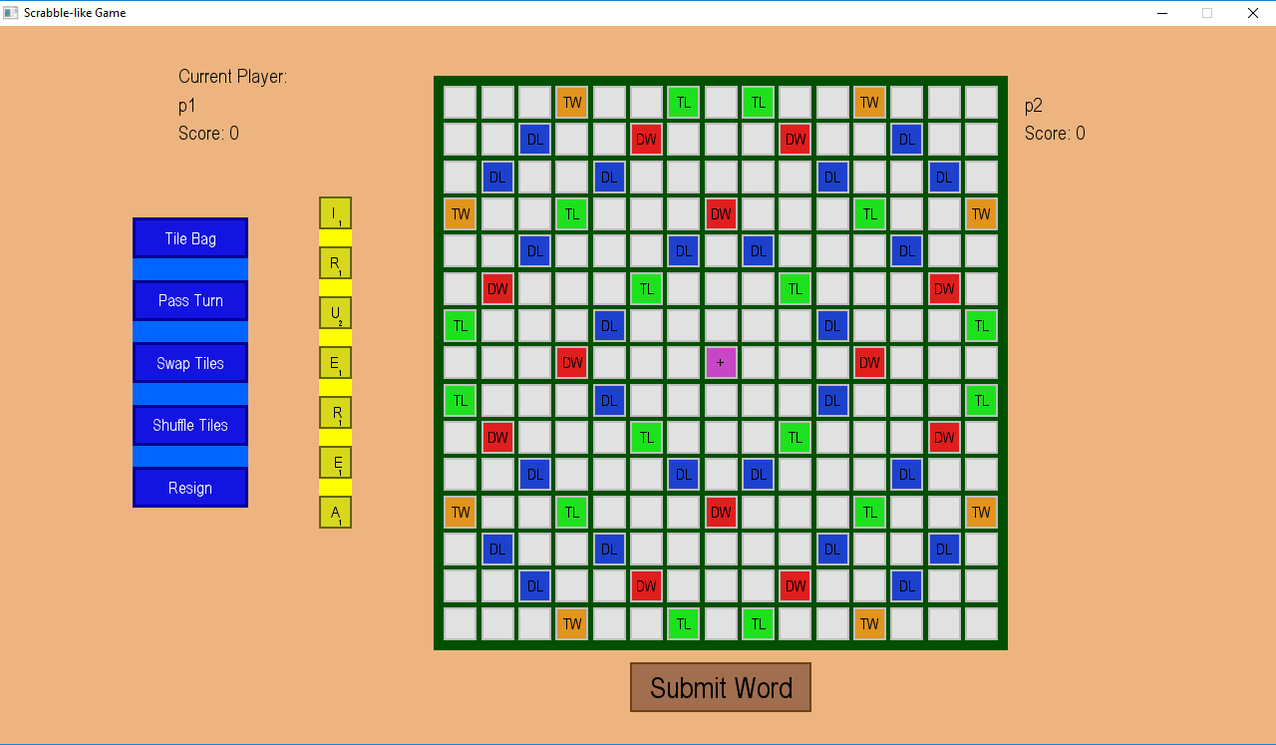

After shuffle:

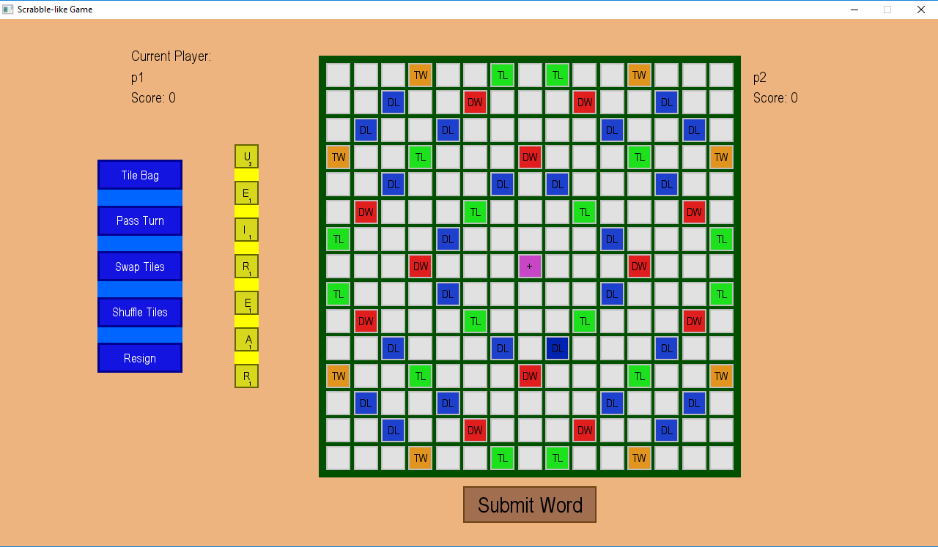



1. When the user places a word down on the board, and tries to submit it, it should be checked whether their word was a valid word by the game. I will know that this is successful by trying to put a word on the board, and then submitting it, and checking the game’s feedback against the dictionary file’s contents. A similar thing should happen for the AI, or the AI should just follow the dictionary file, meaning all of the words it makes are already valid, and not needed to be checked. The limitations to this might be that because the dictionary file is so large, it could take a long time to search through it each time to see if a word is valid. This is why the DAGGAD data structure could come in useful again, as it’s much faster to search through than a pure dictionary file.

* This was **overall successful**. As demonstrated in the Task 4, the game only accepts valid words, and if the user makes a word up, they are told that their word is invalid. However, because the AI is not as fast as I would like it to be and makes use of this method, perhaps if I found a more optimised way of performing the same functionality, it could make the AI’s thinking time slightly faster. The core idea of this criterion has been met, however I would like to discuss how it could be optimised to improve the AI’s performance in further development.

As shown in the above screenshots, only valid words are accepted, and invalid ones are declined:

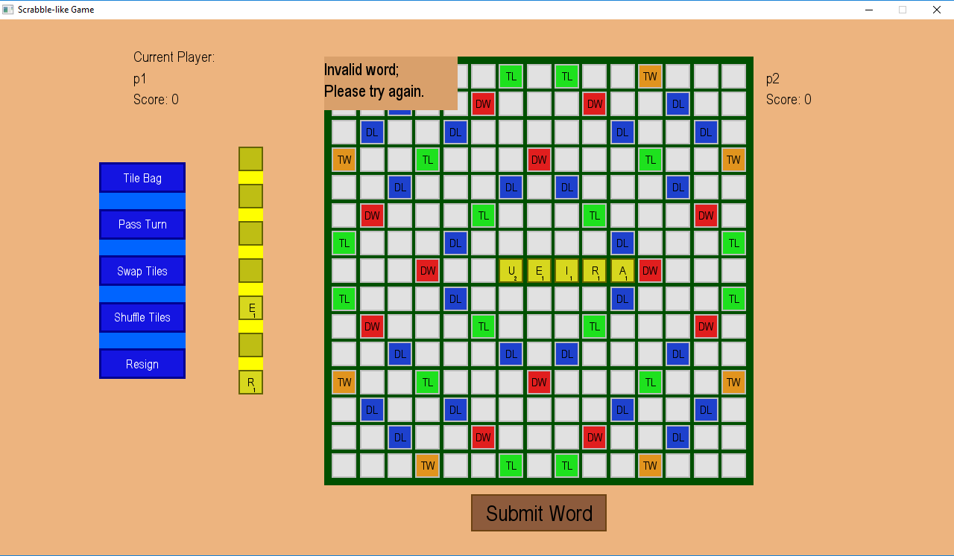

(Also see success criterion number 2)

1. There would be a button that the user can click to resign the game. This would give the other player the win, and potentially ask whether the players would want a rematch, or at least put the user on the main menu. This would force a game to end, and because the winning conditions are different than to a normal game (where the players play until one runs out of letters), it would require a different step in checking winning conditions.

* The main idea in this criterion was met – the user can forfeit at any time, causing them to lose and quit the current game. Although the users has no issue with it as shown in the questionnaire feedback (which is probably because the time to get into a game is much shorter than the time required to play a full game; if I had a ‘timed’ game mode with a shorter duration, then perhaps the user might complain about the time required in the set up process), in my criterion I did mention that I might look into making a rematch button, which I did not due to time constraints, and therefore this criterion is only **partly met**.

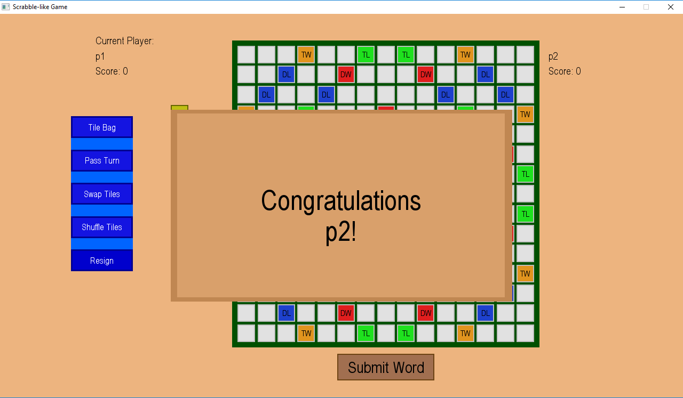

Here the game ended because I resigned.



1. The user should be able to click a button which displays all of the letters which are left in the bag (and the opponent’s rack). This list of letters should be quite easy to keep track of, as I will have a bag ‘list’ out of which letters will be drawn, and once a letter is drawn, it is just removed from that list and put into the player’s rack list.

* This was successful. When the user clicks the ‘Tile Bag’ button, they get a window-like ‘pop-up’ showing them which tiles remain, which has been demonstrated in Task 4. Therefore, this criterion **has been met**.



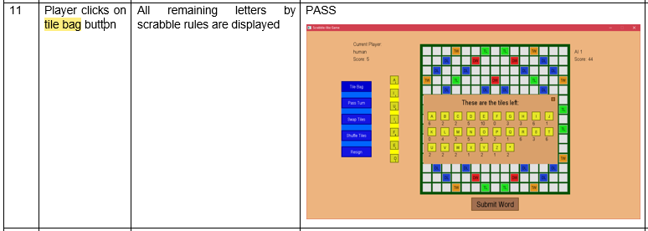

## Further Development for Success Criteria

1. In future development, I might want to make it so that the user can drag-and-drop instead of click and click to move tiles around. This would involve having some kind of an animation to allow the tile to move along with my mouse, and also some timing mechanic, which would allow a short click to be detected as a click and click option, but a click and hold to be detected as a drag-and-drop. Releasing the mouse click would also need to detected so that the tile could be dropped. This would involve differentiating between the two mouse clicks. The animation might be more taxing on the processing of the game (i.e. require more processing time), which would be something which might need to be considered. Another consideration would be to make sure that the tile could not be placed down in a place which is not a tile holder, but as the current implementation already takes care of this, implementing the animation part should be the only thing which needs changing, hence making further development quite easy.
2. Users seem to want feedback for the words which they place down. This is actually not that difficult to implement in my code, as I already have the logical parts of it implemented (as the checking if words on the board are valid and calculating scores methods in the game class). All I would have to do is display these in the GUI probably similar to how I display the warning message, either once they place a tile down, or once they click another button which I can add next to the submit word button to check these things for them and give them feedback.
3. This was fully implemented.
4. To make the AI easier to beat in the VS AI game mode, in my AI class I could most simply just make it so that instead of choosing the highest scoring word (at index 0) it chooses the second one (at index 1) or lower. The user would need to be able to somehow choose this using the GUI, so I would probably need to make a scene similar to the main menu scene, where there is either a scroller or a button array to choose AI difficulty which assigns which index is chosen for the AI, and this value is passed to the AI’s constructor.
5. (see note in previous section)
6. This criterion was fully implemented.
7. This criterion was fully implemented.
8. This criterion was implemented.
9. This criterion was implemented.
10. Because I implemented the AI nearer to the end, when I was shorter on time, I was aiming more to have it working than make the code efficient. This meant that some checks might be repeated, and functions such the hook functions, instead of being one function, got split up, which made my code unoptimized. This results in a loss of efficiency. Also, the fact that I use recursion instead of iteration is another downside, but I was unable to develop a way to do the task iteratively in the short time I had remaining. To improve this, I would need to look at the cases in which the HookH and HookV methods might be checking the same thing multiple times, and perhaps instead of repeating the process, storing the result and using it whenever it is needed.
11. To implement such a rematch button, I would have to have a timer counting down, in the duration of which a player could press the button for a rematch, which would mean that they wouldn’t have to enter their names again to play a new game. If they didn’t press anything and the timer ran out, or they pressed a different button (main menu, which I would have to also implement) then they are put back onto the main menu.

## Usability Features

According to my requirements, I will discuss the features which have or have not been met in my solution to the problem:

1. If the user has entered a word which they are not happy with, they can just press a button and all of the letters would return to their rack, without them having to put them back in one by one. I would do this so that the user is able to more easily play the game, and perform actions quickly. It improves the gaming experience, which is what I as a developer am aiming for. If it isn’t there, then the user might get frustrated and decide to play against themselves on a physical board, as they are able to very quickly remove all letters from the board quickly.

* I have managed to **fully implement** this feature. If the player realises that what they have placed down is an invalid word, and would like to have another look at all of their tiles, then they can just press the ‘shuffle tiles’ button, which returns all tiles from the board back to their rack (and also shuffles them).

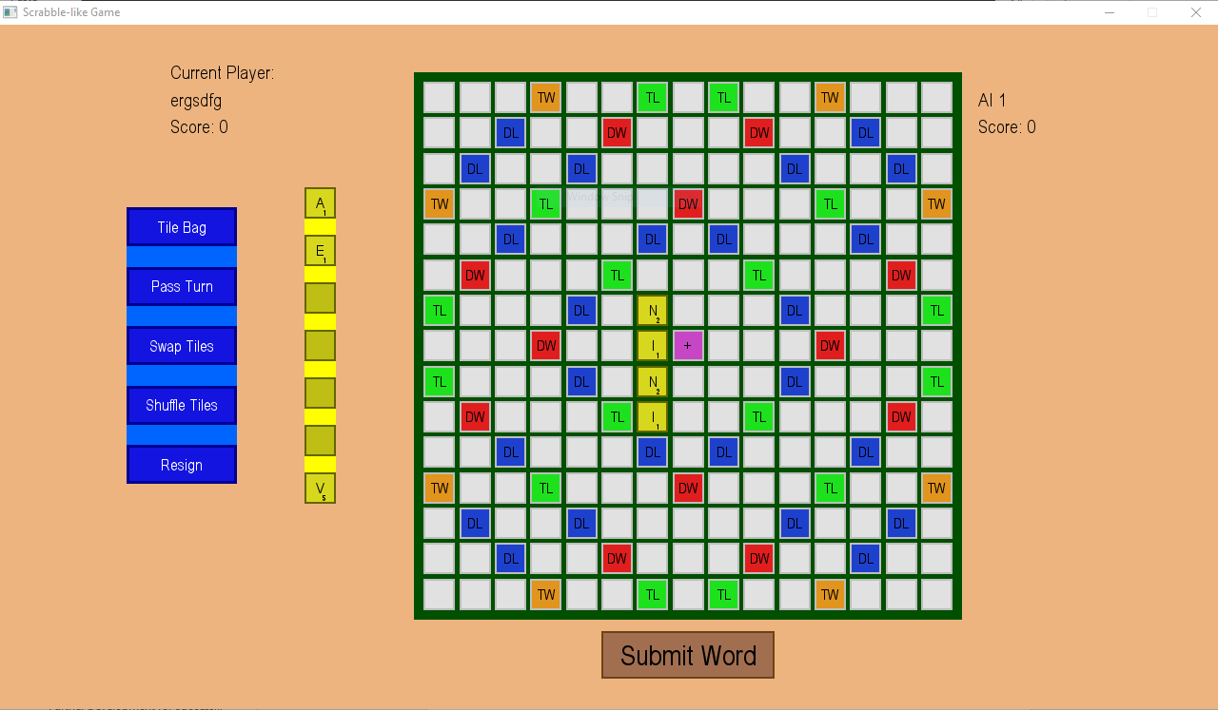

After pressing the button:

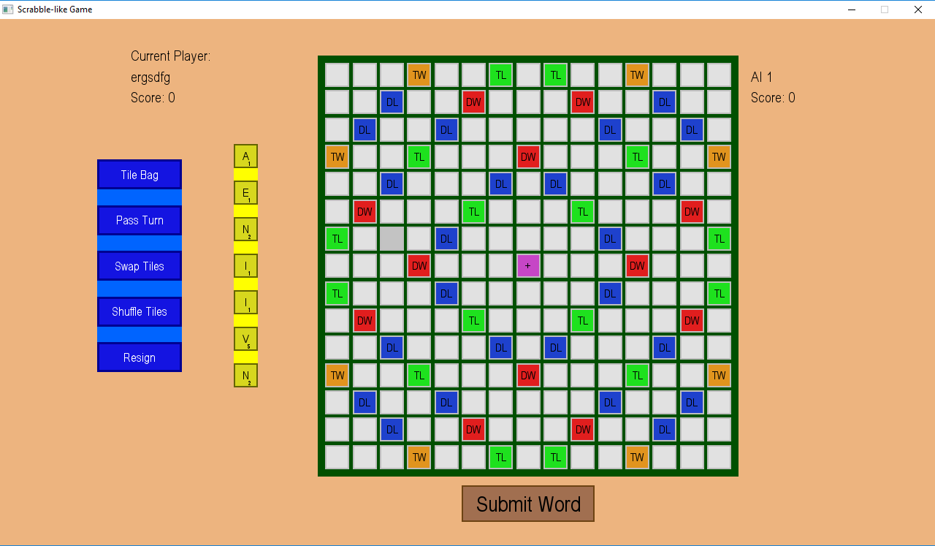

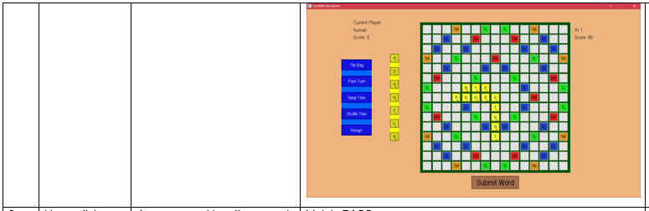

1. On the other hand, the user might not want to put all of their letter tiles back on the rack, so I would like to implement a way in which they can put only certain letter tiles back into their rack, without affecting the others. This would speed the game up, as instead of the user having to constantly remove all letters from the board, they can just pick out one of their letter tiles which make the word invalid, and change it, so that if they had made a spelling mistake, they don’t have to put all of their lettertiles down on the board again, which is more error prone, as there is now the same chance to get a letter wrong as before, and they might make the same mistake again, causing them to get frustrated.

* I have managed to **fully implement** this feature. If the player puts a tile on the board, they are able to click it to select it, and click on the rack to move it back to their rack. This does not penalise them in any way, and only makes the game easier to play, as they can move tiles around on the board and back to their rack (in any position of the rack) one by one, without having to use the shuffle tiles button to put all tiles from the board back to their rack.

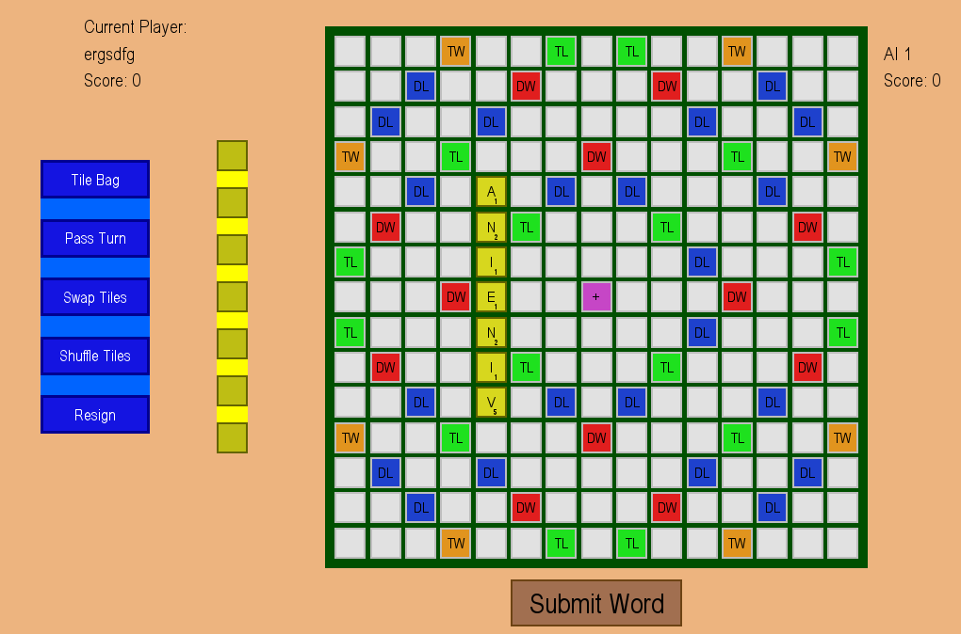

And then I returned one tile:

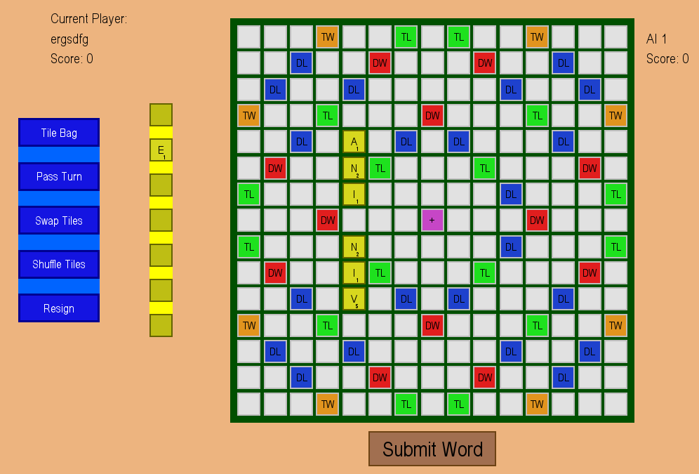

1. If the user submits a word, there would be a short message telling them whether the word was correct or not, and also if it was correct, how many points they gained from it. I would like to add this feature so that the user is always aware of what is happening in the game, making it easier for them to enjoy the gameplay, and not have to manually keep track of their score, which if they had to do, would be no different to playing on a physical board.

* When the user attempts to submit a word which is invalid, they are told that the word is invalid, and that they need to try again. If the word is valid, then their score is incremented, and it’s the next player’s turn, however the user is not explicitly told how many points their play awarded them, which means that some users might not have full awareness of what is happening in the game. Therefore, this feature is only **partly implemented**.

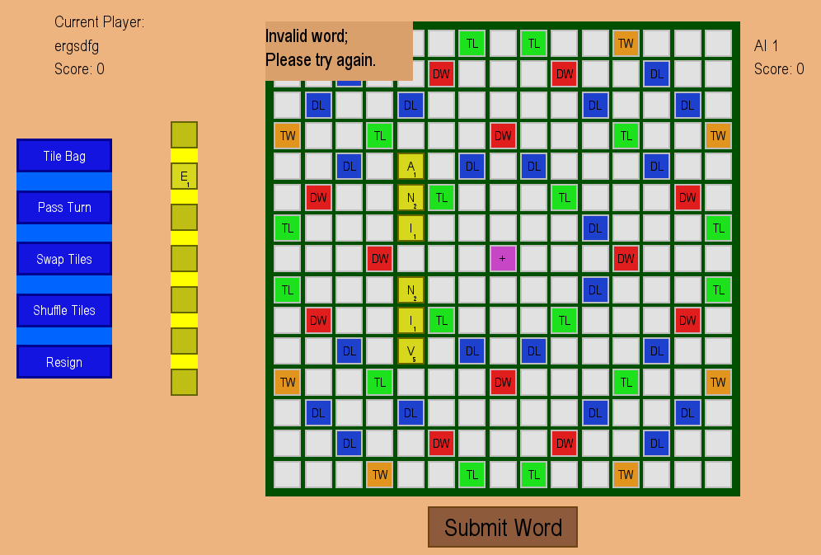

(Also see success criterion 2 for testing table screenshot)

1. The score keeping in the top right and top left for each player are always there, so the players can see how many points they have at each time. The reason for this is the same as above: it makes it so that the user can just focus on gameplay instead of manual score keeping.

* As the players keep submitting valid words, their scores get incremented by the appropriate amounts, and this score is always displayed by their name, which is always clearly visible. Therefore, this feature is **fully implemented**.

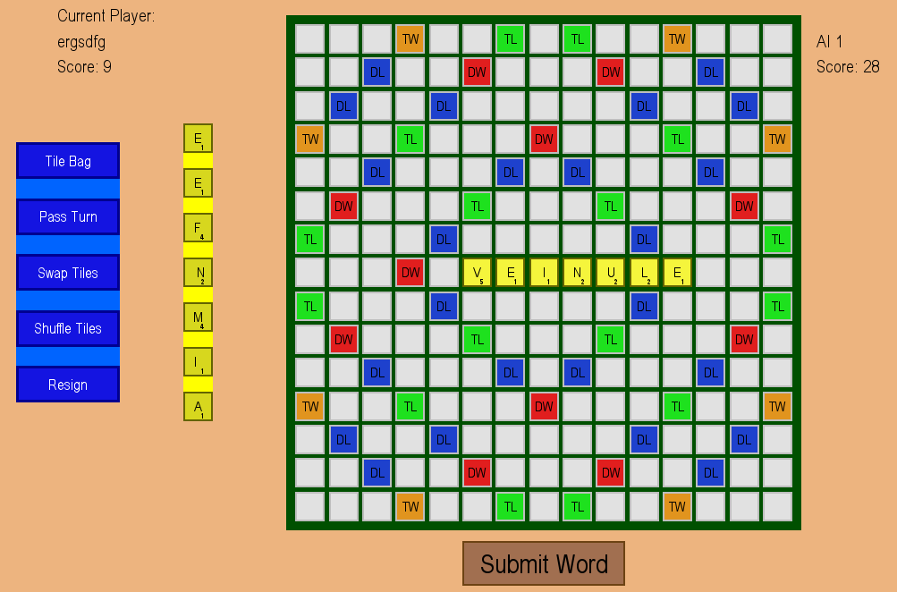

Ergsdf submits vein, AI 1 submits veinule, and their scores are incremented.

(Also see success criterion 2 for testing table screenshot)

1. If they press the exit game button (either the one in main menu or the one in the top right corner of every window in windows 10), before the game quits, there would be a prompt making sure they haven’t accidentally pressed either of the two buttons, which could lose them progress. This would be implemented so that if the user accidentally presses the exit game button, they don’t lose their progress, as they would have to confirm that they meant to exit the game, by clicking again, on a different part of their screen. If they said no, then the game would continue playing, saving them the time it would take to get a game in the same position as before after an accident.

* This feature has **not been implemented** at all due to time constraints. In the current state of the game, if the user tries to exit the game in either of the aforementioned ways, the game instantly exits, without any prompts, meaning that the players could lose some progress accidentally. I will discuss this in further development.

1. An extra feature could get that when the user hovers over a letter tile (either one which has been placed on the board or that is still in their rack), a zoomed in version of it shows up next to their mouse, so that it’s easier for them to see it. This could help the visually impaired or younger children who need to learn the exact correct shape of a letter so that they can write it if they are using my program to learn words. It makes the user experience better as the user is more able to understand and therefore interact with the game.

* Once again, due to time constraints, this has **not been implemented**. This will be discussed in further development. (such a feature would need to have a toggle option, as many might find it annoying)

1. When the user is asked to input their nickname, their input always displayed, so that they know what they are entering. This makes it easier for the user to make corrections to their nickname if they entered it incorrectly more easily, as they can see it as they are typing it. If they were unable to see what they are typing, they might not even know that they are typing, which could confuse the user, and might think that the game has crashed as nothing is happening.

* When the user is prompted to enter their nickname, either in vs AI or vs Player mode, they are able to see what they are typing or erasing, and this is constantly being updates, so they can see every change that is registered. Therefore, this has been **fully implemented**.

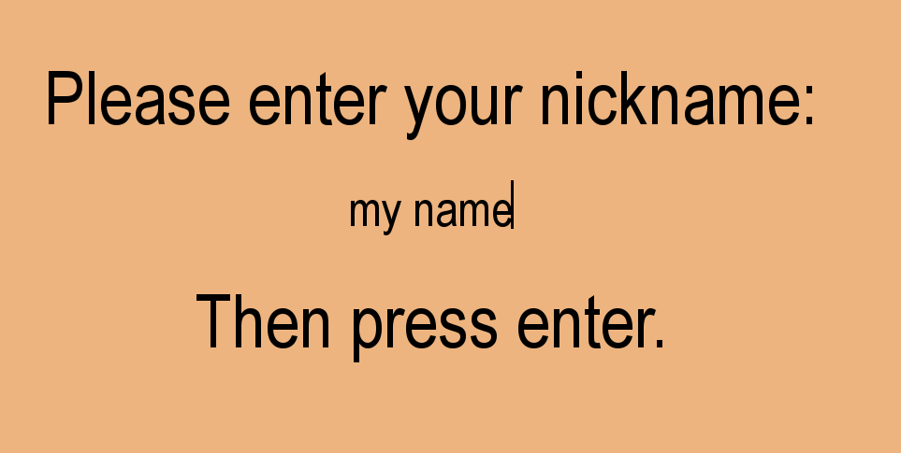 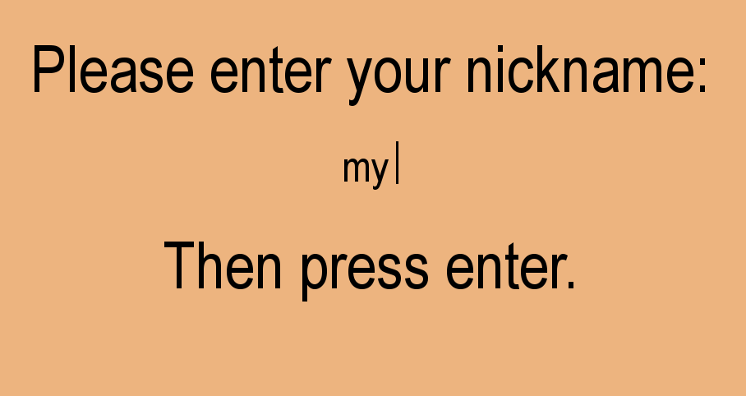

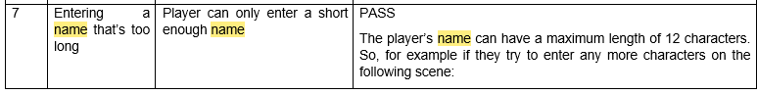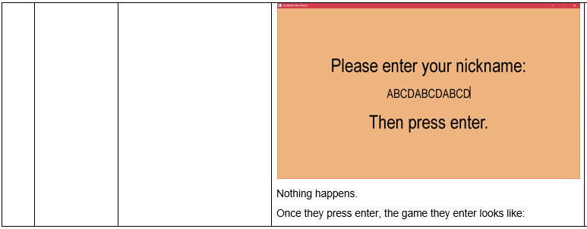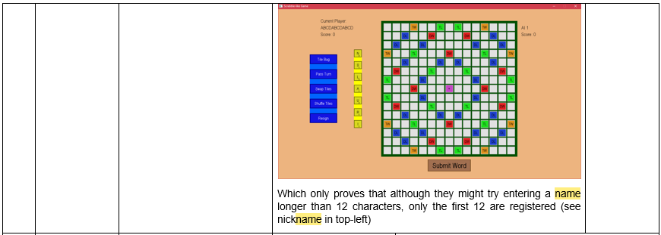

1. For a local player vs player match, a way of entering how long the swap-over wait time is would be variable, and the user can change it. This would make it so that the players have more time to change seats and not see each other’s’ tiles if it takes them a longer time. It just allows to user to have more control over the program, which is always nice.

* Due to time constraints, this feature has also not been implemented. It wasn’t a very important feature, as five seconds should be enough for many such plays, so it wasn’t a very important feature of the game. However, as it has **not been implemented**, I will discuss it in further development.

1. There could be a ‘hall of fame’ with all of the best scores listed in order on a scene which can be accessed from the main menu. This is not that important of a feature, but it does make the game feel like it has some persistent aspect to it, and it would promote rivalry, and therefore more frequent play, which for a game which runs ads, means more revenue.

* Same as above, this has **not been implemented** due to time constraints, and will be discussed further in the further development section.

## Further Developments for Usability Features

1. This has been fully implemented.
2. This has been fully implemented.
3. Just before the player’s turn changes, there can be a short pop-up message, in a ‘window’ similar to the invalid word one, telling them how many points they scored. This would not be very difficult, as I am already calculating how many points the player deserves for the word which they have placed down. This would just help them to know how much their score has increased by.
4. This has been fully implemented.
5. As all of my quit events are handled by one method in the director, instead of exiting the game straight away, I could call another scene where the user is asked to make sure that they want to quit the game. If they do, then the game exits as it does now when exit events are triggered, if not, then they are returned to whatever they were doing before the exit event was triggered.
6. Such a feature would need to have a toggle option, as many people might find it annoying, and I did not want to have an options menu, as that would have taken too long to implement. If I was to just add it in as a default feature and you could not toggle it, then it would probably require some kind of matrix operations to zoom in/enlarge a part of the screen, which would not be very easy to implement. As my target audience isn’t very old or very young people, this feature was not in the forefront of my mind.
7. This has been fully implemented.
8. Similarly to 6, this would have required an options menu, which would have been difficult to implement, as I would have had to pass the options and remember them for the whole game so that they are applied globally. As players which I surveyed (and I suspect most others) were mainly interested at the vs AI mode, this did not come up as an issue for them, which is also why I did not look that deeply into it. If I am looking into implementing a settings menu in the future, then this along with 6 will probably be the first two things to put in it.
9. This feature would not require much effort, as all it would have to be is just another which could be accessed from a button on the main menu scene, and my game could just read high scores from a file which it can edit after each game to record the top 10 high scores.

## Maintenance

One of the maintenance issues is that there might be some undiscovered bugs in my game, which I have yet to discover, but which need fixing. Currently, there is no way to report these. The simplest way to implement this would probably be to give the user an email which they can send bug reports to, which would be accessible somewhere from the main menu. I could give the user a form which they can copy and paste to write their bug report, and then send it to me. However, this might be inconvenient or annoying to do for some players. The most convenient solution would be to have some kind of a reporting system which could automatically send me bug reports without the user having to send it via their email. The location for this could be accessible from the main menu, but also made accessible perhaps if an unexpected error is caught by a try: except: part of my code. The only real way to implement this would be to have a host server which can receive all such reports, which without research, I would not know how to do.

Because modules (such as pygame) get regular updates, one maintenance issue is that some new version of pygame might remove or change some functionality of pygame, which could mean that my whole game would not work that way it is expected to. This is very difficult to foresee, but the best way to avoid it is before updating the pygame version of my game and recompiling it, reading through the update notes from the pygame developers, and making sure that any appropriate changes that are required are made. This will ensure that the minimal amount of unexpected errors occur in the next iteration of the program.

The most obvious maintenance issue is if I, or someone else, decided to add more features into the game, such as those mentioned in the two further development sections above. As it is with code, if you weren’t the one who wrote it, or a long time has passed since you wrote the code, it becomes difficult to know why you have done what you have done. However, with the help of this document, the comments in my program, and the naming scheme used for variables and methods in my program, I think that it shouldn’t be too difficult to figure it out. This does not mean that implementing new features would be the easiest thing, as due to the architecture of my program, one is forced to do some things in a certain way. For example, it is difficult to add a pop-up screen such as the one used for tile bag. This is because all events are received in the director, and then passed down to further classes. A pop-up event requires all other events, except the ones which the window is for, to be paused, and the only way to do this (which is not elegant) is to call the pygame method which receives all events again, and handle them again. But, because I have split my program up into many classes, it is quite easy to make use of for example the GADDAG class in a different program, as it doesn’t depend on anything. This helps with the maintenance, as if a better way of implementing the GADDAG class is ‘discovered’, then not much needs to be changed (i.e. all changes need to be made only in one place).

## Limitations

One major flaw in my solution is that my game requires somewhere between 750 and 1000 MB of RAM, and most of this is because of the GADDAG data structure. Although most modern computers have an average of 8 GB of RAM, this amount of RAM being used is still quite a lot for such a simple game. This is mainly due to the massive size of a dictionary in Python. If this was coded in C or C++, where we could use pointers, as pointers take up less memory, and therefore the overall structure would take up less memory.

Another concern on the performance side is that the AI can sometimes take quite a long time to place a word down, that Windows even thinks that the program has crashed. This is obviously not good, as it means that the user has a bad experience, and has to waste time waiting for the AI. One simple way to fix this is to make sure that no checks are being repeated, as I believe that currently some are repeated (as due to time constraints, the AI had to be implemented in a short time, so the code for it is not the most efficient). One thing to do would be to merge the HookH and HookV methods into one method, and another would be to perhaps remember words which were formed in the same row/column (going through a previous hook) so that they are not checked for validity more than once (as this takes up more processing time)

The above two points means that my game might be unplayable on slower/older computers, just because it has not been programmed efficiently. Next time, I might consider using a different language, and also different modules, which can allow me to make my game more efficient in resource usage.

One limitation in the user interface is that the lettertiles are in a vertical arrangement, which makes it slightly more difficult for a player to spot a word (as compared to a horizontal arrangement). When I was first planning the game, I did not think that this would be an issue, however after a few people played the game, and after I played the game myself, I realised that a horizontal arrangement would be much easier to make words in. If I were to change this, it shouldn’t be too difficult, as all it wold require me to do would be to move the position of the rack to where the Submit Button is, and the Submit Button to below the blue buttons. I would need to re-evaluate my lettertile placements on the rack, but these should not be too difficult to change.

Letters on the rack also cannot be rearranged by trying to swap the position of two tiles; one tile has to be moved off the rack before the order of tiles on the rack can be altered. A feature which I might want to implement would be to allow the user to swap the positions of two tiles on their rack, which would allow them to more easily form words on their rack, and make the gameplay smoother. This is another feature which should not be too difficult to implement, as all it would require me to do is check if I have clicked a lettertile before, and if I am clicking another lettertile, just to swap the two (visually and logically). As I can already determine which lettertile I’m clicking on, this would be quite easy to do.

A limitation to my solution is also that there is no customisation; the user might not like the colour scheme of the game, and might decide to not play it just because of that, which is not a great reason to lose a potential customer over. In further development, I might want to make a customisation menu, probably in the settings menu, which can contain miscellaneous customisation, such as sounds, colours, etc. This can also contain accessibility features, such as high contrast mode, brightness adjustment, or colour blind mode, to help users with different requirements to be able to more easily play my game. Implementing this might sounds easy, but due to the structure of my code, I don’t think it would be, as I am setting the colours of objects in many different places, because having such a menu was not something I had considered when I first starting making my game. In future development, I might want to put any colour declarations in one class or file, similar to the concept of CSS, from which all of my classes might take their colours from.

A slightly less important limitation is that it is only two players that can play the game, so it’s not like scrabble where four players can play the game. The game which I was trying to make does only allow for two players to play, however it might be a good feature to allow more than two players to play. When I first started coding the game, I was thinking about this, which is why instead of having only two players, in some places I have a list of players. However, as I progressed, and time got shorter, I got a complacent, and only made room for two players. I still don’t think that this would be too difficult to implement, as the main thing I would need to change is how many players are asked to enter their names in the director’s while loop. A problem with this though would be that there would still only be two players displayed at any one time on the screen, and due to how visual objects work, it might be difficult to change to any of the other players’ names in the text boxes.

Another big limitation is that the two players which might want to play player vs. player mode have to ‘swap over’ during a 5 second time period (which for one can be annoying to wait, and for two means that they can’t interact as freely as they would be able to in a real scrabble game, due to having to not be near each other when playing). The online version of my game would have eliminated the need for this, however a different local multiplayer option does not really exist. Even bigger games which are local multiplayer are sometimes played in split screen mode, which means that the players can cheat. This can potentially be seen as a feature, where both players have perfect information about the other’s tiles, but in that cause, I should have implemented an option to look at the opponent’s rack separate from the rest of the tiles in the tile bag.

My game has no progression in single player. This is mainly due to not having implemented different AI difficulties, which is definitely a lacking feature. With different difficulty AIs, the player might start off trying to beat the easiest one, and progress once they feel confident beating that AI to a more difficult AI. This would give both a sense of progression, and also allow for more casual VS AI play, if they are not feeling like losing most games. As discussed a few times before, the easiest way to implement this is to choose the second, third, fourth etc. element of the sorted list of valid words for the AI instead of the first element depending on difficulty chosen.

# Bibliography

(n.d.). Retrieved 6 19, 2018, from https://www.cs.cmu.edu/afs/cs/academic/class/15451-s06/www/lectures/scrabble.pdf

(n.d.). Retrieved 6 19, 2018, from https://en.wikipedia.org/wiki/Monte_Carlo_tree_search

*A Faster Scrabble Move Generation*. (n.d.). Retrieved 6 19, 2018, from https://ericsink.com/downloads/faster-scrabble-gordon.pdf

*A Scrabble Artificial Intelligence Game*. (n.d.). Retrieved 6 19, 2018, from http://scholarworks.sjsu.edu/cgi/viewcontent.cgi?article=1574&context=etd_projects

*Developing an Artificial Intelligence to Play*. (n.d.). Retrieved 6 19, 2018, from https://scss.tcd.ie/publications/theses/diss/2015/TCD-SCSS-DISSERTATION-2015-069.pdf

*Gaddag Data Structure – A Way To Quickly Find Scrabble Words*. (n.d.). Retrieved 6 19, 2018, from https://nullwords.wordpress.com/2013/02/27/gaddag-data-structure/

*Maven (scrabble)*. (n.d.). Retrieved 6 19, 2018, from https://en.wikipedia.org/wiki/Maven_(Scrabble)

*scrabble online*. (n.d.). Retrieved 6 19, 2018, from https://www.gamespot.com/computer-scrabble/

*The World's Fastest Scrabble Program*. (n.d.). Retrieved 6 19, 2018, from https://www.cs.cmu.edu/afs/cs/academic/class/15451-s06/www/lectures/scrabble.pdf